What’s the average salary by department and job role?

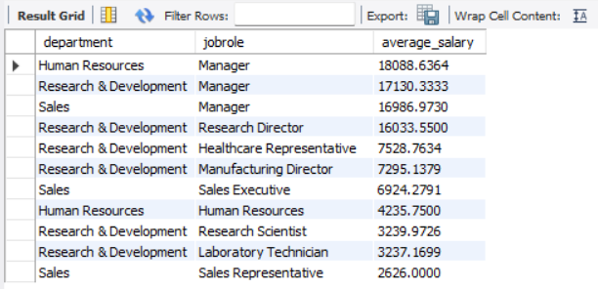

Which employees are top earners in their departments?

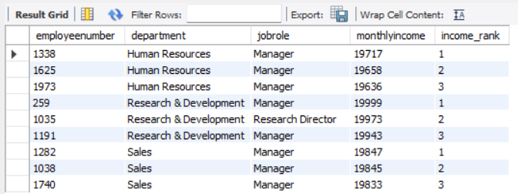

Average monthly income by gender



How does salary vary by education?



Compare each employee’s salary to department average (use CASE logic + window function)

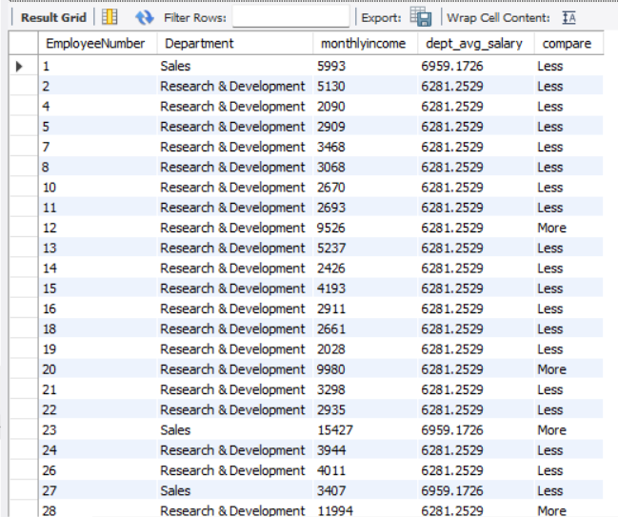

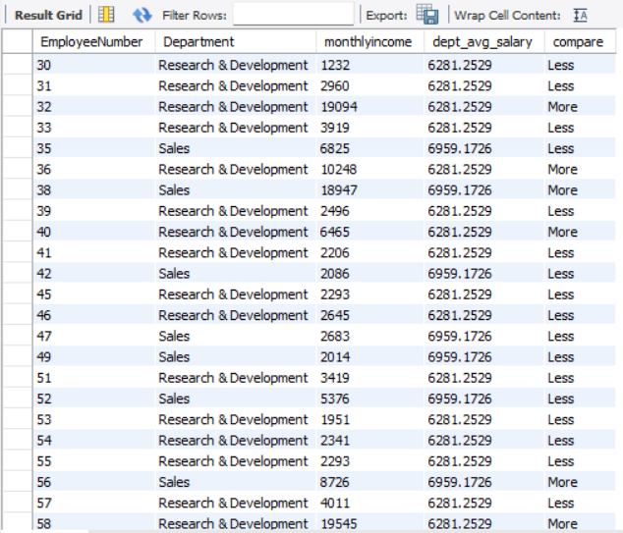

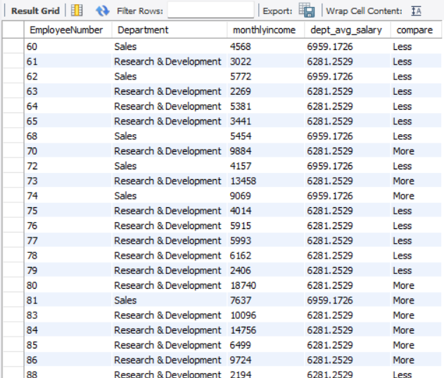

So on…

Highest-paying job roles company-wide

