Who was promoted recently? (YearsSinceLastPromotion = 0)

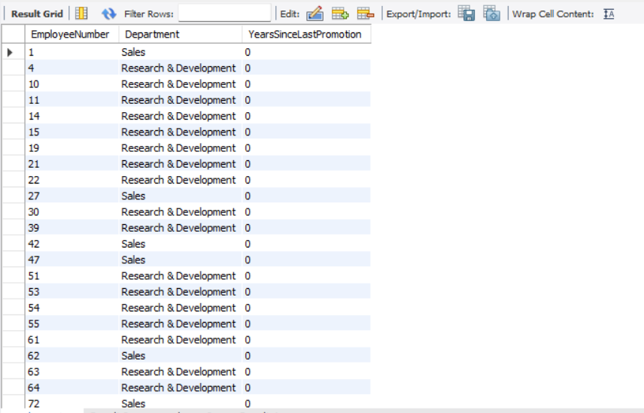

Average years since last promotion by department

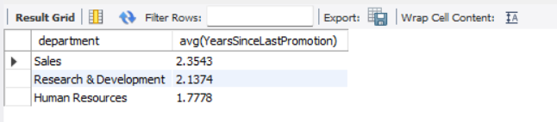

Employees who haven’t been promoted in 5+ years

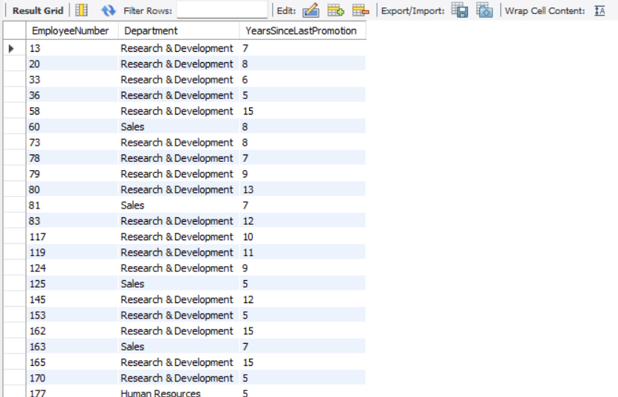

Do promotions correlate with high performance rating?

