Top 3 highest earners in each department (RANK)

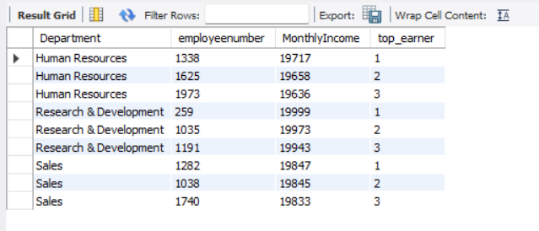

Running total of income by department (SUM OVER)

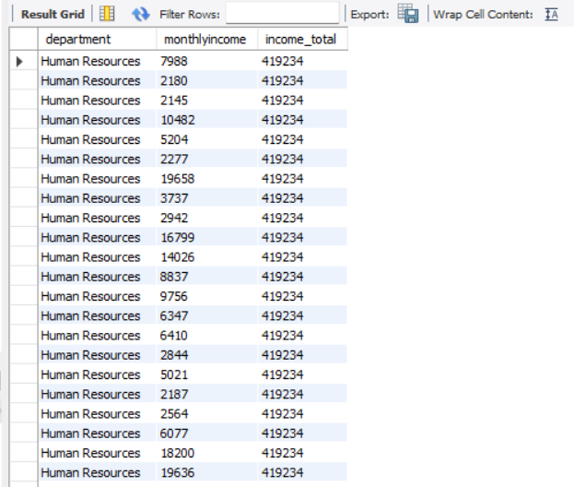

Employee’s income compared to department average

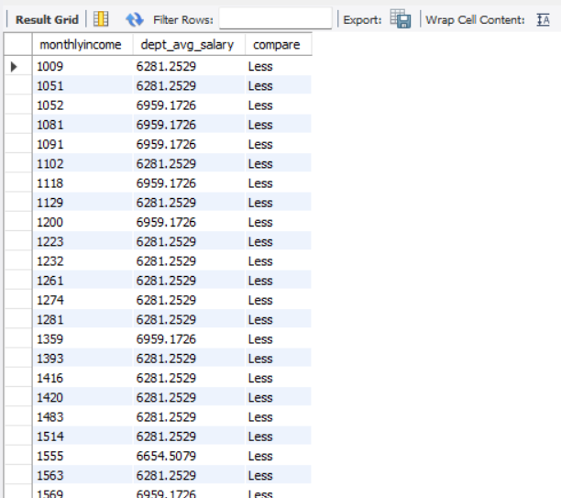

Percent rank or dense rank of employees by income

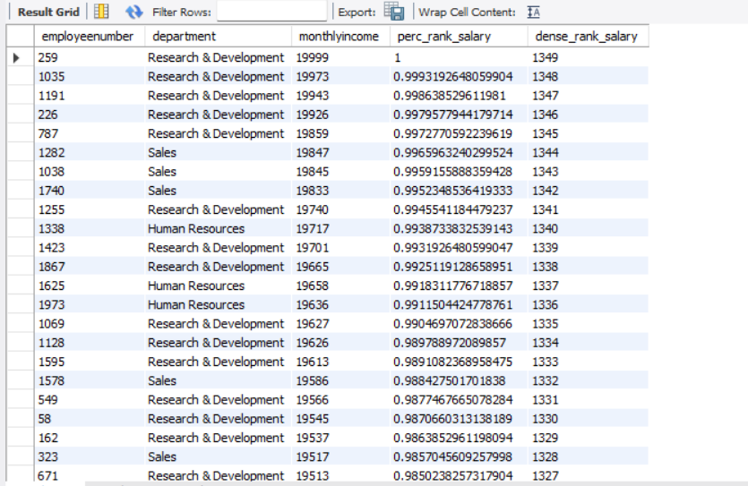

Avg attrition rate by department (optional, use window)

Using normal aggregation function



Using window function

