# Cyclistic Bike Share Analysis

This project analyzes bike share data from Divvy to explore user behavior, trends, and opportunities to convert casual riders into annual members. The analysis focuses on ride duration, usage patterns across weekdays, and differences between casual and member users.

## Visualization 1: Number of Rides by User Type and Day of Week

This bar chart compares the number of rides taken by casual riders and members across each day of the week. The visualization shows that casual riders prefer weekends, while members ride more consistently on weekdays.

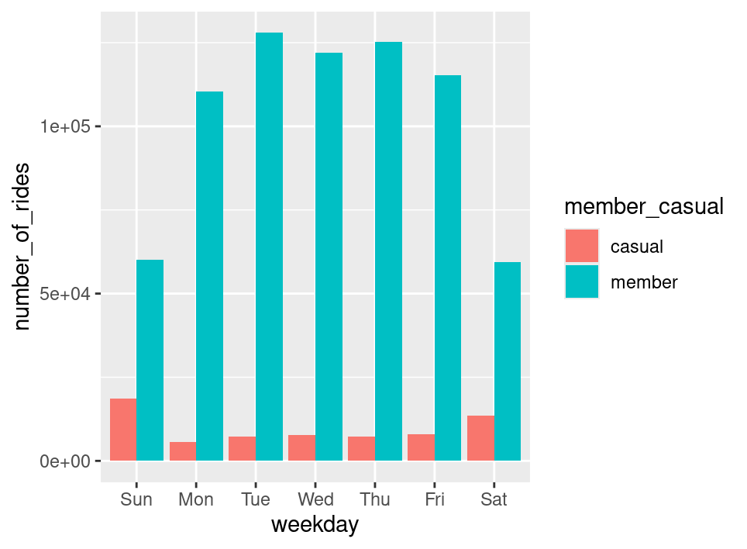

## Visualization 2: Average Ride Duration by User Type and Day of Week

This bar chart displays the average ride duration for casual riders and members across the days of the week. It reveals that casual riders tend to have longer rides compared to members, particularly on weekends.

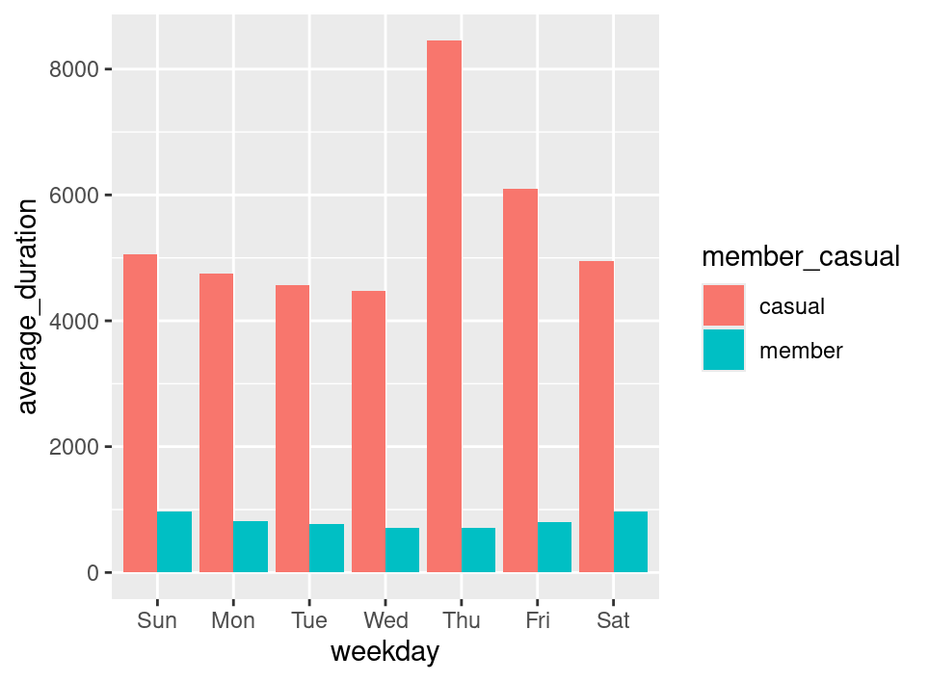

## Conclusion

The analysis highlights distinct usage patterns between casual riders and members. Marketing efforts could focus on encouraging casual riders to convert to membership by emphasizing weekday benefits and offering incentives for regular use.