**TABLEAU VISULIZATION**

For this activity, I have collected Walmart retail data from kaggles. From that data, I have created worksheets of Average measure, map plotting of sales, created tables and doughnut pie-chart. Through all those worksheets, I then prepared Dashboard.

**Worksheet 1**

In worksheet 1, I have calculated Averages of Sales, Profit and discounts.

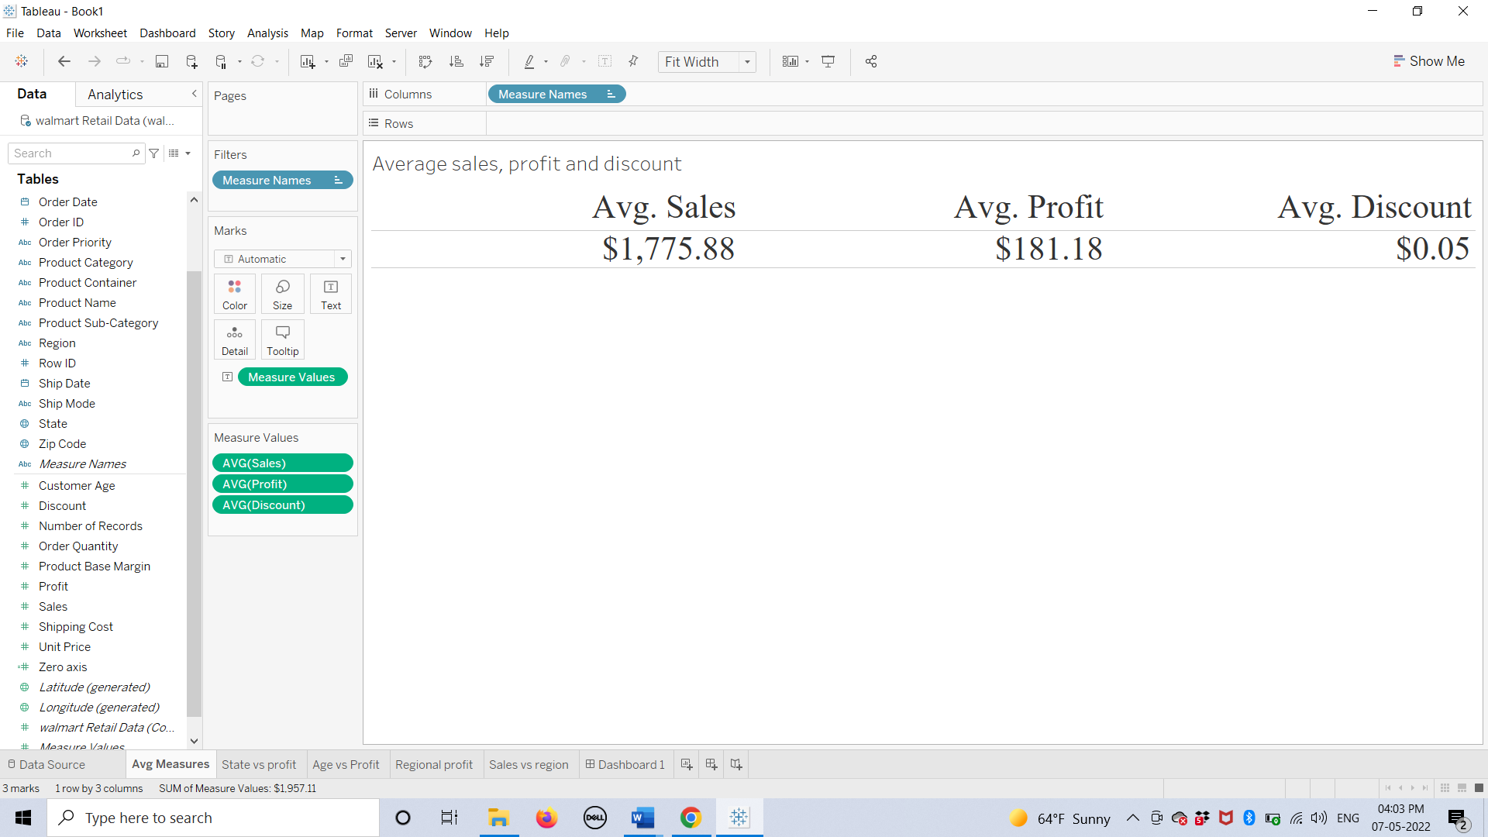

**Worksheet 2**

In worksheet 2, I have created map plotting of profit earned by states In USA.

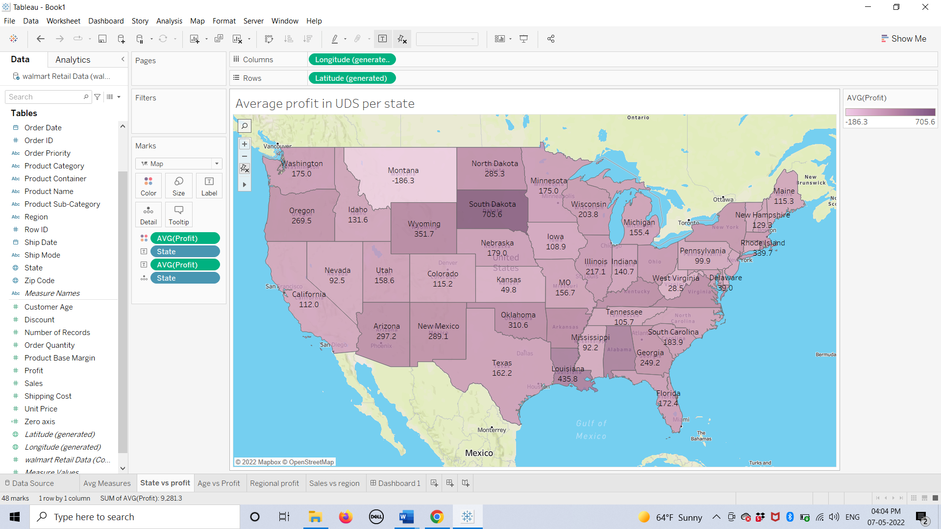

**Worksheet 3**

In worksheet 3, I have created a bar chart showing relation between profit and age of customers.

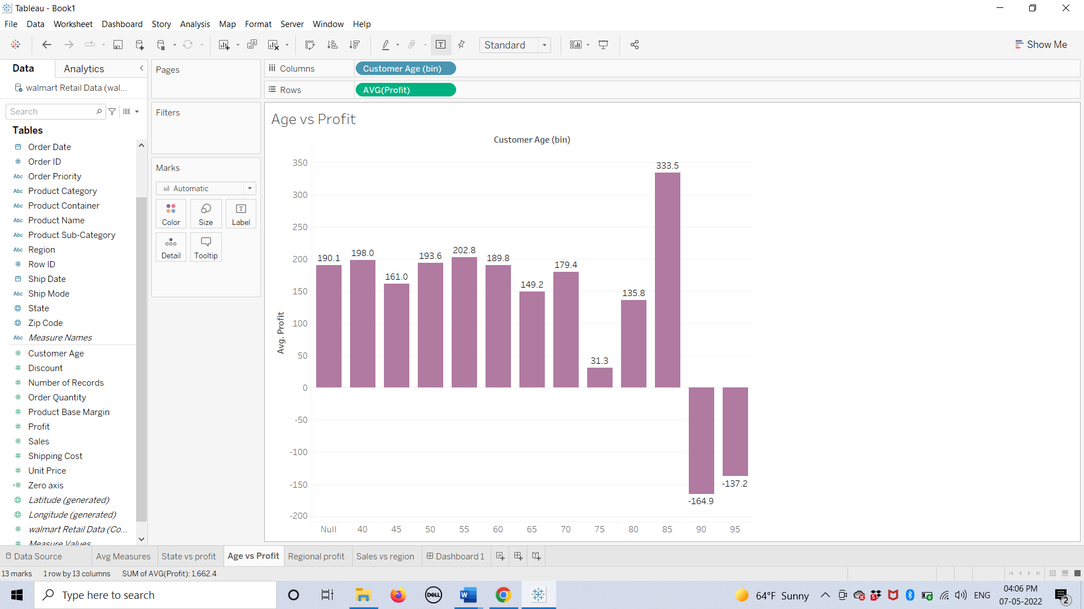

**Worksheet 4**

Here, in worksheet 4, I have created a highlight table of average quarterly profit according to regions.

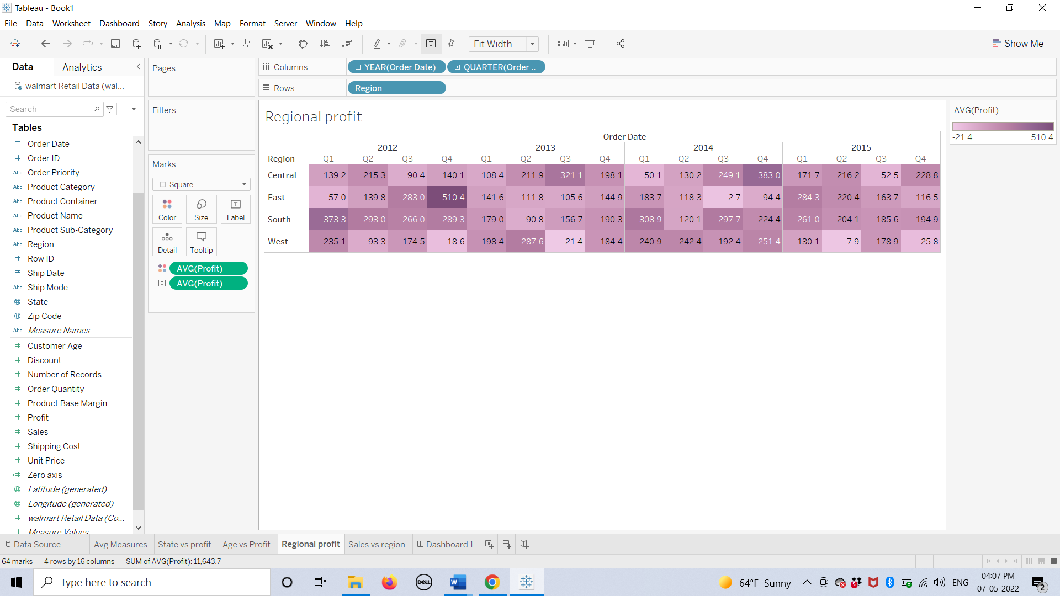

**Worksheet 5**

In worksheet 5, I have created a doughnut pie-chart with the help of “Create calculated field” which shows the total sales as per the region.

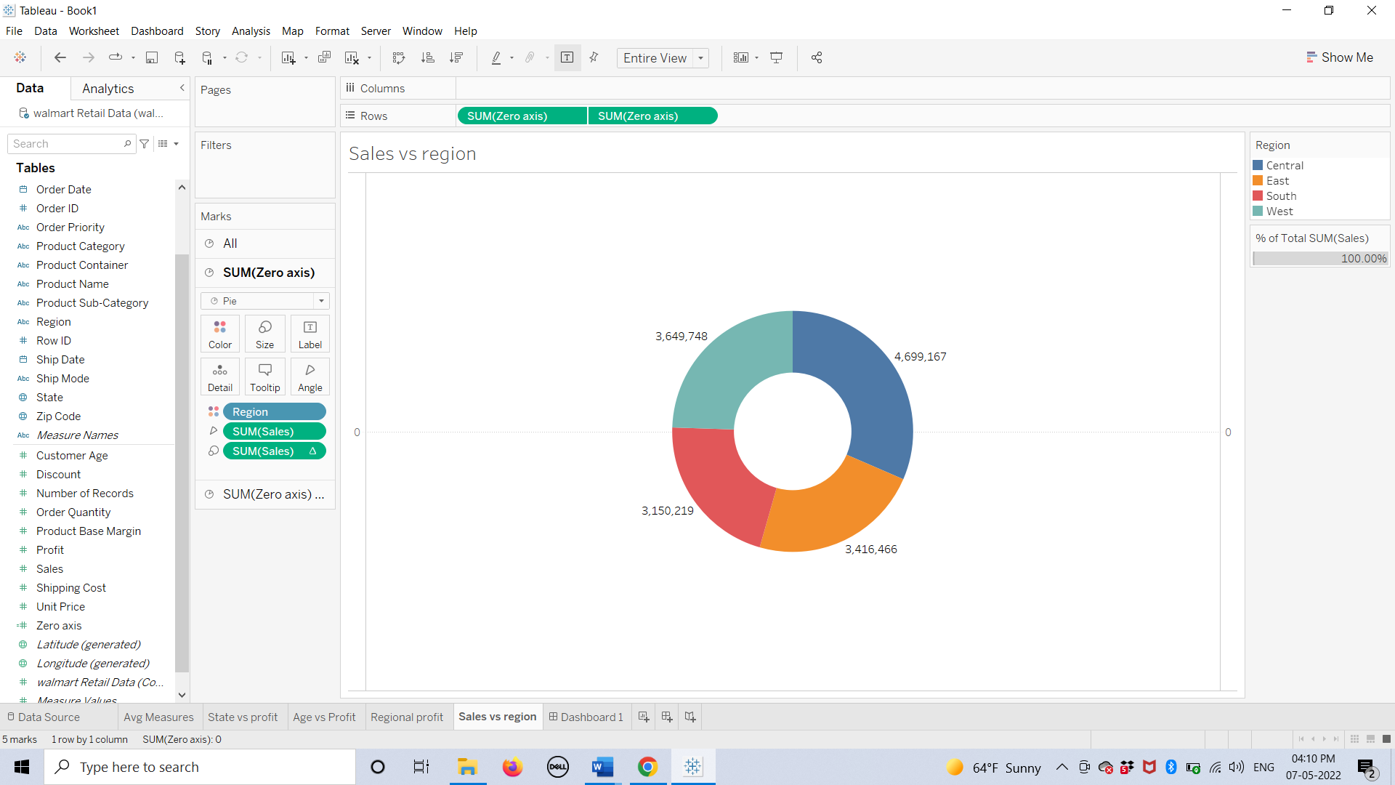

**Dashboard**

Here, we have created a dashboard all the help of all the worksheets we have created.

