**SkillCraftify - Online Examination Portal**

**Overview**

SkillCraftify is an advanced Online Examination Portal designed to streamline the process of creating, managing, and taking online exams. This project harnesses the power of the MERN stack, comprising MongoDB, Express.js, React.js, and Node.js, to deliver a feature-rich and scalable web-based examination system.

**Key Features**

1. **User Authentication**: Enable users to securely register, login, and manage their profiles.
2. **Admin Panel**: Empower admins with comprehensive tools to manage exams, questions, users, and generate insightful reports.
3. **Exam Management**: Seamlessly create, edit, and delete exams with various types of questions.
4. **Question Bank**: Maintain a rich database of questions categorized by subjects and topics for easy access.
5. **Exam Scheduler**: Effortlessly schedule exams and set timings for start and end to accommodate various needs.
6. **Results and Analytics**: Provide detailed reports and analytics to assess exam performance and individual progress.

Technology Stack

* **Frontend**:
  + React.js
  + Redux (for state management)
  + React Router (for routing)
  + Material-UI (for UI components)
* **Backend**:
  + Node.js
  + Express.js
  + MongoDB (with Mongoose ORM)
  + JSON Web Tokens (for authentication)
* **Others**:
  + Socket.io (for real-time communication)
  + Axios (for API requests)

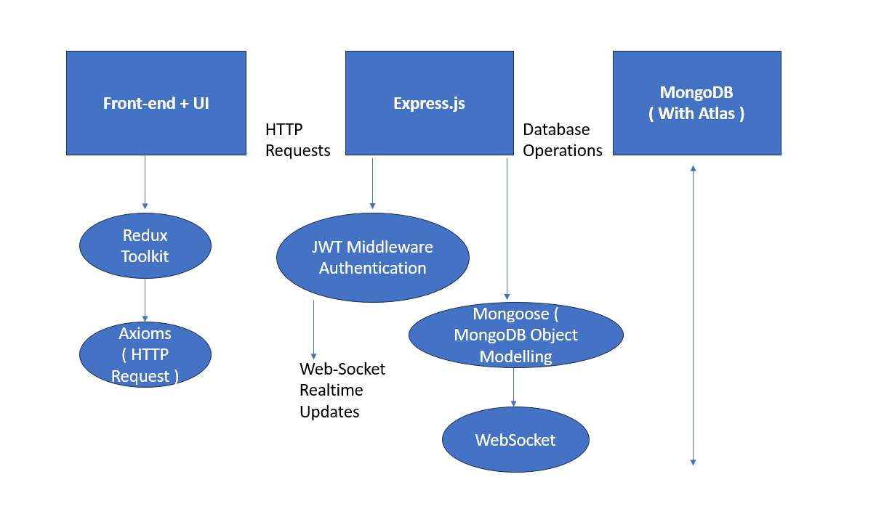

**Database Schema**

**Users**

* _id
* role
* created_at
* updated_at

**Exams**

* _id
* exam_id
* title
* role
* questions (array of question ids)
* start_time
* end_time
* created_at
* updated_at

**Questions**

* q_id
* exam_id
* difficulty_level
* options
* correct_option

**Results**

* _id
* exam_id
* scores
* attempted_at

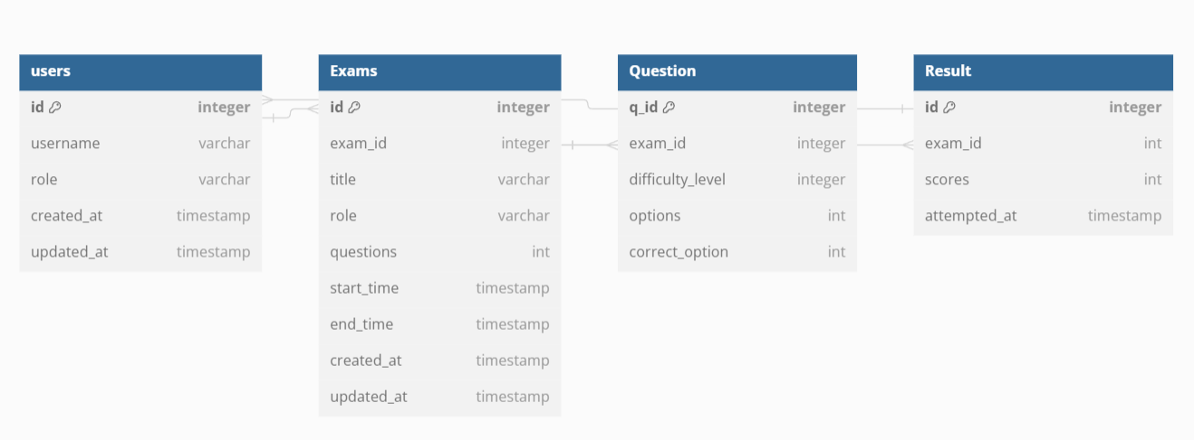

**Installation and Setup**

1. Clone the repository: **git clone** [**https://github.com/Palakpreet/SkillCraftify.git**](https://github.com/Palakpreet/SkillCraftify.git)
2. Install dependencies for the client and server:
   * Client: **cd client && npm install**
   * Server: **cd server && npm install**
3. Configure environment variables:
   * Create a **.env** file in the server directory.
   * Define variables such as database connection URI, JWT secret, etc.
4. Run the development server:
   * Client: **cd client && npm start**
   * Server: **cd server && npm start**

**Conclusion**

SkillCraftify, our Online Examination Portal, is a robust solution for conducting online exams efficiently and securely. With its intuitive user interface, powerful backend architecture, and real-time monitoring capabilities, SkillCraftify offers an enhanced experience for both administrators and users alike. Continuous improvements and feature enhancements will be made to further refine and extend the functionality of the application, ensuring its effectiveness in various educational and professional settings.