Project Design Phase-I
Solution Architecture

Date | 02 November 2026
Team ID | SWUID2026402170
Project Name | Global Olympic Sports Performance Analytics (1992–2026)
Maximum Marks | 4 Marks

Solution Architecture:
Solution architecture is a complex process – with many sub-processes – that bridges the gap between business problems and technology solutions. Its goals are to:
- Find the best tech solution to solve existing business problems.
- Describe the structure, characteristics, behavior, and other aspects of the software to project stakeholders.
- Define features, development phases, and solution requirements.
- Provide specifications according to which the solution is defined, managed, and delivered.

Sample Solution Architecture Diagram:
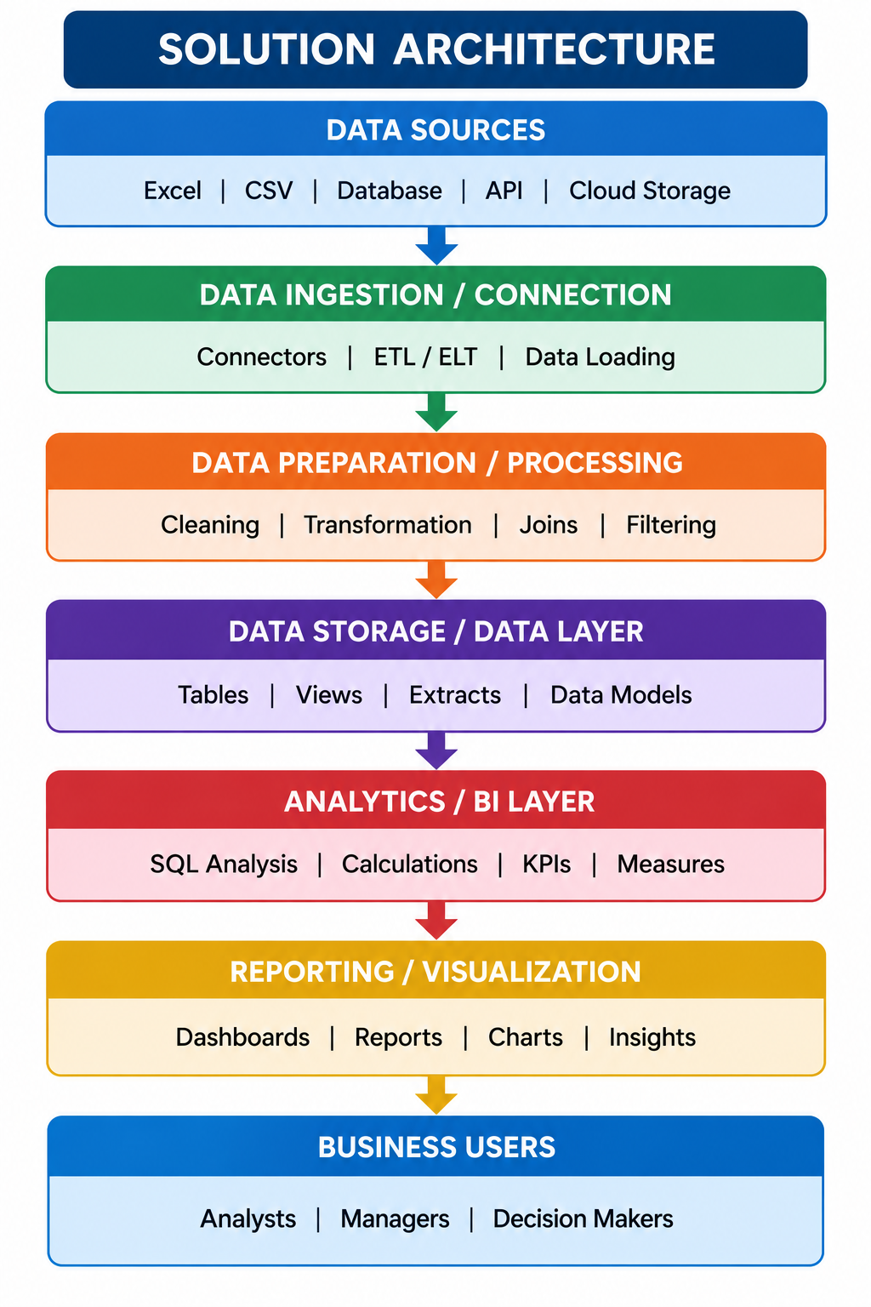

Component Description Table
Component Name | Description / Role in Architecture | Technology Used

Component Description Table
Component Name | Description / Role in Architecture | Technology Used
Data Sources | Stores historical Olympic records across multi-decade cycles (1992–2026). | Relational CSV Files (medal_results.csv, athletes.csv, games_summary.csv, alltime_country_rankings.csv)
Data Ingestion / Connection | Connects and loads raw CSV datasets into the analytical environment. | Tableau Data Connections / CSV Connectors
Data Preparation / Processing | Cleans, transforms, and joins datasets across relational keys (noc_code and year). | Tableau Desktop / Tableau Prep / Relational Joins
Data Storage / Data Layer | Manages structured data models and views for analytical reporting. | Tableau Data Models & Extracts
Analytics / BI Layer | Computes calculations, KPIs, regional efficiency metrics, and per-athlete sport yields. | Tableau Calculated Fields & SQL Analysis
Reporting / Visualization | Presents interactive dashboards and guided data stories. | Tableau Public Dashboards & Story
Business Users / Web Frontend | Delivers responsive web access and seamless dashboard embedding for stakeholders. | Python Flask, Bootstrap 5, Tableau JavaScript Embed API

