CASE STUDY 1: Population Growth Analysis Using Numerical Methods
Scenario
A local government wants to analyze how population changes over time. However, they only have yearly population data, not a continuous function.

Given Data
Year | Population
2020 | 10,000
2021 | 10,800
2022 | 11,900
2023 | 13,200
2024 | 14,800

1. Numerical Differentiation (Growth Rate)
- Use central difference:
$$P^{'}\left(t\right)≈\frac{P\left(t+1\right)-P\left(t-1\right)}{2}$$
- Growth rate for 2021–2023:

For 2021: $\frac{11,900-10,000}{2}$ = 950 people/year

For 2022: $\frac{13,200-10,800}{2}$ = 1,200 people/year

For 2023: $\frac{14,800-11,900}{2}$ = 1,450 people/year

- Table:
Year (t) | Population P(t) | Growth Rate P′(t)
2020 | 10,000 | N/A
2021 | 10,800 | 950
2022 | 11,900 | 1,200
2023 | 13,200 | 1,450
2024 | 14,800 | N/A

What if we want to find the growth rate of the year 2020?
Based on the data use this:
Growth Rate of 2022 and 2021 difference: 1,200 – 950 = 250
Growth Rate of 2023 and 2022 difference: 1,450 – 1,200 = 250
Try: 950 – 250 = 700
The Growth Rate of the year 2020 is 700
Year (t) | Population P(t) | Growth Rate P′(t)
2020 | 10,000 | 700
2021 | 10,800 | 950
2022 | 11,900 | 1,200
2023 | 13,200 | 1,450
2024 | 14,800 | N/A

2. Numerical Integration (Total Change)
- Use Trapezoidal Rule to estimate:
$$\int_{2020}^{2024}{P\left(t\right)dt}$$
Use the formula for n intervals with h = 1:
$P\left(t\right)dt ≈\frac{h}{2}\left[P\left(x_{0}\right)+ 2P\left(x_{1}\right)+ 2P\left(x_{2}\right)+ 2P\left(x_{3}\right)+ P\left(x_{4}\right)\right]$
Calculation:
$P\left(t\right)dt ≈ ½ \left[10,000 + 2\left(10,800\right)+ 2\left(11,900\right)+ 2\left(13,200\right)+ 14,800\right]$
Values inside the brackets:
        - $P\left(x_{0}\right)= 10,000$
        - $2* P\left(x_{1}\right)= 2* 10,800 = 21,600$
        - $2* P\left(x_{2}\right)= 2* 11,900 = 23,800$
        - $2*P\left(x_{3}\right)= 2* 13,200 = 26,400$
        - $P\left(x_{4}\right)= 14,800$
$$P\left(t\right)dt ≈\frac{1}{2}\left[10,000 + 21,600 + 23,800 + 26,400 + 14,800\right]$$
$P\left(t\right)dt ≈\frac{1}{2}\left[96,600\right]=$ 48,300 person-years
Note: In the context of population, this integral represents the "person-years" lived by the population over the 4-year period, often used in demographics to calculate resource needs.

3. Visualization
- Plot:
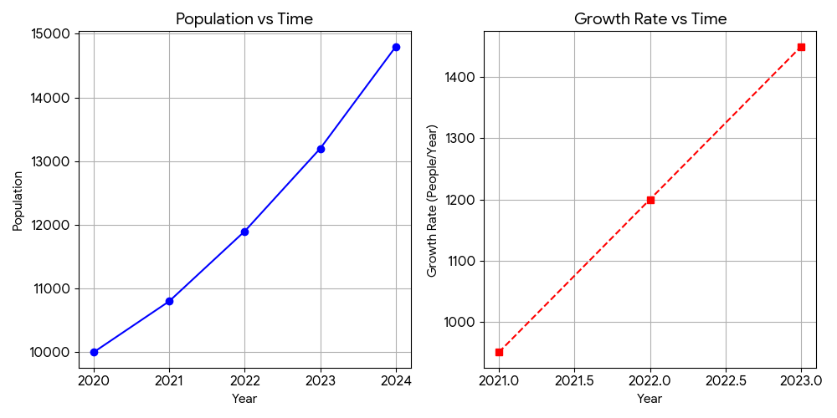
Note: in Growth Rate vs Time I just used the 2021 to 2023
- Code:
import numpy as np
import matplotlib.pyplot as plt

# 1. Given Data
years = np.array([2020, 2021, 2022, 2023, 2024])
population = np.array([10000, 10800, 11900, 13200, 14800])

# 2. Numerical Differentiation (Central Difference)
# Formula: P'(t) ≈ [P(t+1) - P(t-1)] / 2
growth_years = years[1:-1]
growth_rates = []

for i in range(1, len(years) - 1):
rate = (population[i+1] - population[i-1]) / 2
growth_rates.append(rate)

growth_rates = np.array(growth_rates)

# 3. Numerical Integration (Trapezoidal Rule)
# Note: np.trapezoid is the new standard in NumPy 2.0+
total_change_integral = np.trapezoid(population, years)

# --- Console Output ---
print("--- Numerical Analysis Results ---")
print(f"Total Population Estimate (Integral): {total_change_integral}")
print("\nYearly Growth Rates:")
for yr, rate in zip(growth_years, growth_rates):
print(f"Year {yr}: {rate} people/year")

# 4. Visualization
fig, (ax1, ax2) = plt.subplots(1, 2, figsize=(12, 5))

# Plot 1: Population vs Time
ax1.plot(years, population, marker='o', color='blue', linestyle='-')
ax1.set_title('Population vs Time')
ax1.set_xlabel('Year')
ax1.set_ylabel('Population')
ax1.grid(True)

# Plot 2: Growth Rate vs Time
ax2.plot(growth_years, growth_rates, marker='s', color='red', linestyle='--')
ax2.set_title('Growth Rate vs Time')
ax2.set_xlabel('Year')
ax2.set_ylabel('Growth Rate (People/Year)')
ax2.grid(True)

plt.tight_layout()
plt.show()

4. Analysis Questions:
- When did growth accelerate most?
Acceleration in this context is the rate at which the growth rate is changing (the second derivative, P''(t)). We can calculate this by looking at the change in the Growth Rate P'(t) from year to year:

- From 2021 to 2022: 1,200 – 950 = 250
- From 2022 to 2023: 1,450 – 1,200 = 250
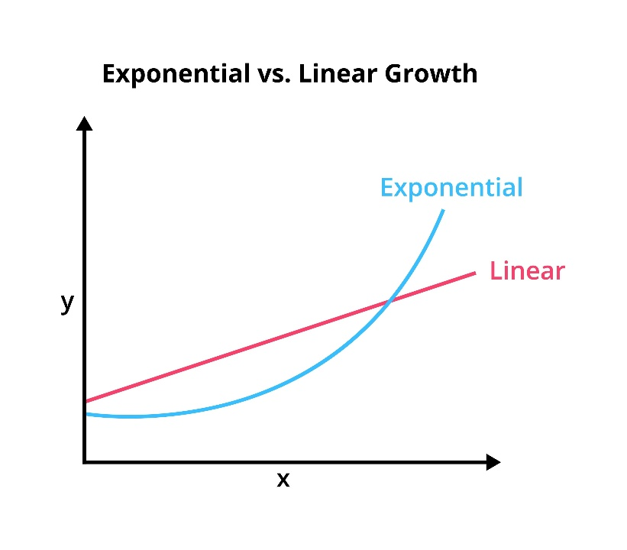
Based on the provided growth rates, the acceleration is constant. The population growth rate increased by exactly 250 people per year each year between 2021 and 2023. Therefore, growth did not "accelerate most" at one specific time; rather, it accelerated at a steady, uniform rate throughout the period.

- Is the growth linear or exponential?
The growth is neither strictly linear nor strictly exponential; it is quadratic. Here is why:
- Why it is NOT Linear: In linear growth, the growth rate (P') would be constant (the population would increase by the same number of people every year). Here, the growth rate is clearly increasing (950 -> 1,200 -> 1,450), so it is non-linear.
- Why it is NOT Exponential: In exponential growth, the growth rate is proportional to the population (meaning the percentage growth stays the same). If we check the percentage growth (P'/P):
- 2021: 950/10,800 $≈$ 8.8%
- 2022: 1,200/11,900 $≈$ 10.1%
- 2023: 1,450/13,200 $≈$ 11.0%
Since the percentage rate is also increasing rather than staying constant, it does not fit the perfect definition of exponential growth.
- Why it is Quadratic: In a quadratic model ($P\left(t\right)= {at}^{2}+ bt + c$), the growth rate (P') increases at a constant linear rate. As shown above, the growth rate increases by exactly 250 every year. This "linear increase in growth rate" is the hallmark of quadratic growth.
Conclusion: The growth is accelerating (non-linear). If you are choosing between the two common categories, it is more "exponential-like" because it is speeding up, but mathematically, it follows a quadratic pattern with a constant acceleration of 250 people/${year}^{2}$.

- Predict population in 2025

Year (t) | Population P(t) | Growth Rate P′(t)
2020 | 10,000 | 700
2021 | 10,800 | 950
2022 | 11,900 | 1,200
2023 | 13,200 | 1,450
2024 | 14,800 | N/A
Formula A:
Using the last observed annual increase (14,800 – 13,200 = 1,600)

$$P\left(2025\right)≈14,800+1,600=16,400$$
Formula B:
Using the last observed growth rate being constant (1,450 + 250 = 1,700)
$P\left(2025\right)≈14,800+1,700=16,500$
Cont.
$$P^{'}\left(t\right)≈\frac{P\left(t+1\right)-P\left(t-1\right)}{2}$$
For 2025: $\frac{16,500-13,200}{2}$ = 16,450
(Note: If assuming exponential growth, the number would likely be slightly higher, around 16,600 but based on the calculation it would likely be in the range of 16,400 to 16,500).

5. Short Analysis Report:

Population Growth Analysis Report (2020–2025)
The population data from 2020 to 2024 reveals a clear trend of accelerated growth, characterized by a consistent increase in the annual growth rate. While the population does not follow a simple linear path—where growth would remain constant—it also doesn't strictly adhere to an exponential model, as the percentage growth rate is not fixed. Instead, the data identifies as quadratic growth. This is evidenced by the fact that the growth rate (P') increased by exactly 250 people/year² during each observed interval. Because this acceleration remained steady, there was no single moment where growth "accelerated most"; rather, the momentum increased at a uniform, predictable pace throughout the period.
When forecasting the population for 2025, two different predictive formulas—a process often referred to as triangulation—offer a range of likely outcomes starting from the 2024 base of 14,800. Formula A assumes the most recent annual increase of 1,600 people will repeat, resulting in a conservative estimate of 16,400. However, Formula B accounts for the ongoing acceleration by adding the expected 250-person increase to the previous growth rate, leading to a forecast of 16,500. Given the consistent historical trend of acceleration, Formula B is likely the more robust prediction. Should the growth pattern begin to shift toward a more aggressive exponential curve, the population could potentially reach as high as 16,600, though current data most strongly supports a final figure in the 16,400 to 16,500 range.
In summary, the population is experiencing a period of steady intensification rather than simple steady growth. By evaluating both the most recent population jump and the underlying acceleration rate, we can conclude that the 2025 population will likely surpass the 16,400 marks. The consistent addition of 250 people to the growth rate each year suggests a highly stable trend, making the quadratic projection (Formula B) the most reliable tool for short-term planning and resource allocation.

