Customer Segmentation & Churn Pattern Analytics
European Banking | Exploratory Data Analysis, Insights and Recommendations

20.4%  Overall churn | 127,644  Premium balance threshold | 23.7%  Premium churn rate | 26.9%  Inactive churn rate

Executive Abstract
This study examines churn across 10,000 European retail-bank customer records. The observed churn rate is 20.4%. Churn is not evenly distributed: it is elevated in Germany, among customers aged 46+, inactive customers, and customers with very high product counts. The findings support targeted retention and supervisory monitoring rather than broad, undifferentiated intervention.

1. Research Scope and Questions
The analysis addresses three policy and management questions: which segments show the greatest probability of exit; whether geography and demographic characteristics concentrate risk; and whether churn could affect financially meaningful customer relationships.

2. Data, Validation and Segmentation Method
The source file contains 10,000 records and 14 columns, including a 2025 reference year. CustomerId was checked for uniqueness; Surname was excluded from analysis; all fields had zero missing values. Binary fields HasCrCard, IsActiveMember and Exited were confirmed as 0/1. Exited=1 denotes churn.
Segments are reproducible: age (<30, 30-45, 46-60, 60+); credit score (low <580, medium 580-700, high >700); tenure (new 0-2, mid-term 3-6, long-term 7+); and balance (zero, low >0-100k, high 100k+). Premium balance is defined as the top quartile of balances, at or above 127644.

3. Overall and Geographic Findings
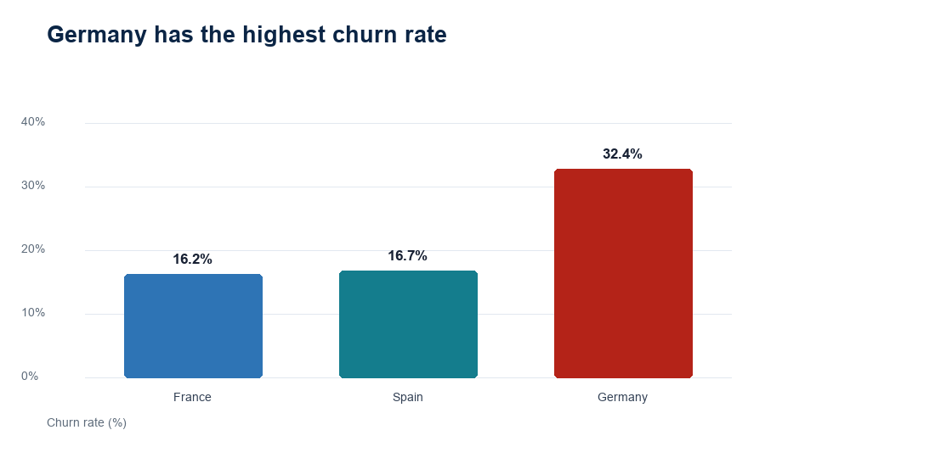
Geography | Customers | Churned | Churn Rate | Churn Contribution
France | 5,014 | 810 | 16.2% | 39.8%
Spain | 2,477 | 413 | 16.7% | 20.3%
Germany | 2,509 | 814 | 32.4% | 40.0%

Germany has the highest churn rate (32.4%), followed by Spain and France. This is a relative-risk result, not evidence of causality; country comparisons should be monitored alongside product mix, local service experience and economic context.

4. Demographic and Tenure Patterns
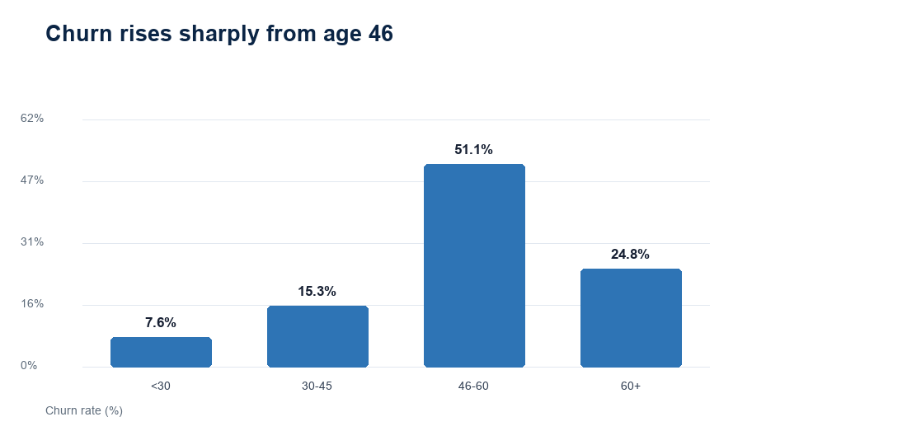
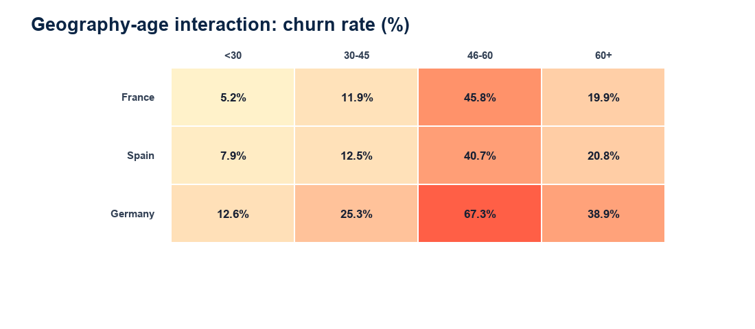
Age Group | Customers | Churned | Churn Rate | Churn Contribution
<30 | 1,641 | 124 | 7.6% | 6.1%
30-45 | 6,248 | 956 | 15.3% | 46.9%
46-60 | 1,647 | 842 | 51.1% | 41.3%
60+ | 464 | 115 | 24.8% | 5.6%

Customers aged 46-60 have the highest rate (51.1%); the 60+ group also exceeds the portfolio average. The geography-age heatmap shows that risk is not explained by age alone, reinforcing the need for local segment monitoring.

5. Engagement, Products and Financial Profile
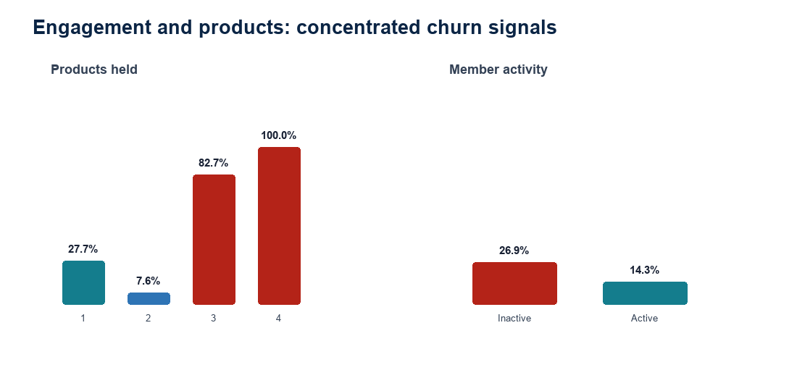
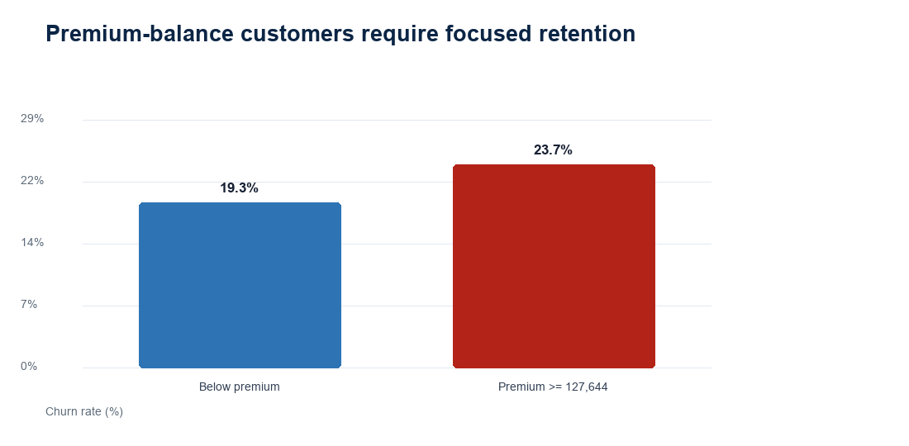
Inactive members churn at 26.9%, compared with 14.3% for active members. Product holding is non-linear: customers with 4 products have the highest observed rate (100.0%); this small segment should be investigated before generalising. Premium-balance customers churn at 23.7%, representing 592 exits and an average balance of 149,051.

6. Segment Insights
- Geographic risk: Germany is the leading churn-rate geography, so a country-specific diagnosis is warranted.
- Lifecycle risk: the highest age-band churn is concentrated among customers aged 46-60, not solely younger, more mobile customers.
- Engagement risk: inactivity has a 1.9x churn-rate multiple versus active membership.
- Value risk: premium-balance churn is 23.7%; retention prioritisation should consider balance and likely relationship value, not volume alone.
- Product-design signal: the outlier churn rate for four-product customers merits a service-journey and pricing review.

7. Recommendations
- Deploy an early-warning retention list combining inactivity, age band, geography and high balance; offer a human outreach or a personalised digital re-engagement journey.
- Commission a Germany service and product-friction review, with comparable journey metrics and complaint themes, before applying broad price or policy changes.
- Create a premium-relationship safeguard: alert relationship teams when high-balance customers become inactive or show declines in product usage.
- Review the four-product customer journey for fee complexity, service handoffs and dissatisfaction; validate the result on a larger time window.
- Govern fairly: monitor false positives and outcomes by geography, gender and age; retain human review and do not use protected characteristics as the sole basis for adverse treatment.

8. Limitations and Next Steps
This is descriptive, cross-sectional EDA for a single reference year. It cannot establish causality, quantify lost revenue, or separate voluntary switching from other exit reasons. Next steps are to add monthly behaviour, transaction/activity measures, product fees, complaint/service data and intervention outcomes; then validate an interpretable churn model out-of-time.

Appendix: KPI Definitions
KPI | Definition
Overall churn rate | Exited customers / all customers
Segment churn rate | Exited customers in segment / customers in segment
Churn contribution | Exited customers in segment / all exited customers
Premium churn rate | Exited premium-balance customers / premium-balance customers
Engagement drop indicator | Inactive churn rate compared with active churn rate

