European Banking Customer Churn
Briefing for Government and Supervisory Stakeholders

20.4%  Portfolio churn | 32.4%  Highest country rate | 26.9%  Inactive-member churn | 23.7%  Premium churn

Decision Message
The data indicate material, uneven customer churn rather than a single portfolio-wide pattern. The strongest descriptive signals are regional variation, inactivity, older age bands, and the exit of high-balance relationships. These patterns warrant targeted supervisory dialogue on service quality, fair treatment and continuity of access - not an inference of misconduct or causality.

What the evidence shows
- 20.4% of the 10,000 customers exited (2,037 people).
- Germany has the highest observed churn rate (32.4%); country differences should be investigated with local context.
- Customers aged 46-60 carry the highest age-band churn rate (51.1%).
- Inactive customers churn at 26.9%, versus 14.3% among active customers.
- Premium-balance customers (top-quartile balance, >= 127,644) churn at 23.7%; this raises potential relationship-value and stability concerns.
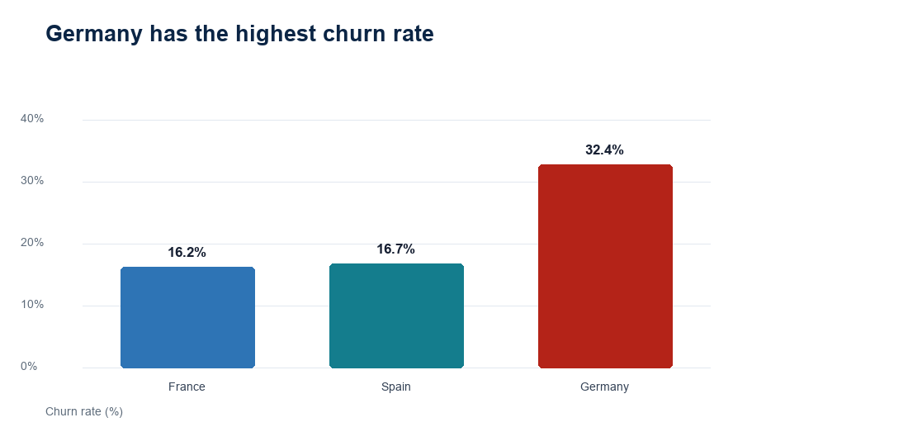

Recommended stakeholder actions
Action | Why it matters
Request segment reporting | Require quarterly churn, complaints, closure reasons and retention outcomes split by geography, age band, activity and balance tier.
Test fair-treatment controls | Assess whether retention offers and account-service changes are equitable; prohibit adverse automated decisions based solely on demographic features.
Focus on preventable friction | Ask German-market providers to review service, pricing and digital-journey friction associated with higher exit rates.
Protect vulnerable continuity | Monitor whether churn reflects loss of access for older or less digitally engaged customers; ensure accessible support routes.
Measure intervention value | Pilot re-engagement with clear consent and opt-out; track uplift, complaints and differential outcomes before scaling.

Safeguards and caveats
The dataset contains no transaction history, reason-for-exit information, product pricing, service contacts or longitudinal observations. Accordingly, findings are associations only. Any future predictive use should include purpose limitation, data minimisation, human oversight, fairness testing and transparent customer communication.

Monitoring indicators
Recommended dashboard indicators are: overall and segment churn rate; churn contribution; churn by geography-age intersection; inactivity-to-active churn ratio; premium-balance churn rate; service-complaint rate; and retention-offer acceptance and outcome rates.

