# Progress Report Deep Learning

* [Pankaj Bhatia](https://loyalistcollege.instructure.com/groups/60091/users/13269)
* [Shreya Kiran Bhoir](https://loyalistcollege.instructure.com/groups/60091/users/12610)
* [Sunil Kumar Jayakrishnan](https://loyalistcollege.instructure.com/groups/60091/users/14861)
* [Palash Pinakin Patel](https://loyalistcollege.instructure.com/groups/60091/users/12953)
* [Jeevan Jot Singh](https://loyalistcollege.instructure.com/groups/60091/users/12786)

[**Babatunde Giwa**](https://loyalistcollege.instructure.com/courses/4369/users/7363)

# Introduction

The Canadian Institute for Advanced Research (CIFAR) is a Canadian-based worldwide research association that unites groups of top researchers from around the world to resolve significant and complex inquiries. It was established in 1982 and is upheld by people, establishments, and organizations, as well as financing from the Government of Canada and the areas of Alberta, British Columbia, Ontario, and Quebec.

# CIFAR 10 data set

The CIFAR-10 dataset is an assortment of pictures that are normally used to train machine learning and computer vision calculations. It is one of the most generally utilized datasets for AI research. The CIFAR-10 dataset contains 60,000 32x32 variety pictures in 10 different classes. The 10 distinct classes address planes, cars, birds, cats, deer, dogs, frogs, horses, ships, and trucks. There are 6,000 pictures of each class.

Computer algorithms for perceiving objects in photographs frequently advance as a visual cue. CIFAR-10 is a bunch of pictures that can be utilized to show a system on how to perceive objects. Since the pictures in CIFAR-10 are low-resolution (32x32), this dataset can permit scientists to rapidly attempt various calculations to see what works.

CIFAR-10 is a named subset of the 80 million minuscule pictures dataset. When the dataset was made, understudies were paid to name all the images.

# Problem Definition and algorithm

As discussed above, the dataset provided consists of 60000 32x32 color images in 10 classes, with 6000 images per class. There are 50000 training images and 10000 test images.

The dataset is partitioned into five preparation groups and one test batch, each with 10000 pictures. The test batch contains precisely 1000 randomly chosen pictures from each class. The training batches contain the excess pictures in arbitrary request, yet some might contain more pictures from one class than another. Between them, the training batches contain precisely 5000 pictures from each class.

# Algorithm

The algorithm used is Convolutional Neural Network. It is an extraordinary neural network that is utilized to break down and cycle pictures. CNN or ConvNet learns directly from the data.

There are 3 crucial factors for using CNN for CIFAR

* CNN removes the need for manual feature extraction. —the features are learned directly by CNN.
* CNNs produce highly accurate recognition results.
* CNNs can be retrained for new recognition tasks, empowering you to expand on pre-existing networks.

Manual feature extraction is distinguishing and portraying the elements that are important for a given issue and executing a method for extricating those highlights.

# Experimental Evaluation Methodology

The first step taken by the group was to understand the desired packages for the project.

The group was aware about Pandas and NumPy, yet more information was expected to show the visual representation of our work and keeping in mind of exploratory analysis, we further got to realize that we could require help of Seaborn, Matplotlib and Sklearn.

Train_test_split is a capability in Sklearn model choice for dividing information clusters into two subsets: for preparing information and for testing information. With this capability, we do not have to partition the dataset manually.

While the team was researching further, we came across the term keras.

Keras and TensorFlow are open-source Python libraries for working with neural networks, making AI models, and performing profound learning. Since Keras is a general Programming interface for TensorFlow, they are introduced together

Keras is a high-level, deep learning API developed by Google for implementing neural networks. It can make the implementation of neural networks easy. It also supports multiple backend neural network computation.

# Results

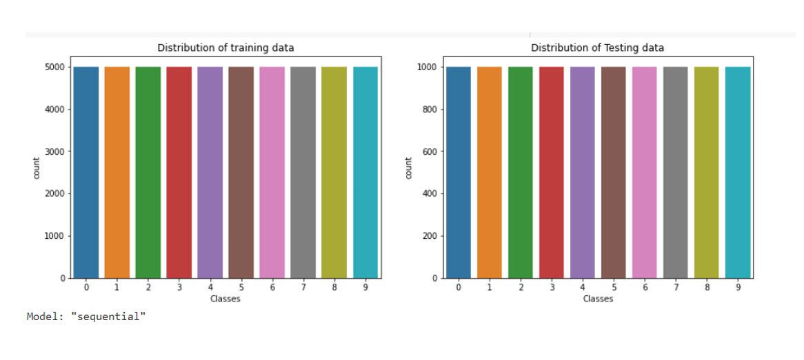

Here is the visual representation of distribution of training data and testing data. There are 50,000 training data and 10,000 test data.

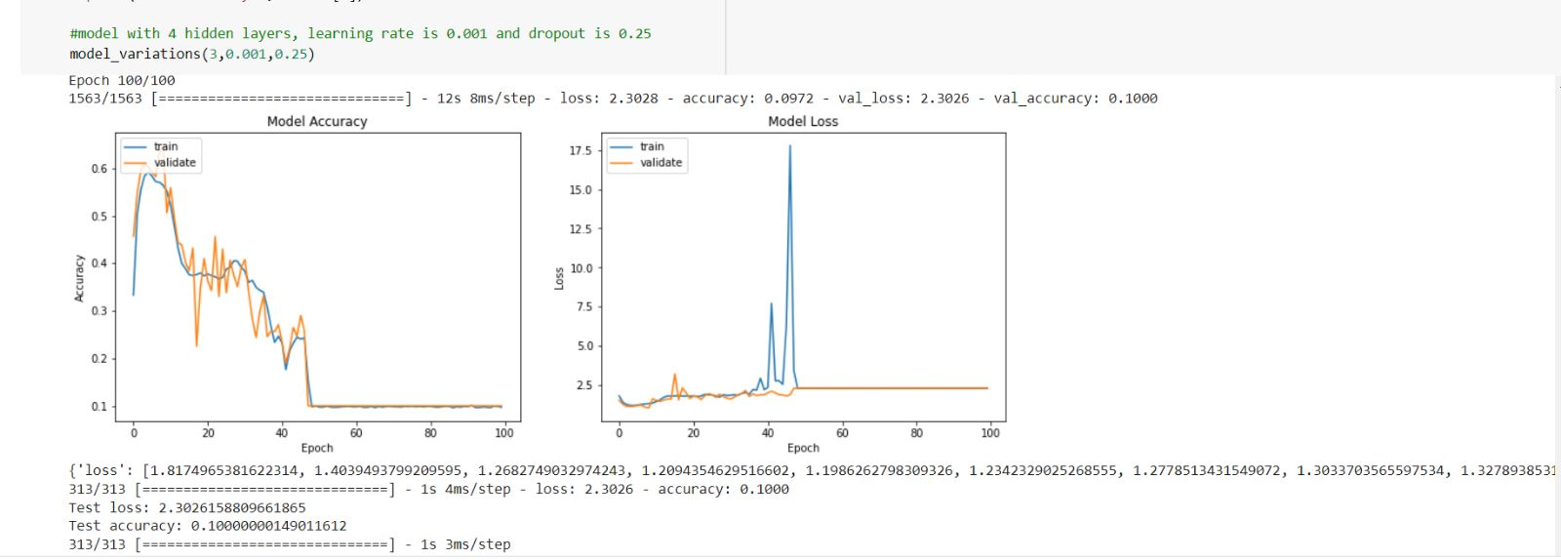

The accuracy of the model with 4 hidden layers, learning rate of 0.001 and dropout rate of 0.25 is 0.0972 and a loss of 2.3028 for 100 epochs.

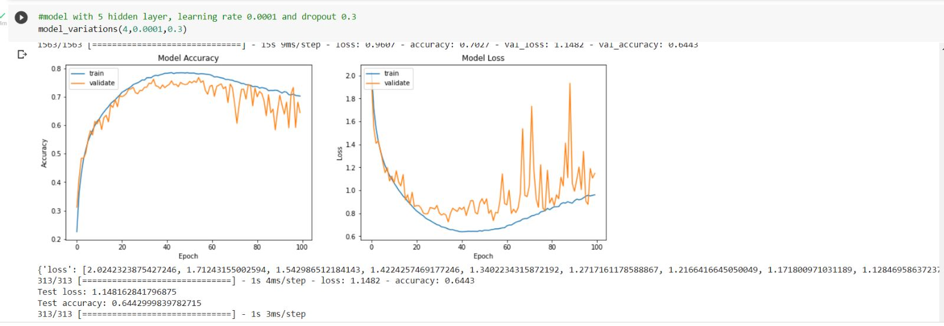

This model has 5 hidden layers with a learning rate of 0.0001 and a dropout rate of 0.3 and it gives an accuracy of 0.7027 and a loss of 0.9607 for 100 epochs.

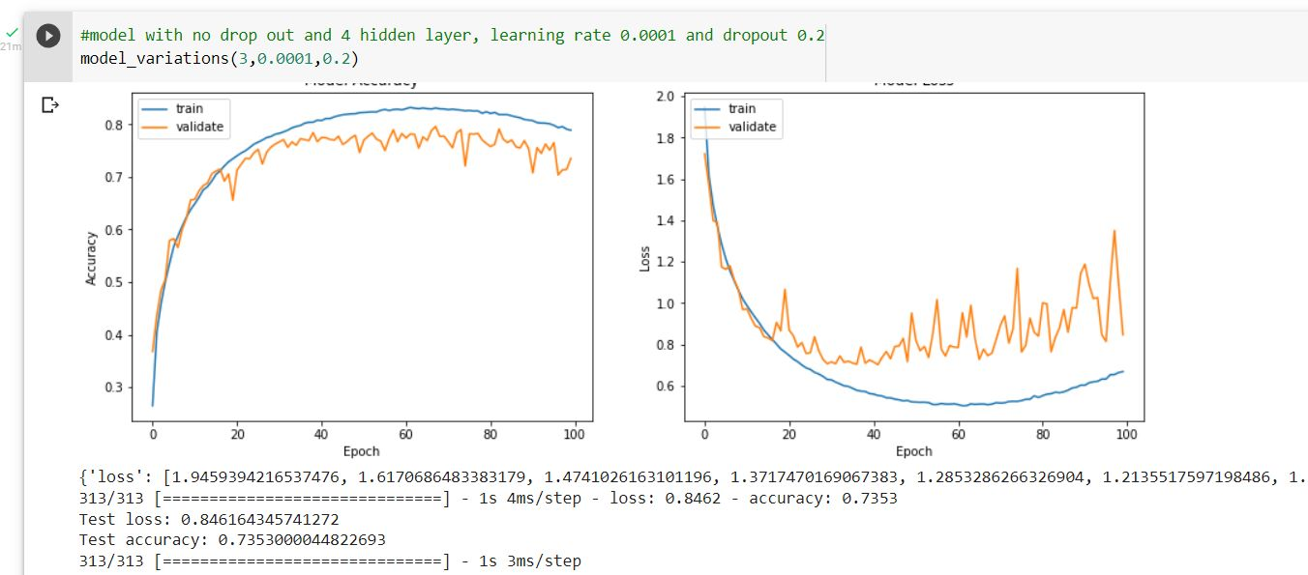

This model has 4 hidden layers with a learning rate of 0.0001 and a dropout rate of 0.2 and it gives an accuracy of 0.6443 and a loss of 0.8462 for 100 epochs.

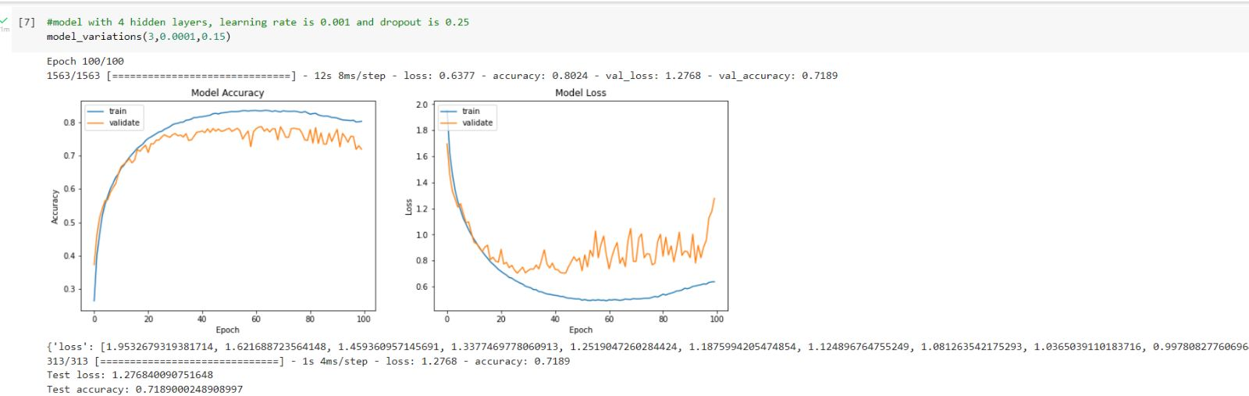

This model has 4 hidden layers with a learning rate of 0.0001 and a dropout rate of 0.2 and it gives an accuracy of 0.8024 and a loss of 0.6337 for 100 epochs.

# Literature Overview

Traditional neural networks have accomplished calculable execution at image classification, they have been portrayed by feature designing, a process that outcomes in unfortunate speculation to data.

From the information established from the research paper “Convolutional Neural Network for CIFAR-10 Dataset Image Classification” by Akwasi Darkwah Akwaboah, the team got to know that CNN can be used to achieve improved performances without the process of using domain knowledge to extract features from raw data.

While going through the research paper, the team encountered some new terminologies such as Pooling and regularization.

From the sources we fetched upon, our group got to know that the main purpose of pooling is to decrease the size of feature maps, which accordingly makes calculation quicker in fact that the quantity of preparing boundaries is diminished.

Regularization is a procedure used to decrease the errors by fitting the function properly on the given training set and avoids overfitting.

One significant benefit of CNNs is their capacity to lessen the quantities of network boundaries and thus the computational weight, while yet achieving expanded performances.

The team glanced at another research paper named “Image Classification with CIFAR 10 dataset” by Y. Lavanya.

In this research paper, we got to know about the SoftMax classifier, whose role is to test the unwavering quality of the model utilizing the Loss function the Cross Entropy function, to amplify the performance of our neural network.

It is a lot simpler for us as people to decipher probabilities as opposed to edge scores.

Further the new term that we encountered was Deep Residual network. It is a convolutional neural network (CNN) that is 50 layers deep. A Residual Neural Network (ResNet) is an Artificial Neural Network (ANN) of a kind that stacks residual blocks on top of each other to form a network.

Conclusion

The four different models provided four different results so when comparing all four models we can conclude that the model 4, the model with 4 hidden layers and learning rate of 0.0001 with a dropout rate of 0.25 is the best model so far with an accuracy of 0.8024 and with a loss of 0.6337. So, we choose the model 4 for better accuracy and results.

# References

<https://en.wikipedia.org/wiki/CIFAR-10>

[CIFAR-10 and CIFAR-100 datasets (toronto.edu)](http://www.cs.toronto.edu/~kriz/cifar.html)

<https://www.geeksforgeeks.org/itertools-in-python3/>

[https://www.jigsawacademy.com/blogs/ai-ml/seaborn-vs-](https://www.jigsawacademy.com/blogs/ai-ml/seaborn-vs-matplotlib/#%3A~%3Atext%3DSeaborn%20vs%20matplotlib%20is%20that%20seaborn%20utilises%20fascinating%20themes%2C%20while%2C%2C%20bar%2Dgraphs%2C%20etc) [matplotlib/#:~:text=Seaborn%20vs%20matplotlib%20is%20that%20seaborn%20u](https://www.jigsawacademy.com/blogs/ai-ml/seaborn-vs-matplotlib/#%3A~%3Atext%3DSeaborn%20vs%20matplotlib%20is%20that%20seaborn%20utilises%20fascinating%20themes%2C%20while%2C%2C%20bar%2Dgraphs%2C%20etc) [tilises%20fascinating%20themes%2C%20while,%2C%20bar%2Dgraphs%2C%20etc](https://www.jigsawacademy.com/blogs/ai-ml/seaborn-vs-matplotlib/#%3A~%3Atext%3DSeaborn%20vs%20matplotlib%20is%20that%20seaborn%20utilises%20fascinating%20themes%2C%20while%2C%2C%20bar%2Dgraphs%2C%20etc)

[https://www.mathworks.com/discovery/convolutional-neural-network-](https://www.mathworks.com/discovery/convolutional-neural-network-matlab.html) [matlab.html](https://www.mathworks.com/discovery/convolutional-neural-network-matlab.html)

[https://www.educative.io/answers/what-are-some-deep-details-about-pooling-](https://www.educative.io/answers/what-are-some-deep-details-about-pooling-layers-in-cnn) [layers-in-cnn](https://www.educative.io/answers/what-are-some-deep-details-about-pooling-layers-in-cnn)

[https://www.researchgate.net/publication/337240963_Convolutional_Neural_Ne](http://www.jctjournal.com/gallery/19-aug2021.pdf) [twork_for_CIFAR-10_Dataset_Image_Classification](http://www.jctjournal.com/gallery/19-aug2021.pdf)

<http://www.jctjournal.com/gallery/19-aug2021.pdf> <https://www.andreaperlato.com/aipost/cnn-and-softmax/>