**Actual code:-**

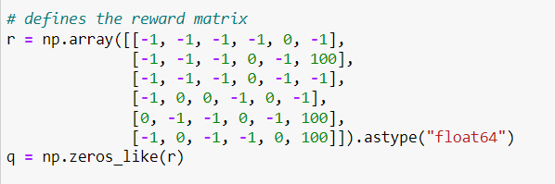

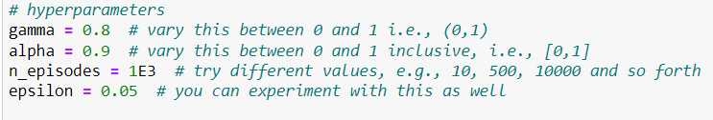

**Output:-**

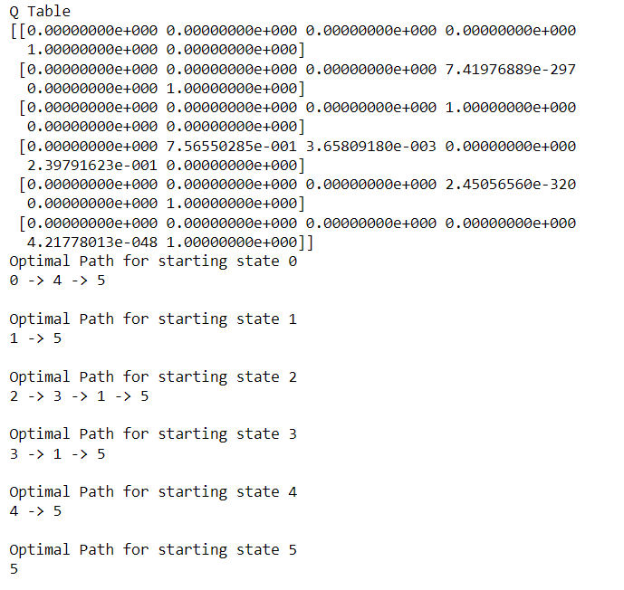

**After changing hyper parameters:-**

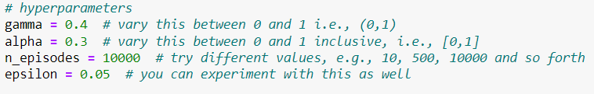

**Output:-**

