[Institute Name]
Automatic Headlight Control System Using Simulink and Stateflow
Course: Model-Based Design using Simulink & Stateflow
Department: Department of Electronics and Telecommunication Engineering
Submitted By: [Your Name]
PRN: [Your PRN]
Project Report

Table of Contents
Update field in Word to populate the table of contents.

Abstract
This project presents an Automatic Headlight Control System implemented using Simulink and Stateflow for an automotive application. The model senses ambient light intensity, vehicle speed, manual override input, and fault status, then generates the final headlamp command. The complete design is divided into four subsystems: Input Subsystem, Logic Subsystem, Stateflow Controller, and Output Subsystem. The Input Subsystem creates four simulation scenarios: day moving, night moving, tunnel entry, and night stopped. The Logic Subsystem processes raw signals into boolean status signals using relational operators and hysteresis logic. Hysteresis is implemented with two thresholds, 300 lux and 500 lux, to prevent rapid switching of headlights near the decision boundary. The Stateflow Controller uses four states, OFF, ON, HOLD, and MANUAL, to generate the final headlamp command. The Output Subsystem displays, plots, and logs the result for verification. Simulation results confirm correct behavior across all scenarios. The model demonstrates how model-based design can be used to build and validate a practical automotive control system.

Introduction
Modern vehicles use embedded control systems to improve safety, automation, and driver convenience. One common example is automatic headlight control, which turns the headlights ON or OFF according to surrounding brightness and vehicle condition.
In practical driving, the vehicle may move in daylight, drive at night, enter a tunnel, stop at a signal in darkness, or require direct manual control from the driver. An automatic controller reduces dependency on driver attention and improves response to changing environmental conditions.
This project models an Automatic Headlight Control System in Simulink and Stateflow. Simulink is used for subsystem-based signal processing and scenario generation, while Stateflow is used for state-based decision making. The final output is the signal headlamp_cmd, where 0 represents headlights OFF and 1 represents headlights ON.

Problem Statement
The objective of this project is to design and simulate an automotive headlight controller that reacts correctly to environmental light and vehicle movement. The system must identify bright and dark conditions, distinguish between moving and stopped vehicle states, allow driver override, and generate a correct final headlamp command for multiple operating scenarios.

System Architecture
The model follows a modular architecture: Input Subsystem -> Logic Subsystem -> Stateflow Controller -> Output Subsystem. This organization separates scenario generation, boolean decision preparation, state-based control, and output verification.
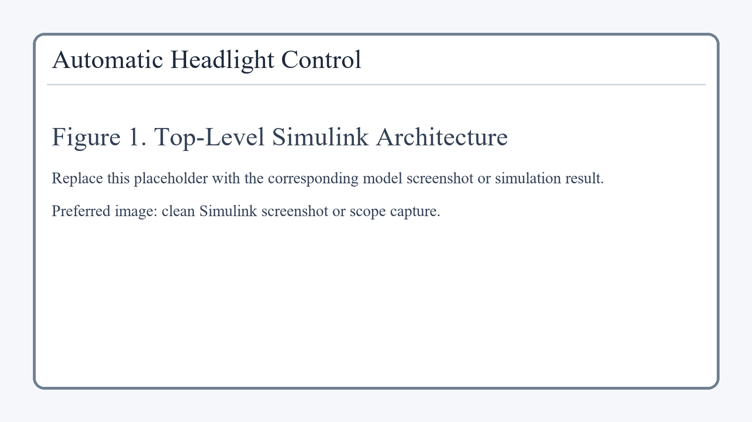
Figure 1: Top-Level Simulink Architecture

Inputs and Outputs
Signal | Type | Description
AmbientLux | Input | Brightness around the vehicle
VehicleSpeed | Input | Vehicle moving or stopped status
ManualOverride | Input | Driver command to force lamps ON
Fault | Input | Fault supervision input, currently held at 0
headlamp_cmd | Output | Final lamp command: 0 = OFF, 1 = ON

Input Subsystem
The Input Subsystem creates the operating conditions required for simulation. A Scenario Constant block selects one of four cases: day moving, night moving, tunnel entry, and night stopped. Based on the selected scenario, the subsystem produces AmbientLux and VehicleSpeed signals.
AmbientLux represents environmental brightness. Day condition is modeled with 800 lux, while night condition is modeled with 100 lux. In the tunnel-entry scenario, the lux value starts at 800, drops by 700 at approximately 10 s, and returns to 800 at approximately 20 s, simulating tunnel entry and exit.
VehicleSpeed is 60 for moving scenarios and 0 for the stopped-at-night scenario. ManualOverride is generated from a manual switch and is passed as a boolean driver command. Fault is currently held at 0 and passed through the model as an available supervisory input.
Scenario | Driving Condition | AmbientLux | VehicleSpeed | Expected headlamp_cmd
1 | Day + Moving | 800 | 60 | 0
2 | Night + Moving | 100 | 60 | 1
3 | Tunnel Entry | 800 -> 100 -> 800 | 60 | 0 -> 1 -> 0
4 | Night + Stopped | 100 | 0 | 1

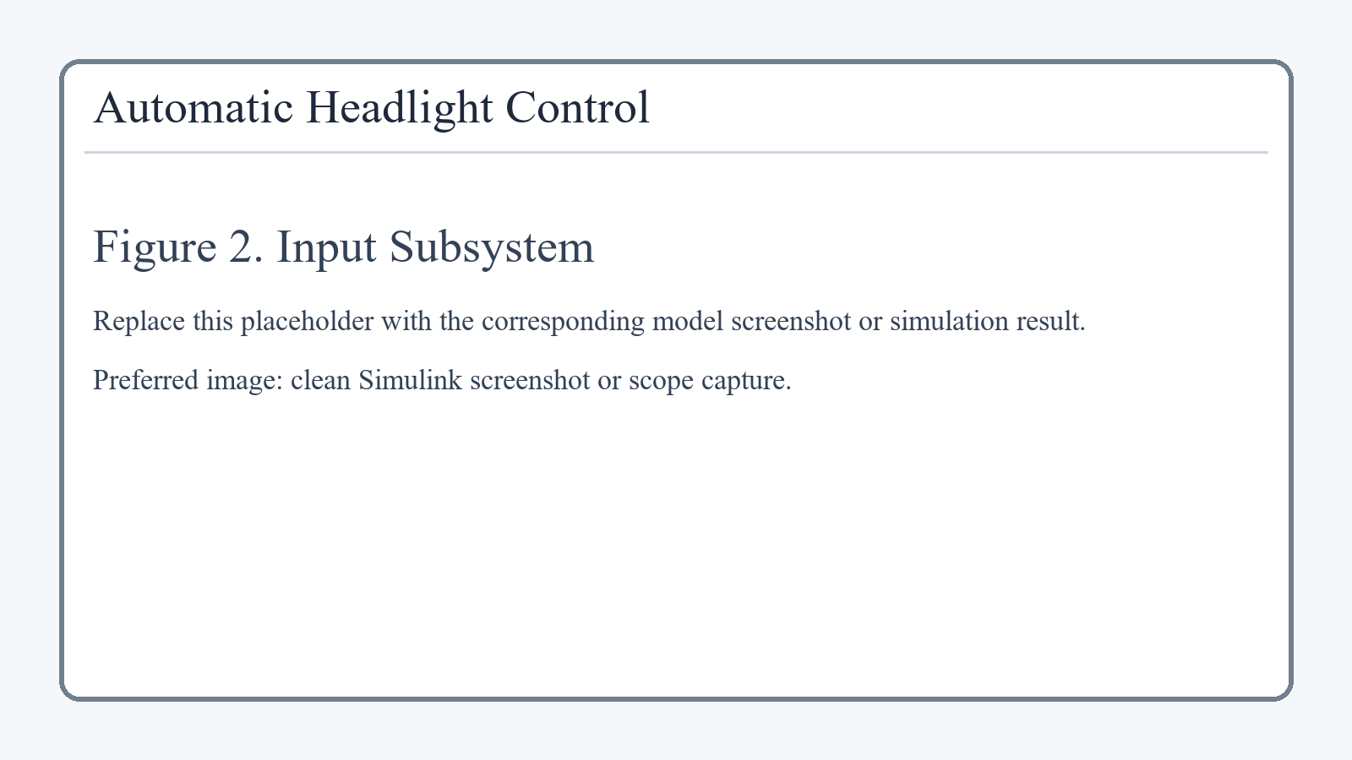
Figure 2: Input Subsystem

Logic Subsystem
The Logic Subsystem converts raw input values into boolean signals that can be used directly by the Stateflow Controller. The most important part is the ambient-light hysteresis logic, which avoids rapid ON/OFF switching near the decision threshold.
Two relational operators are used: AmbientLux < 300 and AmbientLux > 500. The first detects dark conditions and the second detects bright conditions. A Unit Delay stores the previous lux_status value. NOT, AND, and OR blocks are then connected to form the latch equation lux_status = (previous_lux_status AND NOT lux_gt_500) OR lux_lt_300.
VehicleSpeed > 0 generates speed_status. ManualOverride is passed through as override, and Fault is passed through as fault. The final outputs of this subsystem are lux_status, speed_status, override, and fault.
Block / Signal | Logic | Purpose
lux_lt_300 | AmbientLux < 300 | Detect dark condition
lux_gt_500 | AmbientLux > 500 | Detect bright condition
Unit Delay | Stores previous lux_status | Provides hysteresis memory
NOT | Inverts lux_gt_500 | Keeps dark status active until brightness is high
AND | previous_lux_status AND NOT lux_gt_500 | Maintains previous dark state
OR | ... OR lux_lt_300 | Generates final lux_status
speed_gt_0 | VehicleSpeed > 0 | Detect moving condition

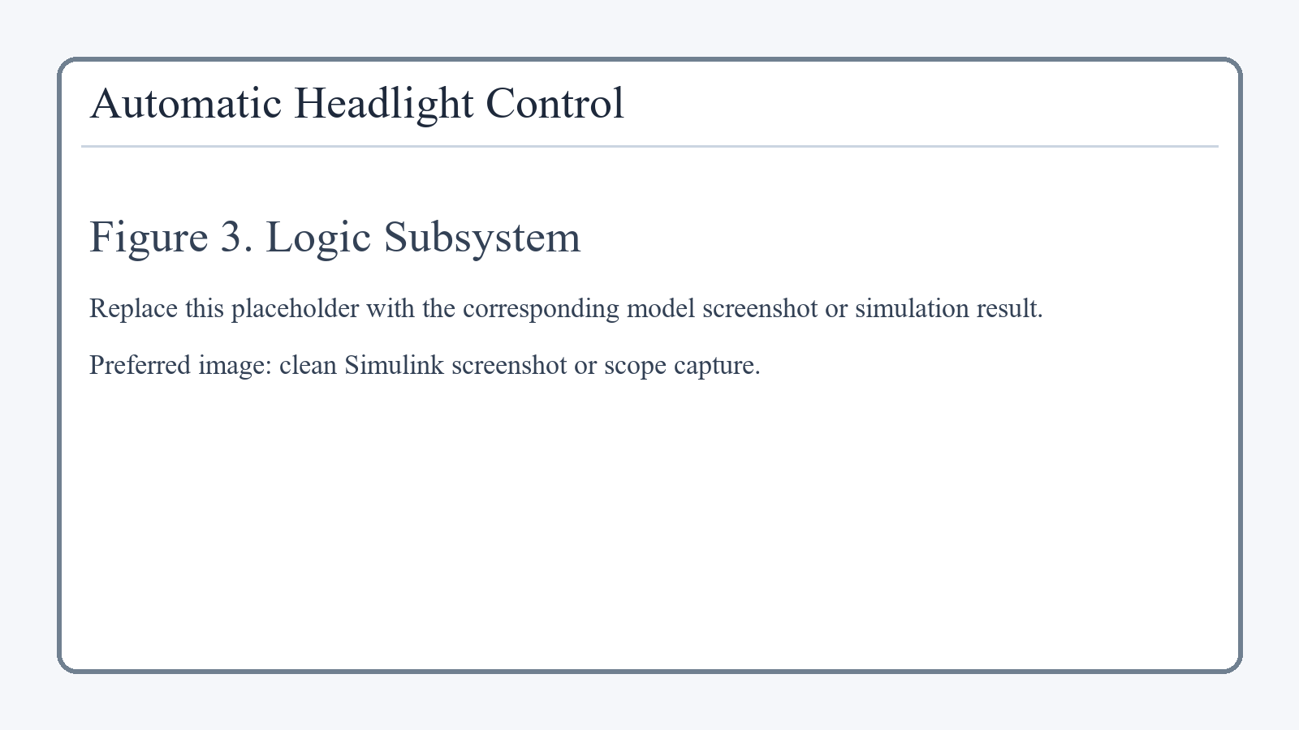
Figure 3: Logic Subsystem

Stateflow Controller
The Stateflow Controller receives lux_status, speed_status, override, and fault, and generates the final headlamp_cmd output.
The chart contains four states: OFF, ON, HOLD, and MANUAL. OFF is active when brightness is sufficient and headlights are not needed. ON is active when it is dark and the vehicle is moving. HOLD is active when it is dark and the vehicle is stopped, keeping the lamps ON for safety and visibility. MANUAL is active whenever ManualOverride is asserted and has highest priority.
The decision sequence is straightforward: if override equals 1, the chart goes to MANUAL. Otherwise, if lux_status equals 0, the chart goes to OFF. If lux_status equals 1 and speed_status equals 1, the chart goes to ON. If lux_status equals 1 and speed_status equals 0, the chart goes to HOLD.
State | Active Condition | Output
OFF | Bright condition | headlamp_cmd = 0
ON | Dark and moving | headlamp_cmd = 1
HOLD | Dark and stopped | headlamp_cmd = 1
MANUAL | Manual override active | headlamp_cmd = 1

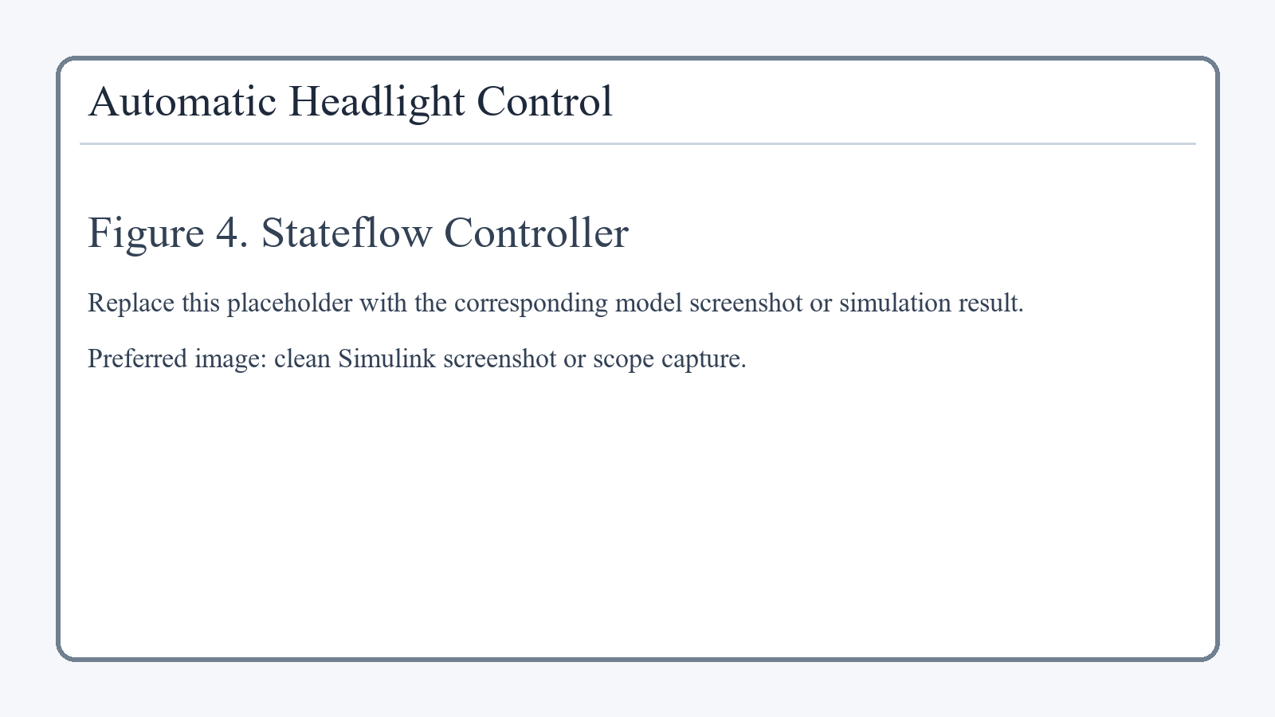
Figure 4: Stateflow Controller

Output Subsystem
The Output Subsystem receives the final headlamp_cmd signal from Stateflow and presents it in three ways.
Headlamp_Display shows the current logical value of the command. A value of 0 means headlights OFF, and a value of 1 means headlights ON.
Headlamp_Scope plots headlamp_cmd over time, making scenario-based transitions easy to verify visually. Headlamp_ToWorkspace logs the output signal as out.headlamp_cmd_ts for simulation verification and reporting.
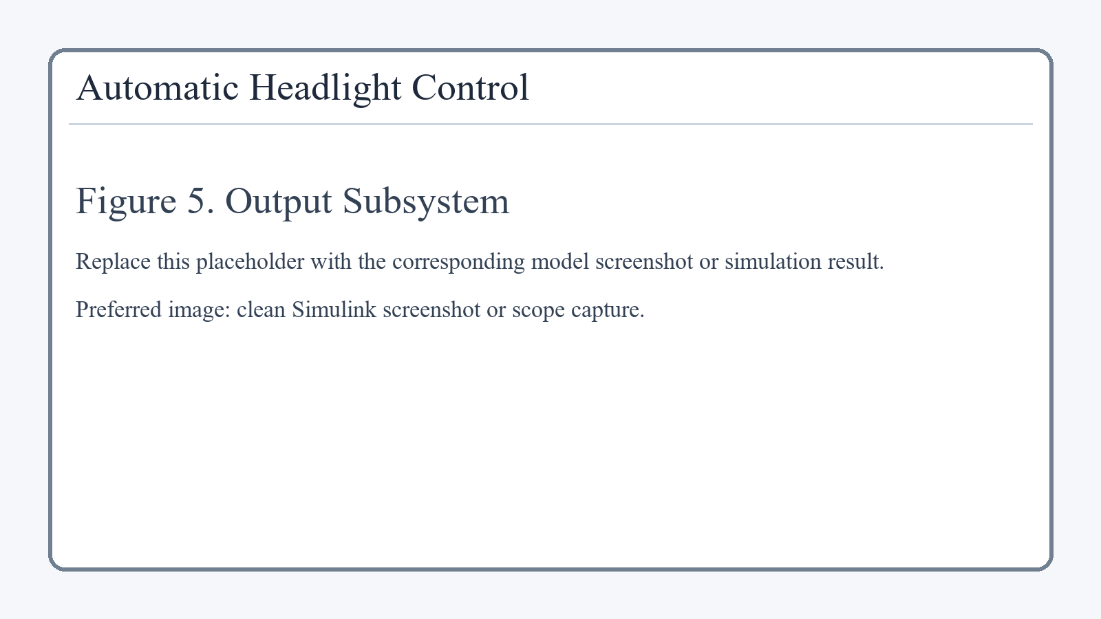
Figure 5: Output Subsystem

Test Cases and Results
The model was simulated for four representative scenarios. The resulting headlamp behavior matched the intended controller logic in every case.
Scenario | Condition | Expected Output
1 | Day + Moving | 0
2 | Night + Moving | 1
3 | Tunnel Entry | 0 -> 1 -> 0
4 | Night + Stopped | 1

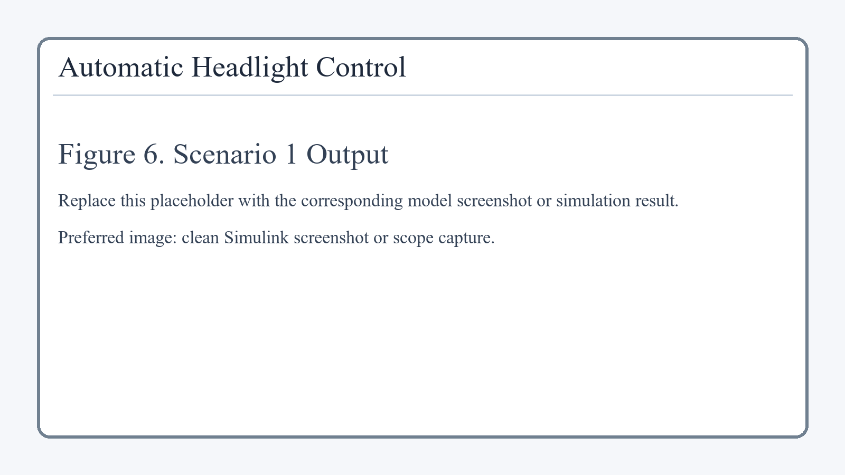
Figure 6: Scenario 1 Scope Output
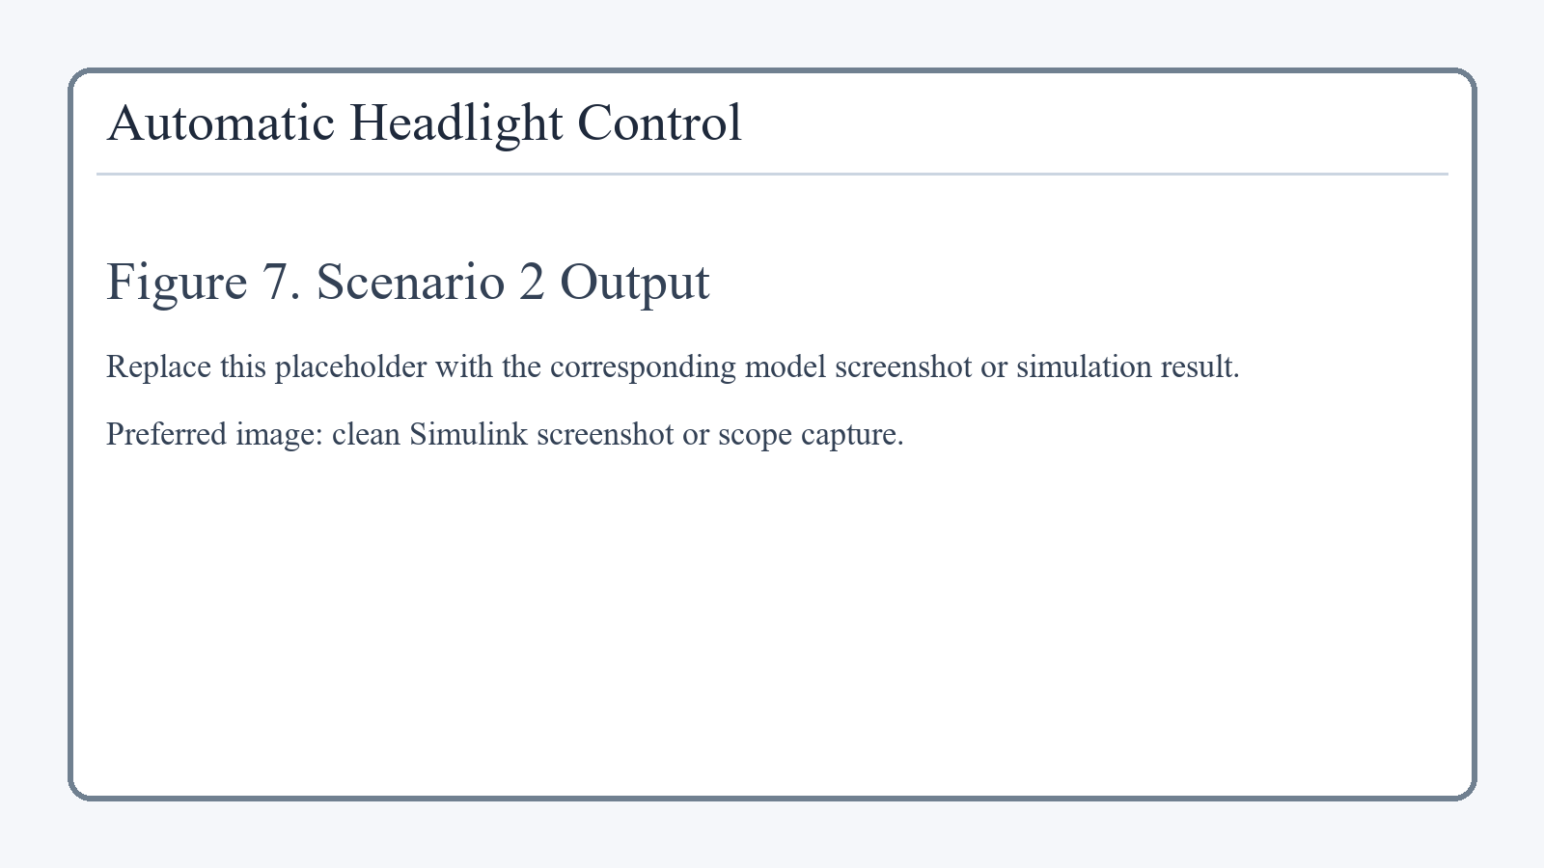
Figure 7: Scenario 2 Scope Output
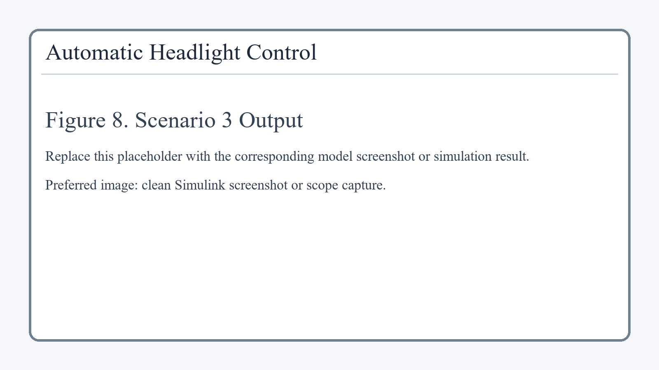
Figure 8: Scenario 3 Scope Output
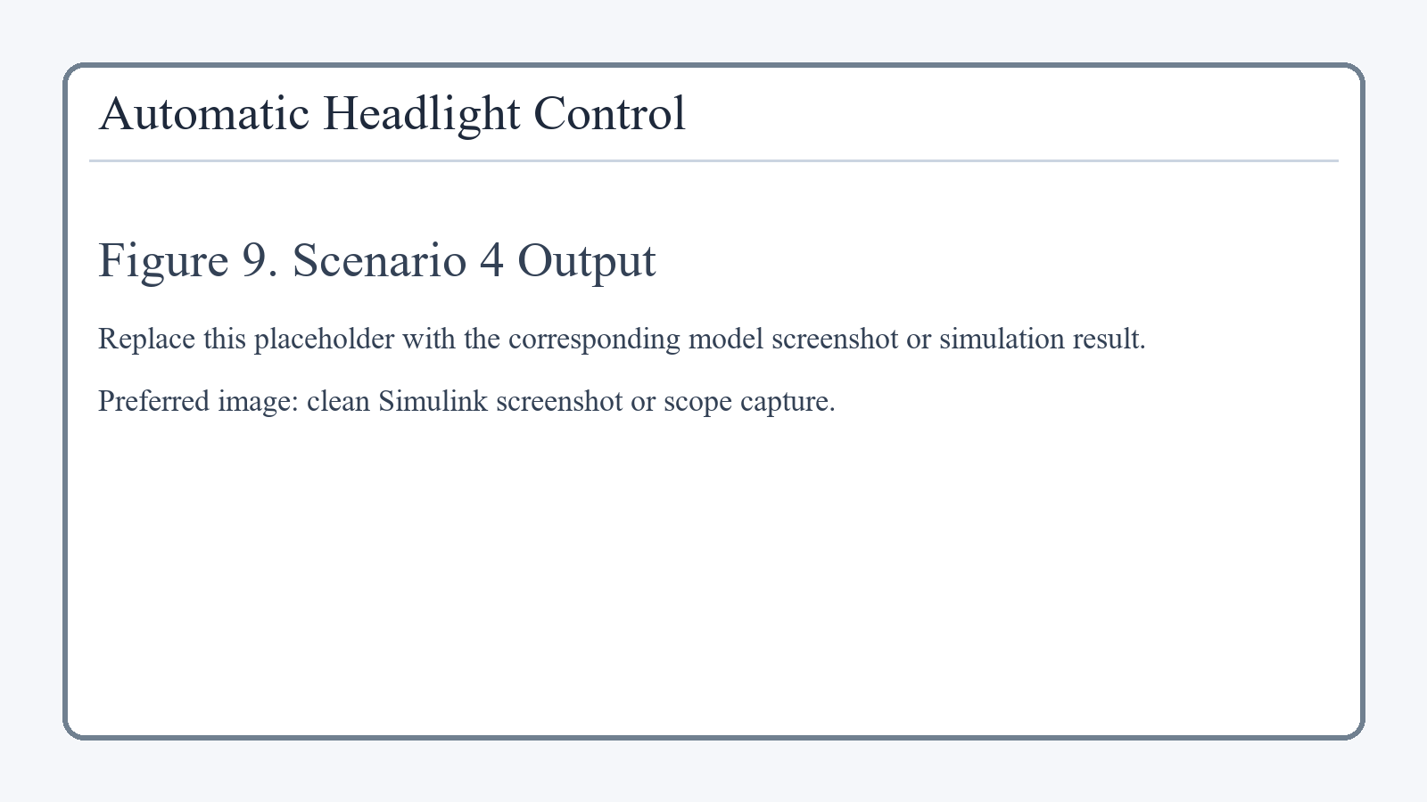
Figure 9: Scenario 4 Scope Output

Conclusion
The Automatic Headlight Control model successfully demonstrates an automotive control application using Simulink and Stateflow. The model senses operating conditions, processes those signals through hysteresis-based logic, makes a state-based decision, and verifies the output through display, scope, and workspace logging. The simulation results confirm correct response in daylight, night driving, tunnel transition, and stopped-at-night conditions.

