Scenario:
You're working on a personal project named "<YourLastname>_local_project" and want to experiment with new features without affecting the main codebase.
Example: Mansueto_local_project
Note:
- Ensure Git is installed on your machine.
- Set up your Git username and email (if not already configured)
- Create a directory called <YourLastname>_local_project, navigate into it, and initialize it as a Git repository
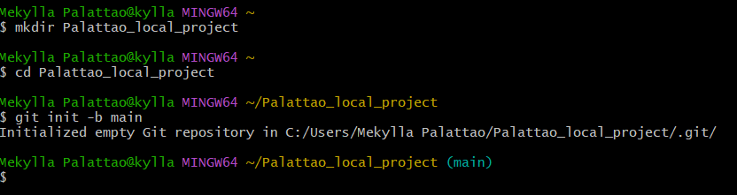
- Multiple commits reflecting changes in different branches.
- Evidence of conflict resolution during branch merging (optional).
- A Git tag-marking version v1.0 (optional).
Source code:
app.py
def greet(name):
return f"Hello, {name}!"

def farewell(name):
return f"Goodbye, {name}!"

if __name__ == "__main__":
print(greet("World"))
print(farewell("World"))

README.md
# Palattao_local_project

A local Git practice project for Machine Problem #1.

## Features
- Greeting feature
- Farewell feature

Tasks:
- Create a new branch:
  - Create a new branch named "feature_x" to isolate your experimental changes.
  - 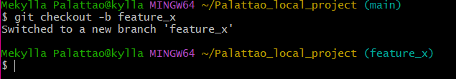

- Stage changes:
  - Make modifications to your project files.
  - Stage the changes using the git add command.

  - 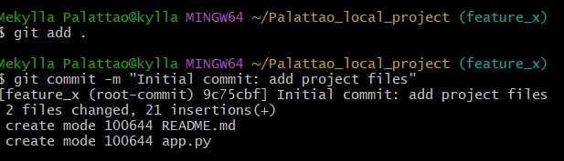

- Commit changes:
  - Commit the staged changes to your local repository using the git commit command. Provide a clear and concise commit message.
  - 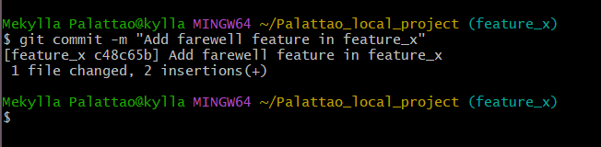
- Switch back to the main branch:
  - Use the git checkout command to switch back to the main branch.
  - 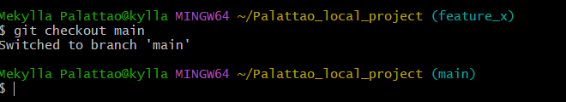
- Merge changes from the feature branch:
  - Use the git merge command to merge the changes from the "feature_x" branch into the main branch. Resolve any merge conflicts that may arise.
  - 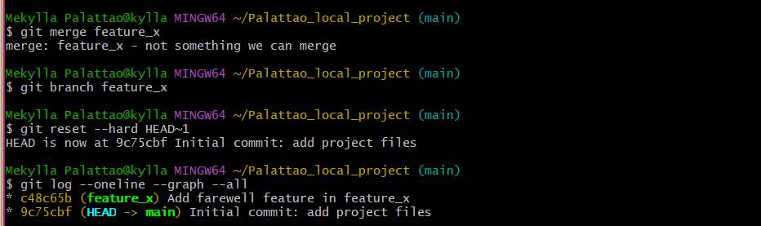
  - 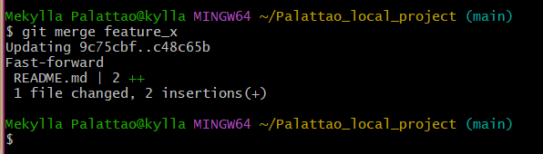
  - 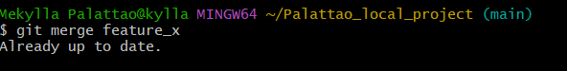
- Viewing the Commit History:
  - Use Git commands to view the commit history and ensure that all commits are in place.
  - 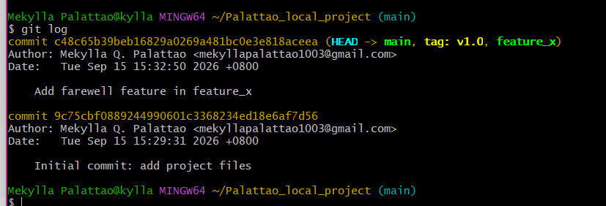

- Tagging Versions (Optional):
  - After completing the merge, use the git tag command to create a tag named v1.0 to mark the first version of your project.
  - 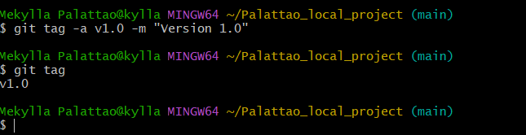
Output:
