Vendor Inventory Reconciliation Service (VIRS)
Review 2 — Master HLD + LLD + Architecture + DB + API + Implementation Readiness
Prepared for review discussion | Single master reference document

1. Purpose of this document
This is the single master document for the VIRS review. It consolidates the architecture, project layers, database design, API decisions, storage/notification alternatives, validation, batch processing, Python backfill, Git workflow, testing expectations, and the explanation to use during the review meeting.
Important: this document deliberately reflects the reviewer feedback from Review 1. The old five-table database design is not the target design. The target is a simpler two-table relational model, with reference inventory treated as a service/source rather than a redundant local table.

2. Review 2 checklist — what must be demonstrable
- REST endpoints are implemented with explicit versioning and documented content negotiation.
- Swagger/OpenAPI matches the implemented request, response, validation and error behavior.
- Python one-time backfill script is delivered and documented, including validation and discrepancy reporting.
- Flyway + JPA database layer is implemented against the revised schema.
- CSV ingestion and validation are implemented, with MinIO as the S3-compatible storage abstraction.
- Batch processing is chunked by record count and uses bounded ExecutorService concurrency.
- Reconciliation result and notification state are persisted without unnecessary tables.
- Slack notification is implemented through an adapter so the notification provider can be replaced.
- Positive, negative and edge-case tests are present; integration/build validation is demonstrated; target coverage is 80%.
- Git shows feature branches, meaningful commits, PR discipline where available, and release tags v0.1.0/v0.2.0 as required.

3. High-level architecture
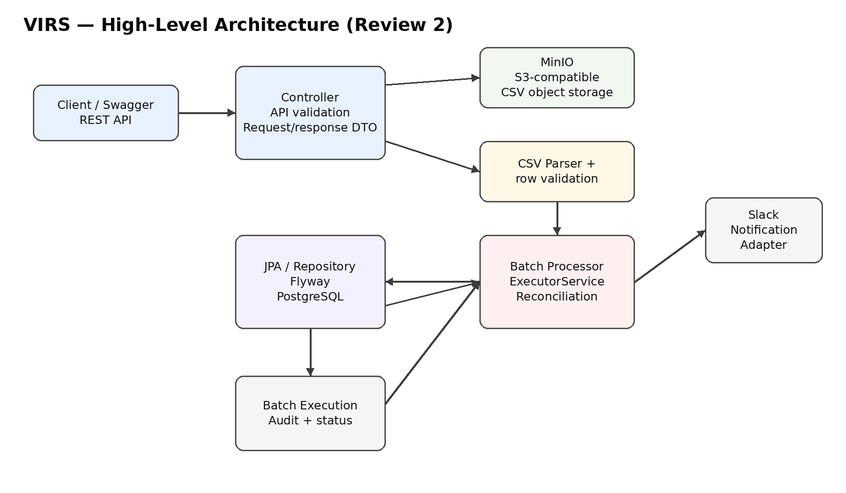
Flow: Client/Swagger → REST Controller → MinIO CSV object → CSV parser/validation → batch processor → JPA/PostgreSQL persistence and reference-inventory reconciliation → Slack notification. Batch execution is recorded for audit and operational visibility.

3.1 Architecture decisions
- MinIO is used as the local/self-hosted S3-compatible object-storage alternative. The application should depend on an object-storage abstraction, not on MinIO-specific business logic.
- Slack is used for discrepancy notification through a notification adapter. The business layer should not depend directly on Slack APIs.
- Secrets must not be hard-coded. Local development uses environment/configured placeholders; the design keeps a provider abstraction so a managed secrets service can be plugged in later.
- The database is responsible for durable business/audit state. Object storage is responsible for the uploaded CSV file.
- Reference inventory is a source/service used by reconciliation; it is not duplicated into an unnecessary INTERNAL_INVENTORY table in the VIRS database.

4. Project structure / layers
Use a conventional Spring Boot layered structure. The key point from Review 1 is that a service is not placed inside the controller; each layer has a distinct responsibility.
Layer | Example package | Responsibility
Controller / API | controller, dto.request, dto.response | REST endpoints, HTTP status, request/response mapping. No business logic.
Service | service, service.impl | Business orchestration: upload, batch execution, reconciliation, notification.
Validation | validation | Request/file/row validation and clear ValidationException messages.
Parser | parser | Read CSV rows and map them to InventoryRequest/domain data.
Batch processing | service/batch or service impl | Split records into chunks and process with bounded ExecutorService.
Repository | repository | JPA persistence only; no business rules.
Entity | entity | Database mapping and persistence model.
Storage | storage / storage.impl | MinIO/S3-compatible upload/download abstraction.
Notification | notification / notification.impl | Slack notification abstraction and implementation.
Utility | util | Constants, UUID generation, date/file helpers, generic validation helpers.
Exception | exception | Domain/application exceptions and global exception handling.
Configuration | config | Object storage, HTTP client, executor, Swagger, application configuration.
Backfill | scripts/backfill or scripts | One-time Python migration/backfill and discrepancy report.

5. Utility and validation code

5.1 Utility classes
AppConstants: Centralizes statuses, file extension and user-facing success messages so literals are not repeated throughout the code.
CommonUtil: Generates UUIDs in one reusable place.
CsvConstants: Centralizes CSV header names such as vendorId, sku, productName, quantity and unitPrice.
DateUtil: Provides current timestamp and consistent display formatting. Persistence should still use typed LocalDateTime/Timestamp rather than formatted strings.
FileUtil: Checks that an uploaded file has a CSV filename and safely extracts the original filename.
ValidationUtil: Provides reusable small checks such as positive/non-negative numeric values and non-blank strings.

5.2 Validation classes
BatchValidation: Validates that a batch request exists, has a file name, has an execution type if the field is retained, and references a CSV file.
CsvValidation: Rejects null/empty uploads, non-CSV files and files above the configured 10 MB upload limit. The size limit is file size, not processing batch size.
InventoryValidation: Validates mandatory vendorId, SKU and productName, non-negative quantity and non-negative unit price.
Recommended improvement: use the same CSV extension constant from AppConstants/CsvConstants instead of repeating '.csv' literals in validation.

5.3 Enums
BatchStatus: PENDING → RUNNING → COMPLETED/FAILED. This represents the lifecycle of a batch execution.
NotificationStatus: PENDING/SENT/FAILED. This represents notification delivery state.
ReconciliationStatus: MATCHED/MISMATCH. This represents comparison outcome.
ExecutionType: Review 1 raised that the meaning of this field was unclear. If the system currently has only one execution mode, the cleanest design is to remove the column. If retained, document real business values such as FULL/RETRY only when those modes are actually supported.

6. Database design — revised target
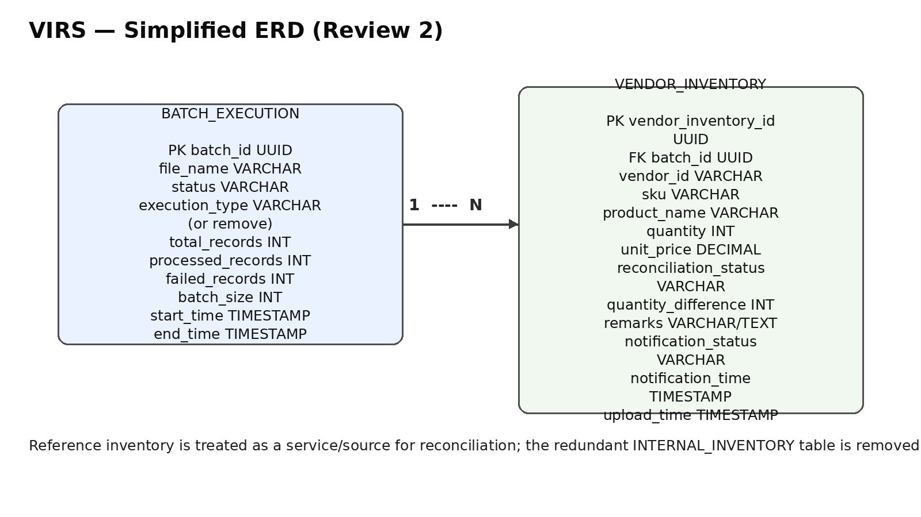
The reviewer feedback specifically requested simplification. The previous INTERNAL_INVENTORY, RECONCILIATION_RESULT and DISCREPANCY_NOTIFICATION tables created duplicate relationships and operational complexity. The revised model keeps batch audit data in BATCH_EXECUTION and row-level vendor/reconciliation/notification state in VENDOR_INVENTORY.

6.1 BATCH_EXECUTION
- batch_id — UUID primary key.
- file_name — uploaded CSV name.
- status — PENDING/RUNNING/COMPLETED/FAILED.
- execution_type — remove if there is only one real execution mode; otherwise document actual supported values.
- total_records — number of valid/received CSV data rows for the batch.
- processed_records — successfully processed records.
- failed_records — records that could not be processed.
- batch_size — number of records per processing chunk, not MB.
- start_time/end_time — execution audit timestamps.

6.2 VENDOR_INVENTORY
- vendor_inventory_id — UUID primary key.
- batch_id — foreign key to BATCH_EXECUTION.
- vendor_id, sku, product_name, quantity, unit_price — vendor supplied data.
- reconciliation_status — MATCHED or MISMATCH.
- quantity_difference — internal/reference quantity minus vendor quantity, with the sign convention documented.
- remarks — optional human-readable discrepancy reason.
- notification_status — PENDING/SENT/FAILED; VARCHAR is appropriate because it stores multiple states, not just true/false.
- notification_time — timestamp when notification was successfully sent.
- upload_time — row upload/persistence timestamp.

6.3 Reference inventory
The reference quantity needed for reconciliation should come from the Internal Inventory/Inventory service or another authoritative source. It should not be duplicated as an INTERNAL_INVENTORY table unless a future requirement explicitly says VIRS owns that data.

7. Batch size and performance strategy

- Proposed default chunk size: 500 records per worker task, configurable through application properties.
- Proposed maximum concurrency: 4 worker tasks, also configurable.
- Example: 10,000 records → 20 chunks of 500 records. At most 4 chunks execute concurrently.
- Use a bounded ExecutorService rather than creating an unbounded thread per record.
- Each task should return a result object containing processed/failed counts and reconciliation outcomes.
- Database writes should be batched where practical, and transactions should be scoped so one bad row does not corrupt the entire file.
- Do not increase thread count blindly; database connection-pool capacity and downstream service limits are the real constraints.
- Record total/processed/failed counts in BATCH_EXECUTION so performance and failures can be audited.

8. CSV ingestion and MinIO flow
- REST endpoint receives MultipartFile.
- CsvValidation checks null/empty/type/size.
- Storage service uploads the original CSV to MinIO and returns an object key.
- A batch execution record is created with PENDING/RUNNING status.
- CSV parser reads rows and maps headers using CsvConstants.
- InventoryValidation validates each row.
- Valid rows are split into configured record chunks.
- Batch processor executes chunks with bounded ExecutorService.
- Each row is reconciled against the authoritative reference inventory source.
- Vendor row is persisted with reconciliation and notification state.
- MISMATCH rows trigger Slack notification; notification status is updated to SENT/FAILED.
- Batch execution is completed with processed/failed counts and end time.

9. API / OpenAPI / versioning / content negotiation

9.1 Recommended endpoints
Method | Path | Purpose
POST | /api/v1/batches | Upload/start a vendor inventory batch.
GET | /api/v1/batches/{batchId} | Get batch status and counts.
GET | /api/v1/batches/{batchId}/records | Get persisted vendor/reconciliation rows.
POST | /api/v1/batches/{batchId}/reconcile | Trigger/retry reconciliation when supported.

9.2 Versioning decision
Use URI versioning (/api/v1/...). The decision is justified by a concrete breaking-change use case: suppose v1 returns quantity as an integer and clients depend on that contract, while a future v2 must expose a richer quantity structure or additional reconciliation metadata. A breaking response/request change should not silently alter v1 clients. v2 allows both contracts to coexist during migration.

9.3 Content negotiation
Use HTTP Content-Type for requests and Accept for responses. JSON is the primary API representation (application/json). The CSV upload endpoint accepts multipart/form-data because the payload is a file. If a future client needs another response representation, content negotiation can be extended without changing the business service.

9.4 OpenAPI
Swagger must describe the exact implemented endpoints, request fields, response fields, enum values, validation errors, HTTP status codes and examples.

10. Python backfill script
The one-time Python script is part of the design, and Its purpose is to migrate/prepare legacy inventory data into the revised relational schema.
- Read the source file/table.
- Validate required columns, UUIDs, SKU, quantity and timestamps.
- Normalize data types and reject invalid rows.
- Map source records into BATCH_EXECUTION + VENDOR_INVENTORY.
- Detect duplicates and reconciliation discrepancies.
- Write a discrepancy report (CSV/JSON) containing row identifier, SKU, reason and source value.
- Use transaction/commit boundaries so rerunning the script does not create uncontrolled duplicates.
- Provide --dry-run and --input/--output arguments where practical.
- Log total, successful, failed and skipped rows.

11. Notification design — Slack
Keep Slack behind an interface such as NotificationService/NotificationClient. The reconciliation service asks for a notification; the Slack implementation performs the actual HTTP call. This keeps the core business logic independent of Slack and makes future replacement with SNS/email/Teams straightforward.
Persist notification_status as PENDING/SENT/FAILED rather than a boolean because a three-state lifecycle is required.

12. Secrets and configuration
- No credentials in source code or Git.
- MinIO endpoint, access key and secret key come from environment/configuration.
- Slack webhook/token comes from environment/configuration.
- Application properties should contain placeholders or environment-variable references, not real secrets.
- Keep a secrets-provider abstraction so AWS Secrets Manager or another enterprise provider can be introduced later without changing business code.

13. Testing and quality gate
- Validation unit tests: null request, blank fields, invalid extension, empty file, oversized file.
- Inventory tests: zero quantity, positive quantity, negative quantity, zero price, negative price, blank vendor/SKU/product.
- Batch tests: empty batch, single chunk, multiple chunks, partial failure, all-success, executor failure.
- Reconciliation tests: MATCHED, MISMATCH and missing reference record.
- Notification tests: SENT, FAILED and retry/pending behavior.
- Controller tests: HTTP 2xx/4xx/5xx and validation error payloads.
- Integration test: Flyway migration + JPA persistence against a test database.
- Build validation: clean build and test run in CI/local.
- Target coverage: 80% or higher, with focus on business logic rather than chasing coverage in trivial getters/setters.

14. Git / release discipline
Recommended workflow: main → develop → feature/* branches → pull request → develop → release tag. Do not commit directly to main for normal feature work.
- feature/design-docs — architecture/ERD/OpenAPI documentation work.
- feature/validation — validation and tests.
- feature/storage-minio — object storage abstraction and MinIO implementation.
- feature/batch-processing — chunking and ExecutorService.
- feature/reconciliation — reconciliation and persistence.
- feature/notification-slack — Slack notification adapter.
- feature/backfill — Python migration/backfill script.
Commit style: feat:, fix:, refactor:, test:, docs:, chore:. Keep commits small and explain one logical change.
Required tags: v0.1.0 for the initial documented/design baseline and v0.2.0 for the implemented Review-2 milestone, if that matches the team's release convention.

