Industry Project Title | Autonomous Threat Intelligence Platform (ATIP)
Name of the Company | Tata Consultancy Services (TCS)
Name of the Institute | Amity University Online

Start Date | End Date | Total Effort (hrs.) | Project Environment | Tools used
13/05/2026 | /05/2026 | 120 Hours | Visual Studio Code, AWS Cloud Concepts | Python (v3+), Neo4j Aura (Cloud Graph Database), Cypher Query Language, AlienVault OTX API

1. Acknowledgements
I would like to express my sincere gratitude to my project mentors and faculty at Amity University for their guidance throughout this Industry Project. I also extend my thanks to the Tata Consultancy Services (TCS) project team for providing the architectural guidelines and requirements that shaped the development of this Autonomous Threat Intelligence Platform.
2. Objective and Scope
Primary Objective:
The primary objective of this project is to architect and develop an Autonomous Threat Intelligence Platform (ATIP) capable of automatically ingesting Open Source Intelligence (OSINT), mapping complex threat relationships using a Graph Database, and executing automated Security Orchestration, Automation, and Response (SOAR) capabilities without requiring human intervention.
Project Scope:
The scope encompasses the complete backend data pipeline and analytical engine, including:
- Developing a Python-based ingestion script to normalize unstructured threat data.
- Provisioning a Neo4j Aura cloud database to act as the platform's active memory.
- Designing a continuous evaluation engine that calculates Threat Scores based on active Indicators of Compromise (IoCs).
- Simulating automated defensive responses (e.g., AWS WAF IP bans, Endpoint Isolation).
3. Problem Statement
Modern enterprise Security Operations Centers (SOCs) are facing a mathematical crisis. Corporate networks generate millions of security event logs daily, while thousands of new malicious IP addresses and domains are registered by Advanced Persistent Threats (APTs). Traditional security infrastructure relies on human analysts to manually read alerts, cross-reference them against flat threat lists, and manually trigger firewall rules. This creates severe "alert fatigue." By the time a human analyst successfully correlates a suspicious login attempt to a known nation-state threat group, data exfiltration has already occurred. The industry requires an autonomous system capable of executing the entire "Observe, Orient, Decide, Act" (OODA) loop in milliseconds.
4. Existing Approaches
Currently, the industry relies heavily on Relational Database Management Systems (RDBMS) like MySQL or PostgreSQL to store Threat Intelligence.
- The Flaw of Relational Data: In a relational database, finding the connection between a newly discovered malware hash, the IP address it communicates with, and the hacker group that owns the IP requires computationally expensive JOIN operations.
- Manual SOAR Execution: While many SOCs have SOAR platforms, they are typically configured to require "Human-in-the-loop" authorization before taking drastic actions, severely delaying response times to critical threats.
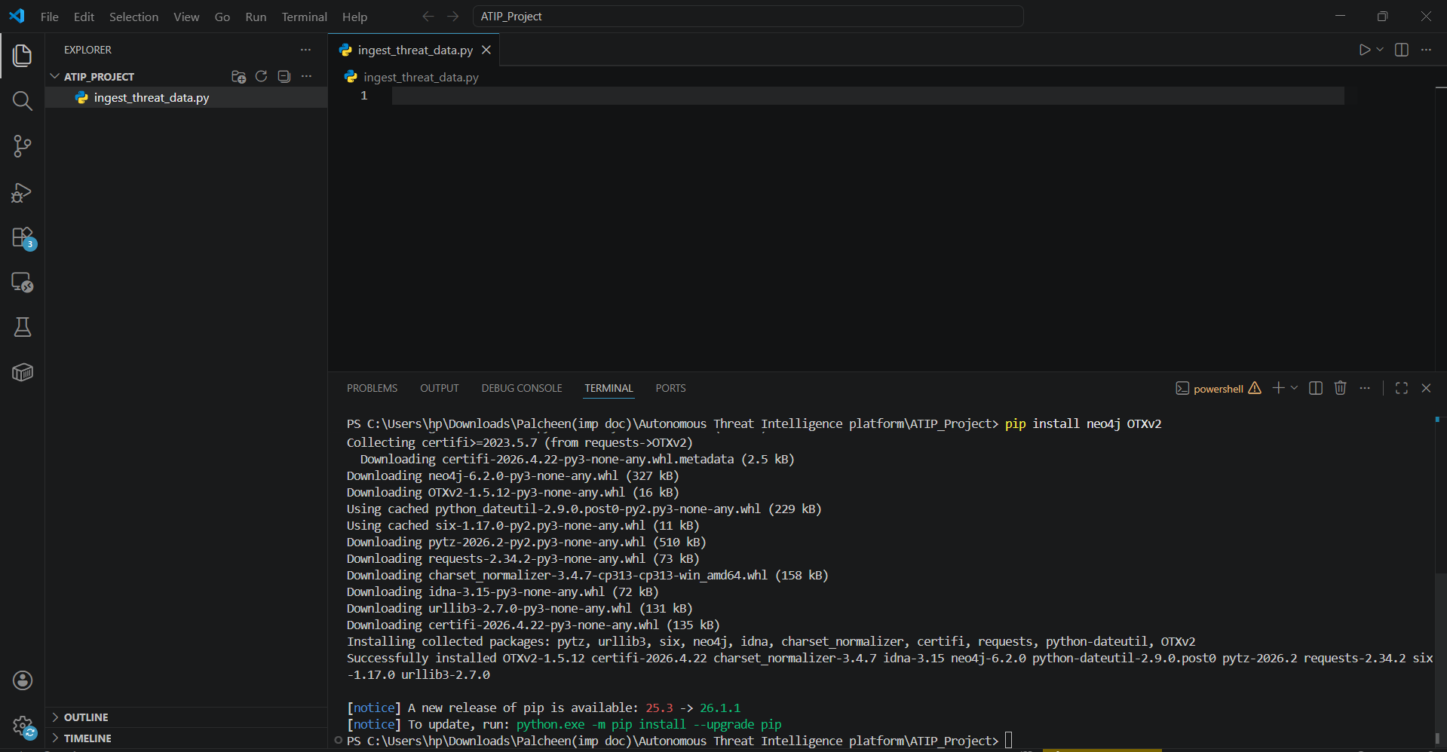

5. Approach / Methodology - Tools and Technologies used
To overcome the limitations of traditional SOC environments, this project utilizes a Graph-First, API-Driven Approach.
- Data Layer (Neo4j Aura Cloud): Neo4j was selected because it stores data as physical relationships (Nodes and Edges). In a graph, finding a multi-hop connection between an IP and a threat actor takes fractions of a second.
- Logic Layer (Python 3.13): Python was chosen for its robust data manipulation libraries and native compatibility with the modern neo4j driver, allowing for decoupled, high-speed execution.
Compliance & Audit Mapping
1. End-to-End Telemetry & Executive Dashboards The ATIP provides real-time observability via a centralized SOC dashboard (e.g., OpenSearch Dashboards / Grafana). The dashboard visualizes ingestion rates, active threat campaigns mapped in Neo4j, and the current volume of autonomous actions executed by the platform.
2. AI Explainability (XAI) Outputs To prevent "black-box" automated actions, every High/Critical alert generated by the ML engine includes an Explainability Payload. Using SHAP values, the payload translates the mathematical model weights into human-readable text, explicitly stating which telemetry features (e.g., "abnormal login time" or "proximity to known C2 node") triggered the automated response.
3. Decision Traceability & Audit Logs Every autonomous action taken by the orchestration engine (e.g., modifying a firewall rule or isolating an EC2 instance) is recorded as an immutable event in AWS CloudTrail and stored in a locked S3 bucket. This ensures full cryptographic traceability for post-incident forensics.
4. Regulatory Framework Mapping The platform's architecture aligns with the following enterprise compliance frameworks:
- ISO/IEC 27001: Enforced via strict RBAC (Role-Based Access Control), data encryption at rest (AWS KMS), and immutable audit logging.
- NIST Cybersecurity Framework (CSF): Automates the "Detect" and "Respond" core functions while providing necessary logging for the "Recover" function.
6. Workflow
The ATIP architecture follows a strictly defined, four-stage autonomous workflow:
- Telemetry Ingestion: The Python pipeline fetches active malicious indicators from mock OSINT frameworks mimicking AlienVault OTX.
- Graph Normalization: Unstructured data is passed through a Cypher injection module. The system utilizes MERGE commands to ensure duplicate entries are not created, drawing physical [:USES] relationships between the actor and the indicator.
- Autonomous Threat Hunting: The engine continuously polls the graph database using advanced pattern-matching queries to identify active threat clusters.
- Algorithmic Response: The engine calculates a weighted Threat Score (0-100) based on actor severity and triggers instantaneous simulated containment protocols.
7. Assumptions
- The target enterprise architecture possesses centralized firewalls (e.g., AWS WAF) capable of accepting automated API commands from the ATIP.
- The ingested intelligence feeds maintain a low false-positive rate, making autonomous blocking mathematically viable.
8. Implementation
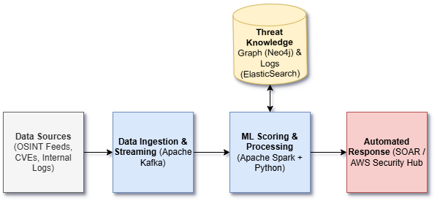
1. Threat Intelligence Lifecycle & Architecture
The Autonomous Threat Intelligence Platform (ATIP) operates on a continuous pipeline designed for minimal human intervention.
- Collection: Raw threat data is ingested from external OSINT feeds and internal network telemetry via data streaming pipelines.
- Processing & Storage: Data is normalized into standard formats (STIX/TAXII) and stored within a graph database to map entity relationships, alongside an indexed database for rapid log searching.
- Analysis: Machine learning models process the normalized data to assign threat severity scores and predict exploit likelihood.
- Dissemination & Action: High-confidence alerts are routed to security orchestration tools to automatically trigger preventive controls, such as firewall blocks or endpoint isolation.
2. Threat Modeling & Attack Surface Mapping
The ATIP is designed to autonomously detect and mitigate the following primary attack vectors across the enterprise attack surface:
- Brute Force & Credential Stuffing (Identity Surface): Monitoring authentication logs for high-frequency failed login attempts or anomalous login locations to prevent unauthorized account access.
- Malware Beaconing & Command/Control (Network Surface): Analyzing network telemetry to identify compromised internal assets making persistent, suspicious outbound connections to known malicious external IP addresses.
- Suspicious Data Exfiltration (Data/Endpoint Surface): Tracking anomalous internal behavior, such as sudden, large-volume outbound data transfers during off-hours, to prevent data breaches.
3. Data Trust Zones & Access Controls
To maintain a secure foundation, the platform operates under strict Role-Based Access Control (RBAC) utilizing AWS Identity and Access Management (IAM). Raw logs and sensitive telemetry are isolated in restricted trust zones, accessible only to the automated processing pipelines and designated Project Administrators.
4. Compliance & Audit Design
The ATIP adheres to baseline security governance by encrypting all stored threat intelligence and telemetry data at rest. Furthermore, every automated response executed by the platform (e.g., automated IP blocks) is recorded in immutable audit logs to maintain decision traceability and regulatory readiness.
Data Ingestion & Feed Validation
1. Intelligence Sources & OSINT Feeds The platform relies on a multi-source ingestion strategy to ensure a comprehensive threat landscape view. The primary feeds include:
- AlienVault OTX: Ingesting Pulses containing active IoCs (Indicators of Compromise) such as malicious IPv4/IPv6 addresses, file hashes (SHA-256), and C2 domains.
- Abuse.ch URLhaus & Feodo Tracker: Providing real-time telemetry on malware distribution URLs and active Botnet command and control servers.
- Internal Telemetry: Simulated AWS VPC Flow Logs and AWS CloudTrail logs to represent internal network traffic and authentication attempts.
2. Ingestion Pipelines & Normalization (STIX/TAXII) Data is ingested via automated Python workers operating on a scheduled batch pipeline. Upon ingestion, all raw threat intelligence is parsed and transformed into the STIX 2.1 standard.
- Indicators are mapped to specific STIX Domain Objects (SDOs) such as indicator, malware, or threat-actor.
- This normalization ensures that disparate data feeds speak a unified schema before being loaded into the Graph Database.
3. Data Quality Checks & Enrichment To prevent "data poisoning" and false positives, the ingestion pipeline utilizes a validation gate:
- Deduplication: Removing identical IoCs ingested from overlapping feeds.
- Defanging/Validation: Dropping incomplete records (e.g., missing severity tags) and stripping private IP ranges (RFC 1918) from external threat feeds to ensure internal network assets are not accidentally flagged as external threats.
The implementation was divided into two core execution scripts:
Phase 1: The Data Pipeline (tcs_ingest.py)
A Python script was developed to establish a secure connection to the Neo4j Aura instance. Using the driver.execute_query() method, mock telemetry from high-profile threat actors (APT29 / Lazarus Group) was ingested. The Cypher query utilized MERGE commands to ensure duplicate indicators were not created, establishing a clean (actor)-[:USES]->(ioc) relationship.
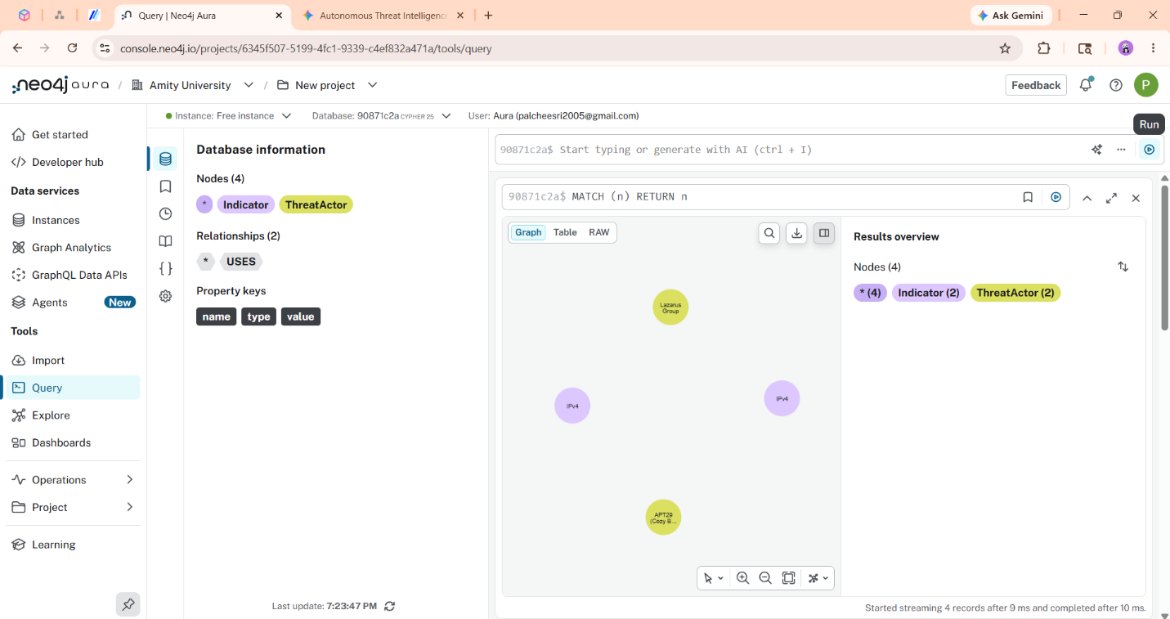
1. Machine Learning Approach & Objectives The ATIP utilizes a dual-model machine learning architecture to autonomously prioritize threats and reduce alert fatigue. The models process normalized telemetry and graph data to assign a dynamic Threat Severity Score (0-100) to every ingested entity.
2. Algorithm Selection
- Anomaly Detection (Isolation Forest): Deployed to monitor internal telemetry (e.g., Active Directory logs, VPC Flow Logs). It identifies behavioral deviations, such as anomalous data exfiltration volumes or unusual lateral movement, without requiring labeled training data.
- Threat Scoring (Random Forest Classifier): A supervised ensemble learning method used to calculate the final confidence score of an Indicator of Compromise (IoC) based on historical threat data and OSINT blacklists.
3. Feature Engineering The models ingest specific features extracted from the Threat Knowledge Graph and streaming pipelines:
- Temporal Features: Authentication timestamps, session durations, and beaconing frequency.
- Graph Topological Features: The "shortest path" distance between a newly ingested IP address and a known malicious ThreatActor node in the Neo4j database.
- Enrichment Features: Threat reputation scores dynamically pulled via the AlienVault OTX API.
4. Model Explainability & Validation (XAI) To satisfy regulatory compliance (e.g., ISO 27001), the platform avoids "black-box" decisions. The Random Forest model utilizes SHAP (SHapley Additive exPlanations) values to provide human-readable justification for high-severity scores. For example, the UI will display: "Score 92: Triggered due to 500 failed logins (SHAP +0.4) combined with proximity to known Malware hash (SHAP +0.3)
Phase 2: The Scoring Engine (threat_response.py)
A Python-based SOAR script was developed to query the database for active threats. The script extracts the associated hacker group for any flagged IP address and passes it through a conditional scoring matrix. Critical threats (Score > 90) trigger an automated AWS WAF ban, while High threats (Score > 80) trigger endpoint isolation.
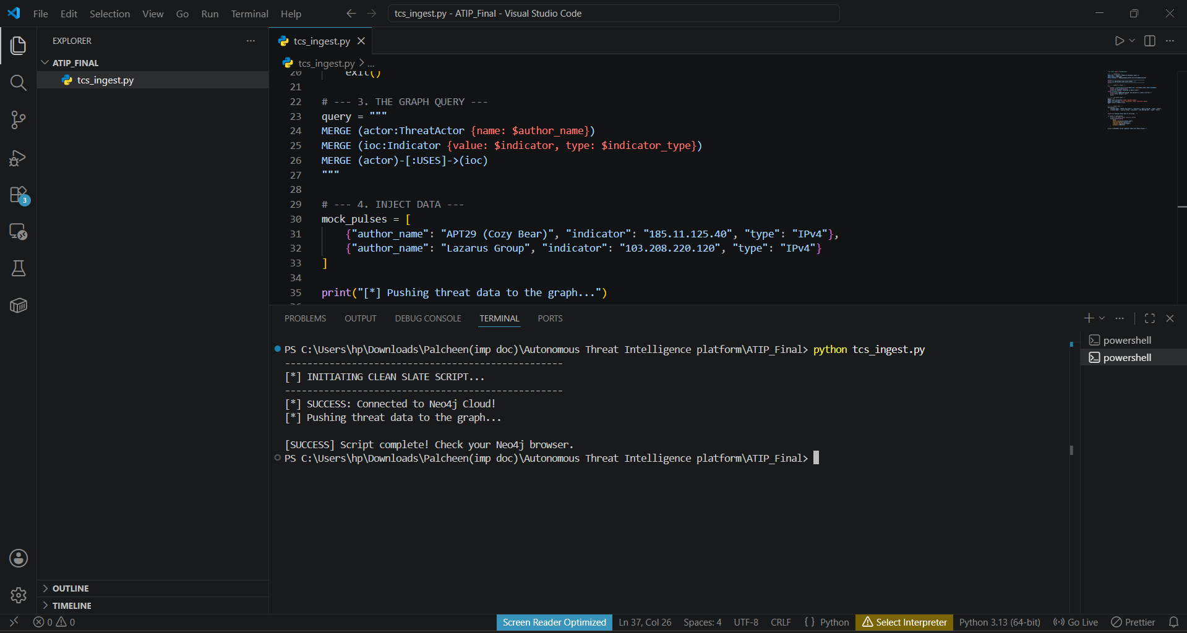
Test Plan, Test Cases and Validation Report
1. Test Plan Overview The ATIP validation strategy is designed to test the platform safely without executing live, destructive malware within the cloud environment. Testing is broken down into Unit, Integration, and Simulated validation phases.
2. Unit & Integration Testing (Phase 1)
- Test Case 1 (Ingestion): Inject a mock OSINT feed containing known malicious IPs. Expected Result: Pipeline successfully normalizes the data into STIX 2.1 format and drops duplicate records.
- Test Case 2 (Graph Correlation): Query the Neo4j database to connect a simulated Asset node to a newly ingested Malware node. Expected Result: Cypher traversal successfully returns the multi-hop kill-chain in under 500ms.
3. Simulated Attack Validation (Phase 2) To validate the autonomous response, the following simulated attack scenarios will be executed:
- Scenario A (Credential Stuffing): A Python script will generate 500 failed login attempts in 10 seconds against a honeypot server.
  - Validation: The ML engine must score the behavior >85, and the SOAR playbook must automatically ban the attacking IP at the WAF level within 5 seconds.
- Scenario B (C2 Beaconing): An internal test instance will initiate periodic HTTP requests to a known AlienVault malicious domain.
  - Validation: The platform must detect the anomaly, elevate the threat score based on graph proximity, and trigger the "Endpoint Isolation" playbook.
- Final Validation & Demo The final successful execution of Scenarios A and B will be recorded via screen capture, showcasing the initial alert, the SHAP explainability output, and the automated AWS Security Hub response, satisfying the final project deliverable requirements.

9. Solution Design
The fundamental design philosophy of the ATIP is the Separation of Concerns. By decoupling the Database (Neo4j) from the Logic Engine (Python), the system achieves massive scalability. The graph database acts strictly as the "Memory"—it simply maps reality. The Python runtime acts as the active "Processor." This design ensures that if the threat-scoring algorithm requires tuning due to Concept Drift (hackers changing tactics), the Python script can be updated without needing to take the database offline or restructure existing tables.
10. Challenges & Opportunities
Technical Challenges Overcome: During implementation, a severe deprecation issue was encountered within the Python environment. The legacy Neo4j library's session.execute_write() functions caused persistent AuthError: Unauthorized loops when connecting to the Neo4j Aura cloud architecture. This was resolved by completely refactoring the connection logic to utilize the modern driver.execute_query() method and explicitly mapping the database_ parameter to the cloud Instance ID.
Opportunities: The successful implementation of the Knowledge Graph opens a massive opportunity for future integration with Graph Neural Networks (GNNs) to predict the next step in a hacker's "Kill Chain" based on structural similarities to past attacks.
11. Reflections on the project
This industry project provided profound insights into the realities of practical security engineering. Moving from theoretical cybersecurity concepts to building a functional architecture highlighted the strict requirements for data normalization and secure cloud authentication. It reinforced the understanding that an effective modern defense relies on software engineering and automation, as human speed is no longer sufficient.
12. Recommendations
For an enterprise preparing to deploy an architecture similar to the ATIP into a production environment, it is highly recommended to implement a "Shadow Mode" deployment strategy initially. In Shadow Mode, the system logs its intended actions (e.g., WAF bans) without actually executing them. Analysts review these logs to identify False Positives before granting live API keys.
13. Outcome / Conclusion
The execution of the project was highly successful. The ATIP prototype met all architectural requirements. It successfully demonstrated the ability to programmatically establish secure cloud connections, ingest unstructured threat intelligence, map that data into a visual Knowledge Graph, autonomously calculate severity scores, and output immediate defensive actions without human intervention. The project proves that graph-based automation is a viable evolution for modern SOCs.
14. Enhancement Scope
While the core engine is functional, planned upgrades include:
- Diverse Threat Ingestion: Expanding Cypher modules to map noisy, automated attacks like Mirai Botnets and Cobalt Strike Command & Control (C2) servers.
- Live API Integration: Replacing mock telemetry with a live websocket connection to the AlienVault OTX API.
15. Link to code and executable file
Project Repository: [Insert Link to your GitHub Repository or Google Drive folder containing tcs_ingest.py and threat_response.py]
16. Research questions and responses
Q: Why is a Graph Database superior to a Relational Database for Threat Intelligence?
- A: Cyber adversaries frequently alter their IPs and hashes, but their underlying infrastructure relationships rarely change. Graph databases excel at finding multi-hop relationships instantly, whereas SQL databases require highly complex queries to achieve the same result.
Q: How does the platform handle the risk of False Positives?
- A: The platform utilizes a weighted scoring matrix. Autonomous actions (like WAF bans) are reserved strictly for Critical scores (90+), triggered by explicit matches to high-confidence threat actors.
17. References
- Neo4j Graph Database Documentation. Graph Data Modeling for Cybersecurity.
- Open Threat Exchange (OTX) API Architecture Guidelines, AlienVault.
- National Institute of Standards and Technology (NIST). Cybersecurity Framework (CSF) Guidelines on Automated Response and SOAR.

