Report for my cybersecurity app

Before getting into further explanation in my project I would like to write about the idea itself. So, the reason I have chosen a password hygiene checker and an incident logbook because I am interested in cyber security and I tried to combine this with software development and the content of the course. Also, some applications for passwords and incident logbooks exist separately, but I haven’t seen them yet together for a small company’s use.
As of Software Development Life Cycle model chosen, I would say I have followed the Waterfall method. First by the requirements of the assignment, I planned out a step-by-step guide to work on my project. Then I have done the design and implement together as I had some changes needed to be done after I reached the verification stage due to having errors in the process of my application. Looking back onto my project it did not entirely follow the SMART goals. So, my application is a specific idea as it has a goal to keep small companies or individuals safe from possible attacks, but measurability is not present at all in my opinion. However, this application was achievable in the given time-bound deadline since it was simple enough to be done and still match the requirements given by the professor. Also, it is relevant to some people.
Before I get into explaining my project in more detail, I would like to disclose my AI usage. "I acknowledge the use of Lovable to create a simple front-end visualization. The prompts used include “create me a simple front-end for my existing backend”. The output of these prompts was used to visualize for the user what I have done so far so they can interact with it."
"I acknowledge the use of Copilot to understand the FastAPI endpoint implementation to python. The prompts used include How do I implement FastAPI endpoints to python. The output of these prompts was used to understand endpoints."
"I acknowledge the use of Copilot to help me structure the workflow of the work process to develop my application. The prompts used include [How can I structure a step-by-step pipeline to start working on the assignment]. The output of these prompts was used to [have a clear path to work out my assignment]."
"I acknowledge the use of Copilot to write a test for my application. The prompts used include [test my application]. The output of these prompts was used to [test my application]."
"I acknowledge the use of Claude to in the terminal I received issues. The prompts used include what dependencies do I need to install and how. The output of these prompts was used to make my app work properly."

Architecture overview diagram.
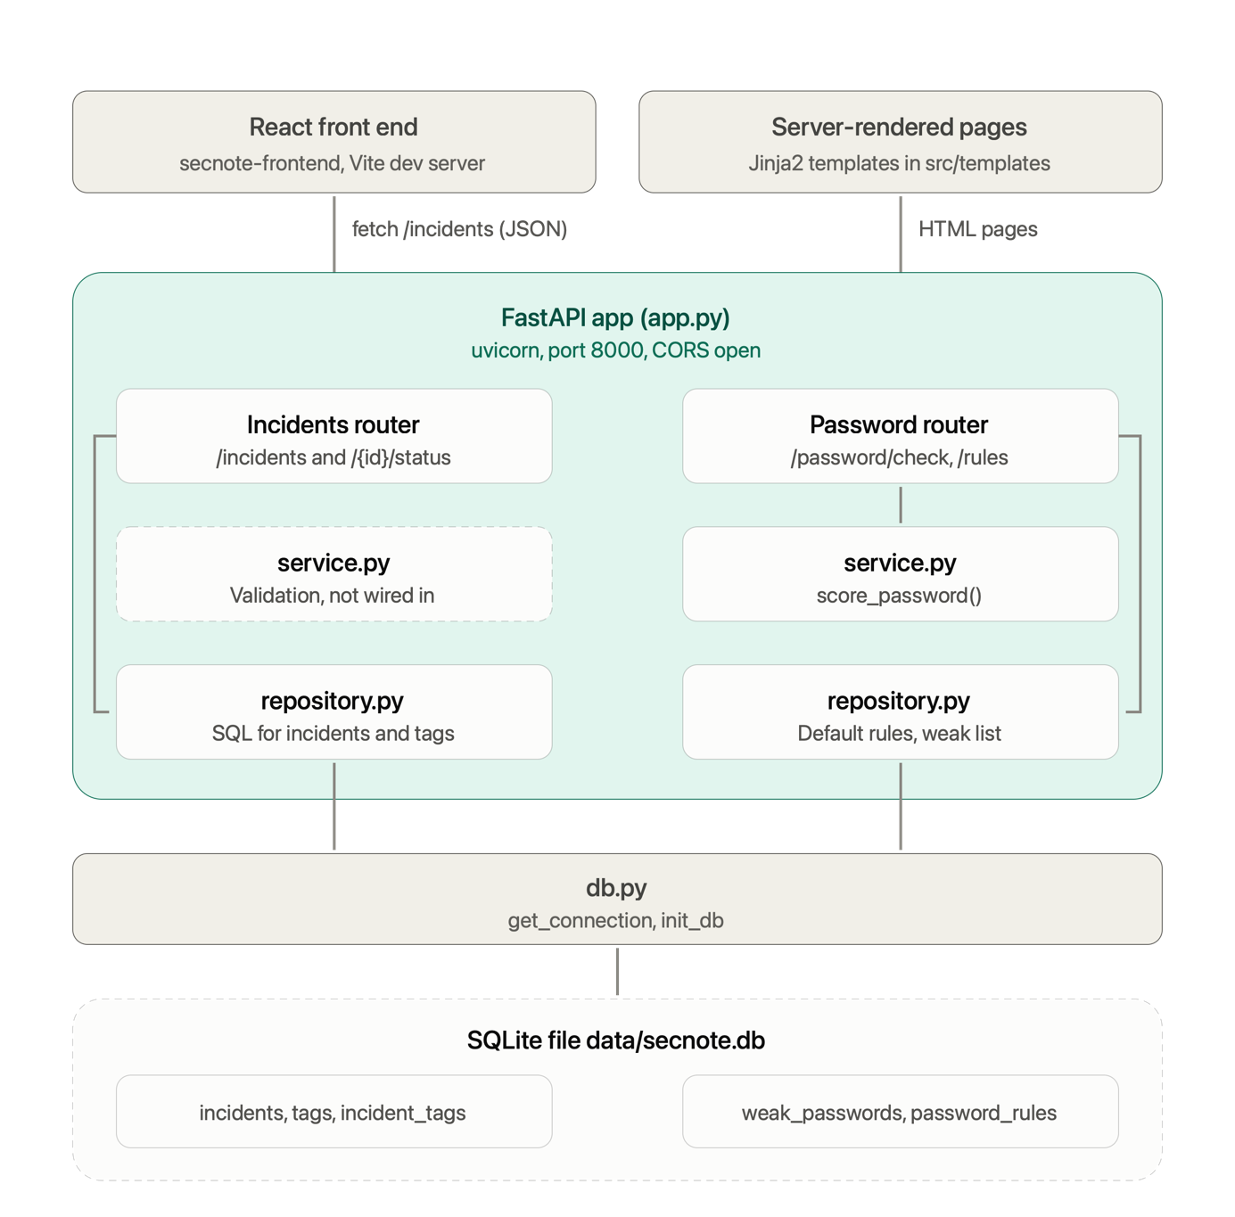

Database model/schema diagram:
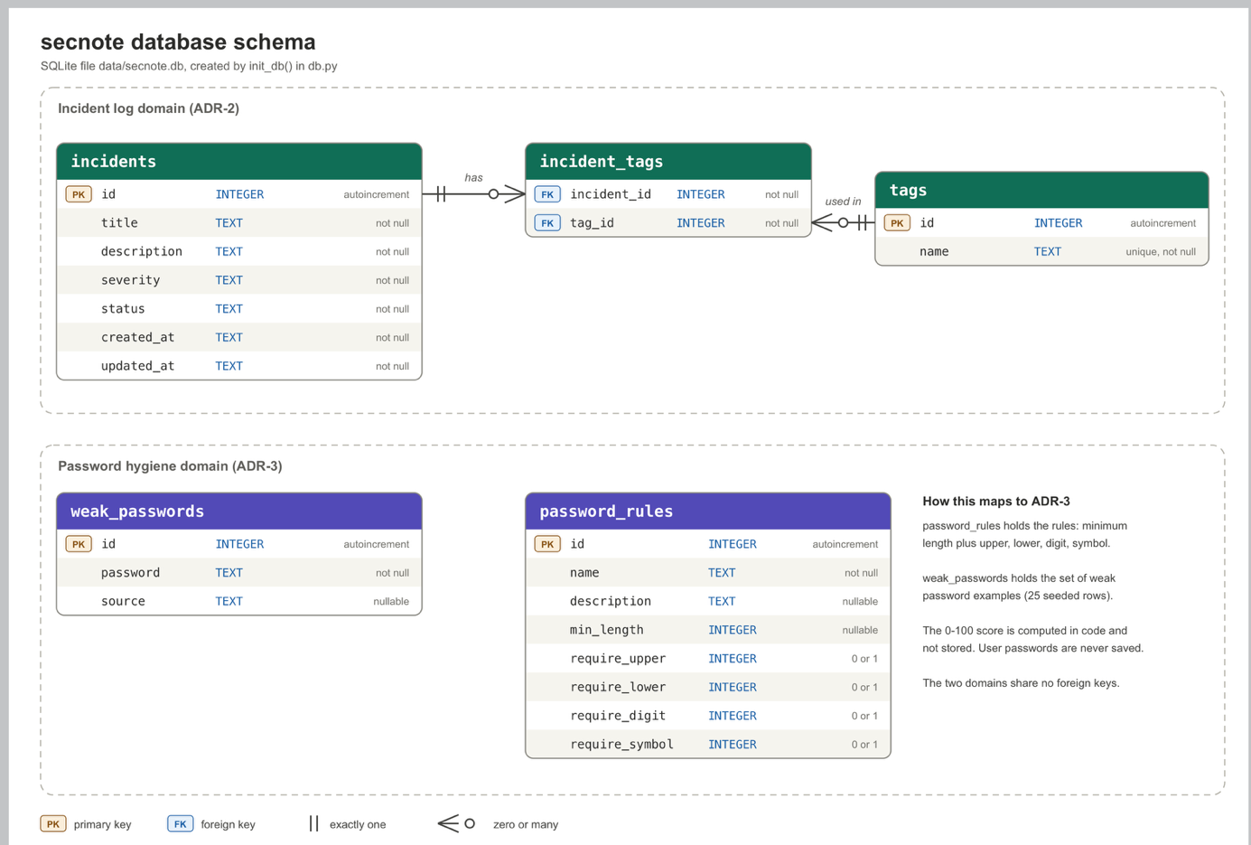

Finally allow me to explain how my project needs to be set up, so a user can enjoy the process. The db.py includes the SQLite connection and the schema for the database itself. The app.py is the main entry point for the process and the whole projects starts from there. Also, the rest of the files look like this.
Incidents/
repository.py ← SQL for incidents
routes.py ← /incidents endpoints
service.py ← allowed severity/status values

password/
repository.py ← weak-password list + rules
routes.py ← /password endpoints
service.py ← scoring algorithm

src/templates/
base.html
password/check.html
password/rules.html

To start up the front and back end the user needs to run the following terminal commands for sure.
- Backend:
  - python3 -m venv .venv
  - source .venv/bin/activate
  - python -m pip install -r requirements.txt
  - python app.py
- Frontend
  - cd DevOPS/secnote-frontend
  - npm install
  - npm run dev
Then connect the front and backend with the following address at the connections page: http://127.0.0.1:8000

So overall I very much enjoyed the making process of my application. However as not having too much experience in coding and in software development in general, it was very hard to work on. Still I believe I managed to put together a good project.

During testing I used pytest and it managed to obtain a very good result. Find it in the picture.
