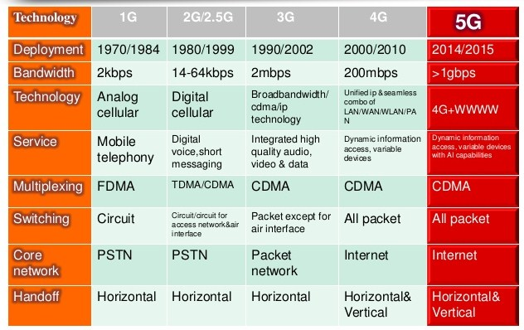
Difference between 1G ,2G , 3G , 4G and 5G.

Bandwidth : Bandwidth is defined as a range within a band of frequencies or wavelengths. Bandwidth is also defined as the amount of data that can be transmitted in a fixed amount of time. For digital devices, the bandwidth is usually expressed in bits per second(bps) or bytes per second. For analog devices, the bandwidth is expressed in cycles per second, or Hertz (Hz).

Analog cellular & Digital cellular :

The main difference between the two mobile cellular systems (1G and 2G), is that the radio signals used by 1G networks are analog, while 2G networks are digital.
Although both systems use digital signaling to connect the radio towers (which listen to the handsets) to the rest of the telephone system, the voice itself during a call is encoded to digital signals in 2G whereas 1G is only modulated to higher frequency, typically 150 MHz and up.

CDMA : is multiple access schme that allows many users to share the same bandwidth.
3G(WCDMA).Each user is assigned a unique spreading code.

FDMA :

