 **DAYANANDA SAGAR COLLEGE OF **

**ENGINEERING**

**Department Of Computer Science and Engineering**

**ABSTRACT:**

This bot calculates the bonus of an employee using their employee ID and then emails them a notification. Interaction with user starts by taking an employee ID as an input. The bot execution can be customized based on the input values provided. This bot calculates the bonus of an employee using their employee ID and then emails them a notification. It explains the concept of AARI in Automation 360 by taking an employee ID as an input and then calculating their bonus from AARI_Data.xlsx input file, after which the bot displays their employment information, such as Rating, Performance, Basic Salary, and Bonus, with a "Submit" and "Cancel" button available to the end-user. The end-user can then change the data if necessary and click on the "Send Mail" button to send an email or the "Cancel" button not to send an email to that employee.

**CONTENT:**

The aim of this project is to automate the bonus calculation process and make it error-free, simpler and faster. This project helps to prevent confusion about manager intent and prevents duplication of efforts.. It makes use of two task bots namely, the bonus calculation bot and and send email bot, two forms, for taking employee ID as input and the other form for human validation details. The process demonstrates the workflow of the project. The final step of the project is to send an email to the respective employee stating the bonus that they have received. This reduces the human errors and improves the efficiency.

**INTRODUCTION:**

The project is based on bonus calculation automation and sending email using automation anywhere robotic interface(AARI). This bot takes employee ID as input and the bonus calculation bot will perform the human validation if bonus is less than 20,000 and sends the employee an email. If the bonus is greater than or equal to 20,000 it will send an email directly.

Two task bots are created, the bonus calculation bot and the send email bot. Two forms are used to implement this project, one is used to take employee ID as input and the other contains details for human validation such as individual rating, performance factor and base salary and gives bonus as the output.

**PROBLEM STATEMENT:**

Automate the Bonus Calculation of Employees and send email with Automation Anywhere Robotic Interface.

**SYSTEM REQUIREMENTS SPECIFICATION:**

• Automation anywhere community edition.

• Processor: 3 GHz or Higher

• RAM: 4GB or higher

• ROM: 200 MB of free hard disk space for installation

**SYSTEM DESIGN:**

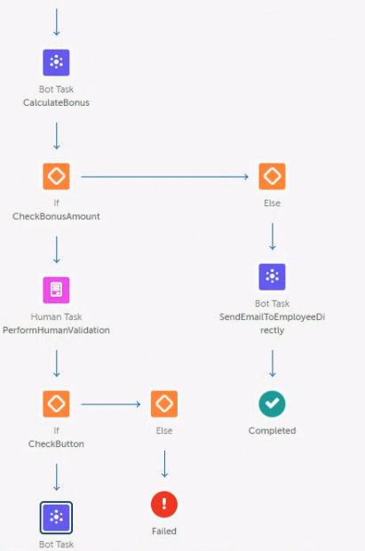

**IMPLEMENTATION:**

**1.Data Collection:** The objective is collect the input of the employee such as the employee ID and the human validation details like individual rating, performance factor and base salary.

**2**.**Data Processing:** The step of consolidation of the data takes place. The goal is to carry out checks of coherence and completeness of the collected data then to carry out preliminary calculations and finally to format the data .

**3.Calculation of bonus:** The bonus calculation bot will perform the human validation if bonus is less than 20,000 and sends the employee an email. If the bonus is greater than or equal to 20,000 it will send an email directly.

**4**.**Communication:** The send email bot will send the email to the respective employee after the bonus is calculated. The from and to address is given and the authenticity is checked in this stage. The option to cancel sending the email is also available.

**RESULTS AND ANALYSIS:**

The bonus calculation bot, avoids the errors due to manual work while imposing on managers the respect of the same rules. Centralization of information, reliability, time saving, credibility, security, etc. are achieved.

Automating the calculation process reduces the time spent checking and recalculating employee bonuses by an average of 40%.

**CONCLUSION AND FUTURE ENHANCEMENT:**

This bot helps in automating the bonus calculation process which is otherwise a tedious, repetitive and time consuming job. Automation of the calculation and reporting processes allow to propose a better transparency of the variable compensation system, both for managers and collaborators. As a result, the computational chain is rationalized and the errors linked to the human management of the process are thus very limited.