

**INTRODUCTION TO DATA MANAGEMENT**

**PROJECT REPORT**

(Project Semester January-April 2025)

***(India Unfolded: A Statewise***

***Population & Area Dashboard)***

Submitted by

Palika Ghai

Registration No: 12310349

Programme and Section: Computer Science & Engineering, K23GS

Course Code: INT217

Under the Guidance of

**(Baljinder Kaur, UID: 27952)**

**Discipline of CSE/IT**

**Lovely School of Computer Science & Engineering**

**Lovely Professional University, Phagwara**

**CERTIFICATE**

This is to certify that Palika Ghai bearing Registration no. 12310349 has completed INT217 project titled India Unfolded: A State wise Population & Area Dashboard, under my guidance and supervision. To the best of my knowledge, the present work is the result of her original development, effort and study.

**Signature and Name of the Supervisor**

**Designation of the Supervisor**

**School of Computer Science & Engineering**

Lovely Professional University

Phagwara, Punjab.

Date:

**DECLARATION**

I, Palika Ghai, student of B. Tech under CSE/IT Discipline at Lovely Professional University, Punjab, hereby declare that all the information furnished in this project report is based on my own intensive work and is genuine.

Date: 13-04-2025 Signature:

Registration No. 12310349 *Palika Ghai*

**ACKNOWLEDGEMENT**

I would like to take this opportunity to express my deepest and most heartfelt gratitude to **Baljinder Kaur ma’am** for her unwavering support, encouragement, and exceptional guidance throughout the course of my journey in mastering data management and Excel-based analytics.

Her profound knowledge, coupled with her patient and student-centric teaching approach, has played a pivotal role in transforming my understanding of Excel from a basic tool to a powerful platform for creating dynamic, highly visualized dashboards. Through her mentoring, I have been able to grasp not only the technical aspects of data handling—such as pivot tables, slicers, and interactive charts—but also the *strategic importance of data storytelling and analysis* in making informed decisions.

Baljinder ma’am has consistently gone above and beyond in simplifying complex concepts, ensuring that each lesson was not only informative but also truly engaging. Her dedication to excellence and her belief in my potential has significantly boosted my confidence in handling large datasets, identifying patterns, and presenting meaningful insights in a visually compelling manner.

Thank you for being such an inspiring mentor. Your dedication to teaching has made a significant impact on my learning, and I will always be grateful for the knowledge you’ve shared with me.

Warm regards, ***Palika Ghai***

**TABLE OF CONTENT**

1. **Introduction**

2. **Source of the Dataset**

3. **Dataset Preprocessing**

4. **Analysis on Dataset**

i. General Description

ii. Specific Requirements

iii. Analysis Results

iv. Visualization

5.**Conclusion**

6. **Future Scope**

7. **References**

8. **Links**

1. **Introduction**

In today’s rapidly evolving and data-centric world, the ability to effectively analyse, interpret, and communicate insights from large and complex datasets has become an indispensable skill across various domains, including academia, business, public policy, and scientific research. With organizations increasingly relying on data to drive decisions, optimize performance, and uncover hidden trends, proficiency in data visualization and analytics has emerged as a key differentiator for professionals and students alike.

Among the numerous tools available for data analysis, Microsoft Excel continues to hold a prominent place due to its accessibility, user-friendly interface, versatility, and rich analytical capabilities. From handling large datasets and performing statistical analysis to building dynamic visual dashboards, Excel offers a comprehensive platform for data exploration and presentation. Its integration of features such as pivot tables, slicers, conditional formatting, and charting tools makes it especially powerful for users who need to convert raw data into insightful visual narratives—without extensive programming knowledge.

This project is centred on the development of an interactive and visually compelling Excel Dashboard based on structured demographic data related to India's population, area, villages, towns, and households from the 2011 Census. The primary objective was to transform raw, unstructured census data into an intuitive and interactive dashboard that allows users to analyse population dynamics, compare state and district-level trends, and derive meaningful interpretations through visual storytelling.

The process involved several core steps, including:

* Data cleaning and structuring for consistency and accuracy
* Application of pivot tables to enable multi-dimensional aggregation and comparison
* Use of slicers to filter data interactively based on user inputs
* Integration of chart types such as column charts, pie charts, and 3D maps for enhanced visualization
* Implementation of conditional formatting to highlight critical values and trends at a glance

Each of these elements was meticulously combined to ensure that the final dashboard is not only analytically robust but also aesthetically pleasing and user-friendly, enabling users from diverse backgrounds to engage with the data effortlessly.

The broader aim of this project extends beyond just technical execution; it serves to demonstrate how tools like Excel can be harnessed to simplify complex data and facilitate data-driven decision-making in both academic projects and professional environments. Through this report, readers are introduced to the step-by-step methodology, analytical framework, visualization logic, and interactive features that together culminate in a practical and functional Excel Dashboard.

By the end of this project, the dashboard stands as a compelling example of how effective data design can bridge the gap between raw data and actionable insights, supporting better understanding, communication, and decision-making in real-world scenarios.

1. **Source of the Dataset**

The dataset utilized for this project is sourced from the Census of India 2011, one of the most extensive and authoritative demographic surveys conducted by the Government of India. Undertaken by the Office of the Registrar General and Census Commissioner, under the Ministry of Home Affairs, the Census represents a monumental effort to capture a detailed snapshot of India’s demographic, geographic, and socio-economic landscape. The data collection spans the entire nation, making it one of the largest exercises of its kind in the world.

This particular dataset, accessible through the official census portal, offers a comprehensive and structured compilation of information regarding:

* Number of villages and towns
* Total number of households
* Population counts (rural, urban, and total)
* Land area (in square kilometers)
* Administrative divisions such as country, state/UT, district, and sub-district levels

It forms the backbone of the Excel dashboard developed in this project, enabling an in-depth analysis of demographic distribution across multiple geographic scales. The richness of this dataset allows users to draw comparisons between various states and districts, evaluate urban-rural divides, and assess population density in relation to available land area.

📎 Link to the dataset:  
<https://censusindia.gov.in/nada/index.php/catalog/42526>

The decennial census is a critical resource not only for the government and policymakers but also for students, researchers, academicians, urban planners, sociologists, economists, and data analysts. Its detailed breakdown enables users to understand macro-level trends (like urbanization or regional population growth) as well as micro-level insights (such as the density of households in sub-districts or village population distribution).

In the context of this project, the dataset has been meticulously pre-processed to ensure consistency, accuracy, and relevance. It serves as a robust foundation for constructing a visually engaging and interactive dashboard that showcases India’s population data through pivot tables, charts, slicers, and conditional formatting.

By visualizing this vast dataset effectively, the project aims to not only highlight the sheer scale and diversity of India’s demographic composition but also demonstrate how Excel can be used as a powerful tool to derive meaningful insights from publicly available government data.

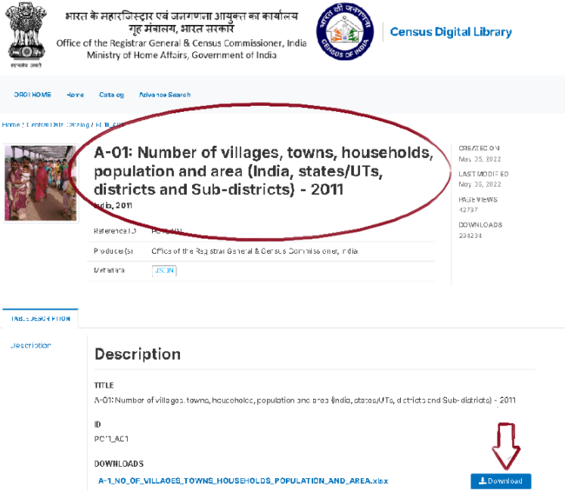

*Figure 1: Source of the Dataset*

1. **Dataset Preprocessing**

Before initiating the dashboard design, it was crucial to undertake a detailed and structured **dataset preprocessing phase** to ensure the **accuracy, integrity, and analytical readiness** of the data within Microsoft Excel. Since the dataset was sourced from the **Census of India 2011**, it contained a massive volume of raw data spread across various **administrative hierarchies**—including the national, state, district, and sub-district levels—making it rich but also complex and unrefined in its original format.

The dataset encompassed numerous columns related to the **number of villages, towns, households, population figures, and land area**, but the raw nature of the data required significant cleaning and transformation to make it suitable for visual and interactive analysis.

The following key steps were taken during the preprocessing phase:

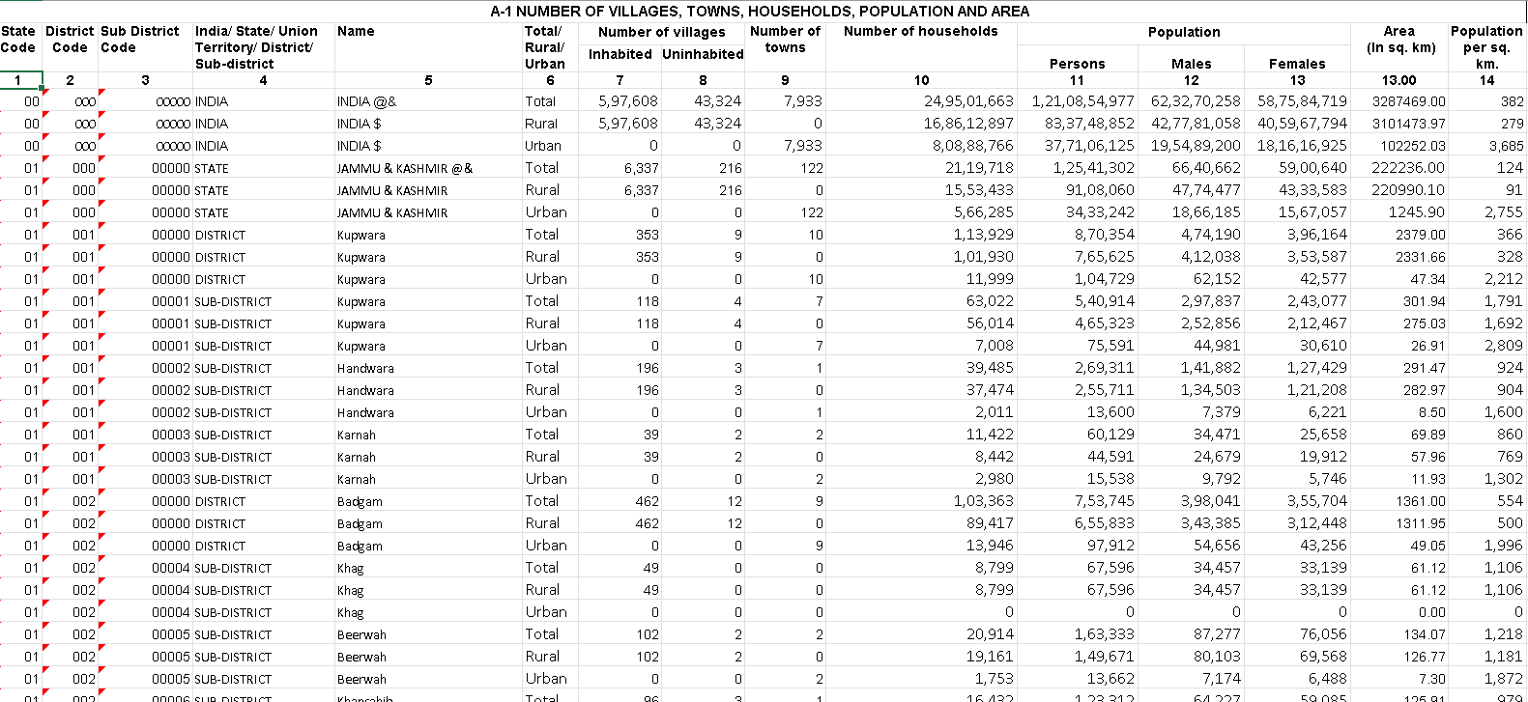

*Figure 2: Unprocessed Data*

**1. Data Cleaning**

* **Redundant entries** such as repeated headers, footnotes, and empty rows were removed to streamline the dataset.
* **Missing values** and inconsistent entries (such as "NA" or "-") were identified and addressed. Irrelevant or incomplete records were excluded as necessary.
* **Text standardization** was performed to maintain consistency in naming conventions across regions, states, and districts.

**2. Data Structuring**

* The dataset was reorganized into a **well-defined tabular format**, with clear headers like *State/UT*, *District*, *Villages*, *Towns*, *Households*, *Population*, and *Area (sq. km)*.
* Unique administrative names were retained as identifiers to maintain data clarity and avoid duplication.

**3. Data Formatting**

* **Numerical columns** were formatted appropriately using comma separators for large values and rounding where needed.
* Data types were validated to ensure compatibility with Excel’s analytical tools, especially for smooth integration with pivot tables and dashboard elements.

**4. Preparation for Dashboard Integration**

* The cleaned dataset was imported into the Excel workbook and designated as a formal **Excel Table** to allow for dynamic referencing.
* This structured format allowed seamless integration with slicers, pivot tables, and charts, facilitating interactivity within the dashboard.

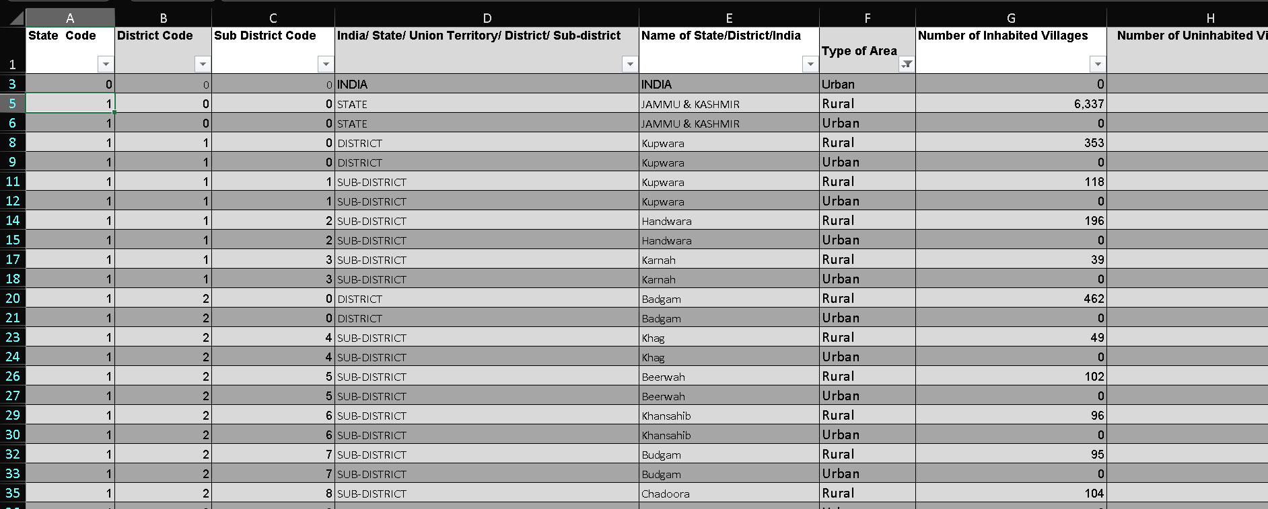

*Figure 3: Processed & Cleaned Data*

**Description**: The image above provides a snapshot of the **preprocessed dataset**, which now consists of **19,992 rows** of clean, structured data, each representing a unique **administrative unit** within the territorial hierarchy of India. These units span multiple levels—including **states, districts, and sub-districts**—and capture essential demographic and geographic information gathered during the **Census of India 2011**.

Each row in this dataset corresponds to a specific administrative region, identified through a set of systematically coded fields such as:

* **State Code**
* **District Code**
* **Sub-District Code**

These codes are linked to corresponding textual identifiers such as the **State Name**, **District Name**, and **Sub-District Name**, ensuring clarity and enabling easier mapping and analysis.

A dedicated column denotes the **administrative level** of the unit (e.g., STATE, DISTRICT, or SUB-DISTRICT), and another column specifies the **area type**—categorizing each region as **Urban** or **Rural**, which is especially vital for urban-rural demographic comparisons.

Additionally, the dataset includes two critical variables:

* **Number of Inhabited Villages**
* **Number of Uninhabited Villages**

These fields help measure habitation patterns and the distribution of population across India's vast landscape, offering insight into settlement trends, development reach, and resource distribution in both densely populated and sparsely inhabited areas.

This structured format, achieved through thorough preprocessing, now supports **seamless pivot table analysis** and **interactive dashboard visualization** within Microsoft Excel. Users can apply filters and slicers effortlessly to explore demographic patterns, urban-rural population distribution, and habitation density across various geographical levels.

The clean tabular format not only improves readability but also ensures compatibility with Excel's advanced data visualization tools, laying the foundation for **interactive maps, dynamic charts, and comparative analysis**. Ultimately, this version of the dataset is designed to provide **clear, accurate, and analyzable insights** from a previously complex and unrefined raw data source.

* **Exploratory Data Analysis (EDA)**

To derive actionable insights from the processed dataset, multiple pivot tables were developed using Microsoft Excel. Each pivot table focuses on a specific analytical objective and offers a unique perspective into India’s demographic, geographical, and administrative structure based on the 2011 Census data. The use of pivot tables helped in dynamically summarizing large volumes of data and supported the development of interactive and insightful dashboard components.

* 1. **State-wise Gender Population**
* A pivot table was created to compare the **sum of male and female population** across Indian states.
* **Uttar Pradesh** recorded the highest population with over **20.8 crore men** and **19 crore women**.
* Other highly populated states include **Maharashtra**, **Bihar**, and **West Bengal**.
* The **total male population** across all states is approximately **171 crore**, while the **female population** stands at around **160 crore**, highlighting a noticeable gender gap.

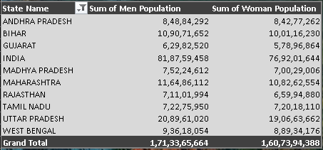

Figure 4:State-wise Gender Population

**2. Household Distribution by Area Type**

* A pivot table summarizing the **number of households** by administrative level and type (Urban/Rural) was created.
* **Rural households** dominate the dataset with a total of **50.58 crore households**.
* **Urban households** contribute around **24.95 crore**, showing a strong rural presence in India’s settlement structure.
* The combined total across all levels (district, state, sub-district) comes to over **1.82 billion** households.

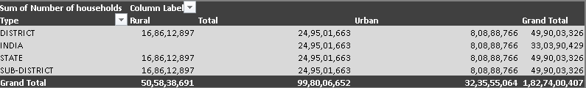

Figure 5: Household Distribution by Area Type

**3. Population Density (per sq. km) by District**

* A pivot table was used to identify districts with **maximum population density**.
* **Vadodara, Bahadurgarh, and Charminar** show extremely high densities, with **Vadodara reaching over 60,000 persons per sq. km**.
* This indicates urban crowding and high population concentration in select districts.

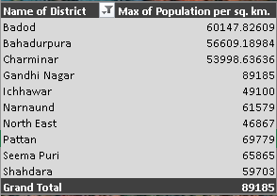

Figure 6: Population Density (per sq. km) by District

**4. District-wise Inhabited and Uninhabited Villages**

* A pivot table was generated to sum the **number of inhabited and uninhabited villages** per district code.
* Some districts like **571 and 573** have more than **10,000 inhabited villages**, indicating widespread rural habitation.
* In contrast, many districts show **fewer than 3,000** inhabited villages.

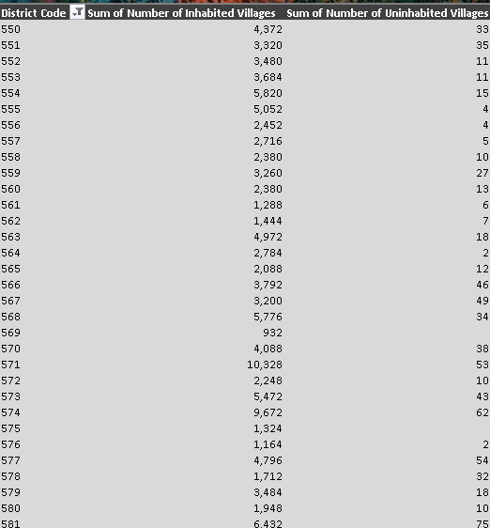

Figure 7: District-wise Inhabited and Uninhabited Villages

**5.Number of Towns by State Code**

* Another pivot table displays the **total number of towns** in each state using state codes.
* **State Code 00** (representing India as a whole) has **15,866 towns**, followed by **State Code 19** with **5,452** towns.
* States like **22, 23, and 32** also show town counts exceeding **3,000**, whereas smaller states or UTs have fewer than **100** towns.

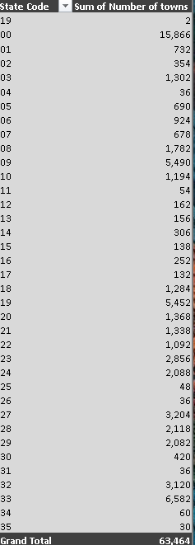

Figure 8: Number of Towns by State Code

Additionally, I have also made,

6. **Interactive Map Visualization of Population Distribution**

1. **Color-coded States**: Each state is shaded based on its total population, providing an immediate visual cue of relative population levels. For example, Uttar Pradesh is displayed in a dark shade due to its population exceeding 39 crores, while states like Mizoram and Arunachal Pradesh appear in much lighter shades.
2. **Population Grouping**: States have been classified into three population groups — **Highly Populated**, **Medium Populated**, and **Low Populated** — based on predefined thresholds.
3. **Dynamic Filtering via Slicers**: An interactive **slicer** is linked to the "Population Group" column. When a user clicks on:

* **"Highly Populated"**, the map highlights only the states in this group (e.g., Uttar Pradesh, Maharashtra, Bihar), fading out others.
* **"Medium Populated"**, only states like Goa, Manipur, and Nagaland remain active.
* **"Low Populated"**, states like Mizoram and Sikkim are emphasized, with all others dimmed.

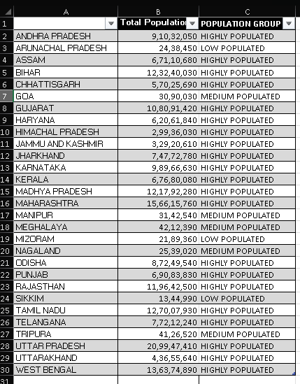

*Figure 9: Interactive Map for Population Distribution*

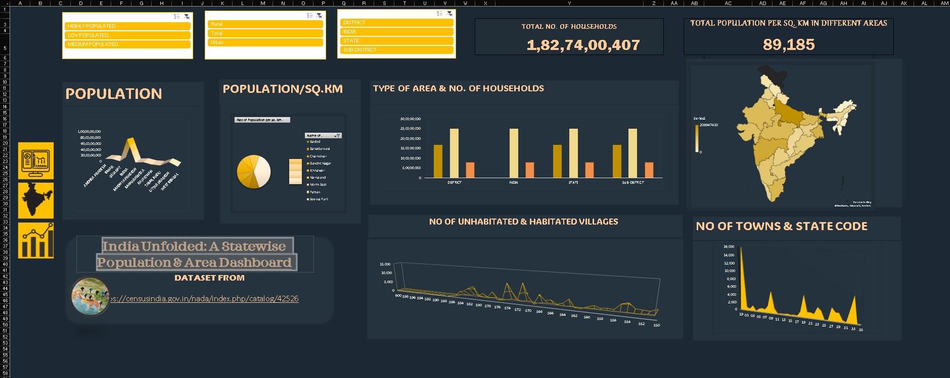

*Figure 10: Complete Dashboard*

1. **Analysis on Dataset**

**1. State-wise Gender-wise Population**

**a) General Description:**This pivot table presents the total male and female population across various Indian states.

**b) Specific Requirements:**Track and compare gender distribution in each state for demographic analysis.

**c) Analysis Results:**

* Uttar Pradesh has the highest population for both males and females.
* Gujarat and Tamil Nadu have a more balanced male-to-female ratio compared to others.
* Maharashtra and Bihar are also among the top populous states.

**d) Visualization:**

* **Chart Type:** 3D Column Chart
* **Description:** Shows state-wise bars for male and female populations.
* **Key Insights:** Uttar Pradesh leads in population, while Gujarat and Tamil Nadu show significant gender parity.

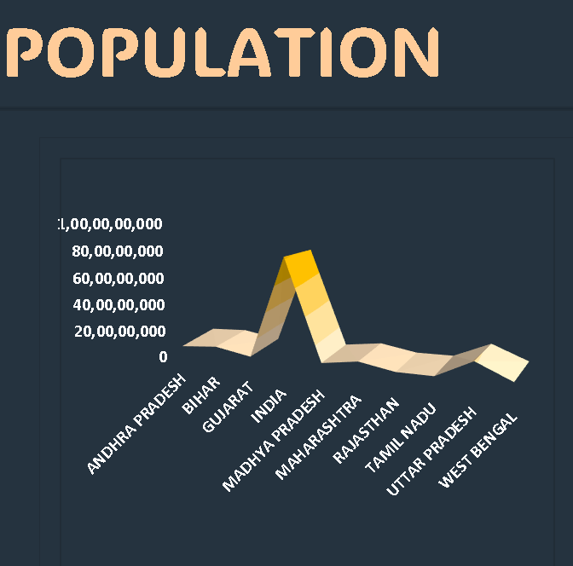

Figure 11: State-wise Gender Population Chart

**Implications:**- Policymakers in male-dominated regions may need to promote women empowerment programs.  
- Gender-specific resource allocation must align with these trends.  
- High male population in industrial states may point to in-migration for employment, stressing housing and services.

**2.** **Type of Area vs Number of Households (Rural & Urban)**

**a) General Description:**This pivot summarizes household counts in rural and urban areas across different administrative types—District, State, Sub-district.

**b) Specific Requirements:**Evaluate household distribution to assess urban-rural spread in administrative divisions.

**c) Analysis Results:**

* States and sub-districts show consistent household counts across all types.
* Urban households dominate, contributing nearly double compared to rural.

**d) Visualization:**

* **Chart Type:** Clustered Column Chart
* **Description:** Separate columns for rural, urban, and total households per area type.
* **Key Insights:** Urban dominance in household numbers indicates ongoing urbanization trends.

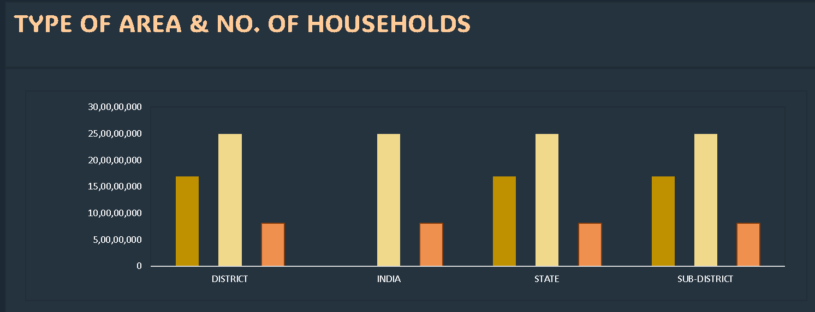

Figure 12: Type of Area vs Number of Households (Rural & Urban)

**Implications:**- Infrastructure planning must remain rural-focused.  
- The urban figures show rapid growth too—suggesting cities need upgrades in housing and waste management.  
- Agriculture sectors should continue to receive support due to massive rural household base.

**3. Population Density per District**

**a) General Description:**Displays maximum population density (population per sq. km) across top districts.

**b) Specific Requirements:**Identify densely populated districts for infrastructure planning and urban management.

**c) Analysis Results:**

* Baddod, Shahdarpura, and Charminar rank among the top in population density.
* Gandhinagar and Patna also show high figures.

**d) Visualization:**

* **Chart Type:** Pie Chart
* **Description:** Slices show the percentage of density per district.
* **Key Insights:** A few districts hold a disproportionately high density, indicating possible overcrowding.

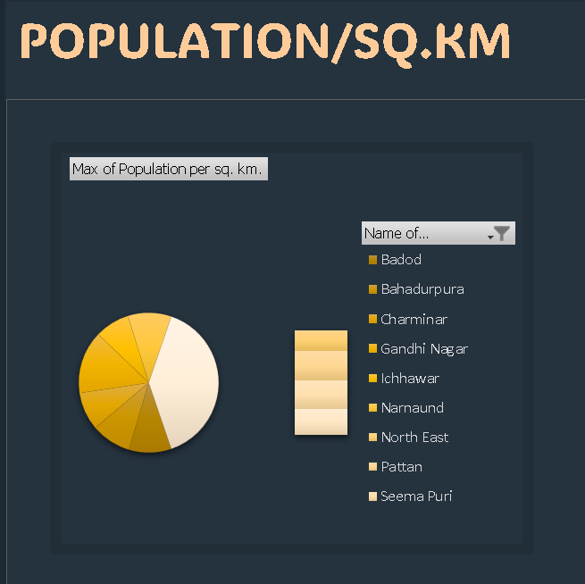

Figure 13: Population Density per District

**Implications:**  
- These hotspots should be prioritized for smart city planning.  
- Public health risks are also higher in dense zones.  
- Overcrowding impacts mental health and sustainability—calling for zoning regulations.

**4. Inhabited vs Uninhabited Villages by District Code**

**a) General Description:**This pivot compares the number of inhabited and uninhabited villages per district code.

**b) Specific Requirements:**Analyze village habitation for rural development and resource allocation.

**c) Analysis Results:**

* District code 570 has the highest number of inhabited villages.
* Many district codes show negligible uninhabited villages, indicating strong rural habitation.

**d) Visualization:**

* **Chart Type**: Line Chart
* **Description:** Trendlines represent both village types across district codes.
* **Key Insights:** Significant spikes for certain codes (e.g., 570), reflecting high rural clustering**.**

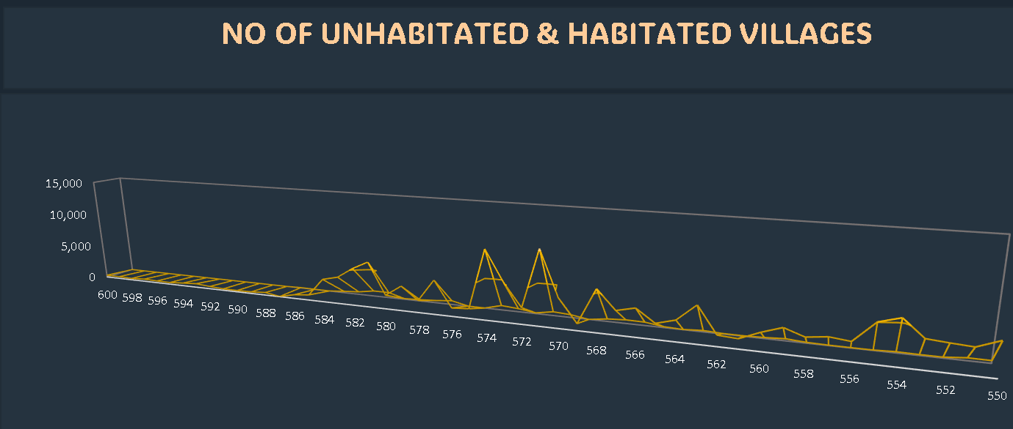

Figure 14: Inhabited vs Uninhabited Villages by District Code

**Implications:**  
- High inhabited village counts mean governments must spread development funds thinly.  
- Uninhabited villages may need revival initiatives.  
- District-wise planning can identify priority areas for support schemes.

**5. Number of Towns by State Code**

**a) General Description:**Shows the total number of towns per Indian state via state codes.

**b) Specific Requirements:**Track urban spread and growth trends by state.

**c) Analysis Results:**

* State code 19 (likely West Bengal) has the highest number of towns.
* Several states have fewer than 100 towns, indicating a more rural structure.

**d) Visualization:**

* **Chart Type:** Bar Chart
* **Description**: Vertical bars comparing state codes to their town counts.
* **Key Insights:** Massive urban concentration in certain states, showing unequal town distribution**.**

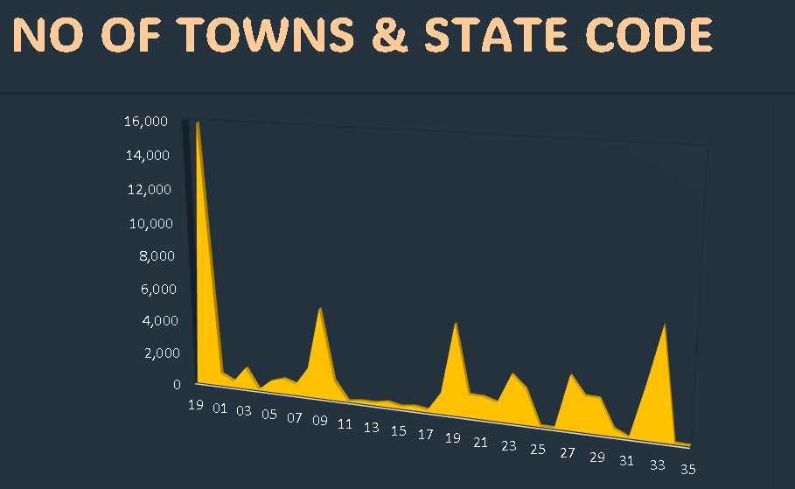

Figure 15: Number of Towns by State Code

**Implications:**  
- States with many towns may require inter-town connectivity improvements.  
- States with very few towns need targeted urbanization initiatives.  
- Stats can inform Smart Cities Mission and funding decisions.

6) **Interactive Map for Population Distribution**

***a) General Description***

*The interactive map embedded in the dashboard provides a visual overview of the population distribution across Indian states, categorized into three distinct groups:* ***Highly Populated****,* ***Medium Populated****, and* ***Low Populated****.*

*This map is designed to be both informative and user-friendly, allowing users to engage with the data in real time using slicers. It is color-coded for immediate comprehension, with darker shades representing higher population clusters. The interactivity allows stakeholders to isolate and examine specific population groups with just one click, improving clarity in demographic visualization.*

***b) Specific Requirements***

*To design this interactive map, the following setup was implemented:*

* ***Base Data****: Preprocessed Census 2011 population data for each state.*
* ***Population Groups****:*
  + ***Highly Populated****: States with population > 6 crore.*
  + ***Medium Populated****: Population between 2 to 6 crore.*
  + ***Low Populated****: Less than 2 crore.*
* ***Tools Used****:*
  + *Excel Map Chart feature.*
  + *Population Group slicer linked to Pivot Table.*
  + *Custom color gradient from light beige to dark yellow.*
* ***Interactivity****:*
  + *The slicer dynamically filters the map.*
  + *Clicking on "Highly Populated" shows only those states, updating the visualization instantly.*

***c) Analysis Results***

*The slicer-driven analysis of the map reveals a clear demographic concentration in certain regions of India:*

* ***Highly Populated States*** *include* ***Uttar Pradesh****,* ***Maharashtra****,* ***Bihar****, and* ***West Bengal****, each exceeding 9 crore in population.*
* ***Medium Populated States*** *like* ***Goa****,* ***Punjab****, and* ***Himachal Pradesh*** *display moderately sized populations ranging between 2–6 crore.*
* ***Low Populated States*** *such as* ***Arunachal Pradesh****,* ***Mizoram****, and* ***Sikkim*** *have populations under 2 crore, largely due to geographical isolation or terrain-driven sparsity.*

*This classification helps to better segment and visualize India's population landscape across different density levels.*

***d) Visualization*** *Figure: Interactive India Map with Population Group Slicer*

* ***Chart Type****: Filled Map (Excel Map Chart)*
* ***Data Range****: State Names, Total Population, and Population Group*
* ***Visual Elements****:*
  + *Shades represent total population intensity.*
  + *Slicer buttons: Highly Populated, Medium Populated, Low Populated.*
* ***Key Insights****:*
  + *The darkest region corresponds to* ***Uttar Pradesh****, reflecting its top population rank.*
  + *Lighter regions like* ***Arunachal Pradesh*** *show sparse demographic presence.*
  + *The slicer allows instant filtering, giving segmented views that are crucial for granular analysis.*

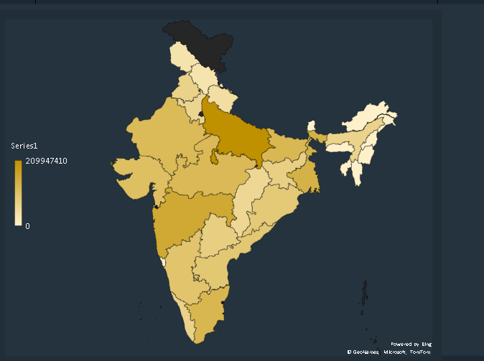

Figure 16: Interactive Map for Population Distribution

**e) Implications**

This interactive map is not only a visual tool but also a **decision-making aid**. For planners and researchers, it highlights where urgent interventions may be needed in infrastructure, healthcare, education, or public transport. For instance:

* **Highly Populated States** may need **more urban housing**, **waste management**, and **public welfare schemes**.
* **Low Populated States**, though less dense, may require **developmental incentives** to improve connectivity and attract migration.

The slicer-based control ensures **ease of analysis** for a wide range of stakeholders — from policy makers to students and NGOs.

1. **Conclusion**

This comprehensive project on India's population and administrative data, derived from the Census of India 2011, goes beyond conventional statistical representation to deliver an insightful and visually compelling narrative of India’s socio-demographic structure. By transforming a vast and raw dataset into an interactive Excel dashboard, the analysis not only reveals critical metrics but also provides a strategic lens through which the nation’s development trajectory can be assessed.

At its core, the dashboard showcases India’s diversity in population distribution, urbanization patterns, household demographics, and rural habitation. Through pivot table analysis, slicers, and layered visualizations, users can seamlessly explore India at multiple administrative levels—from the entire nation to specific sub-districts—uncovering how demographics and settlements are spread and concentrated.

* 1. **Demographic Diversity and Population Distribution:**  
     The stark contrast in population figures across different states and union territories underlines the challenges of resource allocation and infrastructural planning. States like Uttar Pradesh and Maharashtra house a significant portion of the Indian populace, whereas smaller northeastern states and UTs depict lower densities and populations. This asymmetry suggests the urgent need for region-specific governance models—while populous states require decongestion strategies, rural or sparsely populated areas need enhanced connectivity and access to essential services.
  2. **Gender Disparity and Social Indicators:**  
     The observed gap between male and female population figures in several states serves as a critical pointer to prevailing gender imbalances. While the overall ratio is not highly skewed, the persistent differences call for stronger gender equality policies, awareness campaigns, and educational initiatives that can rectify such disparities in the long term.
  3. **Urban-Rural Household Divide:**  
     The clear rural dominance in household distribution highlights India's agrarian and village-based societal structure, even amidst growing urbanization. However, the considerable number of urban households indicates ongoing migration and centralization of resources in cities. This trend demands balanced rural-urban development, with rural areas receiving sufficient investments in infrastructure, health, education, and digital connectivity to reduce migration pressure on cities.
  4. **Density and Pressure Zones:**  
     The population density figures derived at the district level reveal urban hotspots experiencing intense spatial pressure. Areas like Vadodara and Bahadurgarh emerge as dense clusters that likely face infrastructural strain, inadequate housing, and environmental challenges. These findings underscore the need for advanced urban planning, vertical development strategies, and decentralized economic growth models.
  5. **Habitation Trends and Village Revitalization:**  
     The ratio of inhabited to uninhabited villages paints a compelling picture of India's rural habitation dynamics. Regions with a high number of deserted villages raise questions about access to resources, climatic resilience, and socio-economic viability. Focused rural revival strategies—including employment programs, sustainable farming, and micro-industry promotion—are imperative to reverse rural exodus and ensure inclusive development.
  6. **Town Distribution and Urban Planning Gaps:**  
     A comparative look at the number of towns across state codes brings attention to unequal urban expansion. States with disproportionately low town counts may suffer from poor urban infrastructure, governance hurdles, or economic stagnation. Policies such as Smart Cities Mission and urban cluster development can be prioritized in these areas to accelerate progress.
  7. **Dashboard Functionality and Technological Relevance:**  
     The strength of this project lies not only in the insights it provides but also in the intuitive interface of the dashboard. With interactive features like slicers and real-time metric updates, it enables policymakers, students, and researchers to derive context-based insights quickly. Its design caters to diverse audiences—technical and non-technical alike—demonstrating the powerful role of data visualization in communicating complex findings clearly.

In conclusion, the Excel dashboard project successfully bridges the gap between raw census data and real-world policy insights. It empowers stakeholders with actionable information while serving as a practical educational tool to showcase how data can be mined, structured, and visualized to narrate impactful stories. As India gears up for its future censuses and digital governance initiatives, tools like this dashboard exemplify the potential of data-driven development and informed decision-making.

1. **Future Scope**

While this project successfully showcases the immense potential of Excel-based dashboards for demographic exploration using Census of India 2011 data, it also opens up numerous avenues for future development. The current version focuses on static analysis based on a single-year dataset; however, the dashboard’s architecture and the richness of the data lend themselves to much broader, dynamic, and interdisciplinary enhancements. As we move into an era of data-driven governance and intelligent systems, expanding this project’s capabilities will greatly benefit researchers, policymakers, urban planners, and the academic community alike.

**1. Time-Series Analysis and Forecasting of Demographic Trends**

* **Future Expansion:** One of the most promising directions is the integration of previous census data (e.g., 1991 and 2001) along with the current 2011 dataset, thereby enabling a temporal analysis of population growth, migration patterns, urbanization, and settlement shifts. Additionally, future projections for 2031 and 2041 could be made using time-series forecasting methods or machine learning models such as ARIMA, LSTM, or Prophet.
* **Value Addition:** This would allow users to visualize historical trends and future scenarios in population density, gender ratios, household evolution, and urban spread. Such predictive analytics could be instrumental for infrastructure development, sustainable city planning, and anticipatory governance frameworks.

**2. Integration of Socio-Economic and Development Indicators**

* **Add-on Data:** To move beyond pure demographic analysis, the dashboard could be enriched with critical socio-economic indicators such as literacy rates, employment/unemployment ratios, income distribution, poverty indices, GDP contributions by region, healthcare access, and sanitation coverage.
* **Impact:** This holistic view would allow for more nuanced insights into how population metrics correlate with economic performance and quality of life. It could enable researchers to conduct multivariate analysis and identify development bottlenecks at the granular level, which in turn supports evidence-based policymaking.

**3. GIS-Based Visualization and Geospatial Intelligence**

* **Feature Upgrade:** The static map visual currently used can be replaced or supplemented with GIS-enabled, zoomable maps using tools like Power BI, Tableau, QGIS, or ArcGIS. These platforms allow layering of demographic data with geographic and environmental parameters.
* **Outcome:** Such an enhancement would offer spatial clustering, heatmapping, proximity analysis, and hotspot identification. It would enable precise identification of high-density urban pockets, vulnerable rural areas, or underserved zones, thereby aiding smart city planning, climate adaptation strategies, and regional prioritization.

**4. Real-Time and Live Dashboard Integration**

* **Live Data Connectivity:** A future-ready upgrade could involve linking the dashboard to real-time APIs from various government departments (e.g., UIDAI for population tracking, Health Ministry for demographic health stats, Urban Affairs for smart city metrics). This would transform the dashboard into a semi-live data monitoring tool.
* **Application:** Real-time dashboards can be vital in disaster management, migration monitoring, vaccination or epidemic tracking, and emergency response systems. For instance, during pandemics, such tools could assist in population-level health interventions and logistics planning.

**5. Custom Regional and District-Level Report Generation**

* **Enhancement:** The dashboard can be designed to allow dynamic selection of any state, district, or sub-district, and automatically generate customized reports in PDF or Excel format. These reports could include demographic summaries, key metrics, and visual charts tailored for the selected region.
* **Use Case:** This feature would be extremely valuable for local governance bodies, NGOs, field researchers, district magistrates, and development agencies who require area-specific reports for grant applications, program design, or localized interventions.

**6. Sustainability and Environmental Impact Assessment**

* **Additional Metrics:** With the integration of environmental indicators like land-use patterns, deforestation rates, water availability per capita, air/water pollution levels, and biodiversity indices, the dashboard can expand into the realm of sustainable development.
* **Objective:** Such inclusion would allow users to assess how population growth and habitation trends are impacting India’s environmental footprint. It also enables the development of regional “Sustainability Scores” that can be used to guide eco-friendly planning and responsible resource consumption at the micro-level.

In summary, the current dashboard provides a foundational platform that can evolve into a multi-layered, multidisciplinary data ecosystem with wide-ranging applications. Whether it's forecasting future trends, integrating environmental data, or enabling real-time analytics, the potential for expansion is vast. By continuing to build upon this work, we can move towards a future where data doesn’t just inform—it empowers intelligent decisions, sustainable practices, and inclusive development at all levels of society.

1. **References**

* <https://censusindia.gov.in/> (*This website has given the dataset that I used in this project.)*
* <https://support.microsoft.com/en-us/office/create-and-share-a-dashboard-with-excel-and-microsoft-groups-ad92a34d-38d0-4fdd-b8b1-58379aae746e> *(This website helped me in making dashboards in a better way)*
* <https://www.asrepayesh.com/assets/asrepayesh.com/repo/file/storytelling-with-data-cole-nussbaumer-knaflic.pdf> *(This book had a brief description of different types of charts & what else we can implement for making our dashboards appealing)*

**8. Links**

* **LinkedIn:** [**Post | LinkedIn**](https://www.linkedin.com/posts/palikaghai_exceldashboard-studentproject-dataanalytics-activity-7316750844970835969-CLBw/?utm_source=share&utm_medium=member_desktop&rcm=ACoAAEUjxGsBIYk15KpKDdWec7iQBLnss5P8Di0)

***LinkedIn Screenshots (Please go to next page):***

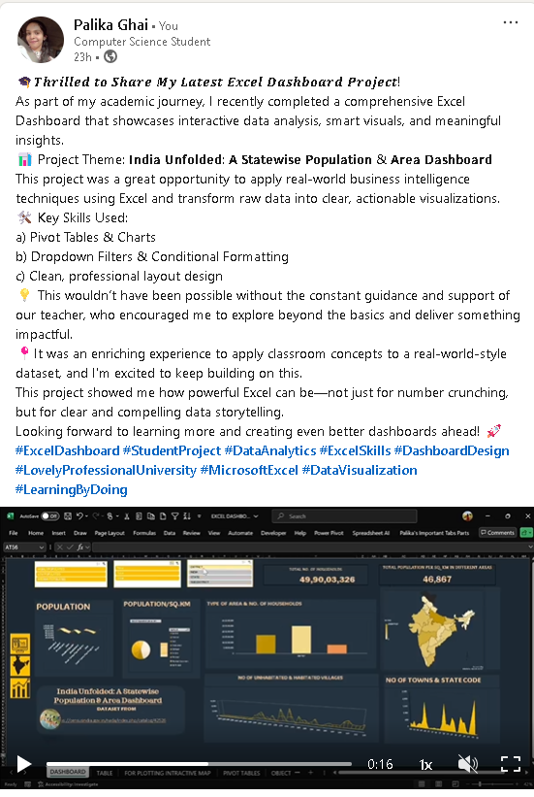

***Figure 17: LinkedIn post with the entire dashboard***

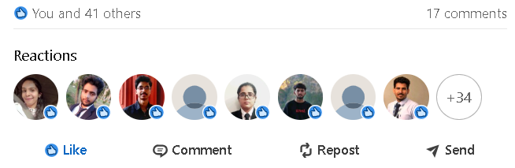

***Figure 18: Likes & Comments on the post.***