Task Description

The goal of this experiment is to detect and resolve a performance problem in a given Palladio model. For detection, we provide a detailed model description and describe the steps to identify the performance problem. For resolving, your task is to implement suitable self-adaptation rules and to show based on SimuLizar simulations that you resolved the performance problem.

Background Questions
- Print this paper. For the next steps, use your print for filling it out.
- Please enter your name
- Please enter your e-mail address. We might use this to contact you with regard to your answers to the open questions.
- How would you rate your knowledge of SimuLizar?
none | low | medium | high | expert

- How many years of experience do you have with SimuLizar?
- How do you prefer to specify reconfiguration rules? (Note: You will have to use your selection for such a specification; if you do not know yet, answer this question after the experiment.)
  - QVT-O
  - Storydiagrams
  - Henshin
- How would rate your knowledge in the technology you selected in question 6?
none | low | medium | high | expert

- How many years of experience do you have with the technology you selected in question 6?

Performance Problem Detection
Please execute the following tasks:
- Install Palladio (latest release) and configure a new workspace as described in the attached “SimuLizarInstallationGuide.pdf”. Afterwards, you will have the CloudStore model in your workspace and a screen capture tool installed.
- Start recording your actions with the previously installed capture tool.
- Please note the starting time.
:hh :mm
- Read the “CloudStoreDescription.pdf” as attached.
- Please answer the following questions:
  - How many Assembly Contexts are described in the “CloudStore Description”?
  - How many Assembly Contexts are specified in the system of the CloudStore model?
  - How many Resource Containers are described in the “CloudStore Description”?
  - How many Resource Containers are specified in the resource environment of the CloudStore model?
  - How many actions are modeled for the “getHome” Operation of the “Homepage” Component of the CloudStore model?
  - What is the purpose of the “getWorker” and the “returnWorker” Actions in the “getHome” Operation of the CloudStore model?

  - Why is the “returnWorker” Action not executed as last?

- Run the “SimuLizar-CloudStore.launch” run configuration that is part of the imported CloudStore project and investigate the analysis result in the EDP2 perspective.
- Please answer the following questions:
  - When is the first time that the response time for the usage scenario is above two seconds?

  - How many CloudStore customers are within the system at that point in time? (note: inspect the LIMBO model for determining an estimate.)

  - Which system operation call(s) have response times over two seconds?

  - What is the bottleneck resource causing response time over two seconds?

  - Given that response times should stay below two seconds, which options do you see to resolve the situation?

- Please note the current time when you finished all the tasks above.
:hh :mm

Resolving the Performance Problem
We have the following requirements defined:
- Performance: Response times shall stay below two seconds. Violations are allowed in the limits given in the “Elasticity” requirement.
- Elasticity: When violations of the performance requirement are detected, CloudStore shall return to a stable state within 20 seconds.
- Cost-Efficiency: The operation costs for operating CloudStore shall be minimized.
Next, your task is to resolve the detected performance problem to meet above requirements. You have to investigate two options for resolving: vertically scaling the CPU of the database and horizontally scaling the database.

Vertical Scaling
In vertical scaling, a fixed server can dynamically speed-up its processing resources over time. Figure 1 illustrates such a scaling for a server.

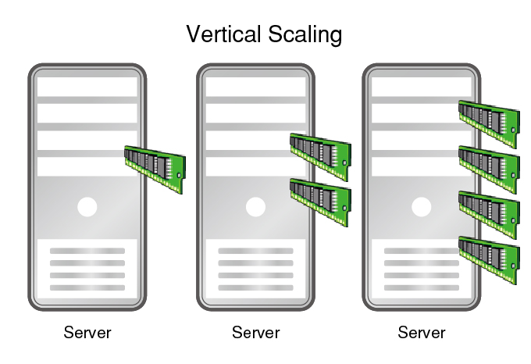Figure 1: A server scales its processing resources up (from left to right)
In your case, you have to scale-up the CPU of CloudStore's database server. For this task, execute the following steps:
- Please note the starting time.
:hh :mm
- Implement appropriate reconfiguration rules for SimuLizar for vertical scaling:
  - You may copy transformation code from existing reconfigurations or completely reuse an existing transformation, if you know any.
  - You have to use your preferred transformation language (that is, the one you selected in question 6 in section 0).
  - Note that the monitor repository of CloudStore includes a monitor (named: “Response Times – Browsing Mix”) that calculates the mean response times for the overall usage scenario in an interval of 5.0 seconds. Use the calculated value to determine whether a reconfiguration needs to be triggered. Use the values of the following table for your reconfiguration:
Scale-Down Threshold | 0.1
Scale-Up Threshold | 0.8
Step Size | 13,350,000,000
Min Rate | 13,350,000,000
Max Rate | 133,500,000,000
Here, the “Scale-Down Threshold” specifies that the current CPU processing rate should be reduced if the calculated mean response times are lower than 0.1 seconds. Likewise, the “Scale-Up Threshold” specifies that the current CPU processing rate should be increased if the calculated mean response times are higher than 0.8 seconds. The “Step Size” is the rate by which scaling adapts the processing rate. “Min Rate” and “Max Rate” specify lower and upper bounds for this rate, respectively.
  - You have a maximum of 1 hour (starting from the time you noted in step 1) to implement the reconfiguration. If you do not manage to provide a working reconfiguration in the given time, skip to step 6.
- Note the current time.
:hh :mm
- Run a CloudStore simulation with your reconfiguration rule and inspect the results.
- Make a screenshot of the “XY Plot” of the “Response Times – Browsing Mix” and store it for later use.
- Note the current time.
:hh :mm
- Please answer the following questions:
  - Did you manage to implement the reconfiguration? (If not, directly skip to question 5.)
  - Is the performance requirement always met?
  - In case of a violation of the performance requirement, does the system return to a stable state within 20 seconds?
  - Note the current time.
:hh :mm
  - In case you copied or reused an existing reconfiguration, which one?
  - Please list any issues during your task:

Horizontal Scaling
In horizontal scaling, a given server is dynamically replicated. Each replica is added to an according loadbalancer that distributes workload among them. Figure 2 illustrates such a horizontally-scaled server with three replica.

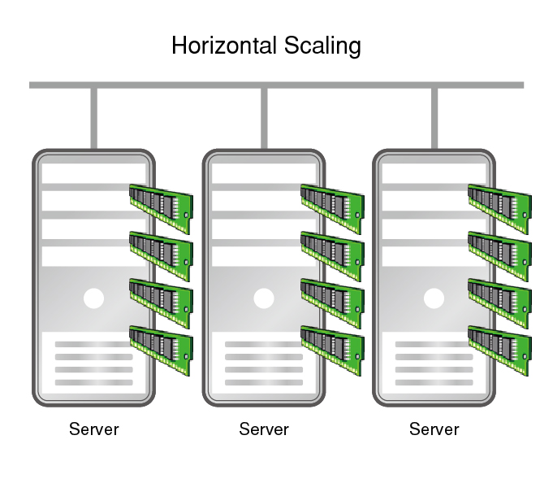Figure 2: A server is replicated and load-balanced (scale-out)
In your case, you have to scale-out CloudStore's database server. This represents an alternative to vertical scaling and allows you to assess whether it is more cost-efficient. For this task, execute the following steps:
- Please note the starting time.
:hh :mm
- Implement appropriate reconfiguration rules for SimuLizar for horizontal scaling:
  - You may copy transformation code from existing reconfigurations or completely reuse an existing transformation, if you know any.
  - You have to use your preferred transformation language (that is, the one you selected in question 6 in section 0).
  - Note that the monitor repository of CloudStore includes a monitor (named: “Response Times – Browsing Mix”) that calculates the mean response times for the overall usage scenario in an interval of 5.0 seconds. Use the calculated value to determine whether a reconfiguration needs to be triggered. Use the values of the following table for your reconfiguration:
Scale-In Threshold | 0.1
Scale-Out Threshold | 0.4
Number of Initial Replica | 1
Here, the “Scale-In Threshold” specifies that the current number of replica should be reduced by 1 if the calculated mean response times are lower than 0.1 seconds. Likewise, the “Scale-Out Threshold” specifies that the number of replica should be increased by 1 if the calculated mean response times are higher than 0.4 seconds. The “Number of Initial Replica” gives the number of database servers at simulation start.
  - The loadbalancer shall work as follows: It forwards workload to a given replica with a probability of 1/(number of current replica).
  - You have a maximum of 2 hours (starting from the time you noted in step 1) to implement the reconfiguration. If you do not manage to provide a working reconfiguration in the given time, skip to step 5.
- Note the current time.
:hh :mm
- Run a CloudStore simulation with your reconfiguration rule and inspect the results.
- Make a screenshot of the “XY Plot” of the “Response Times – Browsing Mix” and store it for later use.
- Note the current time.
:hh :mm
- Please answer the following questions:
  - Did you manage to implement the reconfiguration? (If not, directly skip to question 5.)
  - Is the performance requirement always met?
  - In case of a violation of the performance requirement, does the system return to a stable state within 20 seconds?
  - Note the current time.
:hh :mm
  - In case you copied or reused an existing reconfiguration, which one?
  - Please list any issues during your task:

Finalization
In order to finalize this experiment, you have to execute these last tasks:
- Please ensure that you answered question 6 in section 0.
- Name your above taken screenshots (forename_lastname_vertical.png and forename_lastname_horizontal.png)
- If you have any remarks, feel free to add them here:

- Scan this paper and send it along with the screenshots to Christoph Nützel <christoph.nuetzel@s2011.tu-chemnitz.de>. Add Sebastian Lehrig <sebastian.lehrig@informatik.tu-chemnitz.de> as CC in your e-mail.
Send the recorded screen captures to Sebastian via Skype (sebastian.lehrig)
THANK YOU! :)

