Measuring PalladioFileShare

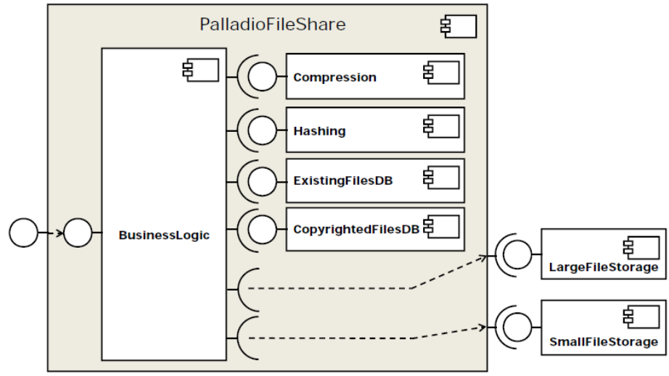

Measurements | Class for measuring / benchmarking | Lenovo -Xint / JIT [ns] | Toshiba -Xint / JIT [ns] | Notizen
1. Compress | CompressBenchmarker
2. Get Hash | HashBenchmarker
3. Query ExistingDB | ExistingDatabaseBenchmarker
4. Query CopyrightDB | CopyrightDatabaseBenchmarker
5. Store small file | SmallFileStorageBenchmarker
6. Store large file | SmallFileStorageBenchmarker
7. Entire application (business logic) | EntireApplicationBenchmarker

Systematic benchmarking especially needed for JIT case!
Consult legacy package and ByCounter for random input generation, etc. Here, concentrate on the set of input files.
Currently implemented by the same Storage class as „Store large file“
Currently implemented by the same Storage class as „Store small file“

