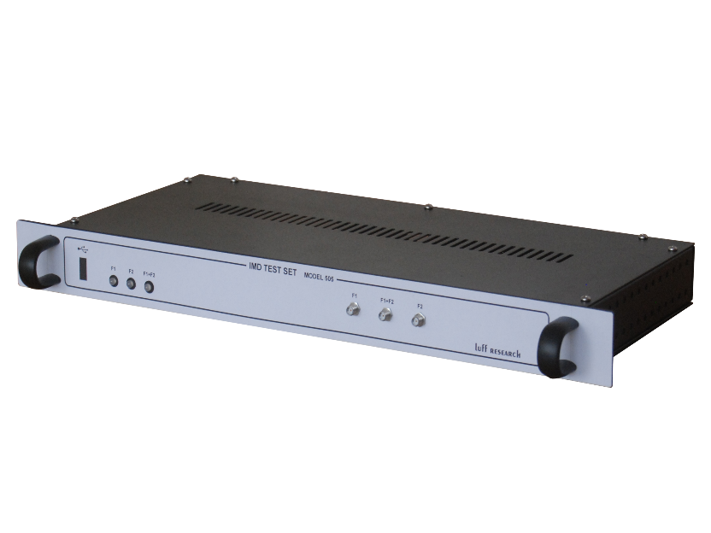
Model IMD Test Set: Inter-Modulation Distortion Test Set
Features
- Two 1 – 4 GHz Frequency Synthesizers (F₁ & F₂)
- Composite Output (F₁ + F₂)
- Simplest Test Set for IMD Testing
- Miniature 1U Module
- USB Controlled w/ Intuitive GUI
- Great Value

Block Diagram
Description
Our team at Luff Research is pleased to introduce our IMD Test Set. As shown in the block diagram, this unit incorporates two independent frequency synthesizers and two level control attenuators. This test set can be used to generate two independent signals or a single composite signal.
This compact 1U chassis makes user friendly IMD testing possible and is a simple alternative to an otherwise expensive cumbersome setup. In addition, our IMD Test Set features an automatic switch to its internal TCXO when the external input is absent.

IMD Test Set Key Specifications
Frequency Range: 1 – 4 GHz
Attenuation Range: +50 dBc
Output Power (typ.): +16 dBc
Configuration: 19” 1U Chassis
Power: 115 VAC
Control: USB / GUI

