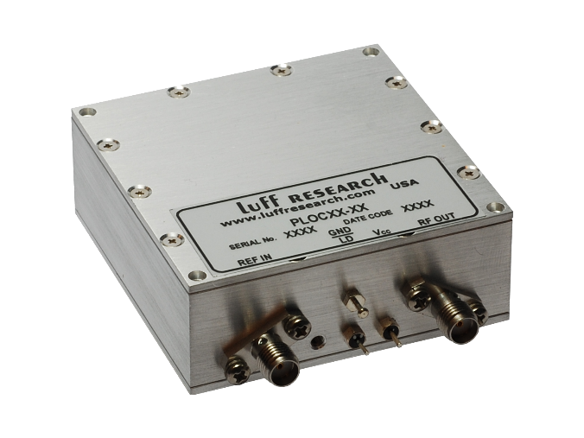
Model PLOC: PLL Frequency Standard Noise Cleanup Oscillator
Features
- Output Frequencies up to 125 MHz
- Ultra-Low Phase Noise
- Self-Contained Frequency Standard
- Excellent Spectral Quality
- EMI Enclosure
- +5.0 VDC Operation/Low Power Design

Block Diagram
Description
The PLOC is a miniature assembly designed to phase-lock the internal OCXO to the input reference signal. The internal OCXO has exceptionally good phase noise performance, and when locked to a source with outstanding long-term stability, this module becomes the ideal frequency source for systems which require ultra-low phase noise. When the input is not present, the internal OCXO acts as the stand-alone precision frequency source.

PLOC Key Specifications
Output Frequency: 5 – 125 MHz
Spurious (max.): -80 dBc
Harmonics (typ.): -30 dBc
Output Power (min.): +13 dBm
Output Power Variation: ±4 dB
External Reference: 5/10/100 MHz
Power Requirements: +15.0 VDC
Temp. Range: -5°C to +65°C

