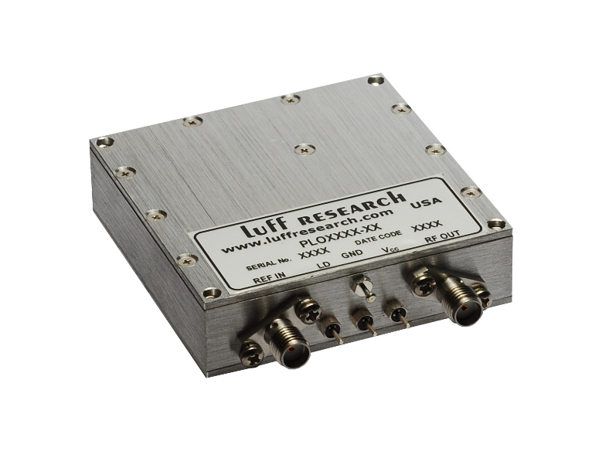
Model PLOX: Phase-Locked Crystal Oscillators
Features
- Output Frequencies up to 1400 MHz
- Input Frequency:
  - Internal TCXO Reference
  - External Reference
- Very Low Phase Noise and Spurious
- Excellent Spectral Quality
- +5.0 VDC Operation/Low Power Design

Block Diagram
Description
Our PLOX offers the lowest phase noise frequency source available. Our newest PLOX models use high quality crystals whose oscillations can be multiplied to any desired frequency between 10 and 1400 MHz. The output frequency from these units can be phase-locked to an external input reference frequency or configured with an internal TCXO.

PLOX Key Specifications
Output Frequency: 10 – 1400 MHz
Stability & Accuracy: Same as input
Internal Reference: ±0.5 PPM
Spurious (typ.): -80 dBc
Harmonics (typ.): -30 dBc
Output Power (min.): +13 dBm
Power Requirements: +5.0 VDC
Temp. Range: -5°C to +65°C

