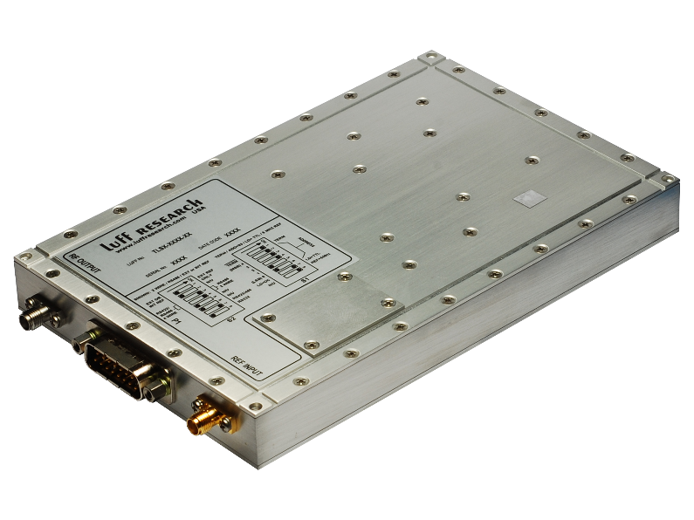
Model TLSD/E: Triple Loop Synthesizer Rev. D/E
Features
- Output Frequencies up to 34 GHz
- Frequency Control via RS-232/422/485:
  - Multi-Drop Bus Configuration
  - USB w/ Optional Adapter
- Input Frequency:
  - Internal TCXO Reference
  - External Reference
- Low Phase Noise and Spurious
- Excellent Spectral Quality
- EMI Enclosure
- +5.0 VDC Operation/Low Power Design

Block Diagram
Description
The TLSD and TLSE models are high performance frequency synthesizers ideal for many SATCOM, military, and communication applications. These units, requiring an input frequency of 5, 10, or 100 MHz, are configured to automatically clean-up the input signal, and when there is no input detected, these units will automatically switch to their internal TCXO/OCXO.

TLSD/E Key Specifications
Output Frequency: 1 – 34 GHz
Spurious: > -60 dBc
Harmonics (typ.): -20 dBc
Output Power (min.): +13 dBm
Output Power Variation: ±4 dB
External Reference: 5/10/100 MHz
Internal Reference: ±0.5 PPM
Load VSWR (max.): 2:1
Acquisition Time (typ.) 100 ms
Alarm: Open Collector/TTL
Temp. Range: -5°C to +65°C

