Model PLOA: Analog Phase-Locked Looped Oscillator
Features
- Output Frequencies from 1 to 10 GHz
- Input Frequency:
  - Internal TCXO Reference
  - External Reference
- Low Phase Noise and Spurious
- Excellent Spectral Quality
- +5.0 VDC Operation/Low Power Design

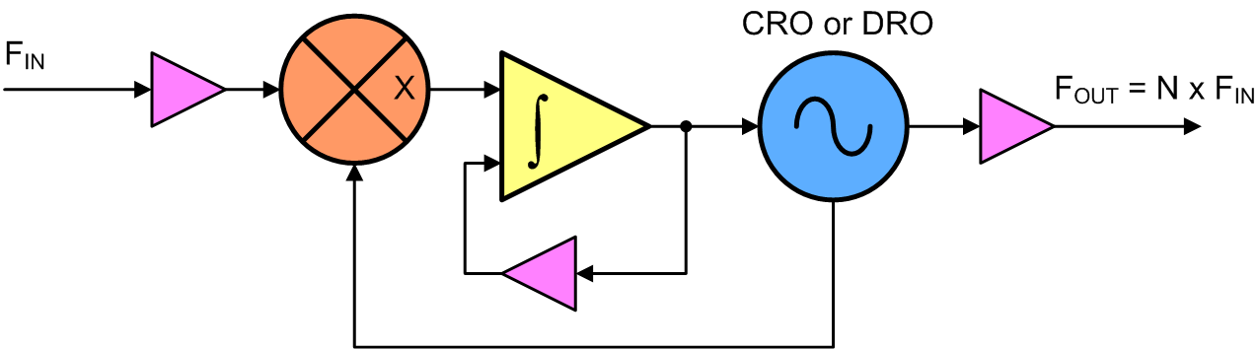
Block Diagram
Description
Our PLOA line features a single Analog PLL design that locks a Voltage Controlled Oscillator to an external/internal reference. This Analog PLL design enables access to a fine precision array of frequencies compared to other PLL devices, giving these units excellent phase noise and spectral quality. However, the output frequency must be an integer factor of the input reference frequency.

PLOA Key Specifications
Output Frequency: 1 – 10 GHz
Spurious: -60 dBc
Harmonics (typ.): -30 dBc
Output Power (min.): +13 dBm
Output Power Variation: ±3 dB
External Reference: 10 - 200 MHz
Internal Reference: ±0.5 PPM
Alarm: Open Collector/TTL
Power Requirements: +5.0 VDC @ 250 mA
Temp. Range: 0°C to +65°C

