Model PLOD: Digital Phase-Locked Looped Oscillator
Features
- Output Frequencies from 0.1 to 34 GHz
- Input Frequency:
  - Internal TCXO Reference
  - External Reference
- Wide Range of Frequencies
- +5.0 VDC Operation/Low Power Design
- Low Cost X-Band PLL

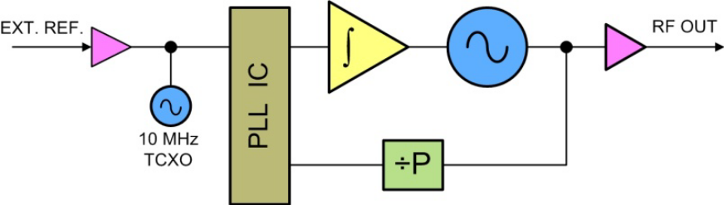
Block Diagram

Description
Our PLOD line features a single Digital PLL design that locks a Voltage Controlled Oscillator to an external/internal reference. This Digital PLL design enables access to a broader range of frequencies compared to other PLL devices. This model is the lowest cost PLL architecture available.

PLOD Key Specifications
Output Frequency: 0.1 – 34 GHz
Spurious: -60 dBc
Harmonics (typ.): -20 dBc
Output Power (min.): +13 dBm
Output Power Variation: ±3 dB
External Reference: 10 / 20 MHz
Internal Reference: ±0.5 PPM
Alarm: Open Collector/TTL
Power Requirements: +5.0 VDC @ 250 mA
Temp. Range: - 5°C to +65°C

