Model SLSM5: Single Loop Synthesizer – Rev. M5
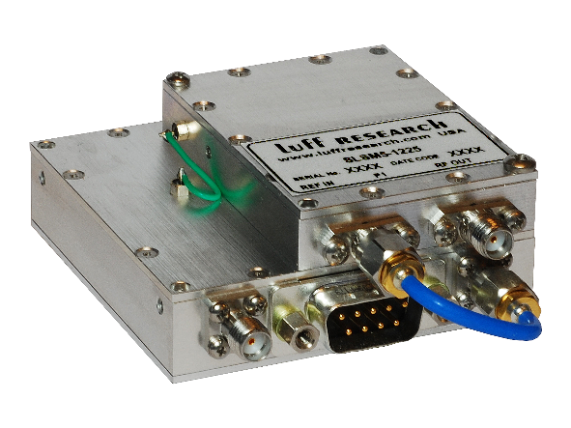
Features
- Output Frequencies up to 34 GHz
- Frequency Control via RS-485 Interface:
  - Multi-Drop Bus Configuration
  - Non-Volatile Memory
  - USB w/ Optional Adapter
- Input Frequency:
  - Internal TCXO Reference
  - External Reference
- Low Phase Noise and Spurious
- Excellent Spectral Quality
- +5.0 VDC Operation/Low Power Design

Block Diagram
Description
The SLSM5 Frequency Synthesizer utilizes the latest Fractional N (÷N) technology to realize a compact high performance frequency synthesizer. This SLSM5 is ideal for many applications ranging from test equipment to SATCOM applications. The SLSM5 is system ready with minimal design integration required. For your leisure, a custom GUI is included for “out-of-the-box” operation.

SLSM5 Key Specifications
Output Frequency: 0.1 – 34 GHz
Spurious: -60 dBc
Harmonics (typ.): -17 dBc
Output Power (min.): +13 dBm
Output Power Variation: ±2 dB
External Reference: 10 MHz
Internal Reference: ±0.5 PPM
Alarm: Open Collector/TTL
Power Requirements: +5.0 VDC @ 600 mA
Temp. Range: 0°C to +60°C

