Run 3 — 100-Trial Walking Perturbation Session
Log analysis report
Session ID: 20260520_001724_6354 Recorded (UTC): 2026-05-20T05:17:24.726Z Schema: Phase 5+ (session_paused / session_resumed present)

Executive summary
Run 3 produced 99 complete walking trials over a 28-minute session, with one additional warmup walk before the first trial_loaded and one trial loaded but not walked at the end. The dataset is clean and usable: the Meta XR spatial anchor stayed within 2.3 cm of its first-localized pose throughout the session and never reached the 5 cm major-drift threshold. There were no obstacle pose jumps, no localization losses, no anchor refreshes, and no inactive (null) trials in this run — every trial was an active perturbation.
Key findings
Subject walk time averaged 2.85 s (SD 0.61 s) over normal trials. Walk time varied meaningfully with perturbation magnitude: trials with 0.35 m perturbations averaged 2.58 s, while 0.70 m perturbations averaged 3.16 s — about a 600 ms difference, consistent with the subject having more to step around. The walk-direction alternated cleanly between trials (odd trials walked one way, even trials the other), confirming the round-trip experimental design. Adaptation across the session was modest: walk times dropped from ~3.0 s in trials 1–10 to ~2.3 s by trials 20–30, then drifted back up to ~3.1 s by trials 80–90 (possible fatigue or increased care).
Anchor stability
The Obstacle Anchor Holder was created and localized 92.6 s into the session at world position (0.012, -0.011, 0.008) m. It remained quiet for the first 19 trials. The first 2 cm drift warning fired during trial 20 — right after the operator's first measurement-pause cycle. Drift activity accelerated dramatically after trial 70: 16 of 17 total drift warnings occurred between trials 74 and 100, suggesting cumulative SLAM-map drift as the session progressed. All warnings were just barely above the 2 cm threshold (range 2.00–2.30 cm), and the anchor never crossed the 5 cm major-drift threshold.
Operator measurement pauses
The 8 intentional drift-measurement pauses (at trials 8, 18, 40, 50, 60, 70, 80, 90) are visible as disarm/arm cycles in the operator timeline and as 50–106 s gaps in trial duration. The walks themselves during these trials were normal duration; the long gap is between the walk and the next trial_loaded. Pause durations decreased over the session (105.8 s → 50.9 s), consistent with the operator becoming faster at the physical measurement.

Session metrics
Session duration | 28.07 min (1684329 ms)
Total events logged | 343
Clean session_end row? | No — last event is session_paused. Subject likely removed the headset rather than quitting the app cleanly. Phase 5 fix means this is not the pre-Phase-5 bug; it is a genuine OS pause that was never followed by a resume + session_end.
trial_loaded events | 100 (trial numbers 1–100)
perturbation_fired events | 100 (trial 0 warmup + trials 1–99)
obstacle_reset events | 100 (one per perturbation; never orphaned)
trigger_fired_inactive events | 0 — every trial in this run was an active perturbation trial
Kinematics files written | 99 (trials 1–99). Trial 100 was loaded 2.5 s before session_paused; no walk occurred, so the async kinematics writer (§5.6) had nothing to flush.
Sample rate (kinematics) | 50.1 Hz median across all 99 trials — clean FixedUpdate behavior
Compromised trials (strict def.) | 0 — zero anchor_major_drift, obstacle_pose_jumped, anchor_localized_lost, anchor_refreshed
Trials with drift warnings | 14 unique trials (17 events) — see Anchor stability section
Operator measurement pauses | 8 (trials 8, 18, 40, 50, 60, 70, 80, 90)
Hand data populated? | Yes — all 99 trials have non-zero hand poses (not Editor mode)

Trial flow and walk times
Walks are tightly distributed. Excluding the 8 measurement-pause trials and the trial 0 warmup, the typical perturbation-to-reset latency is 2.75 s (median), with low variance and a clear effect of perturbation magnitude. Only one non-pause trial has an outlier walk time: trial 4, at 6.7 s with a 0.35 m perturbation — likely a moment of subject hesitation early in the session.
Mean walk time | 2.85 s
Median walk time | 2.75 s
Std dev | 0.61 s
Min / Max | 2.02 s / 6.70 s
0.35 m perturbations | mean 2.58 s (n=48)
0.70 m perturbations | mean 3.16 s (n=43)
All perturbations were toward_user=False | Yes — no "towards user" perturbations in this run
Figure 1. Walk time per trial. Orange bars mark trials immediately followed by an operator measurement pause; red ×s mark trials that produced an anchor drift warning. Walk times themselves were normal during measurement-pause trials — the long gap is between the walk and the next trial_loaded.
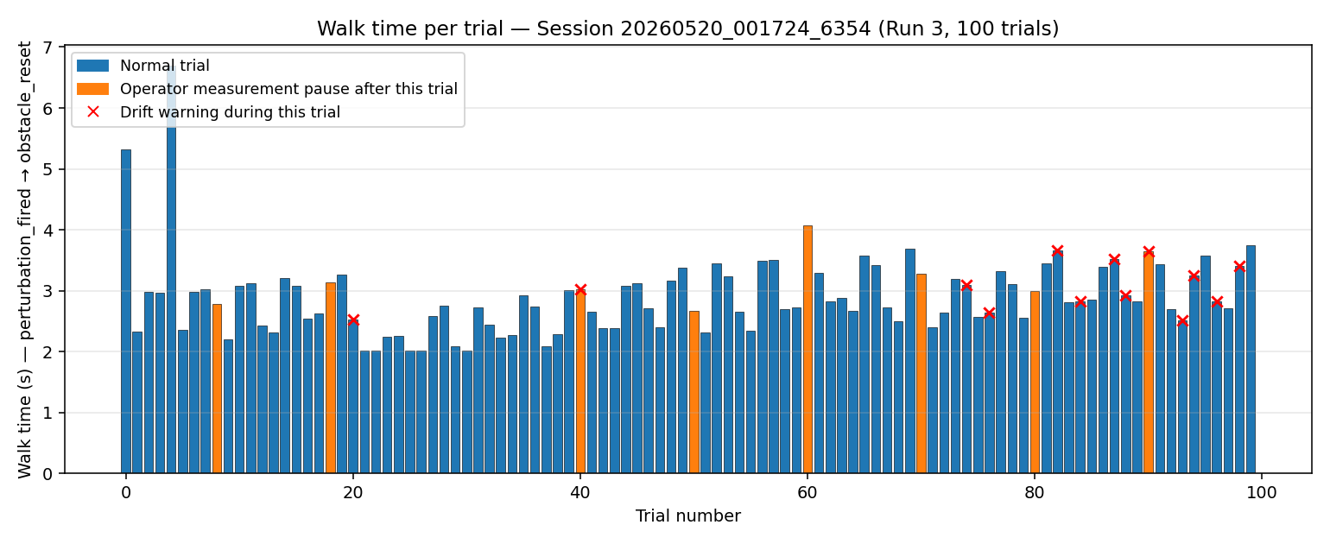
Figure 2. Trial duration on a log scale. The 8 operator measurement pauses are clearly visible as the orange spikes (50–110 s), against a baseline of 9–12 s for ordinary trials. The pauses shorten over the session.
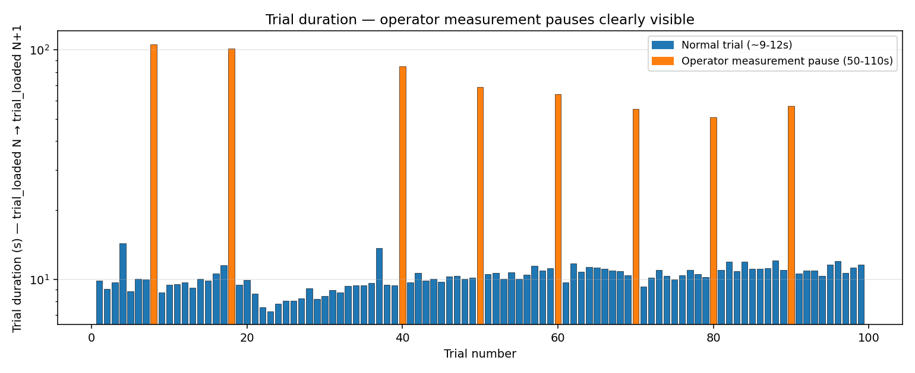
Figure 3. Left: walk time scattered by perturbation magnitude — 0.70 m perturbations consistently take longer. Right: 10-trial-bin walk-time trend with SEM error bars — modest learning in the first 30 trials, slight slowdown later.
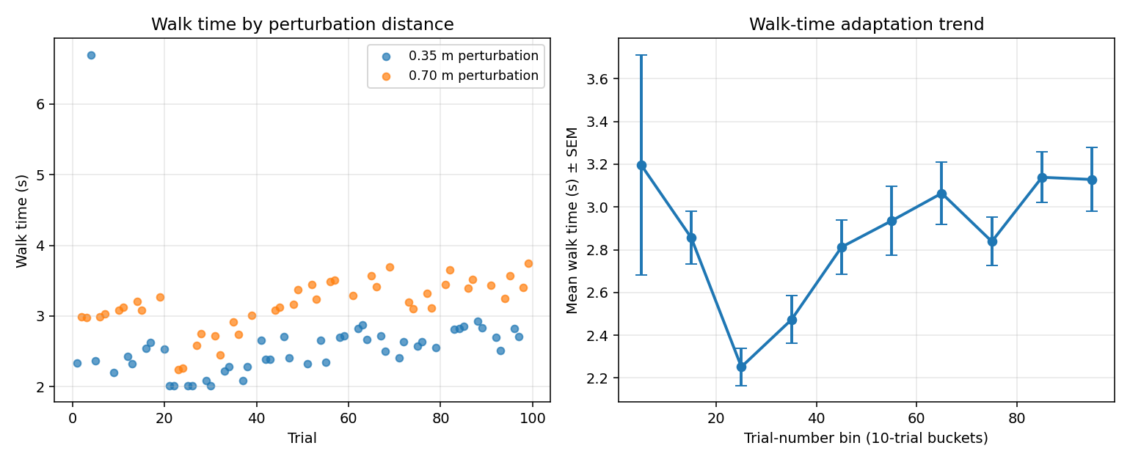

Anchor stability
The Meta XR spatial anchor (Obstacle Anchor Holder) was created at 92.3 s and localized 0.3 s later at world position (0.012, -0.011, 0.008) m — this is the first-localized reference pose against which drift is measured. Over the session, the anchor drifted primarily in the +Z direction (forward in world coordinates), with current positions in the drift events ranging from (0.005, -0.008, 0.025) to (0.023, -0.006, 0.024) — about 2.5 cm of Z displacement, near the 2 cm warning threshold.
Latched-warning semantics (§5.4 of the handoff) mean each warning fires only on the up-crossing through 2 cm; the absence of a 'drift returned' event makes it impossible to tell from these warnings alone whether the anchor snapped back between warnings or sat above 2 cm continuously. Because no obstacle_pose_jumped events fired (which would catch sub-frame snap-backs over 5 cm), any back-and-forth motion was below the 5 cm sample-level threshold and is therefore invisible in this log.
Drift events by 10-trial bin
Trial range | Drift warnings
20–29 | 1
40–49 | 1
70–79 | 3
80–89 | 4
90–99 | 7
100–109 | 1
Figure 4. Anchor drift events plotted in session time. Each red dot is a 2 cm warning. Orange bands mark operator measurement-pause windows. The cluster of warnings after minute ~20 (trial 70+) suggests cumulative SLAM-map drift; the 5 cm major-drift threshold was never crossed.
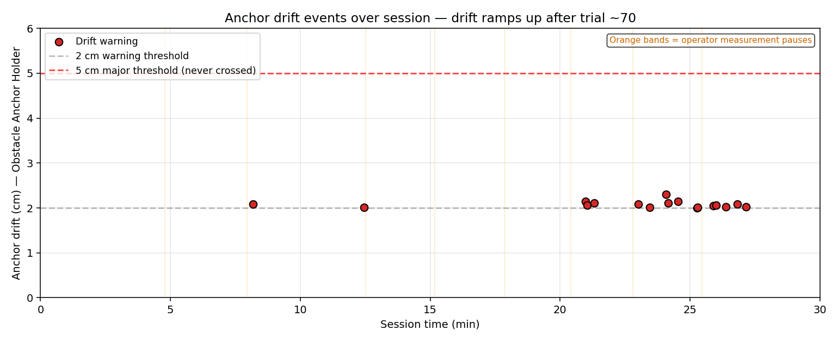
Cross-reference with your physical measurements: the in-headset drift estimates above are sub-3 cm throughout. If your visual passthrough measurements showed larger drift at trials 70+, that would suggest the headset's own drift estimate is conservative (true drift exceeded what the SLAM system reported), which would be the most important calibration finding of this run.

Perturbation response
Aligning each perturbation event to the corresponding kinematics frame reveals a clean experimental signal:
Trigger distance (head→obstacle, XZ) — 0.35 m perturbations | mean 0.687 m
Trigger distance (head→obstacle, XZ) — 0.70 m perturbations | mean 1.390 m
Subject speed at perturbation moment | mean 1.00 m/s (range 0.21–1.83)
Obstacle jump magnitude at perturbation | matches commanded perturbation distance to 4 decimal places (0.3500 / 0.7000)
The trigger distances confirm that the run used move_trigger_distance values of roughly 0.69 m (paired with 0.35 m perturbations) and 1.39 m (paired with 0.70 m perturbations) — i.e., the trigger fired at twice the perturbation magnitude in each case. The subject was walking at approximately 1.0 m/s when the perturbation fired, very consistent across both perturbation conditions, which is good news for the experimental design: walking speed at trigger is not a confound for the walk-time difference between conditions.
Figure 5. Example head + obstacle XZ-plane trajectories for trial 1 (early session) and trial 99 (late session). The obstacle visibly jumps from origin to its perturbed position partway through each walk. The head path shows the subject's consistent forward motion with small lateral variations.
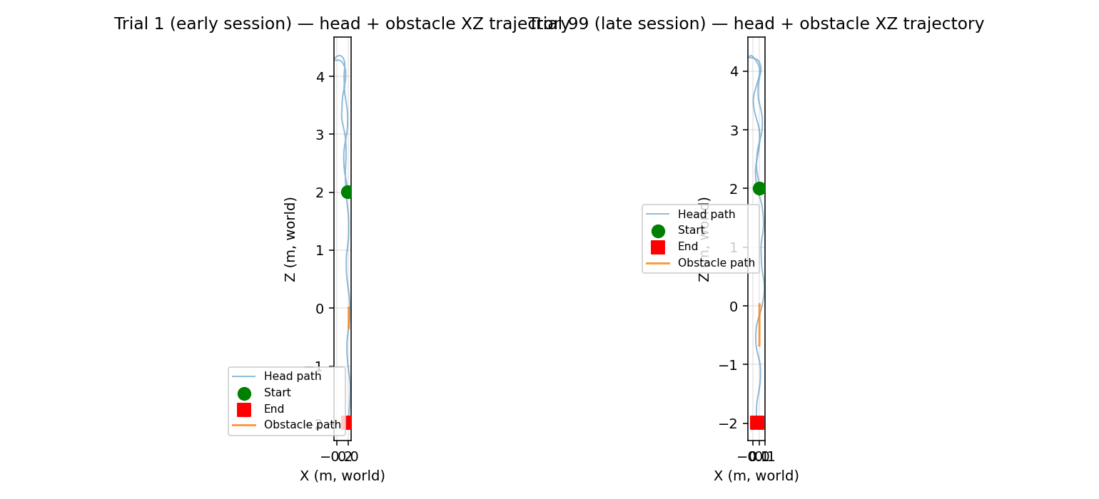

Data quality notes and caveats
Trial-counter offset | The handoff says trials are 0-indexed in kinematics filenames; in this run the kinematics range from trial1.csv to trial99.csv (1-indexed). The "trial 0" warmup walk has no kinematics file — its kinematics were recorded but never flushed because trial_loaded did not fire to open the file.
Trial 100 has no kinematics | trial_loaded(100) fired 2.5 s before session_paused. The subject never began the walk. By the §5.6 async-flush rule, the file simply does not exist; this is expected behavior, not data loss.
No session_end row | The session ended via OS-level session_paused at 28:04. There is no session_end row anywhere in the log. The Phase 5+ schema rules out the pre-Phase-5 bug, so this is a genuine "subject removed headset without quitting" event. Use the last timestamp (1,684,329 ms) as the practical session end time.
Obstacle reset jump invisible in kinematics | Each kinematics file shows exactly one obstacle position jump >5 cm (the perturbation itself). The reset jump happens between the close of trialN.csv and the open of trial(N+1).csv, so it does not appear as a sample-level delta. The obstacle starts each new trial at the anchor origin.
Hand poses in tracking-space frame | Per §5.1, hand position columns are not in world space and cannot be combined with the obstacle position. This run does have valid hand data on all 99 trials (not Editor zeros), so within-frame hand analysis (reach extent, swing magnitude) is feasible.

Recommendations
For downstream analysis of this run: treat trials 1–99 as the analyzable dataset. Exclude trial 0 (no kinematics) and trial 100 (no walk). The 8 measurement-pause trials (8, 18, 40, 50, 60, 70, 80, 90) should keep their walk data — those walks were normal — but their trial duration and the inter-trial gap should be flagged so they do not bias any 'time between trials' analysis. Trial 4 is a 6.7 s walk-time outlier worth a manual look; the rest of the dataset is tight enough that simple mean/median statistics by perturbation condition will be informative.
For the experimental protocol: the absence of inactive trials in this run means there is no within-session contrast for anticipatory behavior. If a primary research question is whether the subject anticipates a perturbation, the next run should interleave is_active=false trials so trigger_fired_inactive events appear in the log.
For data validation: compare your physical drift measurements (taken at the 8 measurement pauses) against the anchor_drift_warning timestamps and magnitudes recorded here. The system's own drift estimate stayed under 2.3 cm; if the physical measurements were larger, the SLAM drift estimate is undercounting, which would be a meaningful finding. The log captures the in-system view; your physical tape measure captures ground truth.

Appendix — file inventory
Folder: 05-19-26 Run 3 100
• trial_log_20260520_001724_6354.csv — 344 rows (1 header + 343 events)
• kinematics_20260520_001724_6354_trial{1..99}.csv — 99 files, 50 Hz pose samples
• Each .csv has a corresponding Unity .meta file (auto-generated, not used)
Companion artifacts produced by this analysis:
• Run3_100trials_analysis.xlsx — multi-sheet workbook with Summary, Event counts, Per-trial table (all 101 rows), Drift events, Operator timeline, and embedded charts.
• Run3_100trials_analysis.docx — this report.

