INTERNSHIP PROJECT REPORT

ONCOLOGY AI
  - Multimodal Oncology Evidence Retrieval and Clinical Information Support


Prepared as a complete project story for mentor, faculty, manager, and interview presentation
Repository-verified edition • August 2026

Document Purpose and Status
This report explains Oncology AI as a user-facing clinical information-support application rather than as a source-code README. It follows the user from account creation through upload, analysis, follow-up questions, evidence review, and history management, introducing technical architecture only where it explains that journey.
Clinical-use boundary Oncology AI is research and internship software for clinical decision support and information support. It is not a certified diagnostic device, does not establish a diagnosis, and must not replace an oncologist, radiologist, pathologist, or other qualified professional.

Status label | Meaning in this report
Currently implemented | Directly verified in the current repository or its checked-in artifacts.
Measured artifact | A result recorded in a dated evaluation output; it is not a universal performance guarantee.
Planned enhancement | A requested capability not fully present in the current implementation.
Screenshot insertion point | A real application capture should be added later; no interface was invented.

Table of Contents

In Microsoft Word, right-click the table above and choose Update Field to refresh page numbers.

1. Project Introduction
Oncology AI is a multimodal oncology clinical-support application developed as an internship project. Multimodal means that the system can work with more than one form of information: written clinical reports, PDF documents, medical images, a user's questions, and the relationship between text and images. Its central purpose is to help a user explore a patient case without manually searching every page or relying on a language model's general memory.
A user can upload an oncology-related PDF, PNG, JPG, or JPEG file and ask a targeted question. The backend first validates and ingests the uploaded material, then retrieves patient-specific material and supporting evidence from dedicated vector collections. Gemini receives this bounded context through the orchestration layer and returns a structured explanation with citations, limitations, care guidance, and a transparent evidence-support heuristic where applicable.
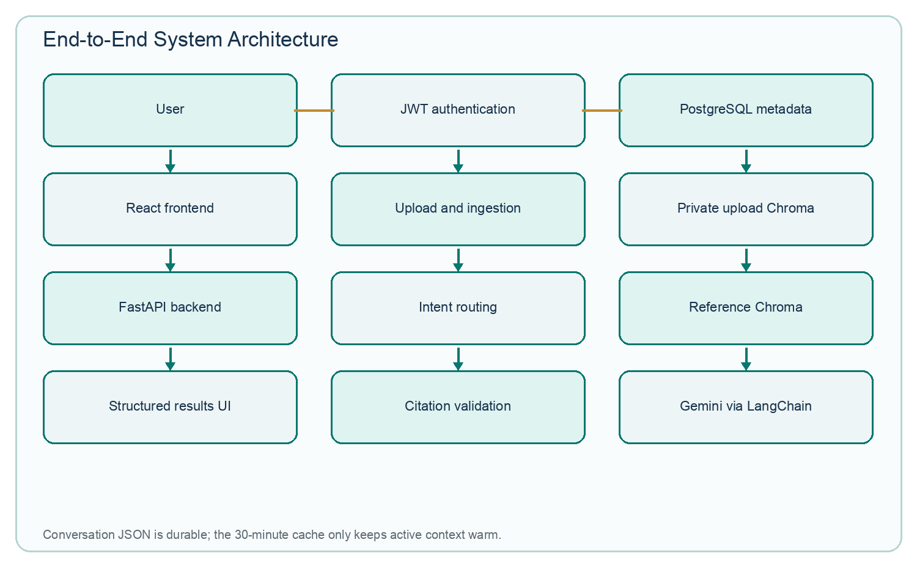
Figure 1. Verified high-level architecture and its principal data paths.

2. Why the Project Was Created
Oncology cases often combine pathology, radiology, biomarkers, molecular testing, treatment history, and follow-up findings. The relevant answer may be one sentence inside a long report, while another report changes its meaning. Clinical language is also deliberately cautious: suspicious, indeterminate, possible, favored, and cannot exclude are not synonyms for confirmed disease.
Oncology AI addresses this information burden by making the case queryable. A user can ask what cancer is documented, whether lymph nodes are involved, what an EGFR or PD-L1 result says, whether chemotherapy is recorded, whether prior surgery is mentioned, or which findings remain uncertain. The answer is intended to use the uploaded case first and add traceable reference evidence where useful, rather than producing a generic oncology lesson.
- Faster access to a specific fact without rereading the entire report.
- A single conversational workspace for reports and supported images.
- Explicit preservation of negation, uncertainty, measurements, dates, and anatomical locations.
- Traceable citations and visible limitations instead of unsupported fluent prose.
- Structured results that separate findings, meaning, staging evidence, uncertainty, and next-step guidance.

3. User Journey from the First Screen

3.1 Opening http://localhost:3000/
The root URL opens a combined welcome and account-access screen. The left side introduces Oncology AI and displays corpus-scale statements; the right side offers Sign In and Sign Up tabs. Sign In is for an existing account. Sign Up creates a private clinical workspace.
SCREENSHOT INSERTION POINT — LOGIN / SIGN UP
Capture the welcome panel, corpus statistics, Sign In and Sign Up tabs, and the non-identifying empty form.
No repository screenshot was available; capture the running application without patient-identifying data.
Figure placeholder: Login / Sign Up screen (real runtime capture required).

3.2 Registration
A new user enters an email address, a password, confirms the password, and chooses a recovery PIN. The current frontend requires a password of at least eight characters and a recovery PIN of exactly four or six digits. The backend rejects duplicate email addresses and duplicate recovery PIN digests.
Recovery credential The PIN is never stored in plain text; the backend stores a keyed digest. The PIN can recover an email address or reset a password, so it should be remembered and protected. Recovery requests are limited to five attempts per ten minutes per process and client address in the current internship deployment.

3.3 Sign In and JWT access
After a successful login, the backend creates a signed JSON Web Token (JWT). From the user's perspective, this token is a temporary digital pass: the frontend includes it with protected requests so the user can reach only their own profile, sessions, uploads, results, and history without sending the password for every action. The default configured token life is 60 minutes unless the environment changes it.

3.4 Profile completion
A newly registered user is directed to Complete Profile before the dashboard. The implemented fields are full name, age, gender, and occupation; the email address is used to ensure the user updates only their own account. Once saved, profile_completed becomes true.

3.5 Dashboard
The dashboard is the working home. It greets the user, accepts a question, offers example prompts, attaches up to three files, and lists recent analyses. A completed analysis can be reopened. Recent items can be renamed, archived, or permanently deleted after confirmation.
SCREENSHOT INSERTION POINT — DASHBOARD
Capture the greeting, prompt composer, attachment control, suggestions, navigation, and recent analyses using synthetic data.
No repository screenshot was available; capture the running application without patient-identifying data.
Figure placeholder: Dashboard screen (real runtime capture required).

3.6 Results and chat
The Results page is also the follow-up conversation surface; there is no separate /chat route. It shows the user's prompt and attachments, processing state, structured clinical answer, evidence, care urgency, case complexity, generation mode, citation status, and the Evidence Support card when the response qualifies. The same screen allows follow-up questions and additional attachments.

3.7 History, archive, profile, and settings
History presents non-archived sessions. Archive presents archived sessions and supports restore or permanent deletion. Profile displays and edits personal account details. Settings supports password and recovery-PIN changes and includes account/security actions. The old /processing route now redirects to the dashboard.

4. User Upload Flow
What the user does. The user selects one to three files in the dashboard or attaches more material during a results conversation. Supported extensions are PDF, PNG, JPG, and JPEG. The frontend submits the user's email, files, and—when continuing an existing case—the session identifier.
What happens behind the scenes. Before any permanent file write, FastAPI verifies ownership, limits the batch to the first three files, checks the filename and extension, reads at most 25 MB plus one byte, rejects empty content, verifies the %PDF- signature for PDFs, and asks Pillow to decode and verify images. If any file in the accepted batch fails these initial checks, the request fails and none of the prepared files are committed.
What the user receives. Valid files are stored under a session-specific server folder using randomized stored filenames, while original names and metadata are saved. Files that fail later quality or ingestion checks are retained with a Rejected status, a numerical ingestion-quality score, and a friendly reason so the user can understand what to replace.
Rule | Verified behavior
Formats | PDF, PNG, JPG, JPEG
Files per request | 1–3; extras are ignored with a message
Maximum size | 25 MB per file
Empty file | Rejected before storage
PDF signature | Must begin with %PDF-
Image validity | Pillow decode and verification before storage
Ownership | Authenticated email/session must belong to the current user

5. Ingestion Pipeline
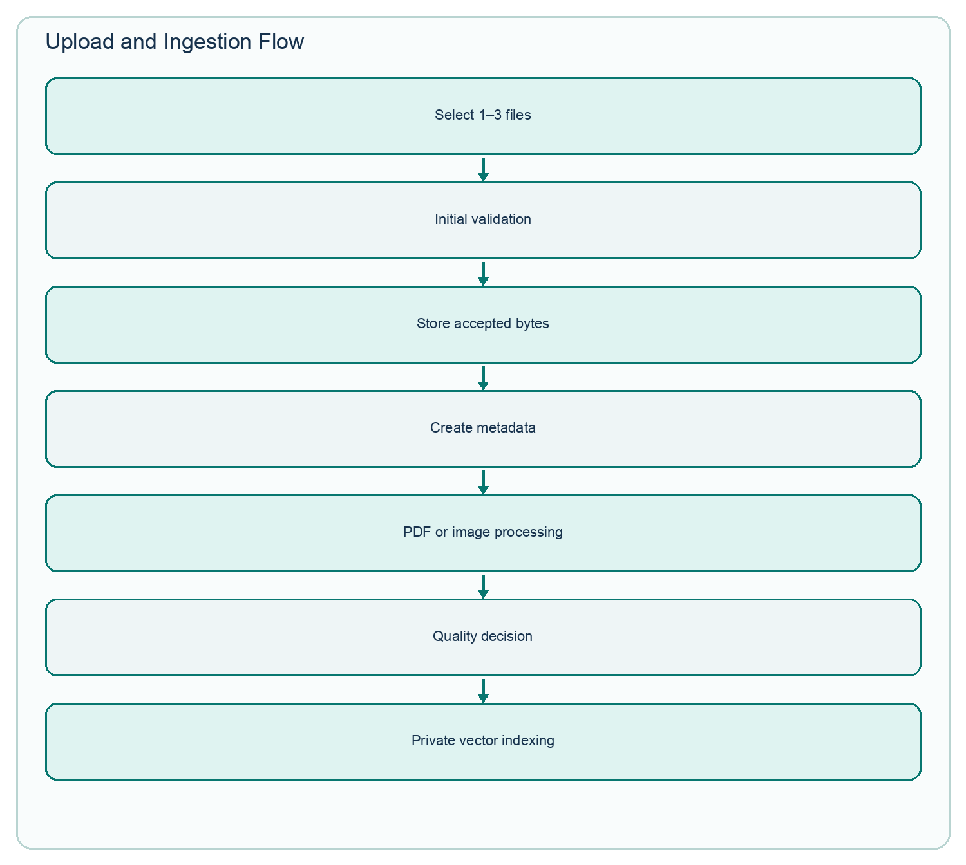
Figure 2. Current upload boundary and ingestion stages.
For a PDF, PyMuPDF extracts text page by page. A page with fewer than 40 extracted characters is treated as potentially scanned and sent to Tesseract OCR when available. Text is cleaned without discarding clinical negation or units, tagged with page markers, and divided into overlapping chunks of at most 2,400 characters with 300-character overlap. Each chunk carries session, file, and chunk metadata before MedCPT embedding.
For an image, Pillow and OpenCV verify decodeability, dimensions, brightness, contrast, and blur. The minimum accepted dimensions are 200 × 200 pixels. An almost white or black image, an undersized image, or a blur score below the configured threshold receives a quality failure. The default minimum final quality score is 40/100. A valid image can also be OCR-processed so report screenshots contribute text as well as visual information.
Accepted uploaded text and images are written to two private Chroma collections—user_upload_text_embeddings and user_upload_image_embeddings. Every record is filtered by user and session identifiers at retrieval time. The large reference collections are deliberately left unchanged.

6. Data Used in the Project
The checked-in manifests record 75,561 clinical text embeddings and 206,784 completed image embeddings. The text source includes 9,523 TCGA report rows that were cleaned and divided into oncology passages. TCGA, The Cancer Genome Atlas, is a large cancer research program whose reports provide realistic oncology terminology and disease-specific context. The image manifest combines 206,528 legacy oncology images with 256 PMC medical images. PMC means PubMed Central, a repository of biomedical literature; its figures can carry interpretable article context.
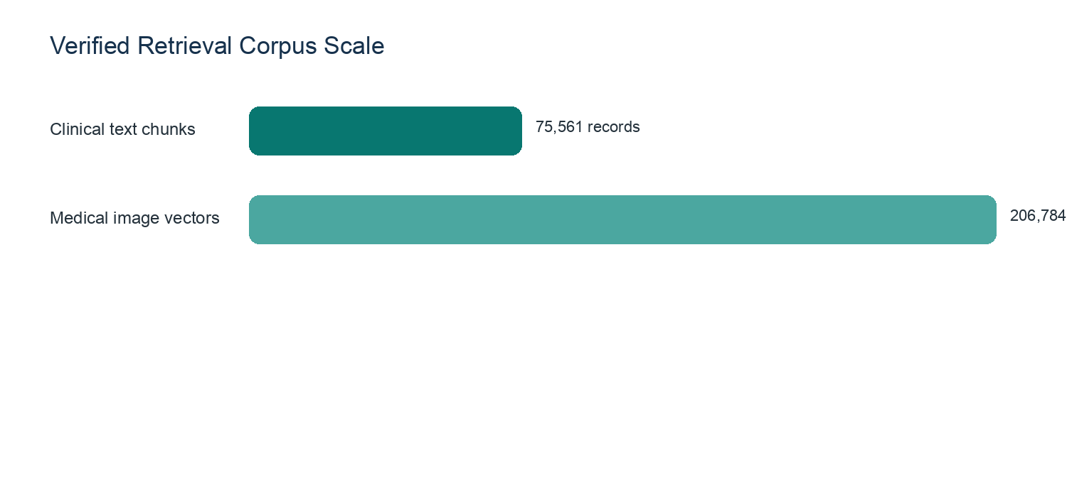
Figure 3. Dataset scale recorded in the current embedding manifests.
Important data caveat The image metadata CSV contains more rows than the completed image-vector manifest because some items failed embedding. The report uses the manifest's 206,784 completed vectors, not the raw metadata-row count. Legacy images may have unknown labels because source captions were empty.

7. Clinical Text Processing
Cleaning removes extraction noise such as null characters, form-feed markers, repeated whitespace, and page-number boilerplate. It intentionally does not simplify away words such as no, not, possible, or cannot exclude. In oncology, “no evidence of metastasis” and “evidence of metastasis” share vocabulary but have opposite clinical meaning.
Chunking is necessary because reports can be longer than an embedding model or generation prompt can handle at once. Overlap keeps a sentence near a boundary from losing its surrounding meaning. Page markers, chunk numbers, session IDs, file IDs, original filenames, and source type help trace a retrieved passage back to the uploaded document.
- Preserve negation and uncertainty.
- Keep measurements and units together, such as 12 mm rather than only 12.
- Retain biomarkers, dates, anatomy, laterality, and procedure names.
- Prefer paragraph and sentence boundaries where possible.
- Use OCR only when extracted PDF text is insufficient, limiting unnecessary OCR noise.

8. MedCPT Text Embeddings
An embedding converts text into a numerical representation. Similar clinical meanings can then be retrieved even when the wording differs. The project uses ncbi/MedCPT-Article-Encoder for stored documents and its matching query encoder for questions. The verified vector size is 768 dimensions, and the reference text collection uses unnormalized vectors with inner-product similarity.
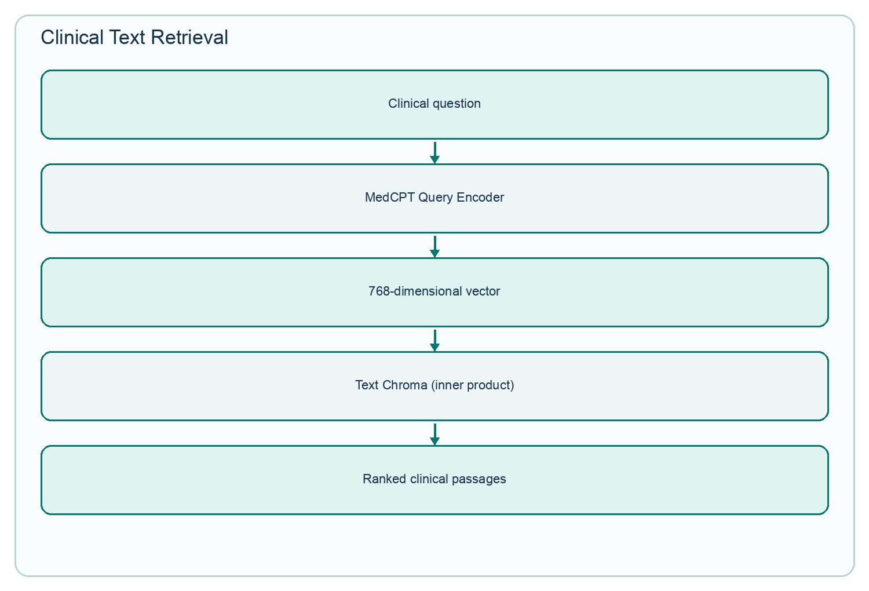
Figure 4. MedCPT keeps clinical text retrieval in its own compatible embedding space.

9. BiomedCLIP Image Embeddings
BiomedCLIP represents a medical image as a 512-dimensional normalized vector. Its paired text and image encoders allow image-to-image retrieval and text-to-image retrieval inside the same BiomedCLIP space. The image collection uses cosine similarity. This is distinct from MedCPT: their raw scores are not compared as though they mean the same thing.
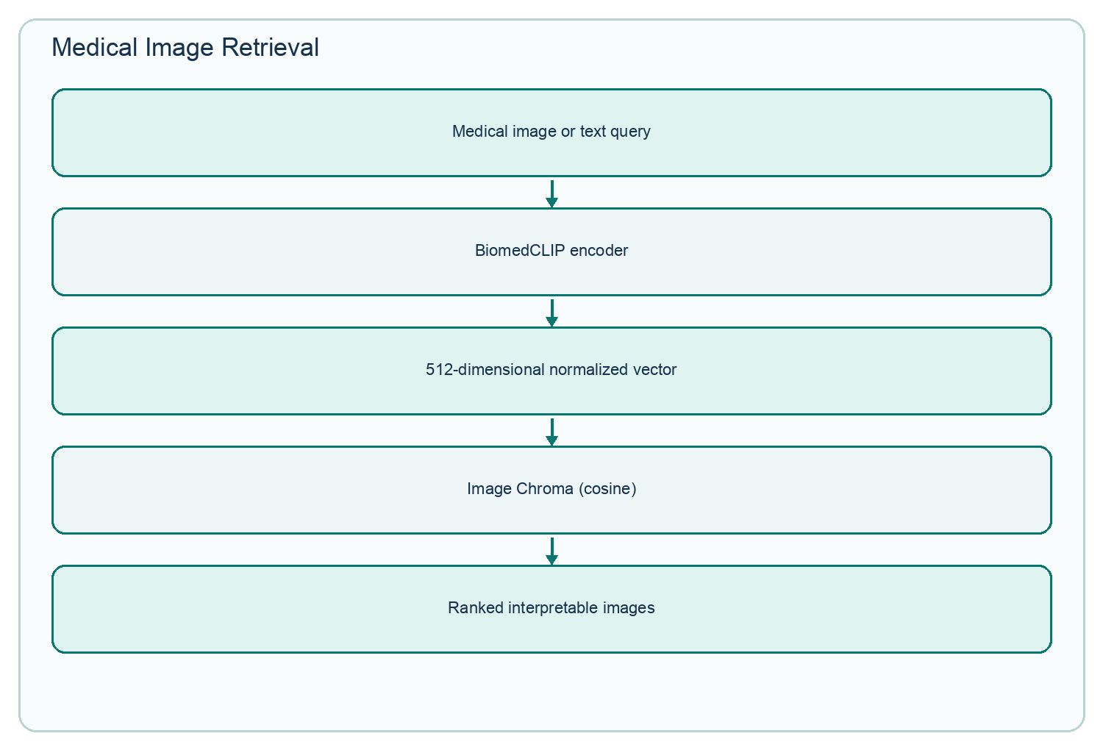
Figure 5. BiomedCLIP image and text queries search the image evidence collection.

10. Chroma and PostgreSQL
Chroma is the similarity-search store. PostgreSQL is the transactional application database. Chroma answers “which vectors are closest to this question or image?” PostgreSQL answers “which user owns this session, what was uploaded, what is its status, and what analysis metadata exists?” They serve different roles and are not interchangeable.
Concern | PostgreSQL | Chroma
Primary purpose | Users, auth-linked state, sessions, uploads, summaries, statuses and metadata | Semantic similarity search over embedding vectors
Typical query | Find this user's sessions or file records | Find nearest clinical passages or images
Collections/tables | One configured application database with related tables | Separate reference and private text/image collections
Access path | Only through FastAPI/SQLAlchemy | Through ingestion and retrieval services with ownership filters

11. Detailed Query Flow
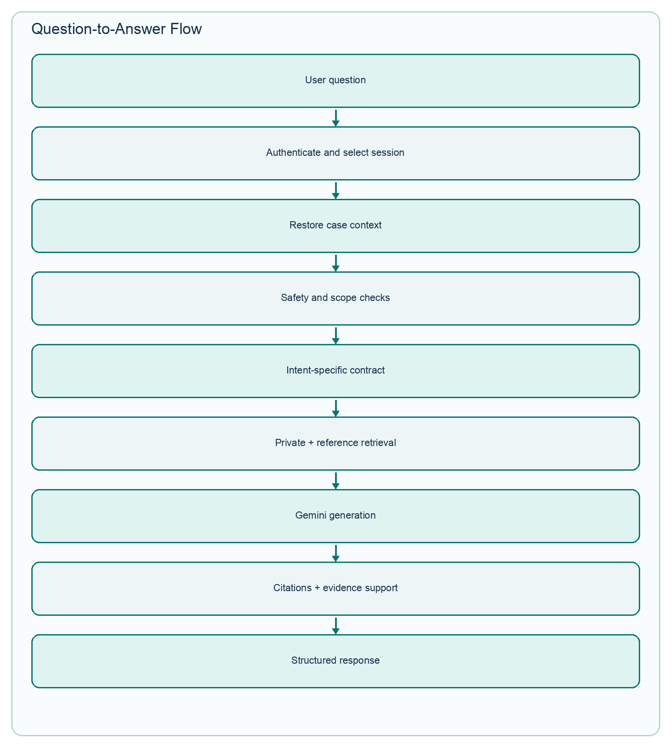
Figure 6. Verified question-to-response sequence.
- The frontend sends a question, token, and optionally a session ID.
- FastAPI authenticates the token and confirms the session belongs to the user.
- The active cache is checked; after expiry, persistent JSON history is reloaded.
- Deterministic greeting/help, emergency, diagnostic-guarantee, and out-of-scope checks run before expensive models.
- The question is classified into a response contract or focused clinical intent.
- Uploaded case context and private vectors are selected; reference text/images are retrieved as needed.
- Evidence is ranked without directly mixing incompatible raw model scores.
- The external prompt contract gives Gemini patient context, evidence, recent/relevant history, and strict output instructions.
- Generated citation IDs are validated against available U (uploaded) and R (retrieved) sources.
- The backend calculates case complexity, care urgency, and an uncalibrated evidence-support heuristic when eligible.
- The React UI renders a structured response and retains the conversation for follow-up questions.

12. Question Intent Routing
Not every question should receive a full report summary. The pipeline distinguishes conversational/general questions, focused patient questions, and full-report analysis. Focused intents include diagnosis/main finding, biomarkers, lymph nodes, metastasis or spread, prior surgery or procedure, treatment, staging, and other targeted facts. A question such as “Did the patient have heart surgery before?” receives a compact, evidence-bound answer rather than a long oncology summary.
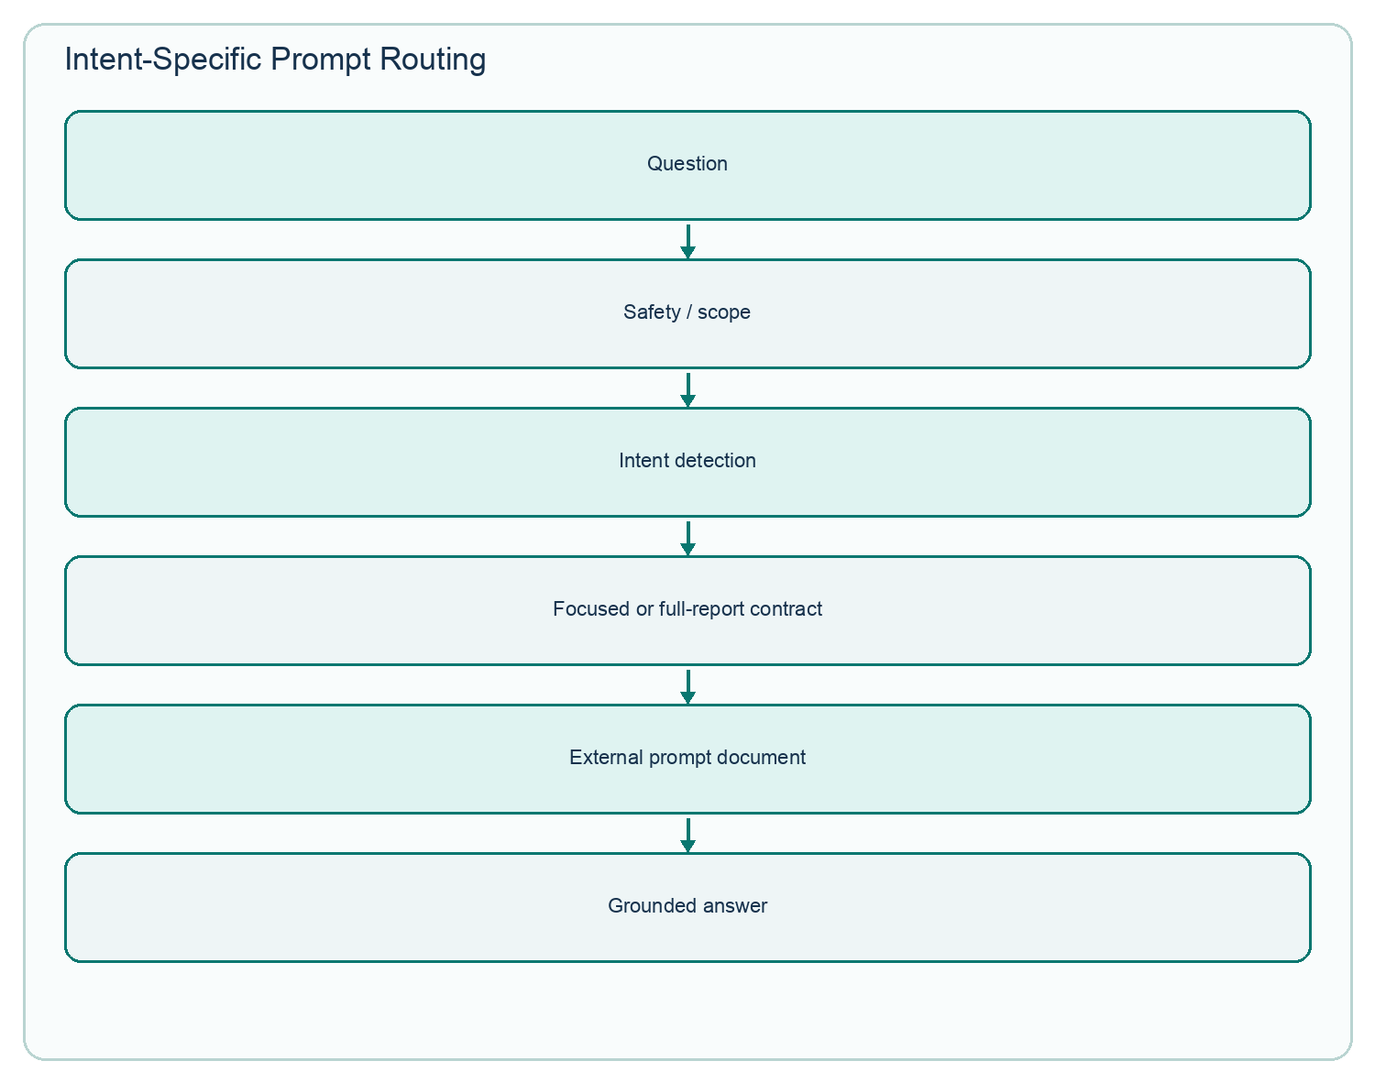
Figure 7. Prompt selection is driven by safety, scope, and clinical intent.

13. External Prompt Documents
The current implementation stores the versioned prompt library in prompts/oncology_ai_prompts.docx and loads sections by Prompt ID through backend/app/langchain/prompt_store.py. This differs from the originally suggested backend/app/prompts/ folder: the externalization goal is implemented, but the location and format are a single Word document rather than many text files.
The verified prompt IDs include general, focused, inventory, answer, and repair/contract templates. Keeping them outside the Python pipeline makes clinical instructions easier to edit, inspect, test for duplicates and missing placeholders, and review without navigating large source-code strings.

14. Retrieval and Ranking
Text questions keep MedCPT report evidence primary. BiomedCLIP text-to-image matches are optional supporting images and must pass similarity and cancer-label consistency checks when a text consensus exists. Image questions retrieve interpretable PMC images and can add OCR-derived MedCPT text. Multiple-image or image-plus-text paths use weighted reciprocal rank fusion (RRF), which rewards items that appear high in one or more rankings.
Where weighted RRF is used Weighted RRF is used for image/OCR and multi-image or multimodal ranking. It is not used to interleave image evidence into every ordinary text question. Text questions preserve MedCPT results as the primary ranked list.

15. Gemini and LangChain
Gemini is the generative model that converts selected context into a readable, structured explanation. It is not asked to answer only from its own memory. The prompt supplies uploaded patient evidence, reference evidence, the selected contract, and strict citation and uncertainty rules. LangChain is the wrapper/orchestration layer around the model call; it is not the language model itself.
Provider failures are classified as quota exhaustion, temporary rate limit, provider outage, network/timeout, or other provider error. The pipeline includes bounded retries for temporary failures and a retrieval-only/extractive fallback so the user can still receive explicit uploaded findings when generation is unavailable.

16. Conversation Memory and File-Based Cache
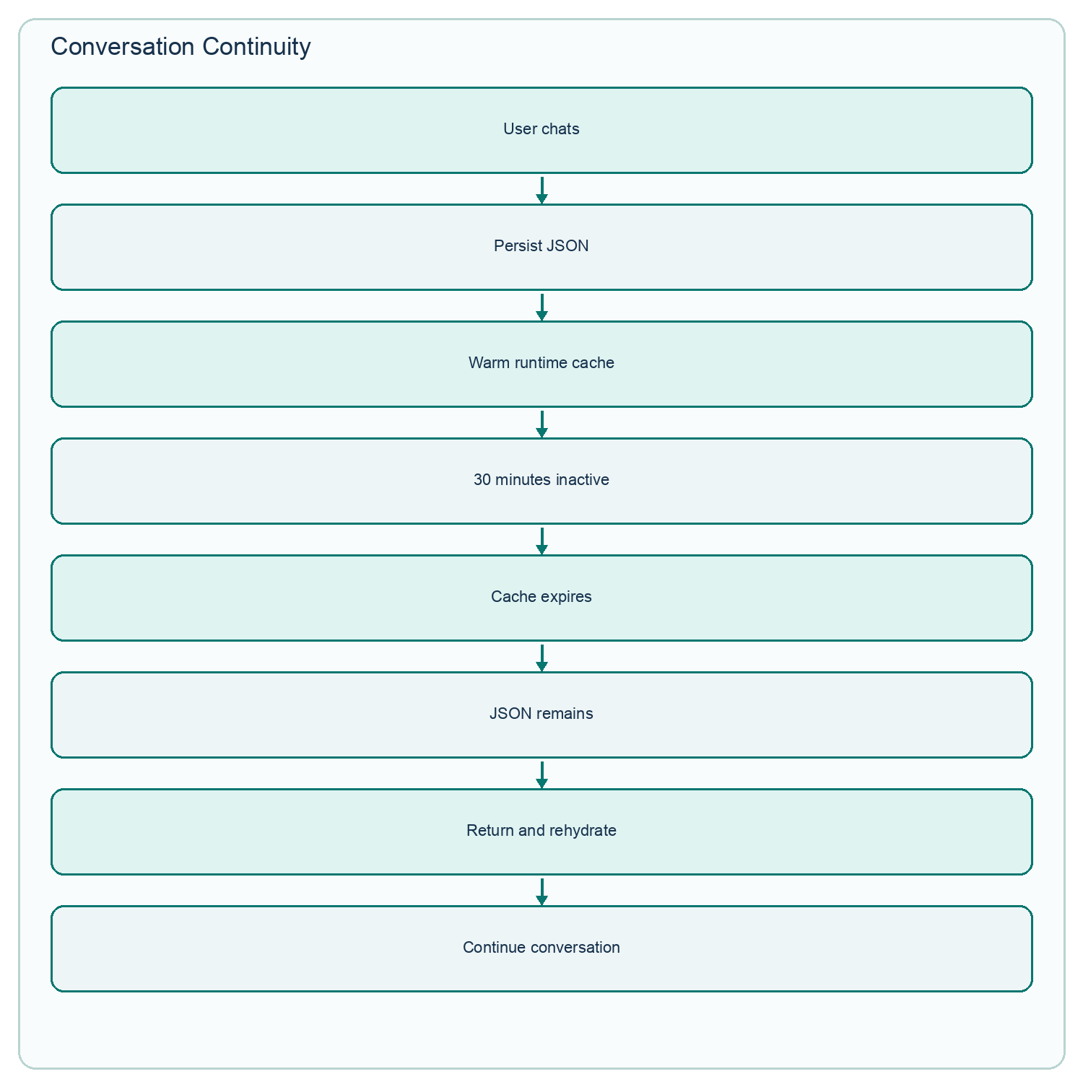
Figure 8. The 30-minute value governs runtime cache activity, not conversation deletion.
Conversation history is durably stored as per-user, per-session JSON. A process-local in-memory cache keeps the hydrated turns active for 1,800 seconds by default and extends the expiry while used. When the cache expires, only the warm copy is removed. The JSON remains and is loaded when the user returns. Permanent session deletion removes the corresponding JSON and private vectors.
The generation prompt does not blindly replay an unlimited transcript. The pipeline reconstructs context from uploaded references, patient summary and documented facts, important clinical categories, relevant older turns, recent messages, retrieved evidence, and the current question. This reduces token cost and prevents unrelated earlier conversation from crowding out the present case.

17. Evidence Support Score
The Results page can show an Evidence Support percentage for analysis responses that contain uploaded or retrieved evidence. It is a transparent heuristic, not a diagnostic probability and not a clinically calibrated accuracy measure. An 86% Evidence Support display does not mean an 86% chance that a diagnosis is correct.
Component | Weight | What it measures
Patient-document support | 35% | Presence and citation of uploaded patient material
Retrieval support | 25% | Amount and modality breadth of retrieved evidence
Citation support | 20% | Whether used identifiers pass structural validation
Evidence agreement | 10% | Consistency and lack of explicit contradictory balance
Completeness | 10% | Penalties for missing information, limitations, and uncertainty

Example UI card 86% Evidence Support — High evidence support. The explanatory panel should list component scores and state: “This heuristic reflects evidence support, not diagnostic accuracy or the probability that the answer is correct.”

18. Multimodal Consistency
When multiple files are analyzed together, the backend extracts identity and case signals from available text. Conflicting patient names, patient IDs, or sex/gender are hard conflicts and stop combined AI analysis. Age differences greater than five years, non-overlapping anatomical focus, and different cancer labels create softer warnings because they may be legitimate in staging or longitudinal care. Modality differences alone never cause rejection.
Example: a pathology report and CT report with the same patient ID but different organs may proceed with an anatomy warning. A report for Patient A and another for Patient B are rejected as a combined case, and no Gemini analysis is performed.

19. Clinical Safety
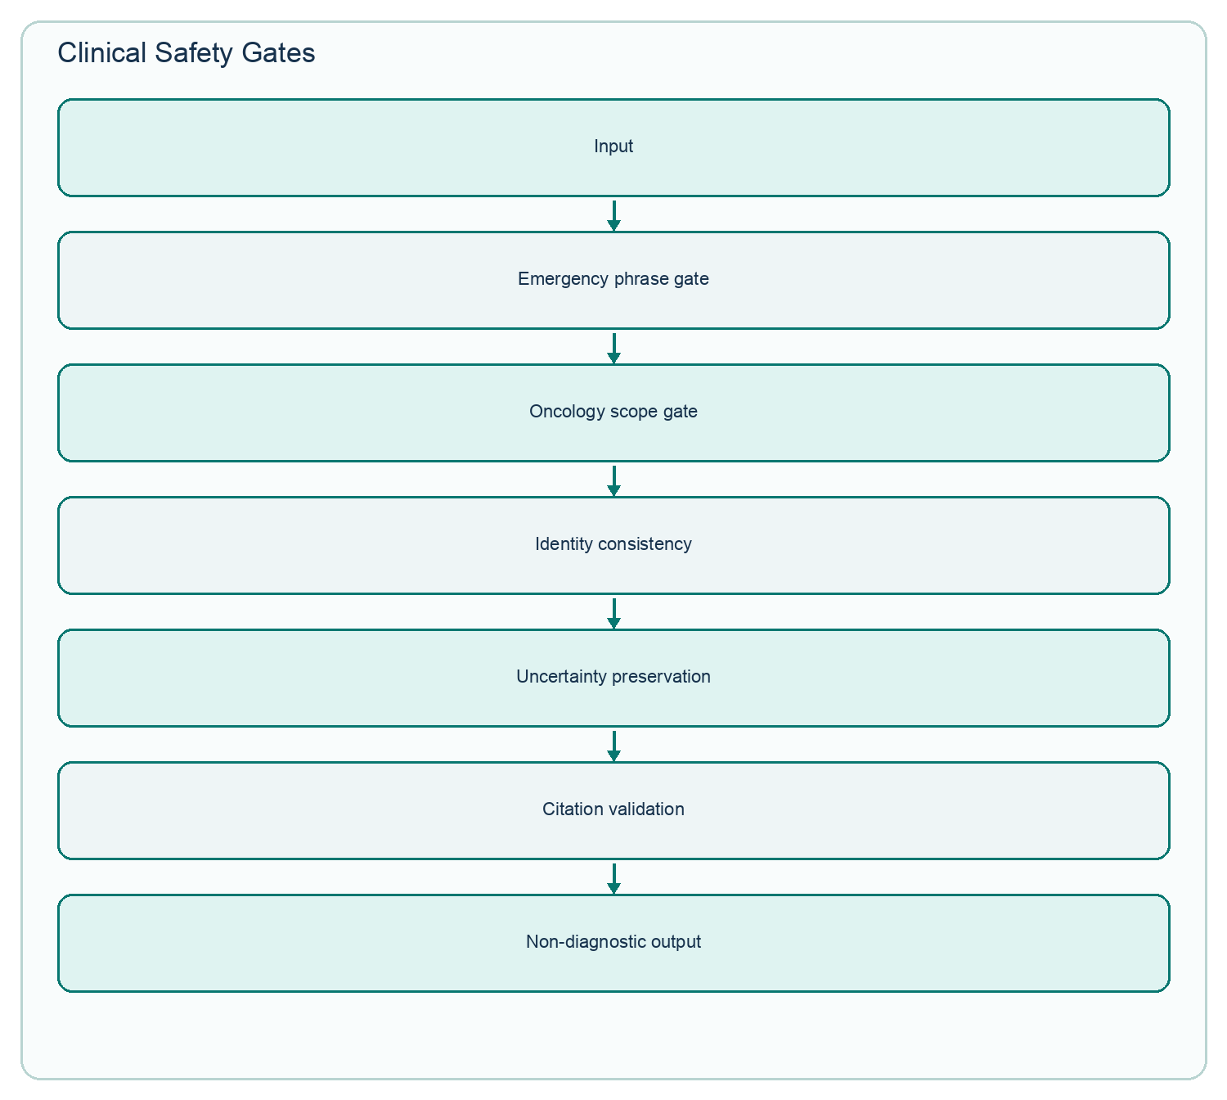
Figure 9. Deterministic and generative safety controls surround retrieval and generation.
Safety begins before model generation. Active emergency language is intercepted; negated or hypothetical emergency phrases are treated differently. Out-of-scope questions are refused, and requests for a guaranteed diagnosis are blocked. The response keeps suspicious or indeterminate wording instead of escalating it into certainty. Citation validation removes or flags unsupported identifiers, and hard identity mismatches stop combined analysis.
Unsafe wording | Safer evidence-preserving wording
The liver lesions are metastases. | The report describes liver lesions as suspicious for metastases; further characterization was recommended.
The scan proves cancer. | The image may support the documented concern, but imaging similarity alone cannot confirm a diagnosis.
You have an 86% chance of cancer. | The answer has 86% Evidence Support under an uncalibrated retrieval-and-citation heuristic; this is not a cancer probability.

20. PostgreSQL Application Architecture
The repository configures one SQLAlchemy database engine from DATABASE_URL. FastAPI is the only intended user-facing access path. The schema covers users and authentication-linked profile data, upload sessions, reports, medical images, summaries/analysis metadata, messages and legacy chat-history compatibility, and quick-response records. Durable conversational content is now sourced from JSON while PostgreSQL retains the application/session metadata needed to catalog and govern it.
Data boundary Users never connect directly to PostgreSQL. The React frontend calls protected FastAPI endpoints; FastAPI verifies the JWT and ownership before any database, file, or vector operation.

21. React Frontend
Page | What the user sees and does | What the backend does
Login / Sign Up | Access or create an account; recover email/password | Hashes password, digests PIN, issues JWT, validates recovery
Complete Profile | Enter full name, age, gender, occupation | Stores profile and completion status
Dashboard | Ask a question, attach files, open/manage recent work | Uploads, ingests, lists sessions, renames/archives/deletes
Results / Chat | Read structured answer and continue the case | Retrieves, generates, validates, scores, persists conversation
History | Review and reopen active analyses | Lists non-archived sessions owned by the user
Archive | Restore or permanently delete archived work | Changes archived_at or deletes files/vectors/history
Profile | View/edit account details | Reads or updates the authenticated user's profile
Settings | Change password or recovery PIN | Verifies credentials and rotates protected values

SCREENSHOT INSERTION POINT — RESULTS / CHAT
Capture the structured answer, Evidence Support card, urgency/complexity guidance, evidence list, disclaimer, and follow-up composer with synthetic data.
No repository screenshot was available; capture the running application without patient-identifying data.
Figure placeholder: Results / Chat screen (real runtime capture required).

22. Results Screen
The Results screen deliberately avoids presenting one unbroken paragraph. Depending on the response contract, it can show a headline, plain-language summary, findings-at-a-glance table, staging section, important limitations, medical-term explanations, uploaded sources, related text/image evidence, citations, case complexity, care urgency, generation status, and Evidence Support.
This structure helps a reader separate what the patient document says, what related evidence adds, what remains unresolved, and what action guidance means. The page labels retrieval-only fallback when Gemini is unavailable and states that urgency guidance is not an emergency diagnosis or cancer-risk probability.

23. History and Archive
Users can reopen completed analyses from Dashboard or History. Sessions support human-readable renaming. Archive is reversible: it records archived_at and removes the item from normal history. Restore clears that marker. Permanent deletion removes the session's stored files, private vectors, runtime cache entry, conversation JSON, and database records according to the implemented route.
SCREENSHOT INSERTION POINT — HISTORY AND ARCHIVE
Capture active and archived session cards, rename/archive/restore actions, and the permanent-delete confirmation using synthetic case names.
No repository screenshot was available; capture the running application without patient-identifying data.
Figure placeholder: History and Archive screen (real runtime capture required).

24. Quick Responses
Greetings, thanks, help, and product-help questions can be answered through deterministic/database-seeded quick responses before model loading, embeddings, vector search, or Gemini. This short path improves response time, reduces model API usage and cost, and makes common conversational interactions predictable. It does not bypass retrieval for genuine clinical questions.

25. Evaluation
The current retrieval summary is a dated, checked-in 50-case evaluation artifact created on 18 August 2026. Its macro Precision@1 is 0.90, Recall@5 is 0.90, MRR@5 is 0.90, and nDCG@5 is 0.90. By query type, Precision@1 is 1.00 for text, 0.90 for image, 0.80 for hybrid, and 0.80 for text-to-image. These values describe the specific known-item/annotation setup and should not be interpreted as clinical diagnostic accuracy.
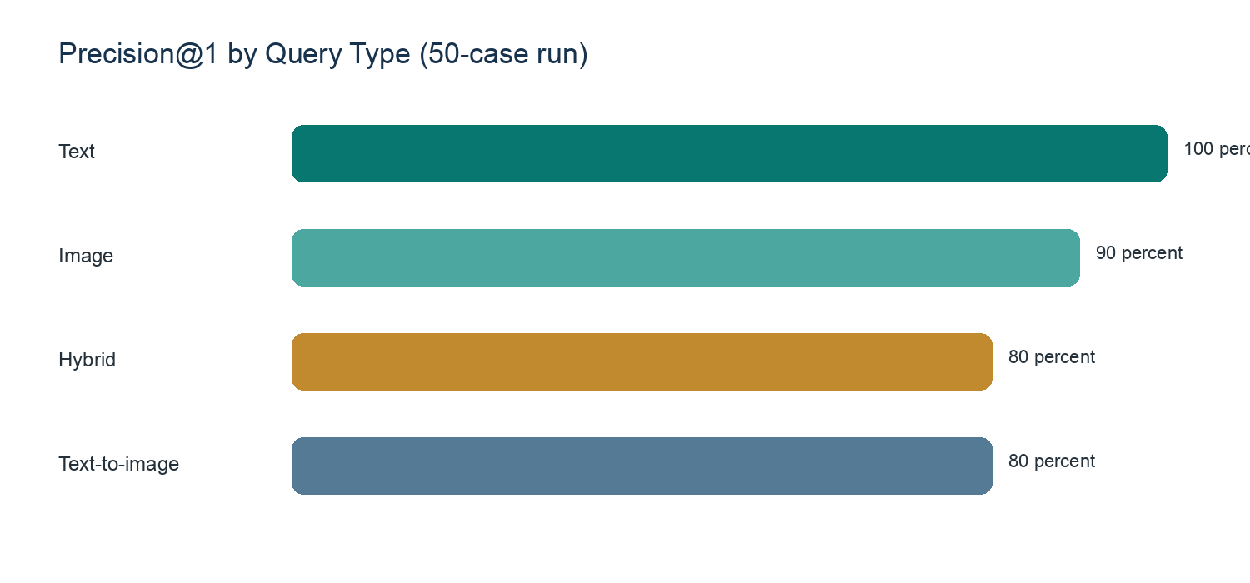
Figure 10. Precision@1 by query type in the current 50-case retrieval artifact.
Metric | Plain-language meaning | Current macro value
Precision@1 | How often the first retrieved item is judged relevant | 0.90
Recall@5 | How often relevant material is recovered within five results | 0.90
MRR@5 | How early the first relevant item appears, capped at five | 0.90
nDCG@5 | How well relevant items are ordered in the top five | 0.90

A separate 20-case automatic answer artifact reports 100% citation validity, citation coverage, structured-section presence, limitation presence, and disclaimer presence. Those checks validate output structure, not clinical correctness. The artifact itself warns that clinician review is required before medical-quality claims.
The performance summary records 41/41 API acceptance checks passing. On the development machine, median overall API time was 835 ms; retrieval requests had a 974 ms median but a much larger 19.3-second p95, while the 16-case structured benchmark had a 17.3-second median. Provider and hardware conditions can change these values.

26. Testing
The repository contains query, ingestion, backend, evaluation, frontend, architecture-contract, safety, consistency, prompt, reliability, and conversation-cache tests. For this documentation pass, 80 focused deterministic backend tests were executed on 26 August 2026 and all passed in 0.307 seconds. The checked-in 41-case API acceptance artifact also reports zero failures. Live Gemini, PostgreSQL, Chroma, and production-build checks were not rerun for this report.
Test category | Purpose | Evidence / result
Prompt store | External document IDs, placeholders, duplicates | 4 focused tests passed now
Conversation JSON/cache | Persistence, expiry, rehydration, isolation | 12 focused tests passed now
Reliability score | Eligibility, components, uncertainty penalty | 3 focused tests passed now
Safety and scope | Emergency, guarantees, oncology boundary | 15 focused tests passed now
Upload ingestion | Chunking, negation, PDF, image quality | 5 focused tests passed now
Multifile consistency | Hard conflicts and soft warnings | 6 focused tests passed now
Architecture contracts | Private vectors, JSON source of truth, DB models | 5 focused tests passed now
Analysis pipeline | Routing, citations, fallbacks, model errors | 30 focused tests passed now
API acceptance artifact | Conversation, retrieval, safety, upload routes | 41 passed / 0 failed (dated artifact)

27. Limitations
Oncology AI is a strong internship prototype, but a professional assessment must be explicit about what it cannot guarantee.
- It is not a certified medical device and has not undergone regulatory validation.
- Gemini output can be incomplete or wrong even when the retrieval context is good.
- The Evidence Support score is a heuristic and is not clinically calibrated.
- Retrieval evaluation uses a limited case set and known-item judgments; it does not establish clinical accuracy.
- OCR can misread scans, screenshots, handwriting, units, or low-contrast text.
- Image retrieval depends strongly on image quality and interpretable labels/captions.
- The legacy image corpus contains records with unknown labels and empty captions.
- Incomplete patient records can produce incomplete answers; missing history cannot be inferred safely.
- External Gemini use introduces internet, quota, rate-limit, latency, and provider-availability dependencies.
- The current local deployment and process-local recovery limiter are not production-scale infrastructure.
- Conversation JSON and uploaded files require stronger encryption, retention governance, and privacy review before clinical deployment.
- Clinician-reviewed testing, monitoring, role-based access, audit logging, and formal threat modeling remain necessary.

28. Benefits and Practical Use
The project's value is organizational and explanatory. It makes long reports queryable, keeps reports and images in one case workspace, retrieves supporting evidence, preserves uncertainty, and presents the result in a form that can be reviewed rather than merely trusted. A user can revisit previous work, continue a case after runtime-cache expiry, and see why an answer received its evidence-support level.
The application is useful as a clinical-information assistant, education and internship demonstration, or research prototype. Its safest role is to help people locate and understand documented information while keeping the final clinical interpretation with qualified professionals.

29. Future Improvements

29.1 Immediate improvements
- Capture and insert de-identified screenshots for every major screen.
- Encrypt conversation JSON and uploaded files at rest; define retention and deletion policy.
- Calibrate Evidence Support against clinician-reviewed answers and rename thresholds if needed.
- Expand prompt and retrieval tests for biomarkers, staging, prior procedures, and longitudinal cases.
- Improve accessibility testing, keyboard navigation, and mobile responsiveness.
- Add production monitoring for latency, quota events, retries, fallbacks, and unsafe-output reports.

29.2 Longer-term improvements
- Clinician-led prospective validation on larger, representative cases.
- DICOM support and modality-specific medical image preprocessing.
- Additional cancer datasets with higher-quality captions and provenance.
- Local/offline language-model options for privacy and resilience.
- Cloud deployment with encrypted object storage, role-based access control, and immutable audit logs.
- Multilingual report explanation and terminology support.
- Stronger longitudinal case reconciliation across dates, institutions, and changing identifiers.

30. Complete Architecture and Conclusion
Figure 11. Final end-to-end view of the implemented system.
Oncology AI combines a React user experience, FastAPI security and orchestration, one PostgreSQL application database, durable conversation JSON, private and reference Chroma collections, MedCPT text retrieval, BiomedCLIP image retrieval, selective weighted RRF, external prompt contracts, Gemini generation through LangChain, citation validation, conservative safety routing, and an uncalibrated Evidence Support score.
Its most important design choice is grounding: the system is built to answer about the uploaded patient case and to show supporting evidence and limitations. Its most important boundary is equally clear: it supports human review; it does not replace it.

Appendix A — Implementation Verification Map
Area verified | Principal repository sources
Routes and limits | backend/app/api/routes/auth.py, upload.py, analysis.py, profile.py
Ingestion | backend/app/services/upload_ingestion.py, pdf_extraction.py; LangChain_Layer/ingestion
Retrieval | Query/pipeline.py, hybrid_search.py, retriever.py, query_encoder.py
Generation/prompts | backend/app/langchain/pipeline.py, service.py, prompt_store.py; prompts/oncology_ai_prompts.docx
Memory/history | conversation_cache.py, chat_history_store.py, UploadSession models/routes
Safety/consistency | safety_responses.py, conversation_responses.py, upload_consistency.py
Frontend | frontend/src/App.js and pages Login, Dashboard, Results, History, Archive, Profile, Settings
Data scale | text_embeddings_manifest.json, image_embeddings_manifest.json, dataset CSVs
Evaluation/testing | Evaluation/outputs/*.json, Evaluation/README.md, TESTING.md, backend/tests

Appendix B — Implemented vs Planned
Requested item | Current status | Documentation decision
Separate backend/app/prompts folders | Not present | Documented actual single external DOCX prompt store
30-minute conversation continuity | Implemented | Clarified cache expiry vs durable JSON
Evidence Support percentage | Implemented, uncalibrated | Documented formula and warning
Hard/soft multimodal checks | Implemented | Documented exact hard conflicts and current soft warnings
Real screenshots in repository | Not present | Added explicit runtime screenshot insertion points
DICOM support | Not implemented | Listed as long-term enhancement
Clinically calibrated confidence | Not implemented | Listed as future validation work
Production privacy/security controls | Partial/local prototype | Listed as deployment limitation and improvement

Appendix C — Documentation Notes
Screenshots used: the real Oncology AI logo only. No UI screenshot files were present in the repository, and the document therefore uses labeled insertion panels rather than invented interfaces.
Diagrams created: overall architecture, ingestion, query flow, MedCPT, BiomedCLIP, prompt routing, conversation cache, safety gates, dataset scale, and evaluation Precision@1.
Implementation mismatch discovered: the prompt system is externalized in prompts/oncology_ai_prompts.docx, not in backend/app/prompts/ with multiple category files. The Results route also serves as the chat screen; there is no separate /chat page. The conversation source of truth is JSON, while PostgreSQL retains application/session metadata and legacy-compatible models.

