Scalable Network I/O: From select to io_uring
Chitiveli Hemcharan Varma  2411095 |  | Gella Naga Sai Krishna  24110122 | Guransh Kaur Saran  24110127
 | Pallav Biyala  24110234 |  | Kowel P Laloo  24110168

I. Introduction
Network servers support a wide range of applications, including web services, file sharing, and real-time communication. As the number of concurrent clients increases, efficiently managing network connections becomes essential for maintaining throughput, reducing latency, and controlling resource consumption.
Linux provides several mechanisms for handling multiple network connections. Traditional interfaces such as select() and poll() monitor file descriptors for readiness, while epoll provides event-driven notification. The newer io_uring interface uses submission and completion queues to support asynchronous I/O operations.
This project implements and evaluates TCP-based Echo and File Transfer servers using four I/O backends: select(), poll(), epoll, and io_uring. Their performance is compared under varying workloads, including different concurrency levels, transfer sizes, connection-management strategies, and client behaviours. The evaluation considers throughput, latency, and resource utilization to identify the practical trade-offs between these approaches.

II. Problem Statement
This project investigates how different Linux I/O mechanisms affect the performance of concurrent network servers. Two TCP-based applications, an Echo Server and a File Transfer Server, are implemented using select(), poll(), epoll, and io_uring.
Inputs: Client connections, network requests, workload parameters such as concurrency and data size, and server configuration settings.
Outputs: Echoed data or transferred files, along with performance measurements including throughput, latency, and resource utilization.
Assumptions and Constraints: The servers operate in a Linux environment and use TCP for communication. Comparisons are conducted under controlled configurations, although results may depend on hardware, operating-system behaviour, and client-side limitations.
Scope: The project evaluates the four I/O backends across different workloads and configurations. The objective is to understand their practical performance characteristics and trade-offs rather than establish a universally superior mechanism.

III. Project Objectives
The primary objectives of this project are:
- Implementation: Develop TCP-based Echo and File Transfer servers supporting four I/O backends: select(), poll(), epoll, and io_uring.
- Concurrency: Enable the servers to handle multiple simultaneous client connections.
- Performance Evaluation: Measure throughput, latency, and resource utilization under varying workload conditions.
- Comparative Analysis: Compare the performance and scalability of the four I/O backends across different workloads.
- Experimental Validation: Verify server correctness and data integrity through automated tests and controlled benchmarking.

IV. Architecture and Design
A. Overall Architecture
The project follows a client-server architecture in which clients communicate with server applications over TCP. Both server applications support four alternative I/O backends: select(), poll(), epoll, and io_uring. These backends provide different mechanisms for monitoring and handling multiple client connections.
The overall architecture consists of three main components:
- Client: Establishes connections, sends requests, and receives server responses.
- Server Application: Processes client requests and performs the required operations.
- I/O Backend: Monitors connection events and coordinates socket I/O operations.
The use of interchangeable I/O backends allows the applications to be evaluated under different networking workloads while keeping the overall application functionality comparable.
B. Echo Server Architecture
[To be completed by the Echo Server team.]
This subsection will describe the Echo Server's architecture, request-response workflow, implementation of the four I/O backends, and relevant design decisions and trade-offs.
C. File Transfer Server Architecture
The File Transfer Server is designed to serve file requests from multiple concurrent TCP clients. Its architecture separates connection management, event handling, and file-transfer processing.
The server uses an event-driven approach to monitor client connections and process socket events. Depending on the selected backend, readiness notifications are obtained through select(), poll(), or epoll(), while io_uring uses submission and completion queues for asynchronous I/O operations.
When a client connects, the server accepts the connection and monitors it for incoming requests. Upon receiving a valid file request, the server processes the request, reads the requested file, and transmits its contents to the client. This process continues while the server handles other active connections.
The four backends provide alternative approaches to connection and event management while supporting the same file-transfer functionality.
Design Decisions and Trade-offs
The following design decisions were made during implementation:
- Multiple I/O backends: Supporting four backends enables comparative evaluation without changing the fundamental application workload.
- TCP communication: TCP provides reliable and ordered data delivery, making it suitable for file transfers.
- Single-threaded server architecture: Simplifies connection management and avoids additional synchronization overhead. However, it limits the ability to exploit multiple CPU cores.
- Configurable transfer parameters: Transfer chunk sizes and socket buffer configurations allow investigation of their effects on throughput and latency.
- Persistent connections: Keep-alive support allows clients to reuse connections, reducing repeated connection-establishment overhead.
These decisions balance implementation complexity, experimental comparability, and performance evaluation.
File Transfer Server Experimental Configurations
Several experiments were conducted to investigate how workload characteristics and server configurations influence performance:
Experiment | Configuration investigated
E5a | Varying concurrency levels and file sizes
E5b | Connection close versus persistent connections (keep-alive)
E7 | Transfer chunk sizes and socket buffer configurations
E8 | Impact of slow-reading clients on concurrent fast clients
E9 | TCP_NODELAY enabled versus disabled
These experiments examine different aspects of network I/O performance, ranging from connection-management overhead to data-transfer behaviour and the handling of heterogeneous client workloads. The detailed methodology, configurations, and measured results are presented in the Evaluation section.

V. Implementation
A. Development Environment and Tools
The project was developed in C for a Linux environment. Linux system calls and networking APIs were used to implement TCP socket communication and the different I/O backends. The implementation uses four mechanisms: select(), poll(), epoll, and io_uring.
The development and evaluation environment consisted of:
- Programming Language: C
- Operating System: Linux running under WSL2
- Networking: Linux TCP socket APIs
- I/O Interfaces: select(), poll(), epoll, and io_uring
- Benchmarking: wrk and custom scripts
- Data Analysis and Visualization: Python, NumPy, and Matplotlib
- Hardware: Intel Core i5-10300H processor (4 cores, 8 logical processors)
B. Echo Server Implementation
[To be completed by the Echo Server team.]
This subsection will describe the Echo Server implementation, including the programming language, libraries, backend-specific implementation, request-processing workflow, and challenges encountered during development.
C. File Transfer Server Implementation
The File Transfer Server was implemented in C using Linux TCP socket APIs. It supports four I/O backends, allowing the server to handle multiple client connections using different event-notification and I/O mechanisms.
The implementation consists of the following major components:
- Socket Initialization: Creates and configures the TCP listening socket, binds it to the required address and port, and starts listening for incoming connections.
- Connection Management: Accepts incoming client connections and maintains the necessary connection state while monitoring active sockets.
- I/O Backend: Implements four alternative mechanisms:
  - select(): Monitors multiple file descriptors using the select() system call.
  - poll(): Uses a polling interface to monitor events on multiple file descriptors.
  - epoll: Uses Linux's event notification interface to monitor socket readiness.
  - io_uring: Uses submission and completion queues to coordinate asynchronous I/O operations.
- File Transfer Processing: Processes client requests, accesses the requested file, and transmits its contents over the TCP connection.
- Benchmarking Support: Provides configurable parameters for evaluating different workloads, including client concurrency, file sizes, transfer chunk sizes, socket buffer settings, connection behaviour, and TCP_NODELAY.

Algorithms and Processing Workflow
The server follows an event-driven processing model. Its general workflow is:
Pseudocode:
INITIALIZE server socket
INITIALIZE selected I/O backend

WHILE server is running:
WAIT for socket events using selected backend

FOR each reported event:
IF event belongs to listening socket:
ACCEPT new client connection
REGISTER client with I/O backend

ELSE IF event indicates client activity:
RECEIVE client request
PROCESS requested file

WHILE file data remains:
READ next chunk
SEND data to client

HANDLE connection according to configured mode
The backend-specific event-monitoring mechanisms differ, but the overall file-transfer functionality remains consistent.
Challenges Faced and Solutions
One major implementation challenge was supporting multiple I/O backends while maintaining consistent application behaviour. Each backend exposes a different interface for monitoring socket events and handling I/O operations. This was addressed by keeping the file-transfer functionality conceptually separate from backend-specific event handling.
Another challenge was evaluating performance fairly across different configurations. Variations in concurrency, file size, connection reuse, and buffer settings can influence measured performance. Controlled benchmark configurations and repeated runs were therefore used to compare the backends.
Slow-reading clients also introduced a challenge because they can affect how quickly the server completes data transfers. A dedicated experiment was conducted to study their impact on concurrent fast clients.
Finally, correctness was checked through automated tests and data-integrity validation to ensure that transferred data matched the expected content.

Repository: CS331-T008-NetworkIO — GitHub repository

VI. Testbed Setup
A. Echo Server Testbed
[To be completed by the Echo Server team.]
This subsection will describe the hardware and software environment used for Echo Server experiments, including CPU, memory, operating system and kernel versions, network topology, client configuration, workload characteristics, and benchmark parameters.
B. File Transfer Server Testbed
1. Hardware Environment
The experiments were conducted on a system equipped with an Intel Core i5-10300H processor operating at 2.50 GHz. The processor has 4 physical cores and 8 logical processors, with Hyper-Threading enabled.
The experiments ran inside WSL2, which reported approximately 7.6 GiB of memory and 2 GiB of swap space to the Linux environment.
CPU affinity was configured to reduce interference between the server and benchmark client:
- Server: Pinned to logical CPU 1.
- Benchmark Client: wrk running with 4 threads, pinned to logical CPUs 2–5.
2. Software Environment
The experimental environment consisted of:
- Host Environment: Windows with WSL2.
- Operating System: Linux running under WSL2.
- Linux Kernel: Version 6.18.54.
- Programming Language: C.
- Benchmarking Tool: wrk.
- Supporting Tools: Custom scripts for experiment execution and result collection.
- Data Analysis: Python, NumPy, and Matplotlib.
3. Network Topology
The server and benchmarking client operated on the same machine and communicated through the loopback interface using TCP.
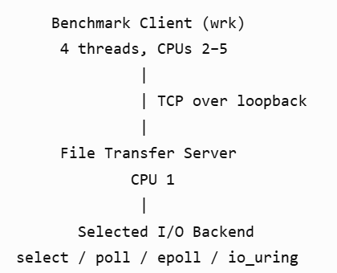
Using loopback communication eliminated external network dependencies and provided a controlled environment for comparing the server implementations.
4. Workloads and Datasets
The experiments used file-transfer workloads with different file sizes and client behaviours.
The evaluated configurations included:
- File Sizes: 4 KiB, 64 KiB, 1 MiB, and 100 MiB, depending on the experiment.
- Concurrency: Different numbers of simultaneous client connections.
- Connection Behaviour: Connection closure after requests versus persistent TCP connections using keep-alive.
- Transfer Configuration: Different transfer chunk sizes and socket buffer settings.
- Client Behaviour: Normal fast clients and artificially rate-limited slow readers.
For the slow-reader experiment, 100 fast clients requested 100 MiB files while additional slow readers consumed data at 100 KiB/s. The number of slow readers was varied to study their effect on concurrent fast clients.
5. Benchmark Configuration
The benchmark campaigns generally followed a consistent execution procedure:
Parameter | Configuration
Warm-up duration | 10 seconds
Measurement duration | 30 seconds
Cooldown duration | 10 seconds
Repetitions | 5 runs per configuration
Client tool | Wrk
Client threads | 4
Server CPU affinity | Logical CPU 1
Client CPU affinity | Logical CPUs 2–5
The slow-reader experiment used an extended measurement duration of 90 seconds.
Measurements were summarized using the median and interquartile range across repetitions. Three unsuccessful runs from the slow-reader experiment were excluded from the accepted-run analysis and documented separately.
The collected metrics included throughput, latency, and tail latency.

VII. Evaluation
A. Echo Server Evaluation
[To be completed by the Echo Server team.]
B. File Transfer Server Evaluation
The File Transfer Server was evaluated across five experiments (E5a, E5b, E7, E8 and E9) to compare the four I/O backends and investigate the effects of connection management, transfer configuration, slow clients and TCP-level settings.
1. Backend Performance (E5a)
The four I/O backends achieved broadly comparable throughput across most tested configurations. However, their performance differences became more noticeable at higher concurrency. At 1,000 concurrent connections, poll achieved approximately 9% lower throughput than epoll.
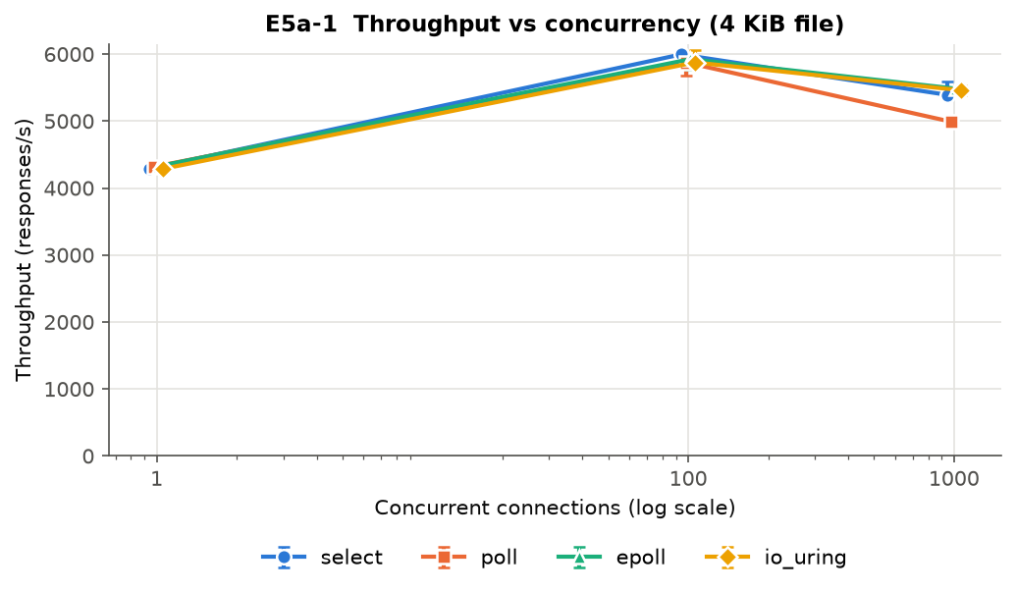
Throughput vs. Concurrency —e5a_1_throughput_vs_concurrency
Large-file transfers reached throughput of approximately 170 MB/s under the tested configurations. These results indicate that all four backends can support high-throughput file transfers, although their behaviour differs under heavier connection loads.
Latency increased with concurrency across the backends. A notable result was observed for io_uring at 1,000 connections: despite maintaining comparable throughput, it exhibited approximately 4.5 times the mean latency of epoll. Its p99 latency reached approximately 13.5 seconds, compared with approximately 0.24 seconds for epoll. This indicates a significant tail-latency disadvantage for io_uring in this configuration.
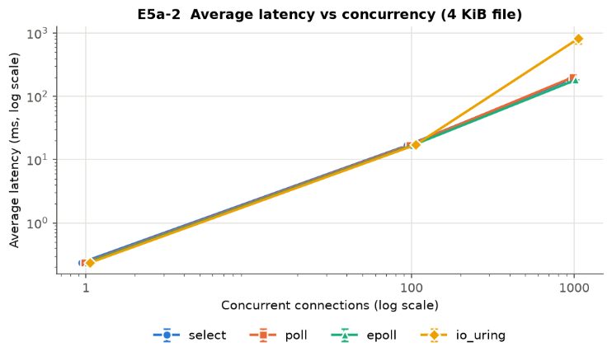
Latency vs. Concurrency — e5a_2_latency_vs_concurrency
CPU-efficiency measurements provided another useful distinction between the backends. In most tested file-transfer configurations, io_uring used approximately 7–13% less server CPU time per response than epoll. This result should be interpreted in the context of the implementation: the readiness-based backends perform an additional copy of file data, whereas the io_uring implementation reads directly into the send buffer. Thus, the measured difference reflects both the I/O mechanism and the implementation.
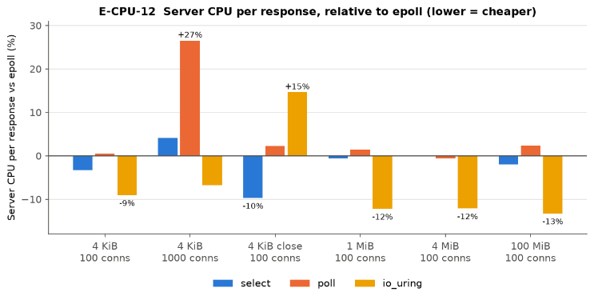
Relative CPU Time per Response — cpu_12_cpu_per_response_vs_epoll
Server core utilisation was also monitored across the benchmark configurations. The measured utilisation reached approximately 48% at its maximum. This indicates that the server core was not continuously saturated during the experiments. However, since the benchmarks were conducted over the WSL2 loopback interface and client-side CPU utilisation was not recorded, the exact source of any throughput limitation cannot be established.
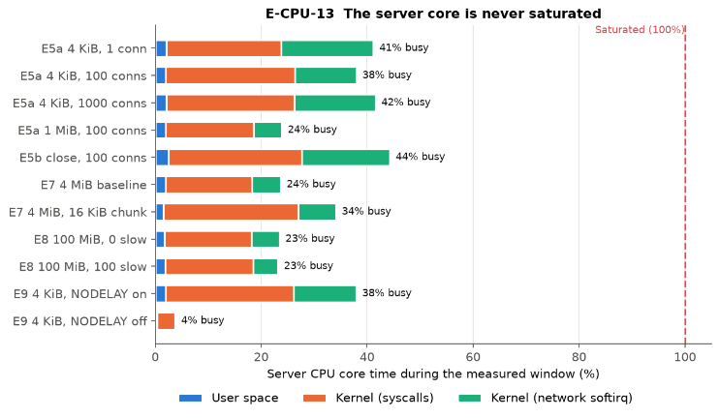
Server Core Utilisation — cpu_13_server_core_utilisation

2. Connection Management (E5b)
The keep-alive experiment compared persistent connections against connection-close behaviour. Enabling keep-alive improved throughput by approximately 5–8% for poll, epoll and io_uring, while select showed negligible improvement.
This suggests that persistent connections can reduce connection-management overhead and improve performance for backends that benefit from connection reuse. Since the experiments were conducted as separate benchmark campaigns, some variation between runs may also have influenced the measured differences.
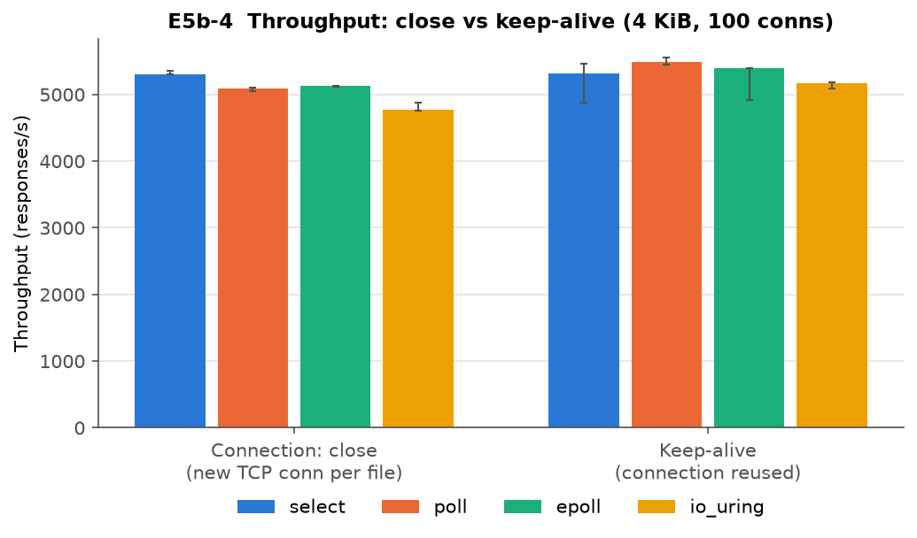
Throughput — Connection Close vs. Keep-Alive — e5b_4_throughput_close_vs_keepalive
3. Transfer Configuration (E7)
The transfer-configuration experiment investigated the effects of application-level chunk size and socket buffer settings. For 4 MiB file transfers, reducing the application chunk size from the 64 KiB baseline to 16 KiB resulted in approximately 41% lower throughput, decreasing from around 169 MB/s to 99 MB/s. Response latency also increased from approximately 2.5 seconds to 4.2 seconds.
In contrast, changing socket send and receive buffer sizes produced no measurable improvement under the tested conditions. These results suggest that application-level transfer chunk size had a more noticeable effect on performance than the socket buffer adjustments evaluated in this experiment.
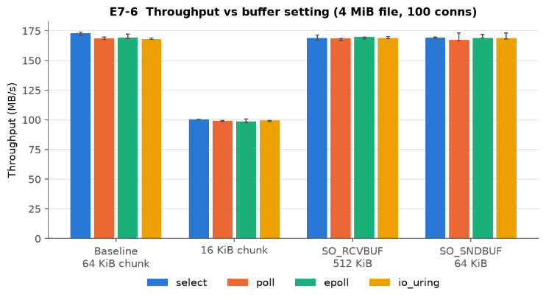
Throughput vs. Transfer Configuration — e7_6_throughput_vs_buffer
4. Slow-Reader Interference (E8)
The slow-reader experiment examined how clients with limited download rates affect concurrent fast clients. One hundred fast clients downloaded 100 MiB files while additional slow readers were introduced at a rate of 100 KiB/s each.
With 100 slow readers, fast-client throughput decreased by approximately 7–11% compared with the configuration without slow readers. This demonstrates that heterogeneous client behaviour can affect overall server performance, even when fast clients continue to receive service.
Three runs at the 100-slow-reader configuration failed to complete any requests and were excluded from the performance summaries. The remaining accepted runs were retained in the analysis, with four repetitions for select, poll and epoll, and five for io_uring. The unsuccessful runs were documented rather than silently discarded.
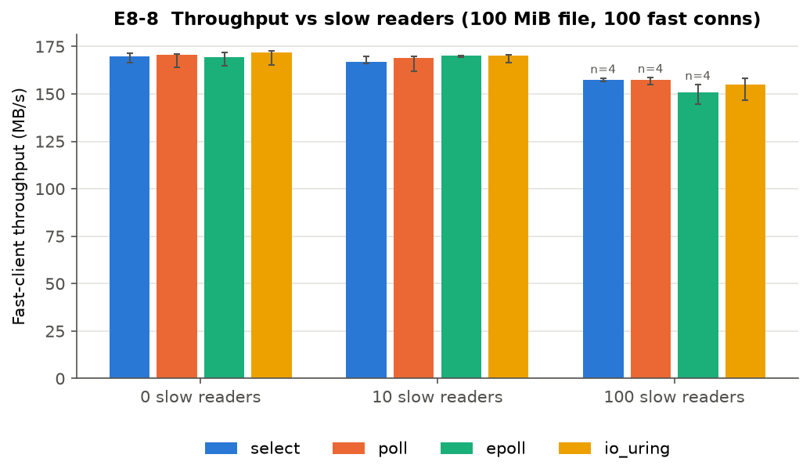
Throughput vs. Number of Slow Readers — e8_8_throughput_vs_slow_readers
5. TCP_NODELAY (E9)
The TCP_NODELAY experiment evaluated the effect of disabling Nagle's algorithm for 4 KiB and 64 KiB file transfers.
For 4 KiB transfers, disabling TCP_NODELAY reduced throughput by approximately 62%, from around 5,900 to 2,270 requests per second. Mean response latency also increased from approximately 17 ms to 44 ms. In comparison, the effect was much less pronounced for 64 KiB transfers.
This indicates that TCP-level configuration can significantly affect small transfers, where protocol overhead and the interaction between Nagle's algorithm and delayed acknowledgements can have a greater influence on performance.
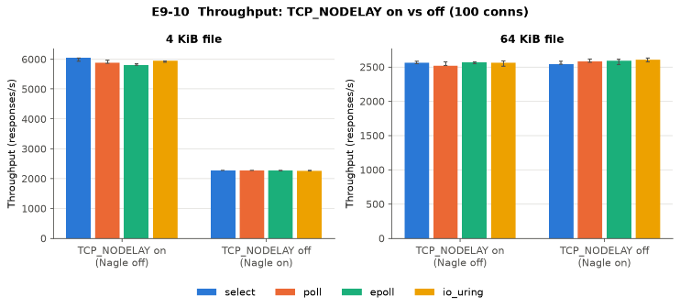
Throughput with TCP_NODELAY Enabled and Disabled — e9_10_throughput_nodelay
Overall Observations
The experiments show that no single I/O backend was consistently superior across every performance metric. Although throughput was broadly comparable in many configurations, differences emerged in CPU efficiency, high-concurrency latency and behaviour under slow-reader interference.
In particular, io_uring demonstrated lower CPU time per response in most tested configurations but substantially higher tail latency at 1,000 connections. Poll showed a throughput disadvantage relative to epoll at high concurrency. The configuration experiments also highlighted the importance of application chunk size, connection reuse and TCP_NODELAY, particularly for small transfers.
Overall, the results demonstrate that server performance depends not only on the underlying I/O mechanism but also on implementation choices, workload characteristics and network configuration.

VIII. Summary
This project implemented and evaluated concurrent TCP-based Echo and File Transfer servers using four Linux I/O mechanisms: select(), poll(), epoll, and io_uring. Their performance was compared across different workloads using throughput, latency, and resource-utilization measurements.
The results showed broadly comparable throughput across backends in many configurations, but important differences emerged under specific workloads. Poll performed relatively worse at high concurrency, while io_uring exhibited substantially higher latency at 1,000 connections despite lower CPU time per response in most tested configurations. Additional experiments demonstrated the benefits of persistent connections and the significant impact of transfer chunk size and TCP_NODELAY on performance.
The evaluation was limited by the use of WSL2, loopback communication, and single-threaded servers pinned to one CPU. Future work could explore physical-network testing, multi-threaded implementations, and a wider range of workloads to investigate scalability and latency further.

IX. Reproducibility
All commands below are executed from the repository root. The source code and experiment configurations are available in the project repository.
A. Environment Setup
1. Install the required dependencies on Linux or WSL:
sudo apt update
sudo apt install build-essential pkg-config liburing-dev \
python3 python3-pip curl wrk
2. Build both server applications and all four I/O backend variants:
make
3. Alternatively, build individual applications:
make echo
make filesrv
B. Echo Server
[To be added by echo team]
C. File Transfer Server
1. Build the four File Transfer Server variants:
make filesrv
2. Start a server, for example:
./build/filesrv-select --port 8081
The other variants are available as filesrv-poll, filesrv-epoll, and filesrv-uring.
3. Run the correctness and benchmark-fixture checks:
make test-filesrv
make test-filesrv-bench
make test-runner-acceptance
4. Alternatively, run the complete available test suite:
make test
5. Generate the benchmark fixtures:
make bench-fixtures
6. Run the individual experiment campaigns using their configuration files:
python3 code/tools/File-Transfer-Server/run_experiment \
code/tools/File-Transfer-Server/configs/filesrv-e5a-size-concurrency.json

python3 code/tools/File-Transfer-Server/run_experiment \
code/tools/File-Transfer-Server/configs/filesrv-e5b-close-retry-c300.json

python3 code/tools/File-Transfer-Server/run_experiment \
code/tools/File-Transfer-Server/configs/filesrv-e5b-keepalive-c300.json

python3 code/tools/File-Transfer-Server/run_experiment \
code/tools/File-Transfer-Server/configs/filesrv-e7-buffer-sensitivity.json

python3 code/tools/File-Transfer-Server/run_experiment \
code/tools/File-Transfer-Server/configs/filesrv-e8-slow-readers.json

python3 code/tools/File-Transfer-Server/run_experiment \
code/tools/File-Transfer-Server/configs/filesrv-e9-tcp-nodelay.json
This runs the benchmarking experiments.
Result and Figure Generation
1. Install the Python plotting dependencies if they are not already available:
python3 -m venv .venv
source .venv/bin/activate
python -m pip install numpy matplotlib
2. Generate the File Transfer Server evaluation figures and summary data:
python3 code/benchmarking-graphs/file-transfer/make_figures.py
The script processes the accepted benchmark runs and generates the plots and data.json containing per-configuration medians, interquartile ranges, sample counts, and rejected-run information.

References
[References do not count toward the 10-page limit.]

Appendix A: Team Work Distribution and Member Rating

A.1 Work Distribution
- Ratings are agreed by the whole team and must be UNIQUE no two members may receive the same rating (no ties).
- Scale: 1–10 (10 = highest contribution). With 3 members, use three different values (e.g., 10, 9, 8).

# | Member Name | Roll No. | Tasks Done | Rating (1–10, unique)
1 | <Member 1>
2 | <Member 2>
3 | <Member 3>

Appendix B: AI Usage Details

B.1 Prompts
Include prompts (or a link to the chat logs) for the most significant uses listed in Table.

# | AI Tool | Purpose
1 | ChatGPT | codex://threads/01a1a2ad-a8c4-7062-9730-30c757a7fa85  https://chatgpt.com/g/g-p-6ae4c7d7be548191adb38bcda1cbb69d-computer-networks/project
2
3
4

Relevant Prompt queries and response .md files be shared on the github <AI Prompts> folder.

