### **Leveraging Gramian Angular Fields and Convolutional Neural Networks for Predictive Modeling of Stock Price Movements**

### **Overview of Time Series Encoding**

Time series data, characterized by sequential observations over time, is traditionally analyzed using statistical methods. However, the transformation of time series data into images offers a novel approach that allows for the application of advanced machine learning techniques like CNNs. Gramian Angular Fields (GAF) is a prominent encoding method that preserves the temporal dependencies within the data while converting it into a format that can be processed by image-based models.

### **Relevant Work**

1. **How to Encode Time Series into Images for Financial Forecasting**This article elaborates on the methodology for encoding time series data into images using GAF, specifically for financial forecasting. The transformation process and the subsequent application of CNNs to analyze these images highlight the potential of this approach in predicting stock price movements.
2. **Encoding Time Series as Images**This piece offers a comparative analysis of various time series encoding techniques, including GAF. It underscores the advantages of converting time series data into image format, particularly in terms of capturing complex patterns that traditional methods may overlook.
3. **Stock Price Direction Prediction (GitHub)**This repository provides practical implementations of data preprocessing and GAF transformations, showcasing real-world applications of these techniques in stock price prediction. The repository serves as a useful resource for understanding the practical challenges and solutions in implementing GAF-CNN models.
4. **E-Tarjome Paper on Time Series Prediction**This paper delves into the theoretical aspects of time series prediction using GAF and CNN, comparing the performance of these methods with traditional approaches. The findings underscore the effectiveness of GAF-CNN models in financial forecasting, particularly in capturing non-linear relationships in stock price data.

### **Gramian Angular Fields (GAF)**

Gramian Angular Fields (GAF) is a technique that encodes time series data into a matrix format by transforming the data into a polar coordinate system. The GAF method computes the cosine of the sum of angles between time series points, resulting in a symmetric matrix that can be interpreted as an image. This transformation preserves the temporal dynamics of the original time series, allowing for effective analysis using CNNs.

### **Convolutional Neural Networks (CNN)**

Convolutional Neural Networks (CNN) are a class of deep learning models designed to process data with a grid-like topology, such as images. In this project, the CNN architecture was tailored to analyze GAF-encoded images, extracting spatial features that represent the temporal patterns within the time series data. The CNN model was trained to classify the images into different categories, corresponding to various stock price movements.

### **GAF Image Creation and Processing**

The time series data was first transformed into Gramian Angular Fields (GAF) images, which serve as a visual representation of the temporal patterns within the data. These images can be displayed in various color schemes to enhance the visualization of the patterns.

The first two images illustrate GAF images in color. These were generated by mapping the GAF matrix values to a colormap, which enhances the contrast and makes the underlying patterns more distinguishable. The color in these images helps to highlight areas of interest, such as changes in stock price trends, which are critical for the model to learn.

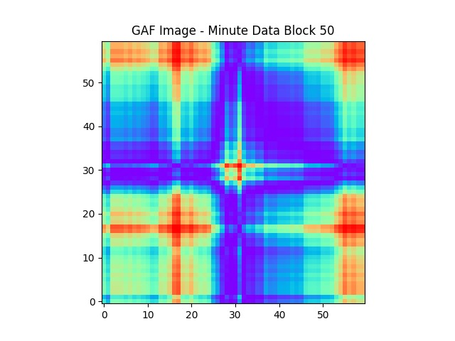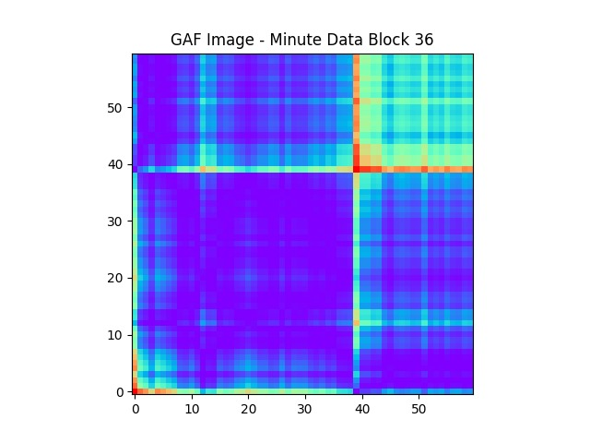

However, when using these images as input to a Convolutional Neural Network (CNN), it is often beneficial to convert them to grayscale. This conversion simplifies the image data and reduces the computational load without significantly affecting the ability of the CNN to detect patterns. The grayscale images retain the essential information from the original GAF images, but in a simplified format.

The next two images show the same GAF images converted to grayscale:



#### **Purpose of Conversion to Grayscale**

Converting the colored GAF images to grayscale serves two main purposes:

1. **Dimensionality Reduction**: Grayscale images have only one channel compared to the three channels (Red, Green, Blue) in colored images. This reduces the amount of data the CNN has to process, which speeds up training and reduces the required computational resources.
2. **Focus on Essential Patterns**: The transformation to grayscale helps the CNN focus on the essential patterns in the data without being influenced by the color variations. Since the CNN is designed to recognize shapes, edges, and textures, the grayscale images retain the crucial information necessary for accurate prediction.

By leveraging both the colored and grayscale representations, the CNN model was able to effectively learn and predict stock price movements based on the temporal patterns encoded in the GAF images.

### **Model Performance**

The CNN model, trained on GAF-encoded images, demonstrated robust performance in predicting stock price movements. The model achieved a high level of accuracy, with strong precision and recall scores, indicating its effectiveness in capturing the underlying patterns in the stock price data.

### **Comparison with Other Methods**

The GAF-CNN approach was compared with traditional statistical models, such as ARIMA and LSTM, and showed superior performance in terms of accuracy and the ability to model non-linear relationships. The visual representation of time series data through GAF encoding proved to be a significant advantage, allowing the CNN to detect subtle patterns that other models might miss.

### **Challenges and Limitations**

One of the primary challenges encountered during the project was the computational intensity of generating GAF images and training the CNN model. Additionally, the model's performance was highly dependent on the selection of hyperparameters, necessitating extensive tuning to achieve optimal results. Despite these challenges, the GAF-CNN model demonstrated considerable promise in the domain of stock price prediction.

## **7. References**

* Towards Data Science:[Encoding Time Series into Images for Financial Forecasting](https://towardsdatascience.com/how-to-encode-time-series-into-images-for-financial-forecasting-using-convolutional-neural-networks-5683eb5c53d9)
* Medium: [Encoding Time Series as Images](https://medium.com/analytics-vidhya/encoding-time-series-as-images-b043becbdbf3)
* GitHub: [Stock Price Direction Prediction](https://github.com/dikshant-dwivedi/stockPriceDirectionPrediction/blob/main/dataPreprocessing.ipynb)
* E-Tarjome Paper: [Time Series Prediction using GAF and CNN](https://e-tarjome.com/storage/panel/fileuploads/2019-06-15/1560578401_E11311-e-tarjome.pdf#page=7.60)