**Q1) Explain the term auditing?**

**Ans-**An audit is independent examination of financial information of any entity, whether profit oriented or not, and irrespective of its size or legal form, when such an examination is conducted with a view to expressing an opinion thereon.

This definition has the following implications:

(a) Audit is independent examination

(b) examination is of financial information when the objective is to express an opinion.

(c) requirement of audit applies in case of every entity, whether profit oriented or not (commercial entities or NGOs), whatever is the business size of entity (Small Size entity or large size entity), whatever is the legal form of the entity (proprietor, partnership or company).

**Q2) Explain the different types of audit?**

**Ans-** Statutory Audit and Internal Audit

Internal audit is done voluntarily without any legal force, whereas Statutory audit is authorised and governed by law.

Although certain types of companies are required to appoint an internal auditor under the Companies Act 2013, there are no reporting guidelines prescribed by the act. The company can in consultation with the Internal Auditor, formulate the scope, and methodology for conducting the internal audit.

**Q3) Explain the concept of consignment accounting?**

**Ans-** Consignment accounting is a business arrangement in which one party (the consignor) agrees to send goods to another party (the consignee) to sell on their behalf. The consignor remains the owner of the goods until they are sold, at which point the consignee receives a commission on the sale.

Under consignment accounting, the consignor records the goods sent to the consignee as inventory on their books, but does not recognize revenue until the goods are sold. This is because the consignor has not yet transferred ownership of the goods to the consignee, and therefore cannot recognize revenue from the sale.

The consignee, on the other hand, does not record the goods as inventory on their books, but rather as goods held in trust for the consignor. When the goods are sold, the consignee records the revenue from the sale, deducts their commission, and remits the remaining proceeds to the consignor.

Consignment accounting is commonly used in industries such as retail, where manufacturers may send goods to retailers on consignment to be sold to consumers. This arrangement allows manufacturers to get their products in front of consumers without having to invest in their own retail outlets, while also minimizing the risk of excess inventory.

**Q4) Explain the concept of a discounting of a bill of exchange?**

**Ans-** Discounting a bill of exchange is a financing technique used by businesses to obtain immediate cash for a bill of exchange, which is a written order that one party (the drawer) gives to another party (the drawee) to pay a certain amount of money at a future date. Instead of waiting for the due date of the bill, the drawer can sell the bill to a bank or financial institution at a discounted price and receive the cash immediately.

The discounting process involves three parties: the drawer, the drawee, and the discounting bank. The drawer first presents the bill of exchange to the drawee, who accepts the bill and promises to pay the specified amount on the due date. The drawer then approaches a bank or financial institution and sells the bill at a discounted rate. The discount is the interest charged by the bank for the time period between the date of the sale and the due date of the bill.

Discounting a bill of exchange provides immediate cash flow to the drawer, allowing them to use the funds for other business purposes. However, it also involves a cost in the form of the discount charged by the bank, which is the interest paid for the early payment of the bill.

**Q5) Compare amalgamation in the nature of merger and amalgamation in the nature of purchase?**

**Ans-** Amalgamation refers to the process of combining two or more companies into a single entity. However, there are two different ways in which this can be achieved: amalgamation in the nature of a merger and amalgamation in the nature of a purchase. Here's how they differ:

Amalgamation in the nature of a merger: In this type of amalgamation, two or more companies combine to form a new entity, with the original companies ceasing to exist. The new entity takes on the assets and liabilities of the original companies, and the shareholders of the original companies receive shares in the new entity in exchange for their shares in the old companies. The new entity is typically formed with the goal of creating synergies between the original companies and leveraging their respective strengths. This type of amalgamation is often referred to as a "merger of equals".

Amalgamation in the nature of a purchase: In this type of amalgamation, one company (the acquiring company) purchases another company (the target company), and the target company is absorbed into the acquiring company. The acquiring company takes on the assets and liabilities of the target company, and the shareholders of the target company receive cash, shares in the acquiring company, or a combination of both, in exchange for their shares in the target company. The acquiring company is typically larger and more powerful than the target company, and the goal of the amalgamation is often to eliminate competition, gain access to new markets or technologies, or acquire valuable assets or intellectual property.

Amalgamation in the nature of a merger involves the creation of a new entity, while amalgamation in the nature of a purchase involves the absorption of one company into another. The former is typically a more collaborative and mutually beneficial process, while the latter is often driven by the acquiring company's desire for strategic advantage or market domination.

**Q6) Compare Amalgamation, absorption and external reconstruction?**

**Ans-** 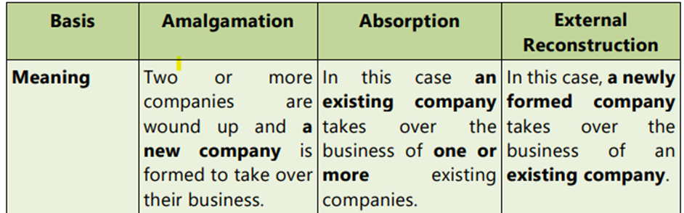

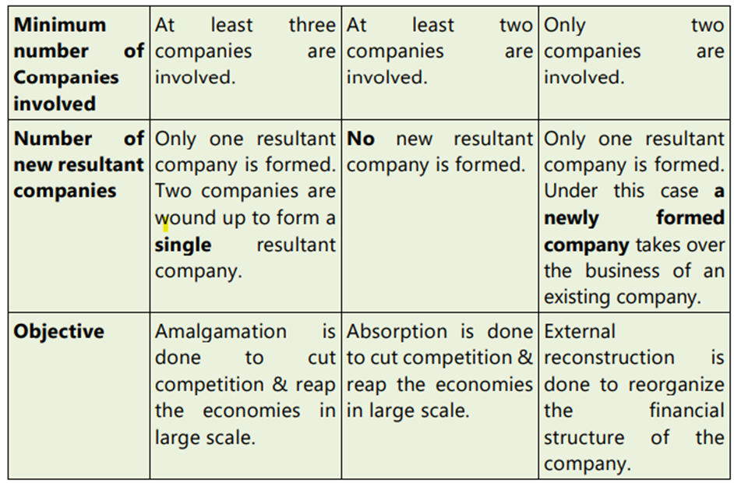

**Q7) Benefits of auditing?**

**Ans-**

**Q8) Purchase Consideration?**

**Ans-**

* It is the price payable by Transferee company to the transferor company for taking over the business of the transferor company
* Amount paid to equity shareholders and preference shareholders is only considered as a purchase consideration
* Purchase consideration does not include the sum which the transferee company will pay to debenture holders or creditors.
* If certain liability of the transferor company is not taken over by Transferee company it will be paid by Transferor company

**Q9) Feaures of Auditing?**

**Ans-**

Systematic examination-

Characterized as a systematic and scientific examination of the books of account of an organization.

2. Check arithmetical accuracy-

Checks the arithmetical accuracy of the books of account by the verification of postings, castings, balances, etc.

3. Check completeness-

Check that none of the entries in the books of account of the client have been omitted in the process of compilation and that nothing which is not in the books of account has found a place in the year-end statements.

4. Done by an independent person or firm-

To be carried out by an independent person (or a firm) who is duly qualified for the job. Should be competent, independent, qualified, and should be possessing the prescribed qualification & certificate of practice.

**Q10) Limitation of audit?**

**Ans-**

1) Judgement In Financial Reporting

2) Generalization and Estimation on the part of the auditor

3) Human Error

4) Ambiguity regarding accounting treatment of certain financial transactions

5) Sample-Based Auditing

6) Management Cooperation Dependency

**Q11) Shalini owes Rs. 26,000 to Anand. Anand draws a bill for Rs. 21,000 on Shalini for 3 months period and received the balance by a crossed cheque.**

**The bill was duly accepted and returned to Anand. On the same day Anand endorsed Shalini's acceptance to Vikram. On the due date Vikram informed Anand that Shalini dishonoured her acceptance and noting charges Rs. 280 were paid. Anand then drew a new bill for 1 month on Shalini including noting charges and interest Rs. 650. On the due date Shalini honoured her acceptance by cheque. Give journal entries in the books of Anand**

**Ans-**

**Particular**

1)Bills Receivable A/c…………Dr. 21000

Bank A/c……………………Dr. 5000

To Shalini's A/c 26000

(Being cheque and acceptance of bill received)

2) Vikram's A/c…………….Dr. 21000

To Bills Receivable A/c 21000

(Being Shalini's acceptance endorsed in favour of Vikram)

3)Shalini's Alc……………………Dr. 21,280

To Vikram's A/c 21,280

(Being endorsed bill dishonoured)

4)Shalini's A/c........... Dr. 650

To Interest A/c 650

(Being interest due)

5)Bills Receivable A/c…………..Dr. 21,930

To Shalini's A/c 21,930

(Being new bill drawn along with noting charges and interest and acceptance received)

6)Bank A/c………………..Dr. 21,930

To Bills Receivable A/c 21,930

(Being Shalini's acceptance duly honoured on the due date)

**Q12) Journalise the following transactions in the books of Apoorva.**

**a) Prashant's acceptance for 60 days Rs. 12,750 deposited into bank for collection.**

**b) Apoorva sold goods to Kirti for Rs. 20,000 and received her acceptance for the same amount for 2 months. The bill was endorsed to Rekha.**

**c) Apoorva renews her acceptance of Rs.36,000 to Anuradha by paying cheque of Rs. 6,000 and accepting a new bill for 2 months for balance along with interest @ 14.5% p. a.**

**Ans-**

1)Bill sent for collection A/c………………Dr 12,750

To Bills Receivable A/c 12,750

(Being bill deposited into bank for collection)

2)Kirti's A/c……...Dr 20,000

To Sales A/c 20,000

(Being goods sold on credit)

3)Bill Receivable A/c……..Dr 20,000

To Kirti's A/c 20,000

(Being drawn and accepted)

4)Rekha's A/c............Dr 20,000

To Bills Receivable A/c 20,000

(Being Kirti's acceptance endorsed)

5)Mukta's A/c……….Dr 24,000

To Bills Receivable A/c 23,850

To Cash A/c 150

(Being Mukta's acceptance dishonoured and Noting

Charges paid)

6)Cash / Bank A/c……..Dr 7200

Bad Debts A/c.....Dr 16,800

To Mukta's A/c 24000

(Being amount received and bad debts written of on account of insolvency)

7)Bills Payable A/c……Dr 36000

To Anuradha's A/c 36000

(Being our acceptance dishonoured)

8) Interest A/c………….Dr 725

To Anuradha's A/c 725

(Being Interest due)

9)Anuradha's A/c………….Dr 6000

To Cash Bank A/c 6000

(Being part payment paid)

10)Anuradha’s A/c…………Dr 30,725

To Bills Payable A/c 30,725

(Being acceptance given to new bill drawn along with interest)