***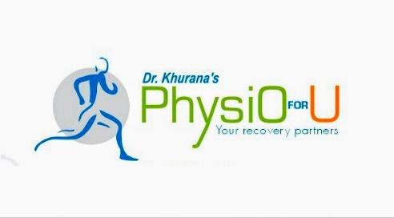   
Dr. Surabhi Pande****Regd. No. A-14414  
BDS,CSD,Dental Surgeon   
Implantologist,  
Certified Sports Dentist* ***Dr. Nitin Khurana*** *Regd. No. 2011/11/PT/001979*  *B.P.Th, MSPT,CKTT,MATT (U.S.A)  
 MASTERS IN SPORTS PHYSIOTHERAPY  
 Head Physiotherapist VCA,  
 BCCI Accredited Physiotherapist   
 Mob. -8875325260   
  
   
  
  
  
Name : …………………………………………………………………………………………………… Age/Sex: ……………………….  
  
………………………………………………………………………………………………………………………………………………………………….  
  
………………………………………………………………………………………………………………………………………………………………….*

*………………………………………………………………………………………………………………………………………………………………….  
  
…………………………………………………………………………………………………………………………………………………………………  
  
………………………………………………………………………………………………………………………………………………………………….  
  
………………………………………………………………………………………………………………………………………………………………….  
  
………………………………………………………………………………………………………………………………………………………………….  
  
…………………………………………………………………………………………………………………………………………………………………  
  
…………………………………………………………………………………………………………………………………………………………………  
   
  
   
Date: ………….. Sign: ……………*