Architecture

# Machine Learning Model

This machine learning architecture is defining how is the model is working from starting to end and what are the success and failure scenarios.

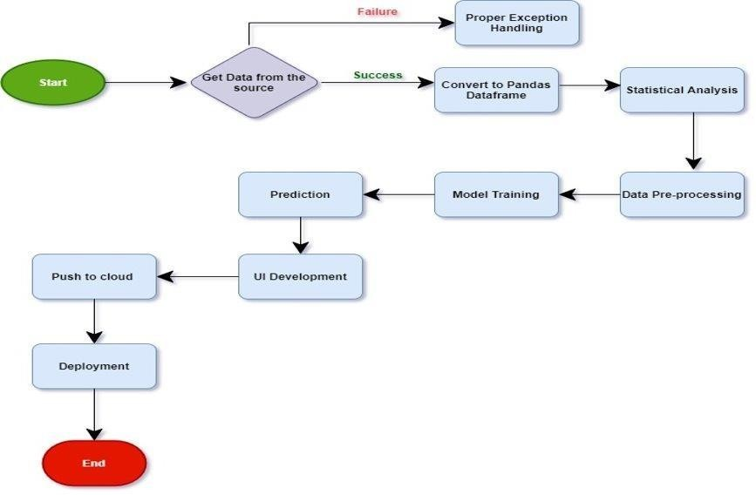

# Input Output Flow of Project

