Restaurant Rating System

***Wireframe Documentation***

Pallav Chavda

Homepage

We have divided Restaurant Rating system into Two Sections: -

1. First thing anyone will see is a pop-up window on Homepage which will ask for User Inputs like what are the facilities provided by the restaurants and what is the location of the reastaurants.

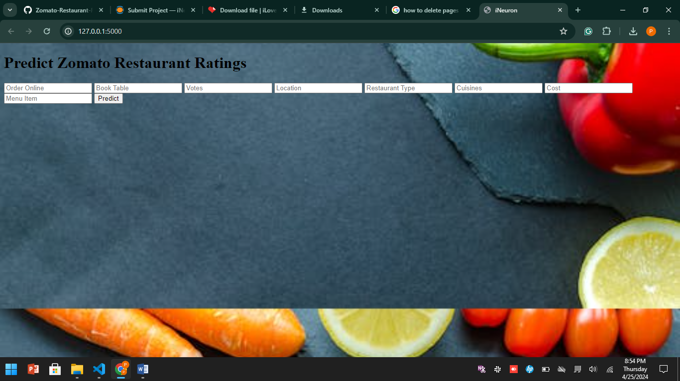

1. The User will encounter with another pop-up window showing the predicted result.



*About Page*

Based on User’s input, our Restaurant Rating System will show the predicted result on the next pop up. A sample view of Homepage showing results is below:

WEB LOGO

PREDICT BUTTON

RESTAURANT DETAILS

The **Crossed Sections** in above sample can be used for images of food as background to give user a good experience. Predicted result will show when all the details are filled and user hit the predict button at the bottom.

WEB LOGO

PREDICTED RESULT

RESTAURANT DETAILS

ZOMATO LOGO