1st assignment :
Install master Jenkins
1 yum list java*
2 yum install java-17-amazon-corretto.x86_64 -y
3 cd /mnt
4 mkdir servers
5 cd servers
6 wget https://dlcdn.apache.org/tomcat/tomcat-10/v10.1.54/bin/apache-tomcat-10.1.54.zip
7 ls -lrt
8 unzip apache-tomcat-10.1.54.zip
9 rm -rf apache-tomcat-10.1.54.zip
10 ls -lart
11 cd apache-tomcat-10.1.54
12 ls -lart
13 cd webapps
14 wget https://get.jenkins.io/war-stable/2.541.3/jenkins.war
15 ls -lart
16 cd /
17 cd /root
18 cd ../..
19 cd /root
20 /mnt
21 cd /mnt
22 cd servers
23 ls -lart
24 cd apache-tomcat-10.1.54
25 ls -lart
26 cd bin
27 ls -lart
28 ./startup.sh
29 cd ../.
30 cd ..
31 chmod -R 777 apache-tomcat-10.1.54
32 cd apache-tomcat-10.1.54
33 cd bin
34 ./startup.sh
35 cd /root
36 ls -lart
37 cd .jenkins
38 ls -lart
39 cd secrets
40 ls -lart
41 cat initialAdminPassword
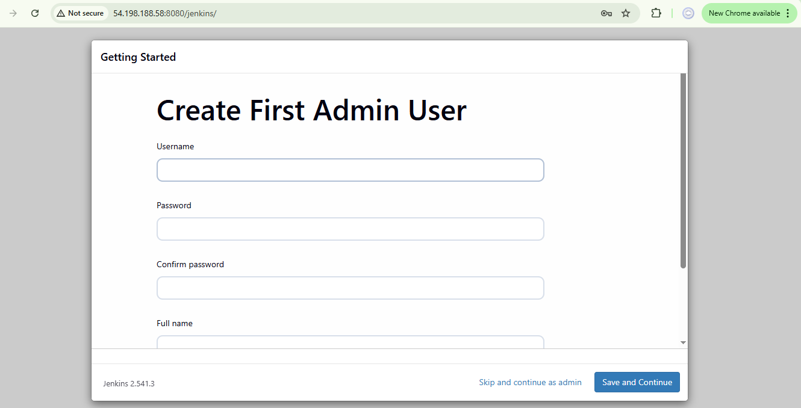
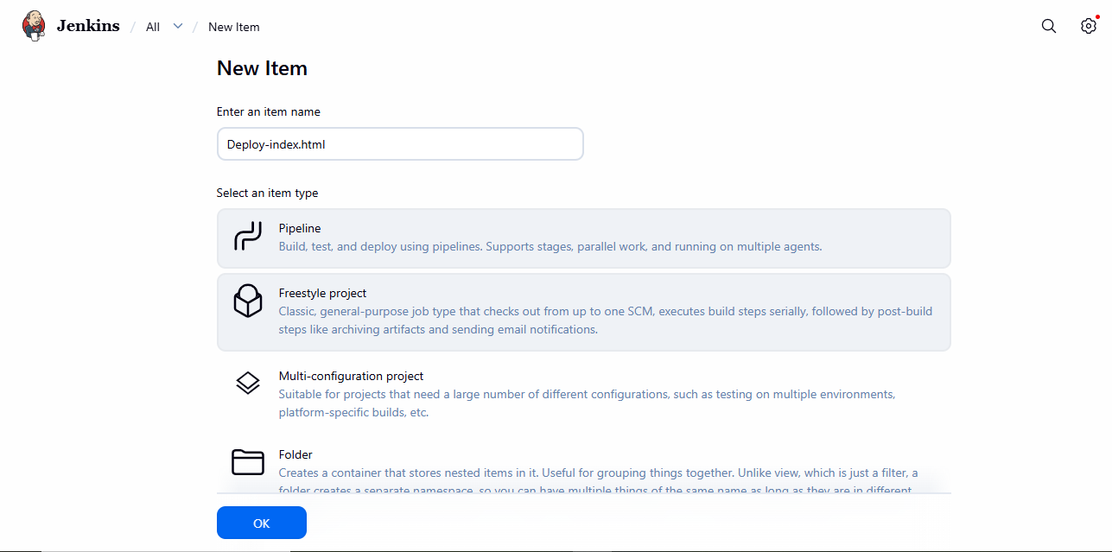
Execute shell :
#!/bin/bash

yum install httpd -y
service httpd start
echo "hello world" >> /var/www/html/index.html
chmod -R 777 /var/www/html/index.html
