Data Analysis Capstone project
Prepared using Power BI
NAME: SINCHANA NARASIMHA MURTHY
USN: 1DA24CS190
4TH SEM ‘D’ SECTION

1. Introduction
This project focuses on analyzing supply chain operations using Power BI. The dashboard was developed to evaluate business performance using key metrics such as revenue generation, order quantities, delivery efficiency, and supplier performance. The project provides insights that help in understanding operational efficiency and identifying high-performing product categories.

2. Dataset Used
Dataset Name: Supply Chain Dataset (supply_chain_data.csv)
Tool Used: Power BI
Dataset Type: Supply Chain and Operational Data
The dataset contains information related to product categories, suppliers, order quantities, delivery days, revenue generated, costs, and profit metrics. The dataset was used to perform operational and comparative analysis.

3. Objectives of the Project
- To analyze revenue generated by different product categories.
- To evaluate supplier performance using delivery days.
- To study delivery speed distribution.
- To identify high-performing product categories.
- To build an interactive dashboard for business insights.

4. Data Transformation and Preparation
The dataset was transformed and prepared in Power BI using Power Query. Necessary data formatting and categorization were performed to support analysis.
- Verified and formatted numeric columns.
- Created delivery speed categories (Fast, Medium, Slow).
- Generated calculated measures using DAX.
- Prepared visual-ready fields for dashboard creation.

5. DAX Measures Used
Total Revenue: SUM('supply_chain_data'[Revenue generated])
Total Orders: SUM('supply_chain_data'[Order quantities])
Average Delivery Days: AVERAGE('supply_chain_data'[delivery days])
Total Profit: SUM('supply_chain_data'[profit])

6. Dashboard Components
- KPI Cards showing Total Revenue, Total Orders, and Delivery Days.
- Bar Chart comparing revenue generated by product type.
- Pie Chart showing order quantities by delivery speed.
- Supplier performance analysis using average delivery days.
- Table visual showing product-wise revenue details.
- Slicers for interactive filtering.

7. Key Findings and Analysis
- Skincare products generated the highest revenue among all product categories.
- The business processed approximately 5K order quantities.
- Most deliveries fall under the medium delivery speed category.
- Supplier performance varies based on average delivery days.
- The dashboard enables interactive and comparative analysis.

8. Dashboard Screenshot
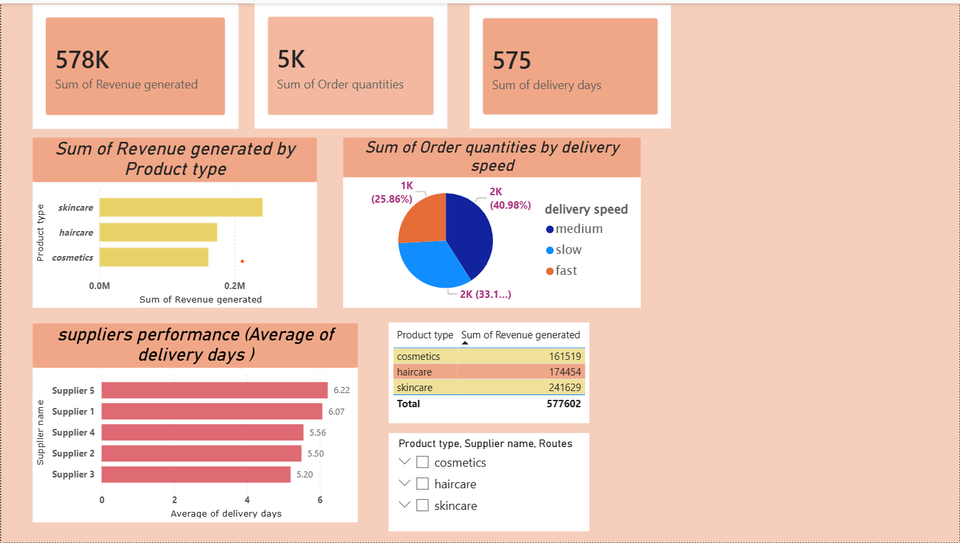

9. Conclusion
The Supply Chain Analysis Dashboard successfully provides insights into business performance, delivery efficiency, and supplier operations. Using Power BI and DAX measures, the project enables interactive analysis and supports data-driven decision-making for supply chain management.

10. Future Scope
- Integration of real-time supply chain data.
- Addition of predictive analytics for demand forecasting.
- Advanced supplier risk analysis.
- Time-series analysis using date-based datasets.

