

**T.E. Project Report**

**On**

**Bluetooth Operated Automated Mini Vacuum Cleaner**

**Submitted by**

**P**

**K**

**S**

**Project Guide:**

**Prof. N. B. Jadhav (Internal Guide)**

**Year: 2018-2019**

**PROJECT ABSTRACT**

Hygiene is an important aspect of our lives. A clean surrounding refers to healthy and happy environment. Cleanliness can be achieved manually or with the use of machines.

A vacuum cleaner is a popular machine for cleanliness for our surroundings. Over the years the awareness of using a Vacuum Cleaner is increasing. This project refers to the use of a Mini Vacuum Cleaner which is as the name suggests is of small size. It can be operated with the use of Bluetooth so that its portability is increased and there is always no need to carry the cleaner all the time. Maintenance of a clean environment is not easy. It needs regular observation of the surrounding and will and means to initiate the process.

A vacuum cleaner makes it easy for us to maintain cleanliness as one does not has to manually do the work. It makes the process easy and quick.

In this project the application is to sweep a carpet area with the use of a carpet sweeper attached to a Bluetooth operated device.

.

**INDEX**

**CHAPTER 1:**

**1.1** Introduction…………….

**1.2** Scope ………………….

**CHAPTER 2:**

**2.1** Review of Literature………………………………..

**2.2** Present Scenario………………………………

**CHAPTER 3:**

**3.1** System Development………………

**3.1.1** Software used **3.1.2** Block Diagram ……………………………………

**3.1.3** Block Diagram Explanation……………………

**3.1.4** Complexities involved……………..

**3.1.5** Code……………………..

**3.2** Hardware modular design……………………………………….

**3.2.1** Hardware used…………………………………………...

**3.2.2** Algorithm …………………………….

**3.2.3** Flowchart…………………….

**CHAPTER 4:**

**4.1** Testing……………………………….

**4.2** PCB Designing………………………………………

**4.3** Result analysis

**4.4** Cost and Billing……………… **4.5** Conclusion…………………………………………..

**Appendix I**

**References**

**LIST OF FIGURES**

|  |  |  |
| --- | --- | --- |
| **SR NO.** | **NAME** | **PAGE** |
| 1 | BLOCK DIAGRAM | 12 |
| 2 | FIGURE 2 | 18 |
| 3 | FIGURE 3 | 19 |
| 4 | FIGURE 4 | 20 |
| 5 | FIGURE 5 | 20 |
| 6 | FIGURE 6 | 24 |
| 7 | FIGURE 7 | 25 |
| 8 | FIGURE 8 | 26 |
| 9 | FIGURE 9 | 31 |
| 10 | FIGURE 10 | 32 |
| 11 | FIGURE 11 | 33 |
| 12 | FIGURE 12 | 33 |
| 13 | FIGURE 13 | 34 |

**LIST OF TABLES**

|  |  |  |
| --- | --- | --- |
| **SR NO** | **NAME** | **PAGE** |
| 1. | TABLE 1 | 24 |
| 2. | TABLE 2 | 26 |
| 3. | TABLE 3 | 31 |

**CHAPTER 1**

**INTRODUCTION**

**AIM:** To build an automated Bluetooth operated Mini vacuum cleaner using Arduino program.

**BACKGROUND:** A **vacuum cleaner**, also known as a **sweeper** or **hoover**, is a device that uses an air pump to create a partial vacuum to suck up dust and dirt from floors and from other surfaces such as upholstery and draperies. The vacuum cleaner evolved from the carpet sweeper via manual vacuum cleaners. The first manual models, using bellows, were developed in the 1860s, and the first motorized designs appeared at the turn of the 20th century, with the first decade being the boom decade.

The end of the 19th century saw the introduction of **powered cleaners**, although early types used some variation of blowing air to clean instead of suction.

The first vacuum-cleaning device for **domestic use** to be portable and marketed at the domestic market was built in 1905 by Walter Griffiths.

A British inventor has developed a new cleaning technology known as Air Recycling Technology, which, instead of using a vacuum, uses an air stream to collect dust from the carpet.

Robotic

In the late 1990s and early 2000s, several companies developed robotic vacuum cleaners, a form of carpet sweeper usually equipped with limited suction power. Some prominent brands are Roomba, bob sweep. These machines move autonomously while collecting surface dust and debris into a dustbin They can usually navigate around furniture and come back to a docking station to charge their batteries, and a few are able to empty their dust containers into the dock as well. Most models are equipped with motorized brushes and a vacuum motor to collect dust and debris. While most robotic vacuum cleaners are designed for home use, some models are appropriate for operation in offices, hotels, hospitals, etc.

**SCOPE:**

Robotic carpet sweepers (vacuum cleaners) are emerging as a new face of cleaning technology. These are portable and due to the use of Bluetooth they can be operated easily and efficiently. Mini vacuum cleaners of various types are available in the market at reasonable prices according to the application for which they are to be used. The main aim of this device is to clean a particular surrounding/area with the use of Bluetooth i.e. cleaning is possible with the use of android mobile phone.

**CHAPTER 2**

**REVIEW OF LITERATURE**

A similar reference about a ‘smart cleaning robot’ has been made by IEEE using the following abstract:

With the advancement of technology, robots are getting more attention of researchers to make life of mankind comfortable. This paper presents the design, development and fabrication of prototype Smart Floor Cleaning Robot (CLEAR) using IEEE Standard 1621 (IEEE Standard for User Interface Elements in Power Control of Electronic Devices employed in Office/Consumer Environments). Subject robot operates in autonomous mode as well as in manual mode along with additional features like scheduling for specific time and bag less dirt container with auto-dirt disposal mechanism. This work can be very useful in improving life style of mankind. A robotic vacuum cleaner is an autonomous electronic device that is intelligently programed to clean a specific area through a vacuum cleaning assembly. Some of the available products can brush around sharp edges and corners while others include a number of additional features such as wet mopping and UV sterilization rather than vacuuming. Some of the available products are discussed below:

1. iRobot[2]

In 2002, iRobot launched its first floor vacuum cleaner robot named Roomba. Initially, iRobot decided to manufacture limited number of units but Roomba immediately became a huge consumer sensation. Due to its increased market demand, a series of following robots have been launched in the market:

1. Roomba

• Launch Date: 2002

• Manufacturer: iRobot (American)

• Type of Use: Dry Vacuum

• Technology: IR, RF and auto-charging mechanism.

1. Scooba

* Launch Date: 2005

• Manufacturer: iRobot (American)

• Type of Use: Wet Washing of Floor

• Technology: IR with virtual wall accessories

• Price: $500

1. Braava

• Launch Date: 2006

• Manufacturer: iRobot, KITECH, Sony

• Type of Use: Floor moping for hard surfaces/Dry clean

• Technology: IR with virtual wall accessories for industrial cleaning

• Price: $700

1. NEATO Robotics[3]

With the advent of robotic vacuum cleaners, many countries had started manufacturing robotic cleaners. China also started manufacturing these robots with more reliable technology and advanced features.

1. Neato XV-11

• Launch Date: 2010

• Manufacturer: Neato-Robots XV series (California)/China

• Type of Use: Vacuum Cleaning

• Technology: Laser range finder technology, SLAM (Simultaneous localization and mapping) and auto-charging

• Price: $399

C. Dyson [4] In 2001, Dyson built a robot vacuum known as DC06 which was never released to the market due to its high price. In 2014, Dyson launched a new product named as Dyson 360 Eye which uses a different technology for path finding as compared to products manufactured by NEATO Robotics or iRobot.

1. EYE-360[5]

• Launch Date: 2016

• Manufacturer: Dyson (UK)

• Type of Use: Vacuum Cleaning

• Technology: It uses a 360 degree panoramic vision camera to monitor its environment in real time and a turbo brush for efficient cleaning along with an auto-charging mechanism (Benchmark in history of cleaning robots)

Note: these references are taken directly from the IEEE Standard website pdf.

**PRESENT SCENARIO**

These types of cleaners are available in the market. It is clear that these vacuum cleaners are used widely and have been recognized as an advancement of technology. This type of device is also called as a Roomba.

**CHAPTER 3**

**SYSTEM DEVELOPMENT**

**SOFTWARES USED:**

* ARDUINO
* AUTODESK EAGLE
* ARDUINO CONTROLLER APPLICATION

**BLOCK DIAGRAM**

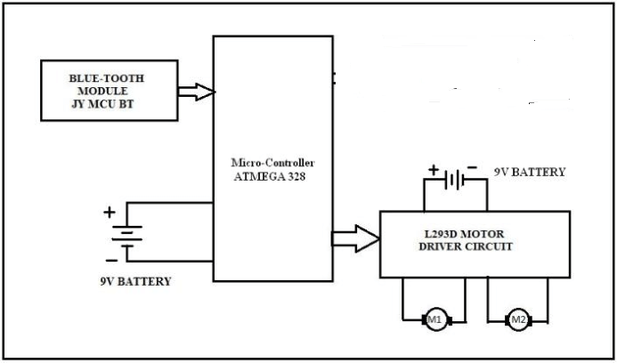

Figure 1

**BLOCK DIAGRAM EXPLAINATION:**

The connections of the controller to the modules shown in the model are according to the digital pins of the IC. Four digital pins of the IC are connected to corresponding 4 pins of the Motor Driver. The outputs of the Driver are connected to the two DC motors named M1 and M2. The TX pin of the Bluetooth module is connected to the RX pin of the ATMEGA IC. One 9V battery is connected to the IC while one is connected to the Motor Driver.

**COMPLEXITIES INVOLVED:**

Every process has some failures same was with this project.

Initially the ultrasonic sensors were to be used but due to their malfunctioning with the Bluetooth module, the idea of using the sensors was omitted.

The first PCB was not working, so change of PCB was needed.

**CODE**

int IN1 = 2;

int IN2 = 3;

int IN3 = 4;

int IN4= 5;

int state;

int flag=0; //makes sure that the serial only prints once the state

void setup() {

// sets the pins as outputs:

pinMode(IN1, OUTPUT);

pinMode(IN2, OUTPUT);

pinMode(IN3, OUTPUT);

pinMode(IN4,OUTPUT);

// sets enablePin high so that motor can turn on:

//digitalWrite(enablePin, HIGH);

// initialize serial communication at 9600 bits per second:

Serial.begin(9600);

}

void loop() {

//if some date is sent, reads it and saves in state

if(Serial.available() > 0)

{

state = Serial.read();

flag=0;

}

if (state == '3')

{

digitalWrite(IN1,HIGH); // set pin 2 on L293D low

digitalWrite(IN2,LOW);

digitalWrite(IN3,HIGH);

digitalWrite(IN4,LOW);

// set pin 7 on L293D low

if(flag == 0){

// Serial.println("Motor: on");

flag=1;

}

}

// if the state is '1' the motor will turn right

else if (state == '1') {

digitalWrite(IN1, LOW); // set pin 2 on L293D low

digitalWrite(IN2, HIGH);

digitalWrite(IN3, HIGH);

digitalWrite(IN4, LOW);/// set pin 7 on L293D high

if(flag == 0){

// Serial.println("Motor: right");

flag=1;

}

}

// if the state is '2' the motor will turn left

else if (state == '2')

{

digitalWrite(IN1, HIGH); // set pin 2 on L293D high

digitalWrite(IN2, LOW);

digitalWrite(IN3, LOW);

digitalWrite(IN4, HIGH);// set pin 7 on L293D low

if(flag == 0){

// Serial.println("Motor: left");

flag=1;

}

}

else if(state == '4')

{

digitalWrite(IN1,LOW);

digitalWrite(IN2,HIGH);

digitalWrite(IN3,LOW);

digitalWrite(IN4,HIGH);

if(flag==0){

// Serial.println("BCk");

flag=1;

}

}

else if (state == '5') {

digitalWrite(IN1,HIGH);

digitalWrite(IN2,HIGH);

digitalWrite(IN3,HIGH);

digitalWrite(IN4,HIGH);

if(flag == 0){

// Serial.println("Motor: OFF");

flag=1;

}

}

}

**HARDWARE MODULAR DESIGN**

**HARDWARE USED:**

* MALE-FEMALE CONNECTOR WIRES
* BLUETOOTH MODULE

HC-06 MODULE

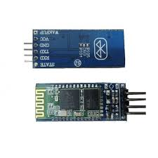

Figure 2

1. Bluetooth protocol: Bluetooth V2.0 protocol standard
2. Power Level: Class2(+6dBm)
3. Band: 2.40GHz—2.48GHz, ISM Band
4. Receiver sensitivity: -85dBm
5. USB protocol: USB v1.1/2.0
6. Modulation mode: Gauss frequency Shift Keying
7. Safety feature: Authentication and encryption
8. Operating voltage range:+3.3V to +6V
9. Operating temperature range: -20ºC to +55ºC
10. Operating Current: 40Ma

* L293N MOTOR DRIVER(DUAL H BRIDGE)

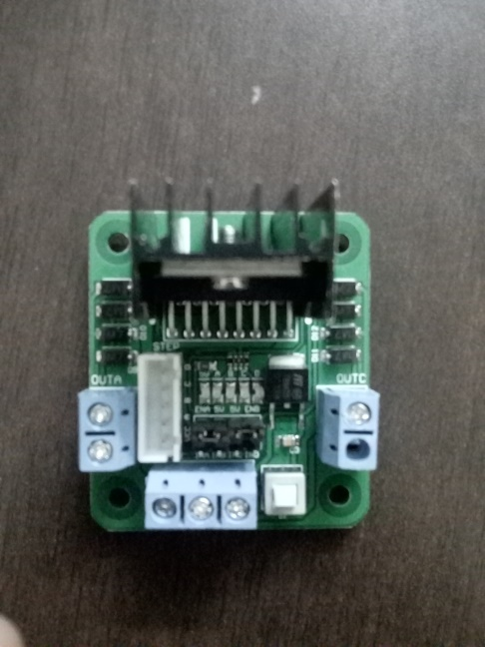

Figure 3

1. Double H bridge Drive Chip: L298N
2. Logical voltage: 5V*
3. Drive voltage: 5V-35V
4. Logical current: 0-36mA
5. Drive current: 2A (MAX single bridge)
6. Max power: 25W
7. Dimensions: 43 x 43 x 26mm
8. Weight: 26g

* ATMEGA328P-U IC

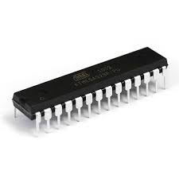

Figure 4

1. 28 pin PDIP
2. No USB interface
3. Two ground terminals
4. 16 MHz Crystal oscillator
5. 3 Vcc terminals

* 7805 VOLTAGE REGULATOR

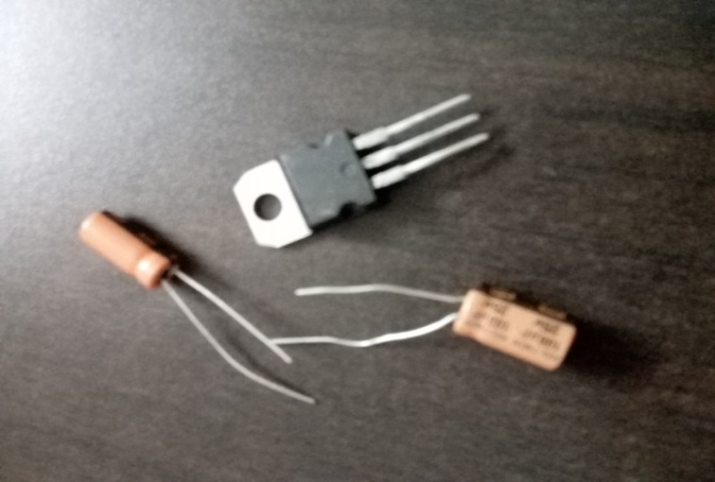

Figure 5

* CAPACITORS

1. 22pf (2)
2. 100 uf (1)
3. 10 uf (1)

* CRYSTAL OSCILLATOR
* RESET SWITCH
* RESISTOR(10K OHM)
* IC HOLDER

**ALGORITHM**

1. Switch on the power supply.
2. Check whether the Motor driver and Bluetooth module got connected.
3. Turn on mobile Bluetooth

.

1. Open the Arduino controller Bluetooth app

.

1. Check whether the Bluetooth module got connected

.

1. Send commands from the mobile to which accordingly the device will operate

.

1. Change the direction and movement of the device according to your wish.

**FLOWCHART**

Bluetooth module and H bridge on?

NO

YES

NO

Bluetooth light stopped blinking

YES

Send commands and change direction of motors

**CHAPTER 4**

**TESTING**

The testing of the components was done using the Arduino geniuno board.

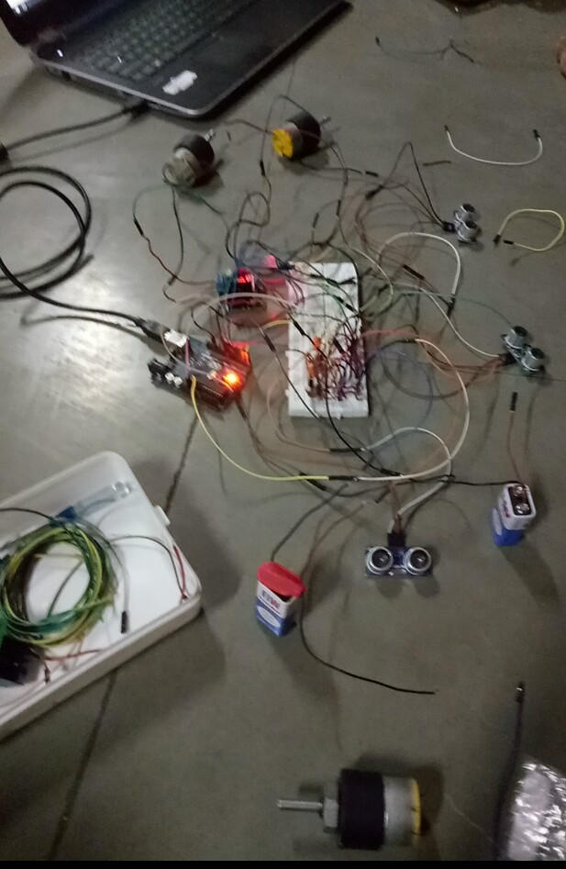

Figure 6

**PCB DESIGNING**

SCHEMATIC DIAGRAM

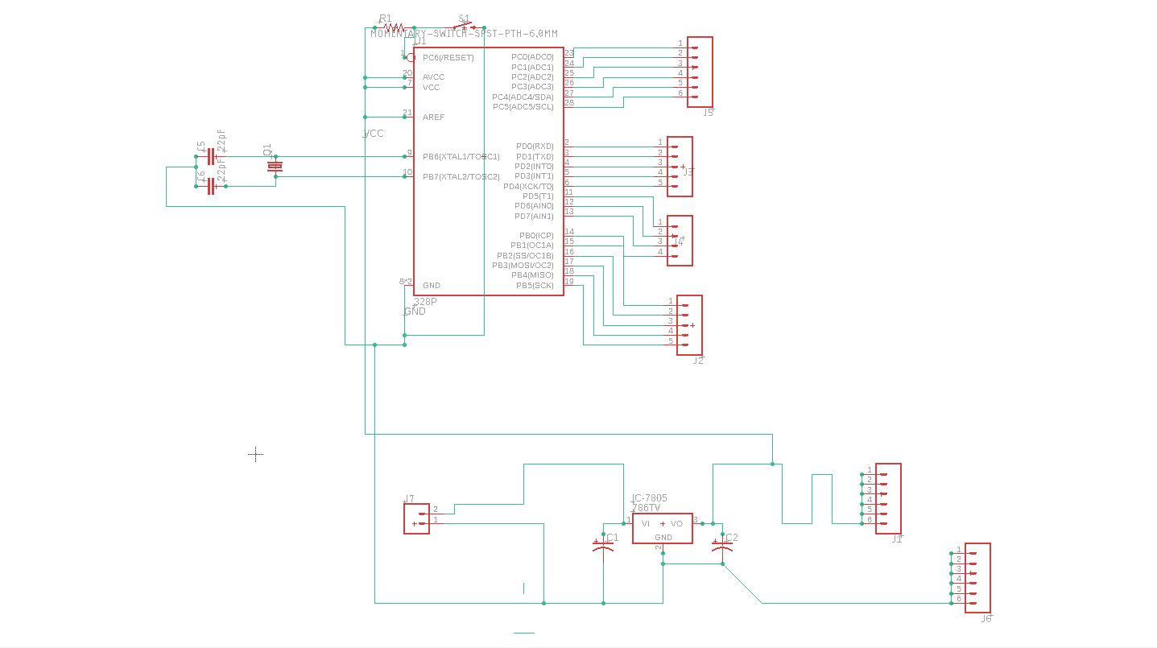

Figure 7

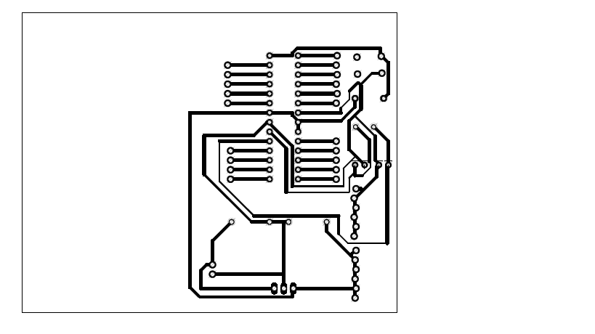

Figure 8:PDF

**RESULT ANALYSIS**

1. For Bluetooth module, we get the commands as it is on the Serial Monitor.
2. For H bridge, according to the Arduino code, the motor shaft rotate

* HIGH,LOW anticlockwise
* LOW,HIGH clockwise
* HIGH,HIGH OR LOW,LOW stop

1. When Bluetooth and H bridge get connected, according to the state input, the direction of motor change

**COST AND BILLING**

Table 1

|  |  |  |  |
| --- | --- | --- | --- |
| **NAME OF PRODUCT** | **QUANTITY** | **PRICE** | **TOTAL PRICE** |
| ATMEGA328P-U IC | 1 | 105 | 105 |
| L293N MOTOR DRIVER | 1 | 180 | 180 |
| HC-06 BLUETOOTH MODULE | 1 | 400 | 400 |
| 9V BATTERY | 4 | 15 | 60 |
| 200RPM 9V DC MOTOR | 2 | 150 | 300 |
| 2WD ROBOT CAR CHASSIS | 1 | 550 | 550 |
| METAL PLATE | 1 | 150 | 150 |
| SCREW DRIVER | 1 | 10 | 10 |
| WIRES | 3 | 40 | 120 |
| MALE-FEMALE CONNECTORS | 2 | 120 | 240 |
| FEMALE-FEMALE CONNECTORS | 2 | 120 | 120 |
| MALE-MALE CONNECTORS | 1 | 120 | 120 |
| 7805 IC | 2 | 5 | 10 |
| 22pf CAPACITORS | 2 | 2 | 4 |
| 100uf CAAPCITOR | 2 | 4 | 8 |
| 10uf CAPACITOR | 2 | 4 | 8 |
| CARPET SWEEPER | 1 | 149 | 149 |
| PCB DESIGN | 1 | 550 | 550 |
| 12 V BATTERY | 1 | 390 | 390 |
| IC HOLDER | 2 | 5 | 10 |
| **TOTAL COST 3484/-** | | | |

**CONCLUSION**

It is an emerging form of technology for cleaning purposes which is controlled via Bluetooth. It is possible to operate this with other wireless communication systems like Wi-Fi, RF module etc. As a 2WD Robot car chassis is used and a Bluetooth module is required than IC and power supply, its cost is low. It is a portable and efficient device. It can be used for domestic purposes for cleaning dust on carpet. It involves the use of plastic materials, wires etc. which makes it easy to handle and is cost effective. Its use has been taken into consideration over the years.

**APPENDIX 1**

**SPECIFICATIONS**

1. ATMEGA328P IC

Table 2

|  |  |
| --- | --- |
| CPU type | 8-bit AVR |
| Performance | 20 MIPS at 20 MHz |
| Flash memory | 32 Kb |
| SRAM | 2 kB |
| EEPROM | 1 kB |
| Pin count | 28 or 32 pin: PDIP-28, MLF-28, TQFP-32, MLF-32 |
| Maximum operating frequency | 20 MHz |
| Number of touch channels | 16 |
| Maximum I/O pins | 23 |
| External interrupts | 2 |
| USB Interface | No |

1. L293N MOTOR DRIVER (DUAL H BRIDGE)

* Double H bridge Drive Chip: L298N
* Logical voltage: 5V*
* Drive voltage: 5V-35V
* Logical current: 0-36mA
* Drive current: 2A (MAX single bridge)
* Max power: 25W
* Dimensions: 43 x 43 x 26mm
* Weight: 26g

1. HC-06 BLUETOOTH MODULE

* Bluetooth protocol: Bluetooth V2.0 protocol standard
* Power Level: Class2(+6dBm)
* Band: 2.40GHz—2.48GHz, ISM Band
* Receiver sensitivity: -85dBm
* USB protocol: USB v1.1/2.0
* Modulation mode: Gauss frequency Shift Keying
* Safety feature: Authentication and encryption
* Operating voltage range:+3.3V to +6V
* Operating temperature range: -20ºC to +55ºC
* Operating Current: 40mA

1. 7805 IC

* Current Rating: Ic = 1A
* Input Voltage Range: 7V-35V
* Output Voltage Range: Vmax = 5.2V, Vmin = 4.8V

**ATMEGA 328P-U IC**

**Figure 9**

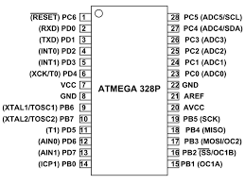

Figure 10

**7805 VOLTAGE REGULATOR IC**

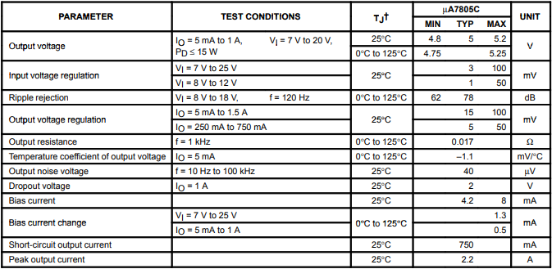

Figure 11

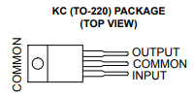

Figure 12

**L293N MOTOR DRIVER**

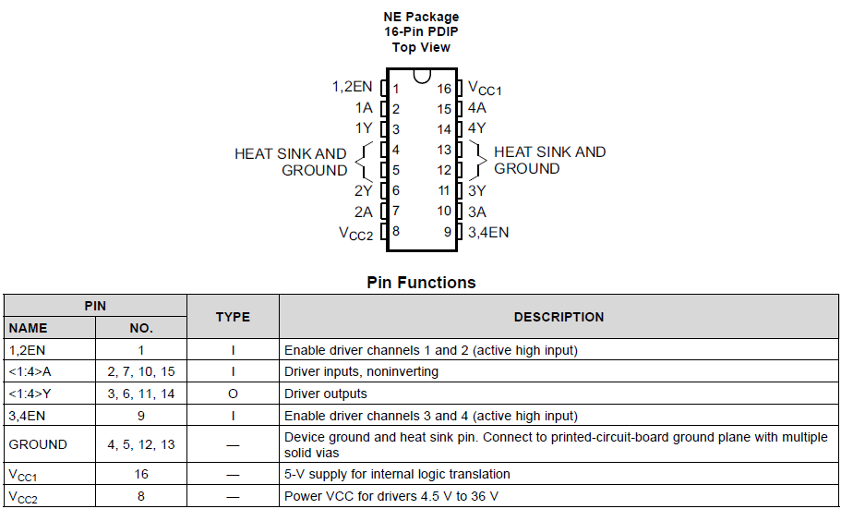

Figure 13

**HC-06 BLUETOOTH MODULE**

Table 3

|  |  |  |
| --- | --- | --- |
| **Pin** | **Name** | **Function** |
| 1 | Key | The pin state determines whether the module works in AT command mode or normal mode  [High=AT commands receiving mode(Commands  response mode), Low or NC= Bluetooth module normally working] |
| 2 | Vcc | +5V Positive supply needs to be given to this pin for powering the module |
| 3 | Gnd | Connect to ground |
| 4 | TXD | Serial data is transmitted by module through this pin (at 9600bps by default), 3.3V logic |
| 5 | RXD | Serial data is received by module through this pin (at 9600bps by default),3.3V logic |
| 6 | State | The pin is connected to the LED on the board to represent the state of the module |

**REFERENCES**

* IOP Conference Series: Materials Science and Engineering
* Exploring Arduino: Tools and techinques for Engineering Wizardry
* HC-05 Bluetooth+ Arduino: Includes the Zs-040