**MAEER’s**



**BE Project Stage-I Report**

**ON**

**UNMANNED REMOTELY CONTROLLED FIREFIGHTING ROBOT**

SUBMITTED BY,

**Swadesh**

**Komal**

**Pallavi**

Project Guide:

**Prof.(Dr.)H.D.Zodpe (Internal Guide)**

**Sponsored by**

**College**

**Year: 2019-2020**

**ACKNOWLEDGEMENT**

A project is an opportunity for the student to practically implement theoretical concepts. It proves to be a learning platform for the students so that they can compete successfully in their professional life. However, in this entire journey of completing the project, we need proper guidance so as to avoid obvious mistakes.

**ABSTRACT**

In this era of technological advances, process automation and robotics have played a vital role. Replacing human labour force with robots have many advantages. Robots are less prone to errors. They can be remotely controlled or completely autonomous. Firefighting is a dangerous profession. In firefighting profession, human lives are at stake every now and then. Replacing humans with robots for firefighting will save several numbers of human lives.

So, this project is designed to develop a fire fighting robot using Wi-Fi technology for remote operation. The robotic vehicle is mainly loaded with camera for image processing, water tanker and pump which is controlled over wireless communication for fire detection and to throw water respectively

**CONTENTS**

**Chapter 1. Introduction**

1.1 Introduction……………………………………………………................................................. 9

1.2 Scope of project ……………………………………………………..........................................10

1.3 Organization of report…………………………………………………….................................10

**Chapter 2. Literature Survey**

2.1 Literature Survey………..……………………………………………........................................11

2.1 Present Scenario……………….…………………………………………..................................13

**Chapter 3. System Development**

3.1 System specifications...................................................................................................................14

3.2 System block diagram..................................................................................................................15

3.3 Flow Chart....................................................................................................................................16

**Chapter 4. System Design**

4.1 Circuit Diagram-1..........................................................................................................................17

Circuit Diagram-2……………………………………………………..........................................18

4.2 Hardware Specifications………………………………………………........................................18

4.2.1 Flame sensor………………………………………………………….................................18

4.2.2 Raspberry 3B………………………………………………………....................................19

4.2.3 Camera…………………………………………………………………..............................21

4.2.4 L293D…………………………………………………………………...............................21

4.2.5 Motor ……………………………………………………………………...........................22

4.3 Software Specification

4.3.1 Raspbian Operating System……………………………………………….........................23

4.3.2 Python…………………………………………………………………………..................23

4.3.3 Python Idle………………………………………………………………….......................24

4.3.4 OpenCV………………………………………………………………………...................24

**Chapter 5. Experimental Implementation and Results**

5.1 Results

5.1.1 Image processing: Fire Detection.........................................................................................26

5.1.2 Graphical User Interface(GUI).............................................................................................27

5.1.3 Code for motor to interact with GUI……………………………………….........................28

5.1.4 Image representation of our work done…………………………………………................30

**Chapter 6. Challenges and Explorations………………………………………………….................31**

**Chapter 7. Conclusion**

7.1 Conclusion…………………………………………………………………….......................32

7.2 Future scope…………………………………………………………………….....................32

**Chapter 8. Applications**

8.1 Applications…………………………………………………………………….....................33

8.2. Advantages……………………………………………………………………......................33

8.3 Disadvantages………………………………………………………………………..............33

**References………………………………………………………………………........................34**

**LIST OF FIGURES**

|  |  |  |
| --- | --- | --- |
| SR NO. | NAME OF FIGURE | PAGE NO. |
| 1. | System Block Diagram | 15 |
| 2. | System Flow Chart | 16 |
| 3. | GUI | 27 |
| 4. | Components interfacing diagram | 18 |

**Chapter 1 INTRODUCTION**

1. **INTRODUCTION**

Safety and speed are two of the most important aspects of any rescue operation. When a building or an area is subject to a fire, it can be very dangerous for any of the rescuing parties to assess the situation themselves without being subject to harm. A great alternative to this would be to use robots. Thus the problem by definition is being able to locate and extinguish a fire as fast as possible using a robot. This is to reduce the likelihood of anyone being injured as well as increase the promptness of putting out the fire. The following are the goals of this project:

* To increase safety associated with firefighting.
* To create a way to check for fires without involving human beings directly such that they are not exposed to any threats.
* Decrease the time taken to traverse a map with potential fire.

To accomplish the afore mentioned goals, the realized robot must have a number of important features. At the end of the project, the robot should be capable of:

* Interacting with fires
  + Detect fire hazards accurately.
  + Extinguish flames.
  + Fire an alarm.
* Providing external communications
  + Live Camera Feed.
  + Remote control technology

To detect the fire accurately proposed system uses sensor fusion technology. Sensor fusion technology is when, to measure a fundamental parameter more than one sensor, technologies and/or device are used. System uses a digital flame sensor as well as a camera with image processing to detect fire. Proposed system is an unmanned vehicle, which is remotely controlled. After detection to extinguish fire, water sprinkler is used.

1. **SCOPE OF PROJECT**

The main objective is to detect fire and extinguish fire without putting human lives at risk.

The scope of the project in the industrial sector is vast, especially in the fire department. The main operation of the robot is to detect and extinguish the fire source with the input from the flame sensors, camera and extinguishing flames with water. It is achieved by integrating flame and camera using sensor fusion technology. System proposes a remote control vehicle that allows user to operate unmanned vehicle in multiple types of areas such fire in homes, commercial buildings, factories, dumping grounds etc.

1. **ORGANIZATION OF THE REPORT**

* Chapter 1: Introduction and scope

This chapter provides an overview of the basic functionality of the system and describes its scope of expansion

* Chapter 2: Literature Survey and present scenario

This chapter enlightens the literature survey of the work done in this field so far as well as the present scenario.

* Chapter 3: System Block Diagram and Flow Chart

Explains in detail the design and development process of the system. Includes system specifications, block diagram, description of each block.

* Chapter 4: System Design

It includes circuit diagram and component specifications.

* Chapter 5: Result and Conclusion

It includes results, conclusion and future scope of project.

* Chapter 6: Challenges and Explorations

Includes important Papers referred for algorithms of the system.

* Chapter 7: Conclusion and future scope
* Chapter 8: Applications

Includes applications, advantages and disadvantages and important Papers referred for algorithms and design of the system.

**Chapter 2 LITERATURE SURVEY**

1. **LITERATURE SURVEY**

While researching about how to detect and extinguish fire accurately using an unmanned vehicle, we came across several research papers regarding fire detection and unmanned vehicle. The summary of research papers we referred is given as follows-

[1]Jayant Suresh proposed a system for fire detection and extinguishing purpose. Proposed system is robot that is remotely controlled. System consist of ZigBees, flame sensors, ultrasonic sensors, bike tire inflator and Arduino as controller. Pair of ZigBees is used to control the direction of robot. To detect fire in 180° angle multiple flame sensors are used. Robot also has feature of obstacle avoidance to achieve so ultrasonic sensor is used. Once fir is detected bike tire inflator knob is pressed using high torque servo motor. Bike tire inflator lets the air out to extinguish fire.

[2]Ahmed Hassanein, Mohanad Elhawary, Nour Jaber, and Mohammed El-Abd proposed a system for fire extinguishing purpose with features such as obstacle detection and avoidance, detecting and extinguishing fires, live camera feeds, fire alarm. Proposed system uses K- Junior V2 robot kit, flame sensor, IR sensors, Air Blower, Wireless Camera, Digital Compass. Heart of K-Junior V2 is a PIC microcontroller. Robot detects fire using flame sensors and extinguishes fire using air blower. IR sensors, digital compass are used for navigation purpose.

[3]Shiva Mittal, Manish Kumar Rana proposed a system for fire detection and fire detection that consists Atmega2560 microcontroller as heart of system, L298 driver based six wheel drive, digital temperature DS28B20, Air Quality Sensor MQ135 and a wireless camera. Robot is remotely controlled with help of Joystick and NRF24L01 module. For fire detection, Air Quality Sensor and temperature sensor are used. If sensors detects fire, solenoid valve is turned on which starts water sprayer.

[4]Kriti Kadam, Ayushi Bidkar developed firefighting robot. The proposed vehicle is able to detect presence of fire and extinguishing it automatically by using gas sensor and temperature sensor. It contains gear motors and motor driver to control the movement of robot . Relay circuit is used to control the pump and when it will detect fire then it will communicate with microcontroller (Arduino UNO R3) through Bluetooth module. The proposed robot has a water jet spray which is capable of sprinkling water. The sprinkler can be move towards the required direction .At the time of moving towards the source of fire it may happen that it will come across some obstacles ,then it has obstacle avoiding capability. It will provide GUI for arduino operation using android. It detects obstacles using ultrasonic sensors upto range of 80 m. Communication between the mobile phone and robot will take place through Bluetooth ,which will have GUI to control the movement of robot . When mobile gets connected to Bluetooth firstly it will set module name, baud rate . It is feasible to implement Bluetooth communication between smartphones and microcontroller. Android controlled robot can be used easily in everyday life such as in homes, market ,companies etc. The development of apps for Android in Android SDK is easy and free of cost

[5]Mohd Aliff, Azavitra Zainal proposed a system for firefighting robot. this paper presents the development of a firefighting robot dubbed QRob that can extinguish fire without the need for fire fighters to be exposed to unnecessary danger. QRob is designed to be compact in size than other conventional fire-fighting robot in order to ease small location entry for deeper reach of extinguishing fire in narrow space. QRob is also equipped with an ultrasonic sensor to avoid it from hitting any obstacle and surrounding objects, while a flame sensor is attached for fire detection. This resulted in QRob demonstrating capabilities of identifying fire locations automatically and ability to extinguish fire remotely at particular distance. QRob is programmed to find the fire location and stop at maximum distance of 40 cm from the fire. A human operator can monitor the robot by using camera which connects to a smartphone or remote devices.

[6]Abdülkadir Çakir, Nyan Farooq Ezzulddın Ezzulddin designed a Fire-Extinguishing Robot using Arduino. Designed robot is able to motion by using the (rotor motor), beyond the barriers by(sensor MZ80), find the flame by (flame sensor), and extinguish the fire by(fan), and it progresses in conjunction with the search for the fire to control it and send message to the mobile or tablet by using (Bluetooth HC-05) when it founded the fire and all of this is controlled by the microcontroller (Arduino Uno ). The robot can move on the specified route without being caught in the obstacles, and conducts a fire scan as it moves. By using the microcontroller module on it evaluates the data in the direction of the software and performs obstacle detection, flame detection, actuation, informing and extinguishing processes. Robot design and application process; the design and development of the mechanıcal system, the design and development of the electronic system, and the preparation of the necessary software. During the design and development of the mechanical system; Draft drawings, measurements, computer aided design and solid modeling programs. The robot designed in the study was able to detect fire sources randomly placed in random obstacle areas and extinguished with determined fire extinguishing systems.

1. **PRESENT SCENARIO**

In the real world, human labor force is largely used to extinguish fire. Some automatic fire detectors and automatic water sprinkler system are used by hotels but they prove to ineffective in cases of large fires, fires due to chemical, fires industries, manufacturing plants, dumping grounds.

Today, many researches have been into firefighting robots but main problem that keeps arising repeatedly is accuracy of fire detection. Current system also lacks in live video feeds. Proposed system provides live video speed over network. To increase accuracy of fire detection proposed system uses sensor fusion technology.

**Chapter 3 SYSTEM DEVELOPMENT**

1. **SYSTEM SPECIFICATIONS**

The main aim is to develop a robust system that is remotely controlled, detect fire accurately and then extinguish it.

* Software:

Raspbian OS

PC/ Laptop with Windows 7

Python IDLE

* Platform / Language used:

Raspberry Pi

Python

* Libraries:

tkinter

Open CV

1. **SYSTEM BLOCK DIAGRAM**

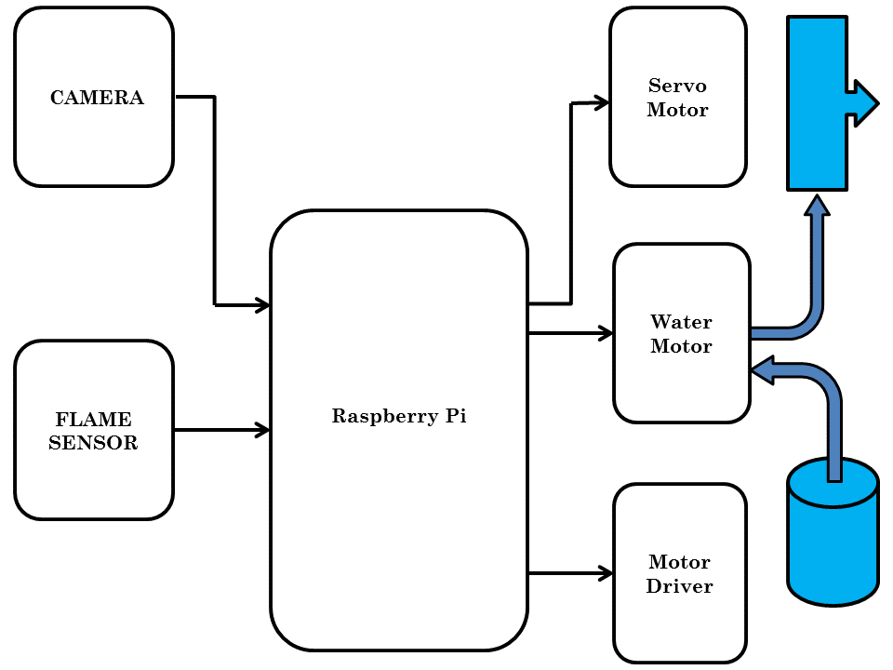

**Fig. Block Diagram of Unmanned Remotely Controlled Firefighting Robot**

Above diagram is block representation of proposed system “Unmanned Remotely Controlled Fire Fighting Robot”. System consist of camera, flame sensor, raspberry pi, water motor, motor driver, DC motors. Heart of system is Raspberry Pi. Raspberry Pi is an on Chip Computer. Flame sensor and Camera is used to detect the flames simultaneously. Use of multiple sensing technologies is known as sensor fusion technology. Sensor fusion is used to increase the accuracy of results. Flame sensor is a digital sensor. After detecting fire flame sensor changes its output state from logic 0 to logic 1 and vice versa. Camera attached to Raspberry Pi is also used to detect fire. For detection of fire camera is accesses using OpenCV library. Raspberry Pi uses a Linux based operating system Raspbian. Raspbian is an OS with multiple development software and software packages such Python IDLE, Thony Editor Etc. Programing language for proposed system is Python as it allows user to deal multiple technologies such as embedded hardware, Image Processing, Machine Learning and IoT etc. Initially all peripherals are initialized system starts checking for fire using flame sensor and camera. If both or any one detects the fire water motor mechanism is used to sprinkle water on fire when detected. For making the system direction controlled GUI is designed using tkinter python library. GUI provides options for right, left, forwards, backward, and stop. Output console of system, live imagery from camera, and GUI for direction control is accessed using remote access tools over Wi-Fi. Remote access tools which can be used are remote desktop, VNC server etc.

1. **Flow Chart:**

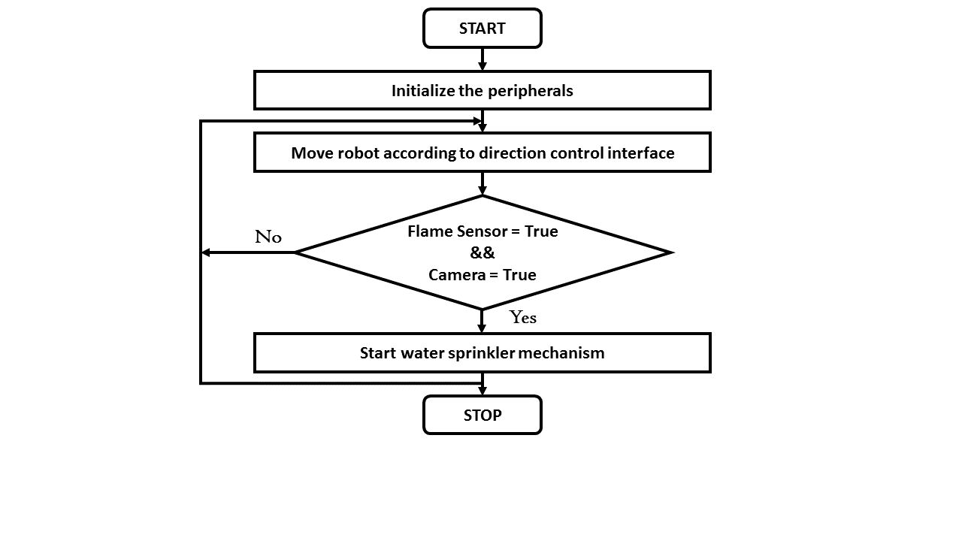

**Fig. Flow Chart of System**

**Chapter 4 SYSTEM DESIGN**

1. **CIRCUIT DIAGRAM**

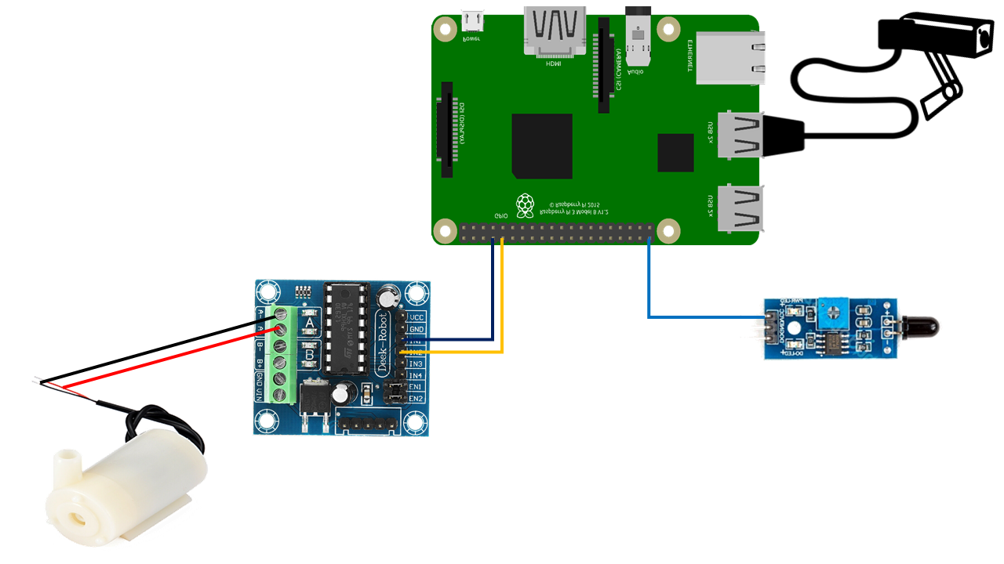

**Fig. Circuit diagram for detection and extinguishing purpose**

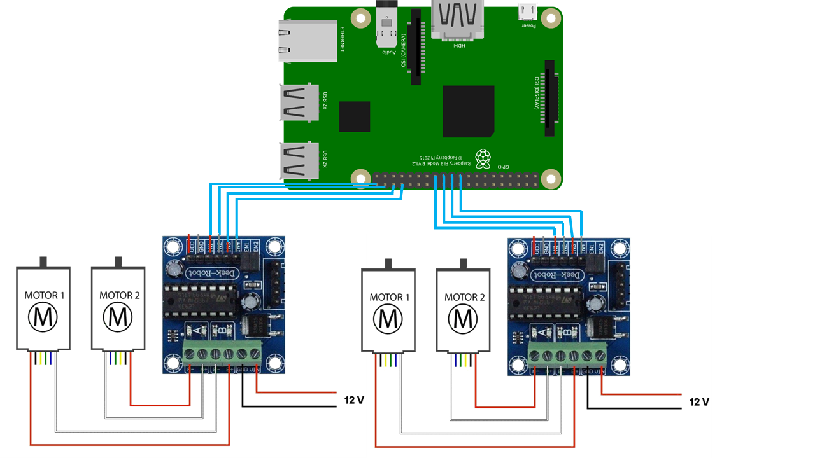

**Fig. Circuit Diagram for robot direction control**

1. **HARDWARE PECIFICATIONS:**
2. **Flame Sensor (SEN-2800):**

Flame Sensor can be used to detect fire source or other light sources of the wave length in the range of 760nm - 1100 nm. It is based on the YG1006 sensor which is a high speed and high sensitive NPN silicon phototransistor. Due to its black epoxy, the sensor is sensitive to infrared radiation. Sensor can be a great addition in a fire fighting robot, it can be used as a robot eyes to find the fire source. When the sensor detects flame the Signal LED will light up and the D0 pin goes LOW.

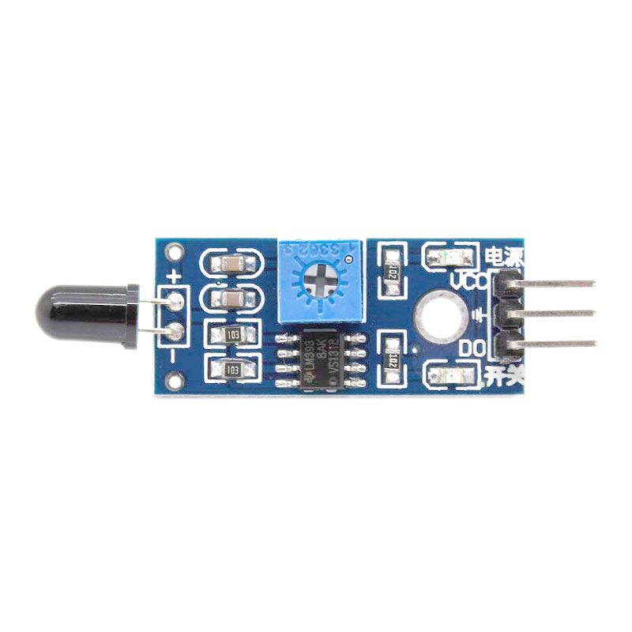

**Fig. Image representation of flame sensor**

**Specification:**

* Working voltage: 3.3v - 5v
* Detect range: 60 degrees
* Digital/Analog output
* On-board LM393 chip
* Dimension**::** 3.2cm x 1.4cm

1. **Raspberry Pi 3B**

Raspberry Pi 3 b model is an upgrade to a next generation main processor and improved connectivity with Bluetooth low energy (BLE) and BCM43143 Wi-Fi on board. Additionally, the raspberry pi 3 has improved power management, with an upgraded switched power source up to 2.5 amps, to support more powerful external USB devices.

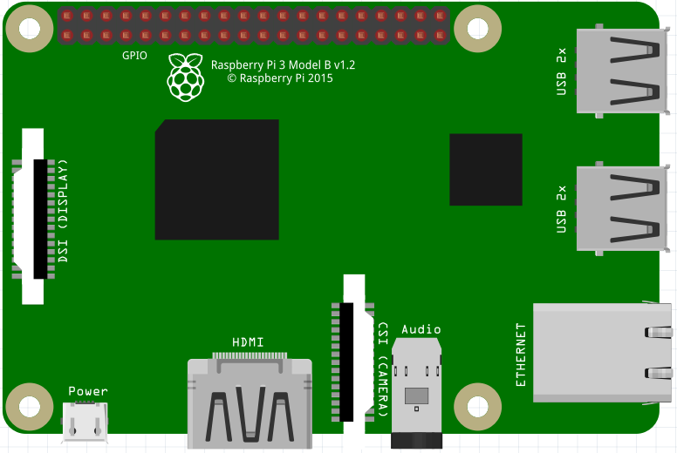

**Fig. Image representation of Raspberry Pi**

**Specification:**

* Broadcom BCM2837 64bit ARMv7 Quad Core Processor Powered Signal board Computer running at 1.2 GHz
* 1GB RAM
* BCM43143 Wi-Fi on board
* Bluetooth low energy on board
* 40 pin extended GPIO
* 4 USB 2 Ports
* 4 pole stereo output and composite video port
* Full size HDMI
* CSI camera port for connecting the Raspberry Pi camera
* DSI display port connecting the Raspberry Pi touch screen display Micro SD port for loading your operating system and sorting data
* Upgraded switched Micro USB power source (now supports up to 2.4 amps)

1. **Camera:**

Camera is sued for fire detection using Open CV

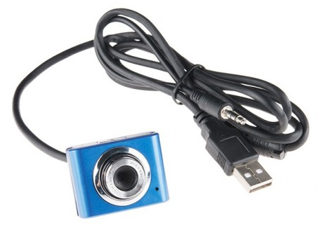

**Fig. Image representation of camera**

**Specification:**

* VGA (Video Graphic Array):
* Resolution: 800 x 600 pixel
* RGB camera 24 bit

1. **L293D:**

Motor Driver ICs are for interfacing motors directly to microcontrollers. Current required for motor is large which a controller cannot provide. Motor driver also prevents any back emf reaching from motor to controller. In proposed system L293D IC as motor driver

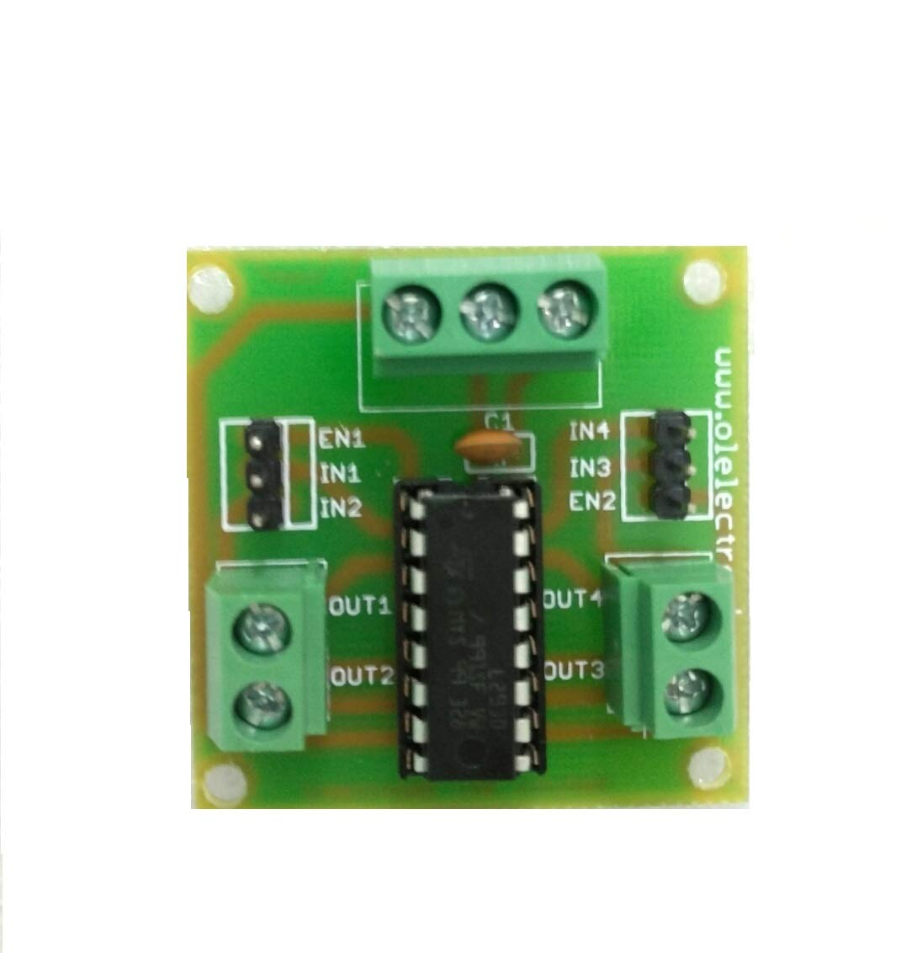

**Fig. Image representation of L293D Module**

**Specification:**

* Wide Supply-Voltage Range: 4.5 V to 36 V
* Separate Input-Logic Supply
* Internal ESD Protection
* High-Noise-Immunity Inputs
* Output Current 1 A Per Channel (600 mA for L293D)
* Peak Output Current 2 A Per Channel (1.2 A for L293D)
* Output Clamp Diodes for Inductive Transient Suppression (L293D)

1. **Motor:**

**Specification:**

* Operating Voltage : 12Vdc
* Speed : 45RPM

1. **SOFTWARE PECIFICATIONS:**

**Raspbian Operating System:**

Raspbian is a [Debian](https://en.wikipedia.org/wiki/Debian)-based [computer operating system](https://en.wikipedia.org/wiki/Operating_system) for [Raspberry Pi](https://en.wikipedia.org/wiki/Raspberry_Pi). There are several versions of Raspbian including Raspbian Buster and Raspbian Stretch. Since 2015 it has been officially provided by the [Raspberry Pi Foundation](https://en.wikipedia.org/wiki/Raspberry_Pi_Foundation) as the primary operating system for the family of Raspberry Pi [single-board computers](https://en.wikipedia.org/wiki/Single-board_computers). Raspbian was created by Mike Thompson and Peter Green as an independent project. The initial build was completed in June 2012.  The operating system is still under active development. Raspbian is highly optimized for the Raspberry Pi line's low-performance [ARM](https://en.wikipedia.org/wiki/ARM_architecture) CPUs.

Raspbian uses PIXEL, Pi Improved X-Window Environment, Lightweight as its main desktop environment as of the latest update. It is composed of a modified [LXDE](https://en.wikipedia.org/wiki/LXDE) desktop environment and the [Openbox](https://en.wikipedia.org/wiki/Openbox" \o "Openbox) stacking window manager with a new theme and few other changes. The distribution is shipped with a copy of computer algebra program [Mathematica](https://en.wikipedia.org/wiki/Wolfram_Mathematica)l and a version of [Minecraft](https://en.wikipedia.org/wiki/Minecraft) called Minecraft Pi as well as a lightweight version of [Chromium](https://en.wikipedia.org/wiki/Chromium_(web_browser)) as of the latest version.



**Fig. Official Logo of Raspbian**

**Python**

Python is an interpreted, object-oriented, high-level programming language with dynamic semantics. Its high-level built in data structures, combined with dynamic typing and dynamic binding; make it very attractive for Rapid Application Development, as well as for use as a scripting or glue language to connect existing components together.



**Fig. Official Logo of Python**

Python is simple, easy to learn syntax emphasizes readability and therefore reduces the cost of program maintenance. Python supports modules and packages, which encourages program modularity and code reuse. The Python interpreter and the extensive standard library are available in source or binary form without charge for all major platforms, and can be freely distributed.

**Python Idle**

IDLE (short for Integrated Development Environment or Integrated Development and Learning Environment) is an [integrated development environment](https://en.wikipedia.org/wiki/Integrated_development_environment) for [Python](https://en.wikipedia.org/wiki/Python_(programming_language)), which has been bundled with the default implementation of the language. It is packaged as an optional part of the Python packaging with many [Linux distributions](https://en.wikipedia.org/wiki/Linux_distributions). It is completely written in Python and the [Tkinter](https://en.wikipedia.org/wiki/Tkinter) GUI toolkit ([wrapper](https://en.wikipedia.org/wiki/Wrapper_function) functions for [Tcl](https://en.wikipedia.org/wiki/Tcl" \o "Tcl)/[Tk](https://en.wikipedia.org/wiki/Tk_(framework))).IDLE is intended to be a simple [IDE](https://en.wikipedia.org/wiki/Integrated_development_environment) and suitable for beginners, especially in an educational environment. To that end, it is cross-platform, and avoids feature clutter. According to the included [README](https://en.wikipedia.org/wiki/README), its main features are:

Multi-window text editor with [syntax highlighting](https://en.wikipedia.org/wiki/Syntax_highlighting), auto completion, smart indent and other. Python shell with syntax highlighting. Integrated debugger with [stepping](https://en.wikipedia.org/wiki/Program_animation), persistent [breakpoints](https://en.wikipedia.org/wiki/Breakpoint), and call stack visibility.

IDLE has been criticized for various usability issues, including losing focus, lack of copying to clipboard feature, lack of line numbering options, and general user interface design; it has been called a "disposable" IDE, because users frequently move on to a more advanced IDE as they gain experience.

Author [Guido van Rossum](https://en.wikipedia.org/wiki/Guido_van_Rossum) says IDLE stands for "Integrated Development Environment", and since Van Rossum named the language Python partly to honor British comedy group [Monty Python](https://en.wikipedia.org/wiki/Monty_Python), the name IDLE was probably also chosen partly to honor [Eric Idle](https://en.wikipedia.org/wiki/Eric_Idle), one of Monty Python's founding members.

**OpenCV:**

Open source Computer Vision (OpenCV) is an image processing and computer vision library mainly developed for artificial vision. It has a BSD license (free for commercial or research use). OpenCV was originally written in C but currently, it's a whole C++ interface and there's additionally a full Python interface to the library. Open source computer Vision Library, also called OpenCV, is associated in a freeware software package that is aimed toward computer vision. It is used in this project because of its versatility as well as the fact that it has a C++ interface. OpenCV runs on most of the major Operating Systems (OS), which makes it useful when using another computer to program or test.

**Chapter 5 EXPERIMENTAL IMPLEMENTATION AND RESULTS**

1. **RESULTS**

**5.1.1. IMAGE PROCESSING:DETECTING FIRE**



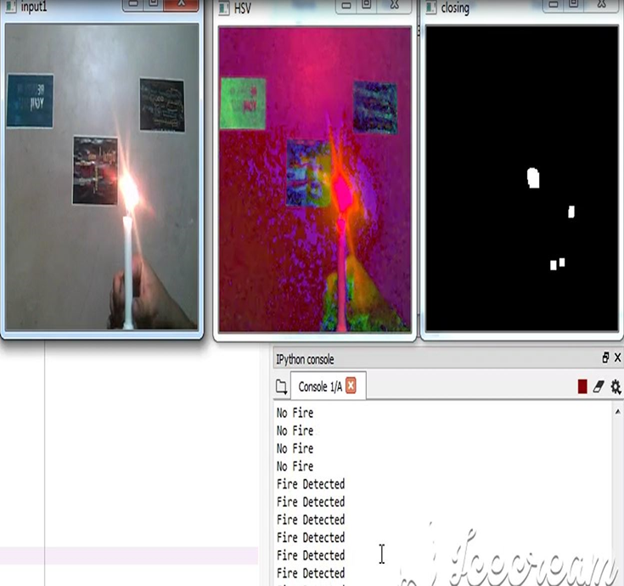

**5.1.2.GUI-GRAPHICAL USER INTERFACE:**

**for remotely control of vehicle using Wi-Fi technology**

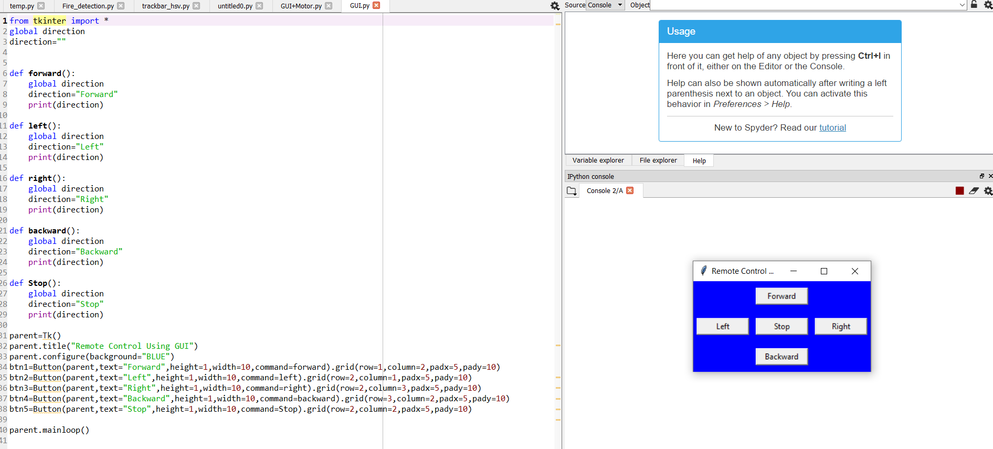

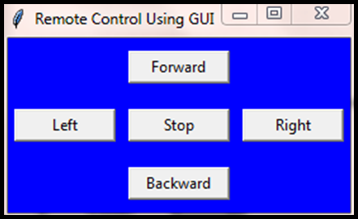

**This is the GUI with which we can control the direction of the robot.**

**5.1.3.Code built for motor to interact with GUI using Tkinter**

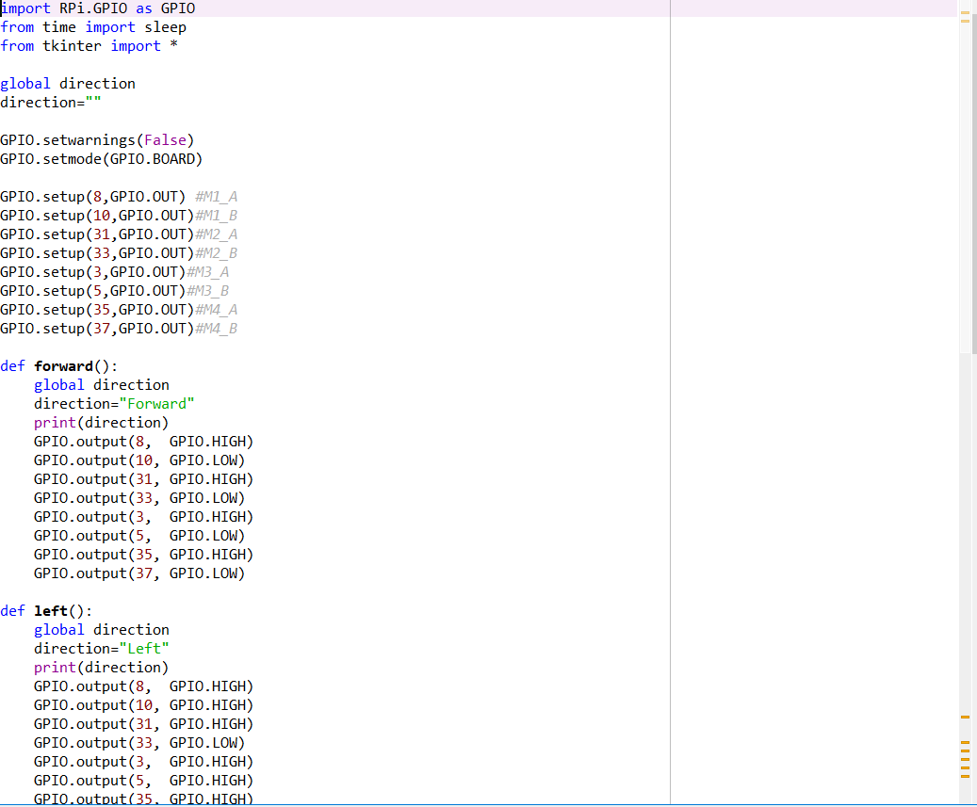

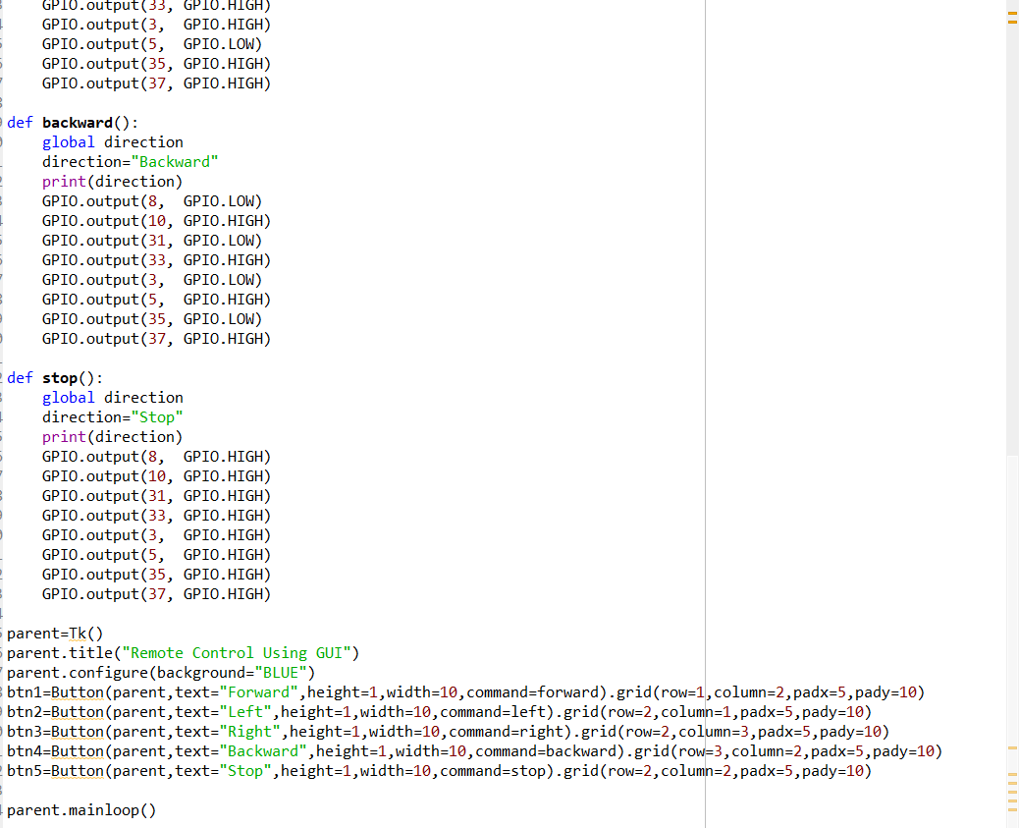

**4 5.1.4.Image Representation of work done on our fire extinguishing robot before lockdown**

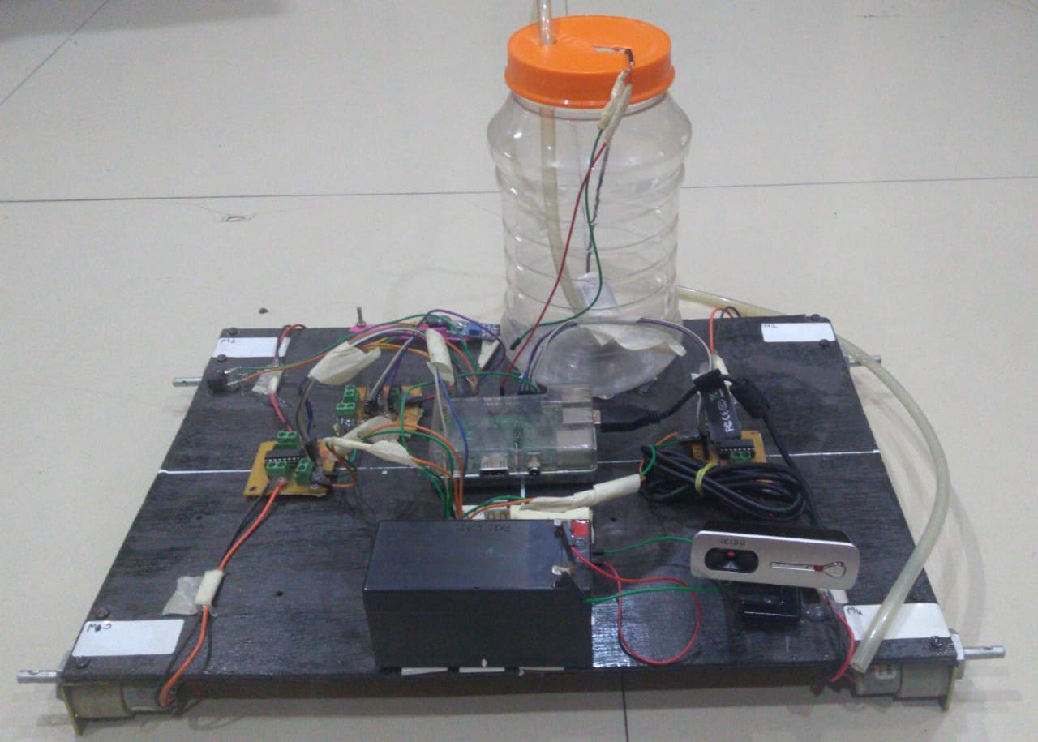

**Fig. Image Representation of fire extinguishing robot**

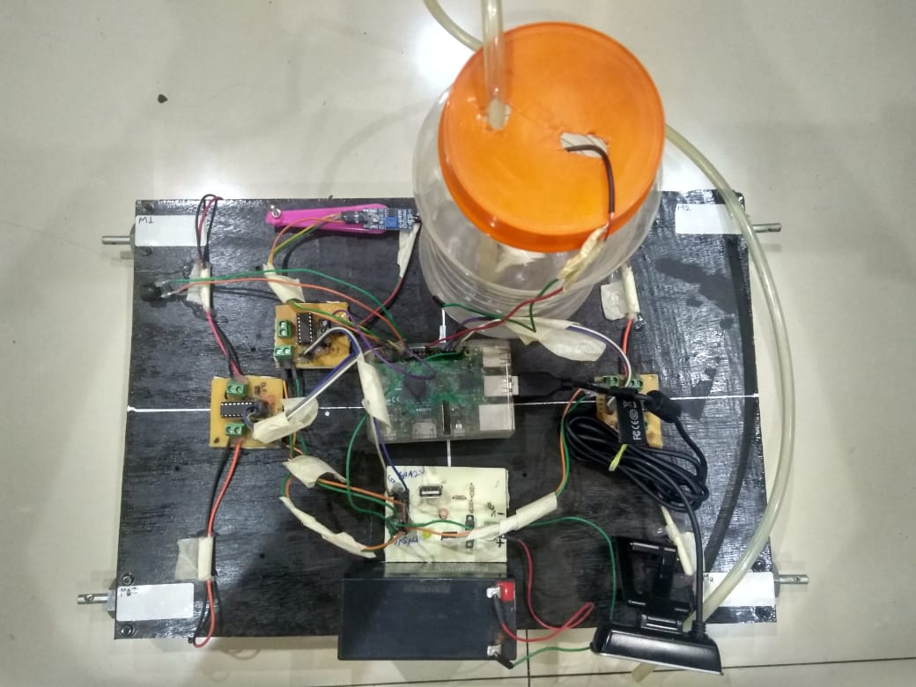

**Fig. Image Representation of fire extinguishing robot**

**Chapter 6 CHALLENGES AND EXPLORATIONS**

1. Our algorithm for image processing was not working accurately, and then we changed the platform to spyder,an open source software for better user interface.

2. Fire detection was one of the major part of this project and it needs to be accurate but we were not getting

accurate results in pixels for image processing. So we used HSV algo.

3. A component of our project, that is nozzle of the water tanker to throw the water was not available in the market and due to this lockdown, search for it stopped. It is shown below:

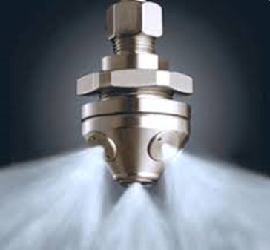

4.Due to this lockdown, we tried to explore for simulation for our project. Our hope was Microsoft IOT Azure raspberrypi online simulator but as we explored further, we get to know that it hasn’t been available for Customization yet.

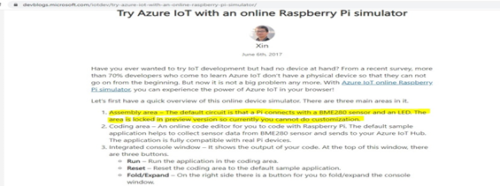

**CHAPTER 7**

**CONCLUSION**

In this project, we have planned to propose an unmanned vehicle for fire detection and extinguishing purpose that is remotely controlled. The proposed method promised to be highly beneficial for the security purpose and industrial purpose.

As far as the work is done, system is able to detect fire using flame sensor and camera using open CV. Robot changes direction according to the input given by user using GUI. System will be able to detect fire using both flame sensors and camera with image processing. But the work of extinguish the fire using water sprinklers is remaining and has been left due to this pandemic and lockdown crisis.

**FUTURE SCOPE**

* At present, camera can rotate up to 180 degrees but it can made to rotate 360 degress in future.
* In future, robot will also be capable of throwing water with controlled robotic arms or the whole water extinguishing system will be replaced with CO2 extinguisher which will make it qualified to use it in large scale and save more lives.
* Camera and video transmission can be added.
* Weight capacity of the robot can be improved.

**CHAPTER 8 APPLICATIONS**

**8.1 APPLICATIONS**

* Can be used in server rooms.
* Extinguishes fire where probability of explosion is high.
* Usable in Power plant control rooms, Captain bridges, Flight control centers.
* Disaster area monitoring and rescue.

**8.2.ADVANTAGES**

* To detect the exact direction of the fire source.
* Capability of sensing accurately with increased flexibility.
* Reduce human effort.
* Reliable and economical.
* Not sensitive to weather conditions.

**8.3 DISADVANTAGES:**

* No monitoring system for the vehicle
* Our system used only for less than 3.5Kg application.
* It is not used to put out large fires.

**8.4 REFERENCES**

1. Jayanth Suresh, “Fire-Fighting Robot”, 2017 International Conference on Computational Intelligence in Data Science(ICCIDS)
2. Ahmed Hassanein, Mohanad Elhawary, Nour Jaber, and Mohammed El-Abd, “Autonomous Firefighting Robot”, 978-1-4673-7509-2/15/$31.00 ©2015 IEEE
3. Shiva Mittal, Manish Kumar Rana, Mayank Bhardwaj, Meenakshi Mataray, “Ceasefire: The Fire Fighting Robot”, International Conference on Advances in Computing, Communication Control and Networking (ICACCCN2018)
4. Kirti Kadam, Aayushi Bidkar, Vaishnavi Pimpale, Dhanashree Doke, Rachana Patil, “Fire Fighting Robot”, International Journal Of Engineering And Computer Science ISSN:2319-7242 Volume 7 Issue 1 January 2018, Page No. 23383-23485
5. Mohd Aliff , MI Yusof, Nor Samsiah Sani, Azavitra Zainal, “Development of Fire Fighting Robot”, (IJACSA) International Journal of Advanced Computer Science and Applications, Vol. 10, No. 1, 2019
6. Abdülkadir ÇAKIR, Nyan Farooq Ezzulddın EZZULDDIN, “Fire-Extinguishing Robot Design by Using Arduino”, IOSR Journal of Computer Engineering (IOSR-JCE) e-ISSN: 2278-0661,p-ISSN: 2278-8727, Volume 18, Issue 6, Ver. V (Nov.-Dec. 2016), PP 113-119
7. Shashi Kumar, Vibhash S. Sisodia, “Development of wireless Fire-Detection and multipurpose Extinguisher Robot”, International Journal of Engineering Science Invention (IJESI) ISSN (Online): 2319 –6734, ISSN (Print): 2319 –6726
8. K. L. Su, "Automatic Fire Detection System Using Adaptive Fusion Algorithm for Fire Fighting Robot," 2006 IEEE International Conference on Systems, Man and Cybernetics, Taipei, 2006, pp. 966- 971.
9. T. L. Chien, H. Guo, K. L. Su and S. V. Shiau, "Develop a Multiple Interface Based Fire Fighting Robot," 2007 IEEE International Conference on Mechatronics, Kumamoto, 2007, pp. 1-6
10. J. H. Kim, B. Keller and B.Y Lattimer, “Sensor fusion based seek-and find fire algorithm for intelligent firefighting robot,” 2013 IEEE/ASME International Conference on Advanced Intelligent Mechatronics (AIM), July 9-12, 2013, Australia, pp. 1482-1486.
11. E. Mahdipour and C. Dadkhah, “Automatic fire detection based on soft computing techniques: review from 2000 to 2010”, Artificial Intelligence Review, vol.42, no. 4, December 2014, pp. 895-934.
12. K. Miyazawa, "Fire robots developed by the Tokyo Fire Department," Advanced Robotics, vol. 16, pp. 553-556, 2002
13. P. H. Chang, Y. H. Kang, G. R. Cho, J. H. Kim, M. Jin, J. Lee, J. W. Jeong, D. K. Han, J. H. Jung, and W. J. Lee, "Control architecture design for a fire searching robot using task oriented design methodology," in SICE-ICASE, 2006. International Joint Conference, 2006, pp. 3126-3131
14. C. F. Tan, M. Alkahari, and A. Rahman, "Development of Ground Vehicle for Fire Fighting Purpose," 2011.