**AI GENERATED IMAGE AND ANALYSIS**

AI is the most used technology in the recent days from house chores to business problems. There has been a rapid advancement in AI. Generative AI prompts, particularly those that generate images from textual descriptions, have opened new possibilities for artists, designers, marketers, and other professionals. There are various Ai tools such as chatgpt, gemini, co pilot, google AI etc. Now I have generated a promote to produce an image about the future technology in 3 different Basic AI tools like Chatgpt, Co pilot and Gemini AI.

1. CHATGPT

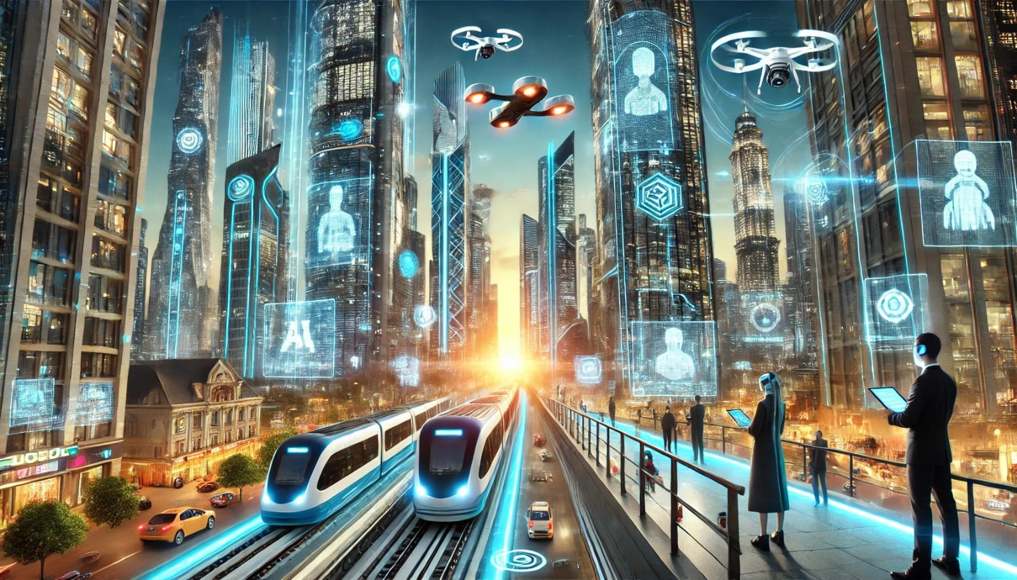

This is the image generated when we passed the prompt in chatgpt.

A futuristic cityscape with towering skyscrapers made of glass and metal, illuminated by neon lights. Flying cars zip through the air, and advanced AI robots assist humans on the streets. Holographic advertisements project from buildings, and a high-speed train hovers above the ground using magnetic levitation. The sky is filled with drones delivering packages, and people wear augmented reality glasses. The scene is vibrant, showing a seamless integration of technology into daily life.

The image produced by chatgpt is given by DALL.E, an Ai model that is designed to generate images. This aligns with deep learning and NLP. It produces high quality and realistic images. One of its con is that it may not always produce photorealistic or technically flawless images.

1. CO – PILOT

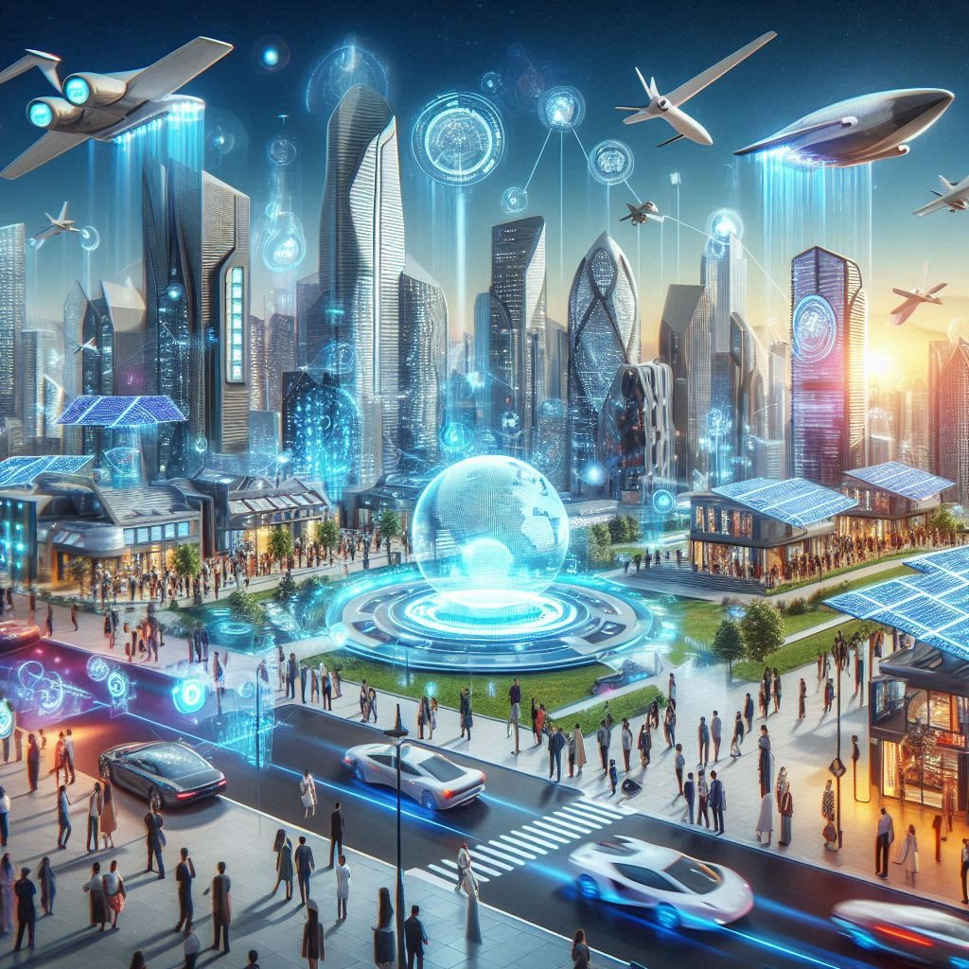

This is the image generated by co pilot when the same prompt is passed.

This is generated through DALL.E integration, it is simply an extension of Chatgpt.

The prompts tend to be more conversational or detailed, allowing users to refine requests in real time.

1. GEMINI AI



Whereas this is the image generated by Gemini AI.

The underlying technology is from Google DeepMind. It uses various deep learning strategies for generative tasks. In image generation, Gemini AI focuses on producing outputs that are grounded in real- world asthetics. It is known for producing photorealistic images. It is close to reality. One of its cons is that it is not as abstract when compared to DALL.E .

I felt that Gemini AI is better as it resembles more towards reality but at the same time chatgpt shows as abstract version of the future technology that would benefit the world if developed in that way. Chatgpt shrines when it comes to artistic concepts that require imagination and flexibility.