**Farm Yield Optimization Analysis**

1. Productivity & Performance

• Identify the top 3 most productive plots based on average yield per harvest. Show the

plot_name, crop_type, and average_yield_kg.

Answer:

select p.plot_name, p.crop_type, round(avg(yield_kg),2) as average_yield_kg

from plots p

join yields y

on p.plot_id=y.plot_id

group by p.plot_name, p.crop_type

order by average_yield_kg desc

limit 3;

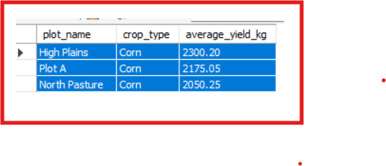

• Calculate the total water consumption for each plot and rank them from highest to

lowest. Show plot_name and total_water_liters.*/

Answer:

select p.plot_name, sum(il.water_amount_liters) as total_water_liters

from plots p

join irrigation_logs il

on p.plot_id=il.plot_id

group by p.plot_name

order by total_water_liters desc;

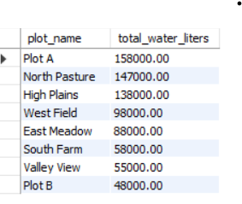

/*2. Yield & Environmental Analysis

• Determine the average yield for each crop type under different weather conditions. The

output should have crop_type, weather_condition, and average_yield_kg.

• Find the highest-yielding plot for each soil type. Show the soil_type, plot_name, and

highest_yield_kg. */

select p.crop_type, round(avg(y.yield_kg),2) as average_yield_kg, y.weather_condition

from plots p

join yields y

group by p.crop_type, y.weather_condition

order by p.crop_type, average_yield_kg desc;

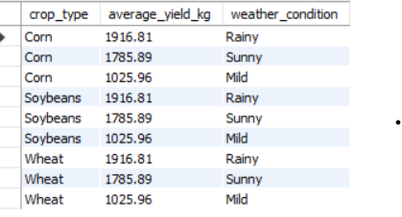

select p.plot_name, p.soil_type , sum(y.yield_kg) as highest_yield_kg

from plots p

join yields y

group by p.plot_name, p.soil_type

order by p.soil_type, highest_yield_kg desc

limit 1;

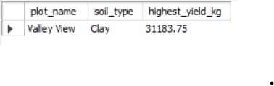

/*3. Farmer & Resource Management

• Identify the farmer who manages the plots with the lowest average water

consumption. Show the first_name, last_name, and their plots'

average_water_liters_per_plot.

• Calculate the number of harvests per month for the last 12 months. Show the month

and the number of harvests. */

select f.first_name, f.last_name, p.plot_name, round(AVG(il.water_amount_liters),2) AS average_water_liters_per_plot

from plots p

join farmers f on f.farmer_id= p.farmer_id

join irrigation_logs il on il.plot_id= p.plot_id

GROUP BY f.first_name, f.last_name, p.plot_name

ORDER BY average_water_liters_per_plot ASC;

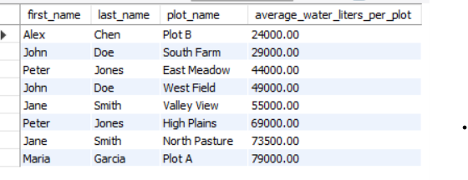

select

year(harvest_date) as year,

month(harvest_date) as month,

count(yield_id) as number_of_harvests

from yields

where harvest_date>= DATE_SUB(CURDATE(), INTERVAL 12 MONTH)

group by year,month

order by number_of_harvests;

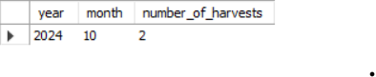

/*4. Advanced Analysis (Bonus)

• Find plots that have a below-average yield for their specific crop type but an above

average water consumption compared to all other plots with the same crop. List the

plot_name, crop_type, yield_kg, and water_amount_liters. */

select round(avg(yield_kg),2) from yields;

select round(AVG(water_amount_liters),2) from irrigation_logs;

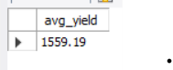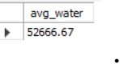

SELECT

p.plot_name,

p.crop_type,

ROUND(AVG(y.yield_kg), 2) AS yield_avg,

ROUND(AVG(il.water_amount_liters), 2) AS water_avg

FROM plots p

JOIN yields y ON p.plot_id = y.plot_id

JOIN irrigation_logs il ON p.plot_id = il.plot_id

GROUP BY p.plot_name, p.crop_type

HAVING AVG(y.yield_kg) < 1559.19

AND AVG(il.water_amount_liters) > 52666.67

ORDER BY yield_avg, water_avg;

