Q4. Please share any supporting evidence that best reflects your contributions this cycle.
I performed key client-side activities using the Nandini Sharma account; however, the appreciation received from the client was attributed under Nandini Sharma’s name, while the work was executed by me (Pallavi Ghaste).
“I earned client appreciation for delivering results under challenging circumstances by bringing Panama in line.
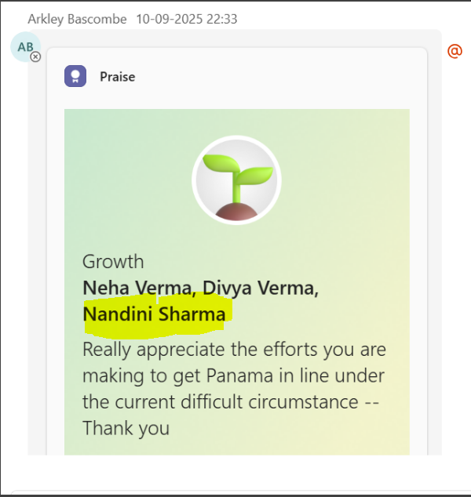
My commitment to project success was further demonstrated by extending support beyond working hours during the Admin system’s latest run, which was recognized by the client.

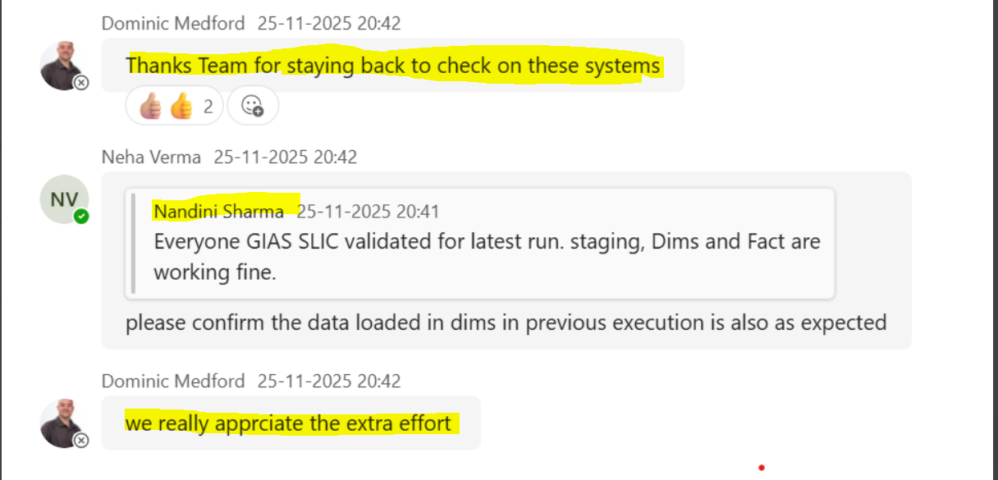

I received repeated appreciation from clients during meetings for my contributions and effective delivery.

