# HealthAI: Intelligent Healthcare Assistant Using IBM Granite

PROJECT TITLE : HealthAI: Intelligent Healthcare Assistant Using IBM Granite

Team Size : 2

Team Leader : Kudumula Venkata Pallavi

Team Member : Galla Manasa

Team ID : LTVIP2025TMID38383

College Name : Rise Krishna Sai Prakasam Group of Institutions

## VIRTUAL INTERNSHIP PROGRAM

Internship Details : Generative AI with IBM Cloud

Internz : Smart Internz & IBM

Company : Smart Bridge powered by Smart Internz

## 1. Introduction

HealthAI is a real-time intelligent healthcare assistant developed using IBM Granite, Streamlit, and Python. It helps users get doctor-like responses, predict diseases, suggest treatments, and visualize health data interactively.

## 2. Declaration

We declare that the project titled 'HealthAI: Intelligent Healthcare Assistant Using IBM Granite' is our original work, completed under the guidance of Smart Internz and IBM.

## 3. Acknowledgment

We express our gratitude to Smart Internz and IBM for providing this opportunity. We also thank our mentors and faculty for their continuous support and encouragement.

## 4. Abstract

This project presents a smart healthcare assistant that provides AI-based disease prediction, chatbot consultation, treatment suggestions, and visual analytics using open-source tools and IBM Granite.

## 5. Problem Statement

Access to reliable and quick healthcare advice is limited. Many individuals rely on internet sources, which are not always accurate. HealthAI addresses this gap using AI for safe and instant health guidance.

## 6. Brainstorming & Ideation

The initial concept revolved around challenges like misdiagnosis, remedy unawareness, and high consultation costs. The idea was to use AI to create a reliable assistant that understands symptoms and provides relevant health info.

## 7. Requirement Analysis

Functional: Disease prediction, remedy suggestions, chatbot interaction.  
Non-Functional: Real-time performance, mobile usability, data privacy.  
Technical: Python, Streamlit, IBM Granite, dataset integration.

## 8. Project Design

The system includes a Streamlit-based frontend with forms and chat interface, a backend in Python that processes logic, and IBM Granite LLM for natural language Q&A.

## 9. Project Planning

A 4-week plan was made:  
Week 1 - Requirements and model setup  
Week 2 - UI and backend logic  
Week 3 - Remedies and AI testing  
Week 4 - Integration and deployment

## 10. Tools and Technologies Used

- Python  
- Streamlit  
- IBM Granite LLM  
- Pandas  
- Plotly  
- GitHub  
- Smart Internz platform

## 11. Modules Implemented

1. Patient Chat: Conversational health queries  
2. Disease Prediction: Based on symptoms  
3. Treatment Plans: Recommended medications  
4. Health Analytics: Visualization of metrics

## 12. How to Use the HealthAI Application

1. 1 Open App:[HealthAI Streamlit App]

(https://healthai-kp65rjz9aspoqpt5wcohvn.streamlit.app/)

1. Choose Feature: Patient Chat / Disease Prediction / Treatment Plans / Health Analytics  
   3. Input Data: Type symptoms or condition  
   4. Submit: Click generate  
   5. Output: Get response from AI instantly

## 13.Sample Module output

🏘️Home Page:

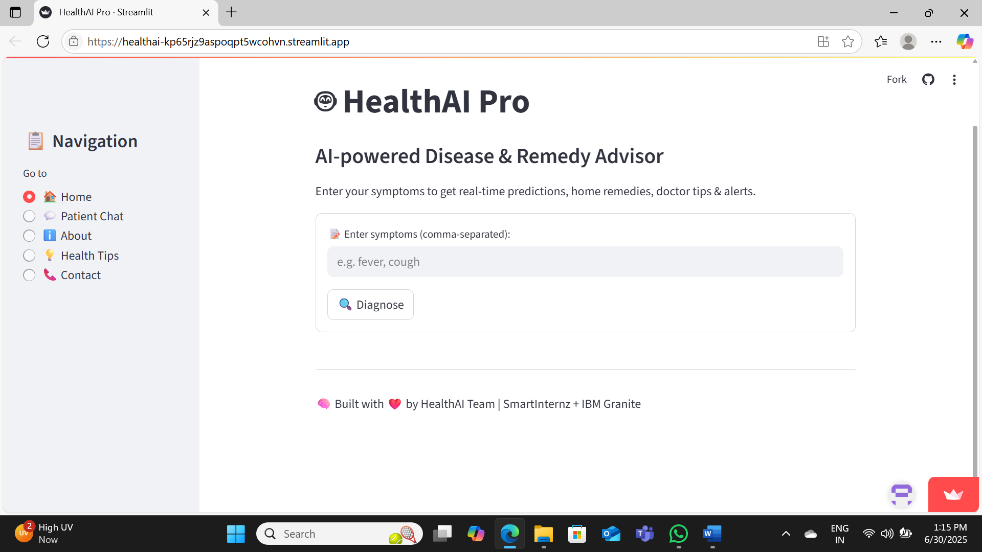

**💬 Module: Home – AI-powered Disease & Remedy Advisor**

**User**: fever, cough  
**AI**: You may be experiencing symptoms of the common cold or flu. Suggested remedies include:

* Stay hydrated and rest
* Use a humidifier to ease breathing
* Take paracetamol if fever persists
* Consult a doctor if symptoms worsen or last more than 3 days

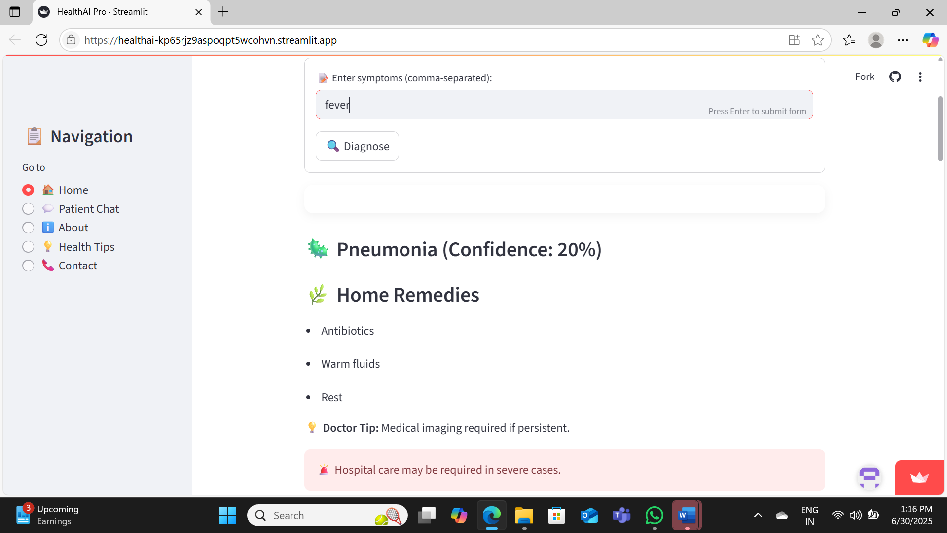

**🧪 Module 2: Disease Prediction**

**Input Symptom**: Fever  
**AI Response**:  
🦠 **Pneumonia** (Confidence: 20%)

**🌿 Home Remedies:**

* Antibiotics
* Warm fluids
* Rest

💡 **Doctor Tip**: Medical imaging required if persistent.  
🚨 **Warning**: Hospital care may be required in severe cases.

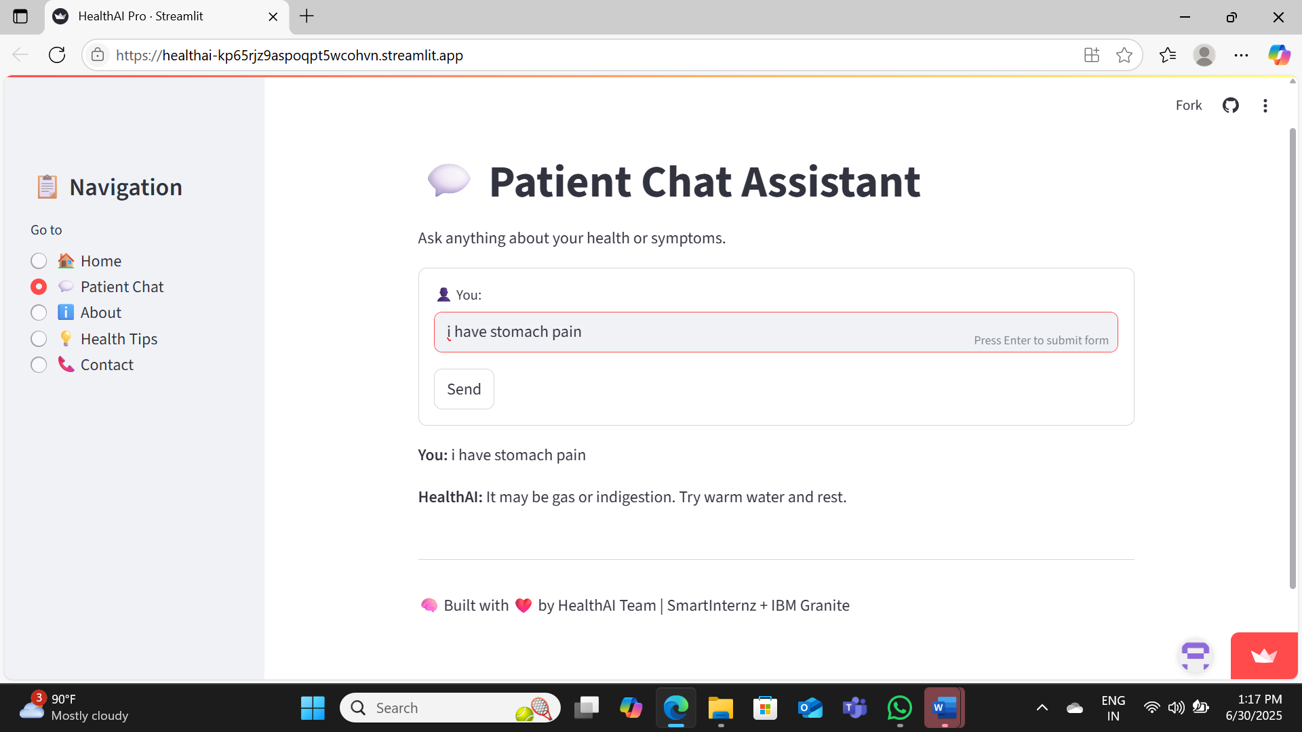

**💊 Treatment Plans**

**Condition:** Stomach Pain (due to gas/indigestion)  
**Plan:**

* Drink warm water frequently.
* Take Antacid syrup 10ml after meals.
* Avoid spicy, oily, and heavy foods.
* Rest and avoid stress.
* If pain persists beyond 24 hours or worsens, consult a physician.

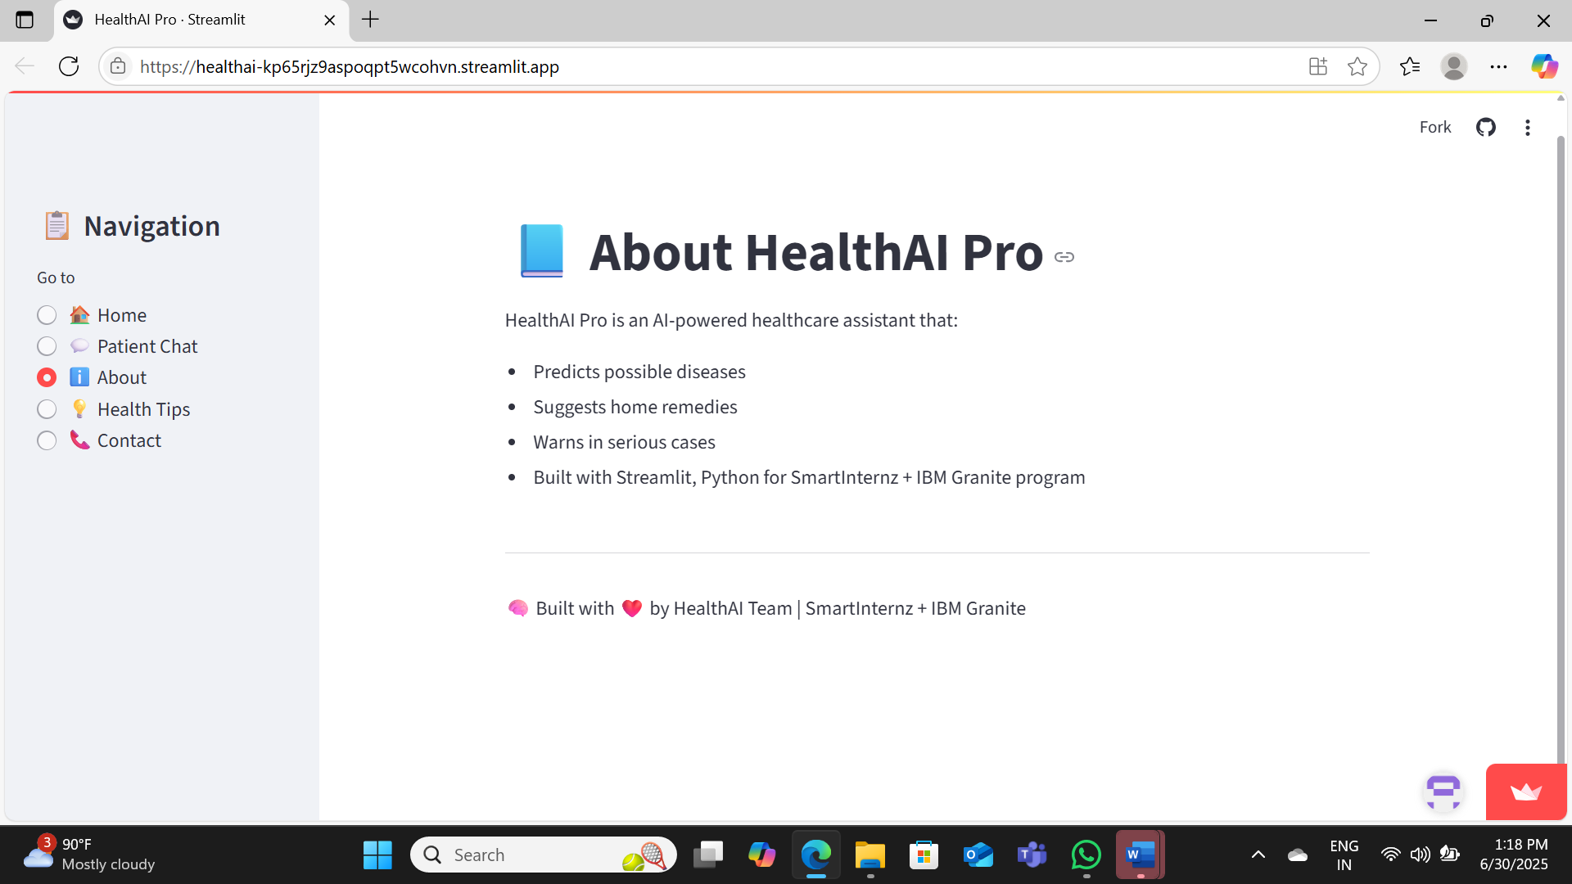

**📄 About HealthAI Pro**

**HealthAI Pro** is an AI-powered healthcare assistant that:

* 📊 Predicts possible diseases based on symptoms.
* 🌿 Suggests appropriate home remedies.
* 🚨 Warns users in serious or emergency cases.
* 🛠️ Built with **Streamlit** and **Python** for the **SmartInternz + IBM Granite** program.

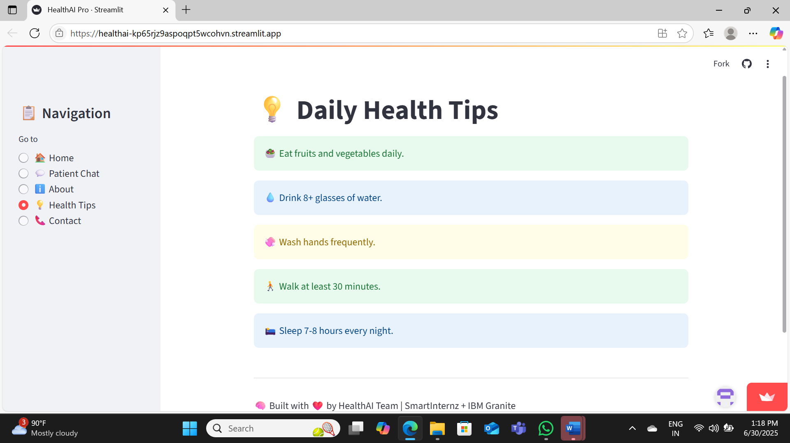

**💡 Daily Health Tips**

* 🥗 **Eat fruits and vegetables daily.**
* 💧 **Drink 8+ glasses of water.**
* 🖐️ **Wash hands frequently.**
* 🚶‍♂️ **Walk at least 30 minutes.**
* 🌙 **Sleep 7–8 hours every night.**

## 14.Technical Architecture

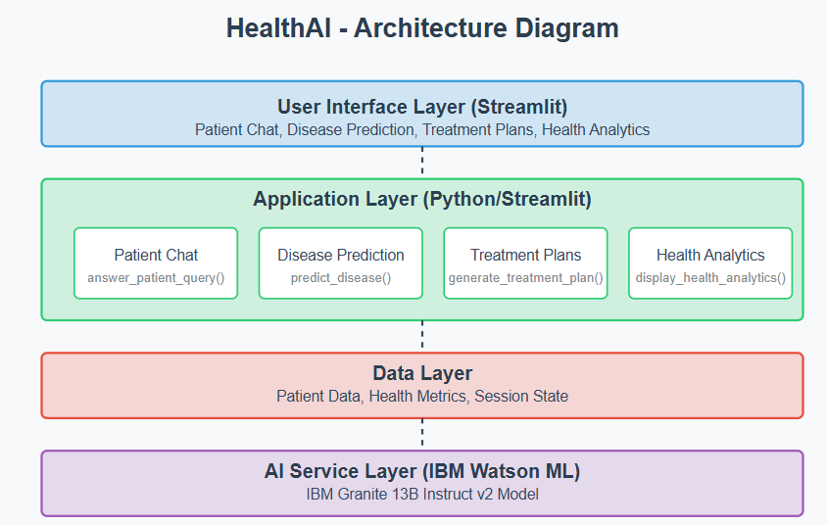

The architecture comprises:  
- UI layer (Streamlit)  
- Backend logic (Python)  
- LLM integration (IBM Granite)  
- Data layer (CSV/dictionary-based)

## 15. Project Workflow

Stages: Requirement gathering → Design → Development → Testing → Deployment.

## 16. Milestone 1: Model Selection and Architecture

IBM Granite was chosen for its ability to understand and respond to natural health queries in multiple formats. The app's flow and logic were defined.

## 17. Milestone 2: Core Functionalities Development

Each module (chat, prediction, remedies) was independently developed, tested, and merged for a seamless user experience.

## 18. App.py Development

The central Python script managing page routing, user inputs, model responses, and display formatting using Streamlit.

## 19. UI Design

Simple and user-friendly layout using sidebar menus, buttons, forms, and visual charts created via Streamlit.

## 20. Project Development

Developed the modules and integrated them with IBM Granite. Ensured compatibility across mobile and desktop.

## 21. Functional & Performance Testing

- Functional: Accurate disease mapping, valid remedies, appropriate chat replies  
- Performance: Under 2s response time, works on multiple platforms

## 22. Deployment

Locally on VS Code using Streamlit and online via Google Colab with ngrok tunneling for public access.

## 23. Future Scope

- Doctor verification support  
- Integration with wearable devices  
- User login and history  
- API-based cloud deployment

## 24. Conclusion

HealthAI proved to be an insightful AI application in healthcare, enabling better learning, development, and real-world value creation.

## 25. Project Links

🌐 App: https://healthai-kp65rjz9aspoqpt5wcohvn.streamlit.app/

💻 GitHub: https://github.com/Pallavi2125/HealthAI