# LAB – 7

EXPERIMENT 1

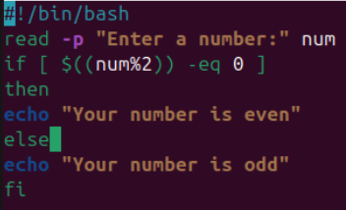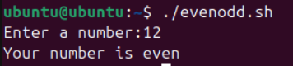

EXPERIMENT 2

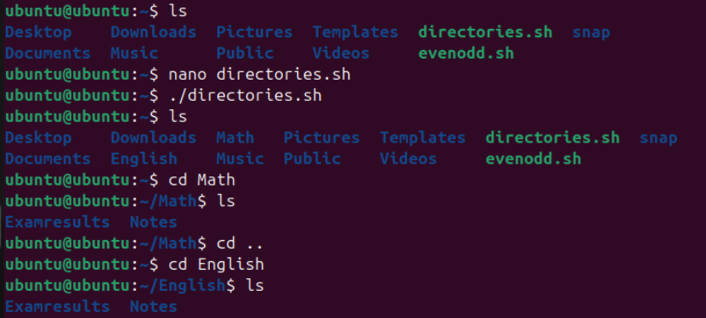

EXPERIMENT 3

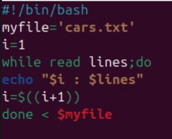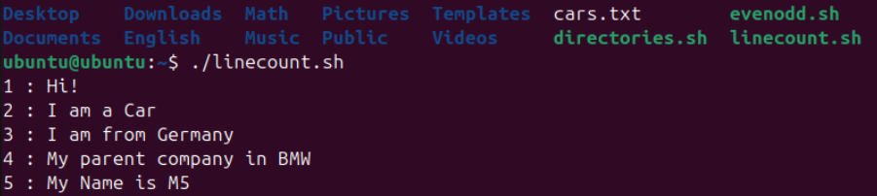

EXPERIMENT 4

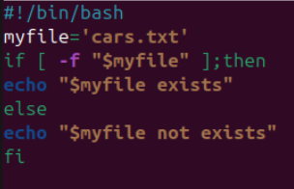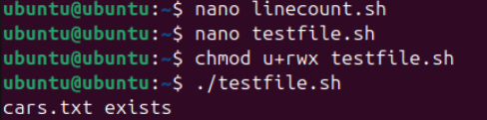

EXPERIMENT 5

