Vel Tech Rangarajan Dr. Sagunthala R&D Institute of Science and Technology

(Deemed to be University Estd. u/s 3 of UGC Act, 1956)

School of Computing
B.Tech. – Computer Science and Engineering
VTR UGE2021- (CBCS)

Academic Year: 2025–2026
SUMMER SEMESTER - SS2526
Course Code : 10211CS207
Course Name : Database Management Systems
Slot No : S4L5

DBMS TASK - 9 REPORT
Title: CRUD operations in Graph databases

Submitted by:
VTUNO | REGISTER NUMBER | STUDENT NAME
vtu29811 | 24UECS1201 | G.pallavi

AIM:
To perform CRUD operations like creating, inserting, querying, finding, deleting operations on graph spaces.
The steps to get started with Neo4j's Aura Graph Database:
Step1: Copy and paste the following link into your web browser: https://neo4j.com/cloud/platform/aura-graph-database/?ref=docs-get-started-dropdown
Step2: Click on "Start Free."
Step3: Choose the option to "Continue with Google."
Step4: Click the "Open" button.
Step5: After clicking "Open," a text file will be automatically downloaded. This file contains your user ID and password details.
Step6: Copy the password from the downloaded text file and paste it where required.
Step7: Close the "Get started with Neo4j with beginner guides" if it's open.
Sep8: You're now ready to begin practicing with the Graph Database.

Create Node with Properties
Properties are the key-value pairs using which a node stores data. Create a node with properties using the CREATE clause and need to specify these properties separated by commas within the flower braces “{ }”.
Syntax
CREATE (node:label { key1: value, key2: value, . . . . . . . . . }) return node

To verify the creation of the node, type and execute the following query in the dollar prompt.
Syntax:
MATCH (n) RETURN n
Creating Relationships
To create a relationship using the CREATE clause and specify relationship within the square braces “[ ]” depending on the direction of the relationship it is placed between hyphen “ - ” and arrow “ → ” as shown in the following syntax.
Syntax:
CREATE (node1)-[:RelationshipType]->(node2)
Syntax:
MATCH (a:LabeofNode1), (b:LabeofNode2)
WHERE a.name = "nameofnode1" AND b.name = " nameofnode2"
CREATE (a)-[: Relation]->(b) RETURN a,b

Deleting a Particular Node
To delete a particular node and need to specify the details of the node in the place of “n” in the above query.
Syntax:
MATCH (node:label {properties . . . . . . . . . . }) DELETE node

Create a graph database for student course registration, create student and dept node and insert values of properties.
Create a CrickerBoard Node:
create(cb:CricketBoard{BoardID:'BID01',Name:'Chennai Cricket Board', Address:'Chennai', Phone:9988776699}) return cb
Create Team Nodes:
create(t1:Team{teamID:'CCB01',BoardID:'BID01',name:'ABS EXPRESS', Coach:'G.D.RAMESH', Captain:'SAMPATH KUMAR'}) return t1
create(t2:Team{teamID:'CCB02',BoardID:'BID01',name:'AVG EXPRESS',Coach: 'T.KARTHIKH', Captain:'Y.JOHN'}) return t2
Create Player Nodes:
create(p1:Player{PlayerID:'1',TeamID:'CCB01',Name:'Raj',Age:23,DateofBirth:'29-JUN-1996', PlayingRole:'Bowler',email:'rajn@gmail.com'}) return p1
create(p2:Player{PlayerID:'33',TeamID:'CCB01',Name:'Anand',Age:23,DateofBirth:'02-JAN-1999', PlayingRole:'Batsman',email:'balajid@gmail.comm'}) return p2
create(p3:Player{PlayerID:'65',TeamID:'CCB02',Name:'Suresh',Age:27,DateofBirth:'02-JUN-1996', PlayingRole:'Batsman',email:'sureshd@gmail.comm'}) return p3
create(p4:Player{PlayerID:'75',TeamID:'CCB02',Name:'Rohit',Age:33,DateofBirth:'02-JUN-1991', PlayingRole:'Batsman',email:'srohit@gmail.comm'}) return p4
Creating Relationship among CricketBoard and Teams:
match(cb:CricketBoard{BoardID:'BID01'}),(t1:Team{teamID:'CCB01'}) create(cb)-[r:has]->(t1) return cb,r,t1
match(cb:CricketBoard{BoardID:'BID01'}),(t2:Team{teamID:'CCB02'}) create(cb)-[r:has]->(t2) return cb,r,t2
Creating Relationship among Players and Teams:
match(p1:Player{PlayerID:'1'}),(t1:Team{teamID:'CCB01'}) create(p1)-[r1:playfor]->(t1) return p1,r1,t1
match(p2:Player{PlayerID:'33'}),(t1:Team{teamID:'CCB01'}) create(p2)-[r2:playfor]->(t1) return p2,r2,t1
match(p3:Player{PlayerID:'65'}),(t2:Team{teamID:'CCB02'}) create(p3)-[r3:playfor]->(t2) return p3,r3,t2
match(p4:Player{PlayerID:'75'}),(t2:Team{teamID:'CCB02'}) create(p3)-[r4:playfor]->(t2) return p4,r4,t2
Display All nodes: match(n) return n
Output:
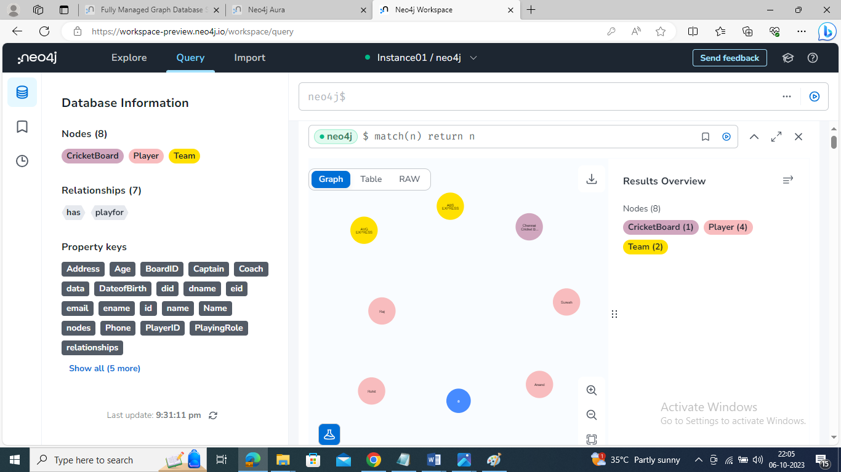

OUTPUT:
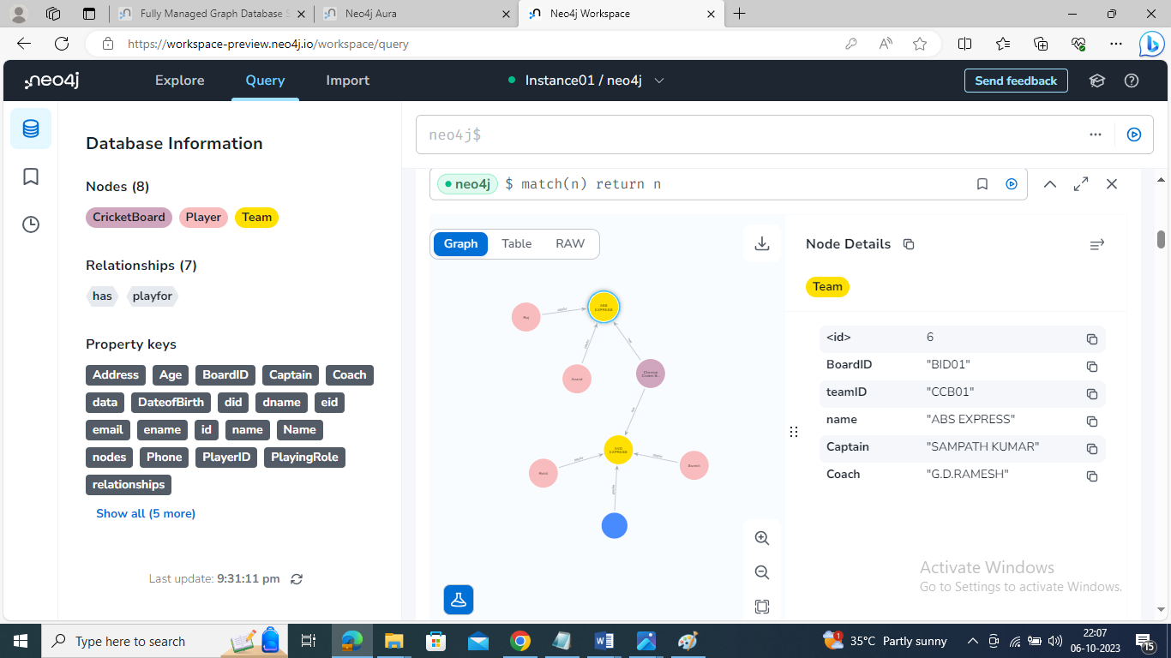

Retrieve particular player details:
match(p:Player{PlayerID:'33'}) return p

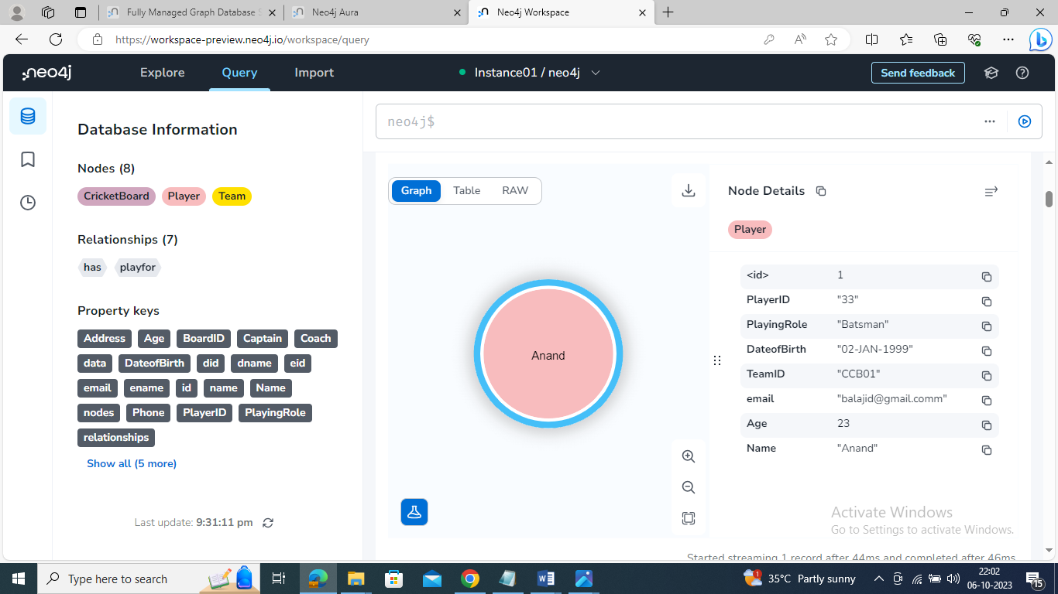

Update particular player details:
match(p:Player{PlayerID:'1'}) set p.age=27 return p

Output:
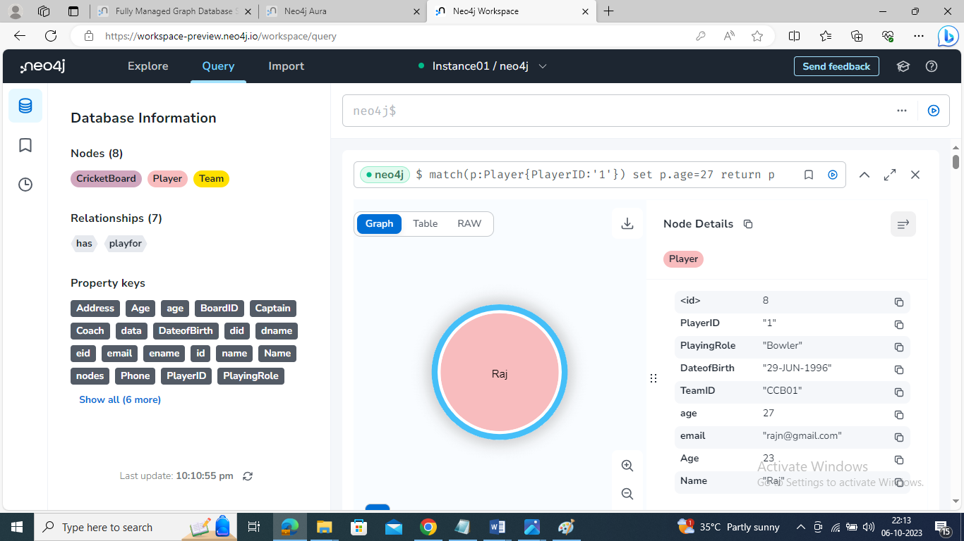

Delete particular player from the team:
match(p:Player{PlayerID:'33'}) delete p
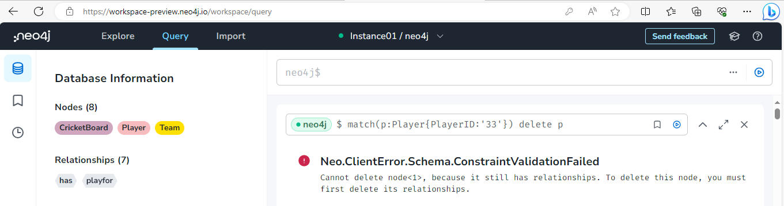

Result:
Thus the CRUD operations like creating, inserting, querying, finding, deleting operations on graph spaces were executed successfully.

