SR UNIVERSITY, WARANGAL
SCHOOL OF COMPUTER SCIENCE AND ARTIFICIAL INTELLIGENCE
DEPARTMENT OF COMPUTER SCIENCE AND ENGINEERING

PROJECT REPORT
ON
SHARED CAB BOOKING SYSTEM
Data Analytics and Visualization

Submitted in partial fulfilment of the requirements for
DATA ANALYTICS AND VISUALIZATION
(Course Code: 25CAI202PC201)

Submitted by
K. PALLAVI
Roll No.: 2503A52356

Under the guidance of
MINAKSHI MAM

Academic Year 2026–2027

CERTIFICATE
This is to certify that the project report entitled “SHARED CAB BOOKING SYSTEM” is a bonafide work carried out by K. PALLAVI (Roll No.: 2503A52356) in partial fulfilment of the requirements for the course Data Analytics and Visualization (25CAI202PC201) at SR University, Warangal, during the Academic Year 2026–2027, under the guidance of MINAKSHI MAM.
The report presents an analysis of the shared cab booking dashboard supplied for this project.
Faculty Guide: Minakshi Mam
Signature of Faculty Guide: __________________________
Signature of Head of Department: ____________________
Date: ____________________ Place: Warangal

DECLARATION
I, K. PALLAVI (Roll No.: 2503A52356), hereby declare that this project report titled “SHARED CAB BOOKING SYSTEM” has been prepared by me as part of the Data Analytics and Visualization course. The report is based on the dashboard screenshot supplied for the project. Any figures stated in the report are taken from the visible dashboard, and limitations or items requiring verification have been identified.
Place: Warangal
Date: ____________________
Signature of Student: ____________________

ACKNOWLEDGEMENT
I express my sincere gratitude to MINAKSHI MAM for the guidance and support provided during this project. I also thank the Department of Computer Science and Engineering, SR University, Warangal, for providing the opportunity to work on the Shared Cab Booking System dashboard as part of the Data Analytics and Visualization course. Finally, I thank everyone who supported the preparation of this project report.

ABSTRACT
The Shared Cab Booking System is a data analytics and visualization project that summarizes student cab requests and booking progress. The supplied dashboard displays 100 requests, 100 student IDs, an estimated cab-fare total of approximately ₹1,20,000 and an average of 2.00 seats needed. Destination-wise counts are Warangal (41), Hanamkonda (33) and Kazipet (26). The status chart shows Matched (32), Group Formed (24), Waiting (24) and Booked (20). The dashboard includes KPI cards, destination charts, a college comparison, a status doughnut chart and slicers for college, destination and travel date. The report interprets only information visible in the supplied screenshot and identifies data details that need verification, including a mismatch between the college chart and college slicer.
Keywords: Shared Cab, Student Travel, Booking Requests, Power BI, Data Analytics, Data Visualization.

TABLE OF CONTENTS
- 1. Introduction
- 2. Data Overview
- 3. Methodology
- 4. Data Analysis
- 5. Dashboard Visualization
- 6. Findings and Conclusion
- 7. Limitations and Future Scope
- 8. Appendix
Page numbers can be updated in Word after final formatting.

CHAPTER 1 – INTRODUCTION

1.1 Introduction
The Shared Cab Booking System is a data analytics and visualization project that presents student cab-booking requests in a dashboard. It focuses on requests made by students travelling to common destinations such as Warangal, Hanamkonda and Kazipet. By bringing booking information together, the dashboard helps users review request volume, destination demand, college-wise requests, estimated fare and booking progress.

1.2 Problem Statement
Students travelling along similar routes may make separate travel arrangements. This can make it difficult to identify other students with similar travel plans and understand the overall demand for shared transport. The project organizes cab-request information and displays it through visual summaries so that common destinations, request status and estimated travel costs can be reviewed more easily.

1.3 Objectives
- To summarize the number of cab requests and student records.\n• To understand demand across the destinations shown in the dashboard.\n• To compare request counts across colleges.\n• To review booking progress through status categories.\n• To present estimated cab fare and average seats needed.\n• To provide interactive filters for college, destination and travel date.

1.4 Scope
The dashboard is designed for reviewing shared-cab request information. The supplied screenshot demonstrates summary indicators and charts. It does not, by itself, verify live cab availability, payment processing, GPS tracking, automatic student matching or a completed booking transaction.

CHAPTER 2 – DATA OVERVIEW

2.1 Dataset Description
The dashboard displays a total of 100 cab requests and a count of 100 student IDs. The underlying dataset file, original publisher, full column list and data dictionary were not supplied with the screenshot. Therefore, this report describes only the fields and measures visible in the dashboard.

2.2 Fields and Measures Visible
The dashboard includes Request_ID, Student_ID, Estimated_Cab_Fare_INR, Seats_Needed, Travel_Date, College, Destination, First_Pickup_Location and Status. These labels are taken from the supplied dashboard. The exact definitions and data types should be confirmed against the original dataset.

2.3 Dashboard Summary
The displayed total estimated cab fare is approximately ₹120K (about ₹1,20,000). The average number of seats needed is 2.00. Destination request counts shown are Warangal – 41, Hanamkonda – 33 and Kazipet – 26. The dashboard shows 100 requests in total.

CHAPTER 3 – METHODOLOGY

3.1 Project Workflow
The project workflow can be described as: collect cab-request records → review and prepare the data → create summary measures → build charts and filters → interpret the dashboard. The screenshot confirms the final dashboard view, but it does not provide enough evidence to document the exact cleaning operations or formulas used.

3.2 Data Preparation Checks
Before final submission, check for blank Request_ID and Student_ID values, duplicate requests, inconsistent destination and college names, invalid travel dates, negative or missing fare values, and seats-needed values outside the expected range. Keep an unchanged copy of the original data and document every correction. These are recommended validation checks; the screenshot does not confirm that each check has already been completed.

3.3 Tools
Microsoft Power BI is represented by the interactive dashboard layout and visual elements. If Excel was used to prepare the source table, include the actual workbook and steps in the final submission. The precise software versions and transformation scripts were not provided.

CHAPTER 4 – DATA ANALYSIS

4.1 Request and Student Count
The dashboard reports 100 Request_ID records and 100 Student_ID records. This indicates that the displayed counts are equal. It should not be assumed that every student can make only one request unless uniqueness is checked in the source data.

4.2 Destination-wise Analysis
Warangal has the highest displayed request count with 41 requests, followed by Hanamkonda with 33 and Kazipet with 26. Together, the three destination counts add up to 100. This indicates that Warangal is the largest destination category in the displayed data.

4.3 College-wise Analysis
The college chart displays a request-count comparison. The visible category labels appear to include College A, College D, College B and College C, with approximate values 27, 25, 24 and 24 respectively. However, the filter beside the chart lists College A, College B and College C only. This mismatch should be checked against the original data and visual configuration before submission; the chart should not be treated as fully validated.

4.4 Booking Status Analysis
The status chart shows Matched – 32 (32%), Group Formed – 24 (24%), Waiting – 24 (24%) and Booked – 20 (20%). Matched is the largest category. The four displayed counts total 100, matching the request count.

4.5 Estimated Fare and Seats
The total estimated cab fare displayed is approximately ₹120,000. The average Seats_Needed value is 2.00. These are dashboard-level summaries; the screenshot does not provide the fare distribution, individual trip fares, currency calculation logic or whether the estimate represents all requests or only a filtered selection.

4.6 Travel Date Filter
A travel-date range filter is visible, showing 09-01-2026 to 09-12-2026. The filter allows the dashboard viewer to narrow the displayed information by travel date. Confirm the date format and whether the range is inclusive in the underlying report.

CHAPTER 5 – DASHBOARD VISUALIZATION

5.1 Dashboard Components
The dashboard contains four KPI cards: Count of Request_ID, Count of Student_ID, Sum of Estimated_Cab_Fare_INR and Average of Seats_Needed by Travel_Date. It also contains a destination treemap, a destination-wise column chart, a college-wise line chart, a status doughnut chart, a college slicer, a destination slicer and a travel-date range slicer.

5.2 Interpretation
The KPI cards provide a quick summary of request volume and estimated travel requirements. The treemap and column chart show how requests are distributed by destination. The college chart supports comparison between college categories, subject to resolving the label mismatch. The doughnut chart shows the progress/status mix of requests. Slicers allow the viewer to filter the report and examine selected subsets.

5.3 Dashboard Screenshot
The supplied dashboard screenshot is included below as the visual reference for this report. The screenshot is a static view; interactive filtering can be demonstrated in the Power BI report file.
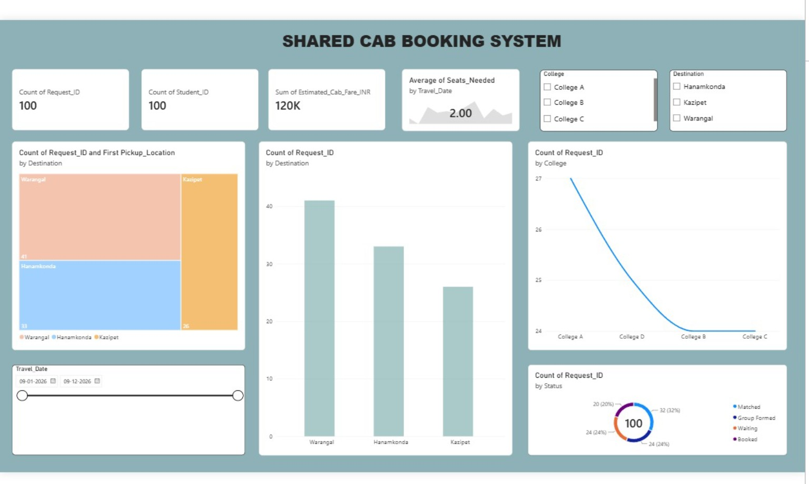
Figure 5.1: Shared Cab Booking System dashboard screenshot supplied for the project.

CHAPTER 6 – FINDINGS AND CONCLUSION

6.1 Key Findings
- The dashboard summarizes 100 cab requests and 100 student IDs.\n• Warangal is the most selected destination (41 requests), followed by Hanamkonda (33) and Kazipet (26).\n• The total estimated cab fare is approximately ₹1,20,000.\n• The average number of seats needed is 2.00.\n• Matched is the largest status category with 32 requests (32%).\n• The college chart contains a category-label inconsistency that requires verification.

6.2 Conclusion
The Shared Cab Booking System dashboard demonstrates how cab-request data can be summarized and explored using data visualization. It gives a consolidated view of request volume, destination demand, college-wise distribution, estimated fare, seat requirements and booking status. These summaries can help a project team understand travel demand and identify areas that may need attention. The accuracy of further conclusions depends on validating the original dataset and correcting the college-chart inconsistency.

CHAPTER 7 – LIMITATIONS AND FUTURE SCOPE

7.1 Limitations
- The raw dataset and its complete data dictionary were not supplied for this report.\n• The original data source and collection method are unknown.\n• The screenshot does not prove that cab matching, group formation, booking, payments or notifications operate as live application features.\n• The college chart appears to contain a College D label while the slicer lists only Colleges A, B and C.\n• The meaning and calculation method of the estimated fare and average seats measures should be confirmed.

7.2 Future Scope
- Connect the dashboard to a validated, regularly updated request database.\n• Add route and pickup-point matching based on students’ travel plans.\n• Add verified booking confirmation and cancellation tracking if the application supports these features.\n• Include trip-level fare details and a transparent fare-sharing calculation.\n• Add filters for status, travel date, destination and college.\n• Add map-based route visualization and notifications in a future application version.\n• Apply privacy controls so student contact and travel details are visible only to authorized users.

CHAPTER 8 – APPENDIX

8.1 Suggested Measures
The following are example Power BI measures. Use them only after confirming the exact table and column names in the project dataset:\n\nTotal Requests = COUNT('CabData'[Request_ID])\n\nTotal Students = DISTINCTCOUNT('CabData'[Student_ID])\n\nEstimated Fare Total = SUM('CabData'[Estimated_Cab_Fare_INR])\n\nAverage Seats Needed = AVERAGE('CabData'[Seats_Needed])

8.2 Pre-submission Checklist
- Replace the example table name CabData with the actual Power BI table name.\n• Verify that the destination counts total the expected number of records.\n• Resolve the College D label/filter mismatch.\n• Confirm the travel-date format and filter range.\n• Verify the estimated-fare total and average-seat calculation.\n• Add the actual dataset source, cleaning steps and screenshots if available.\n• Update page numbers and obtain required signatures.

