Decision Surface

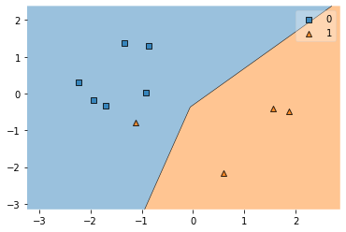 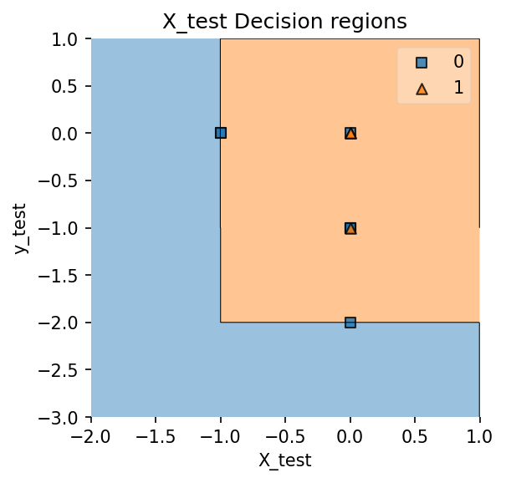

**u-shape Concerticcir1**

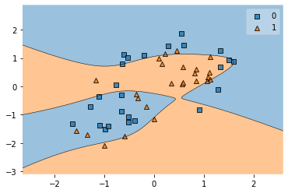 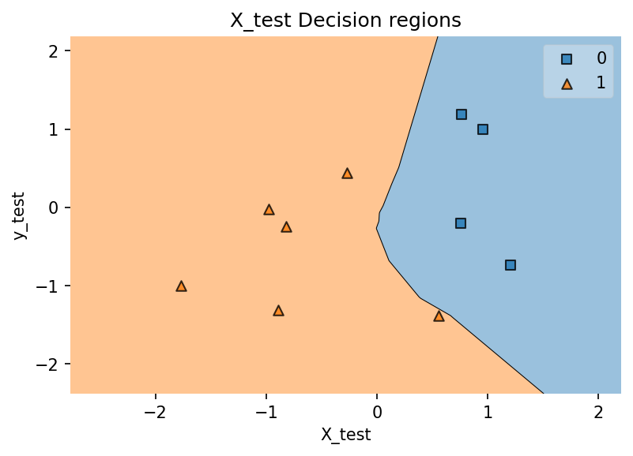

**Concerticcir2 Linearsep**

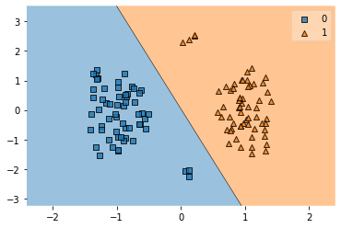 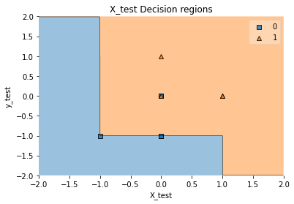

**Outlier Overlap**

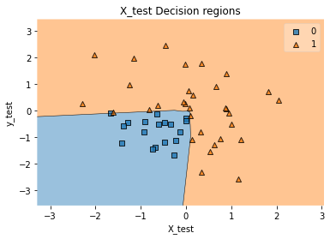 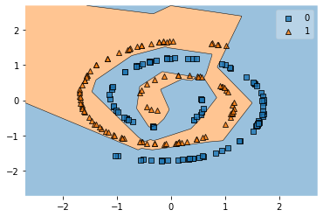

**XOR Twospirals**

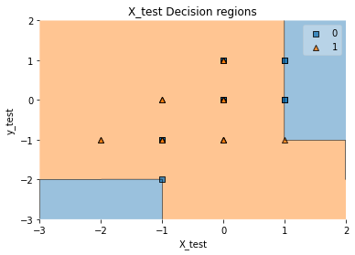

**Random**

Accuracy:

1. Ushape - 90
2. Concerticcir1 - 70
3. Concerticcir2 - 74
4. Linearsep - 90
5. Outlier - 100
6. Overlap - 77
7. XOR - 78
8. Twospirals - 97
9. Random - 65