1. 10000 Users on fulll dataset. Around 23000 recipes on hp laptop

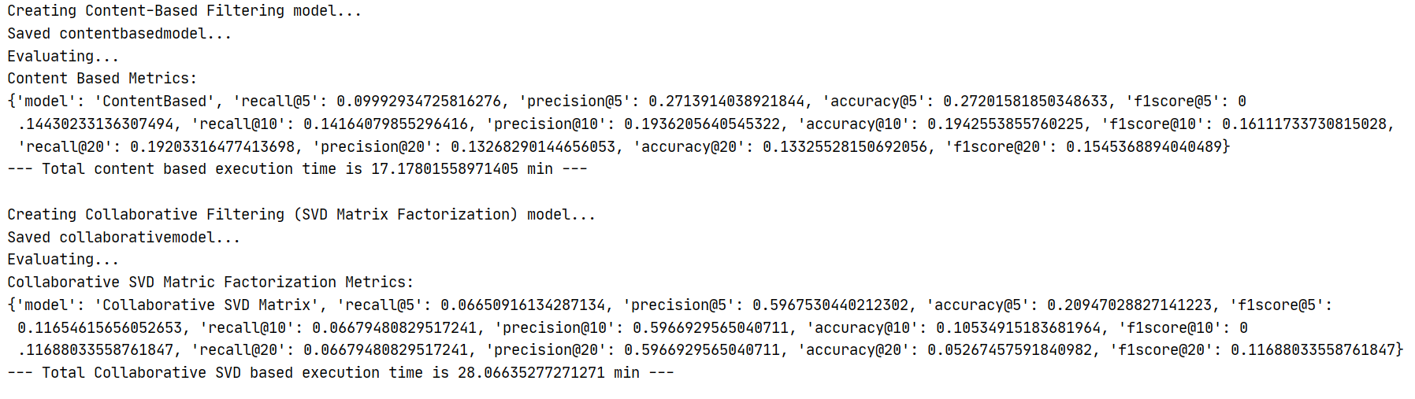

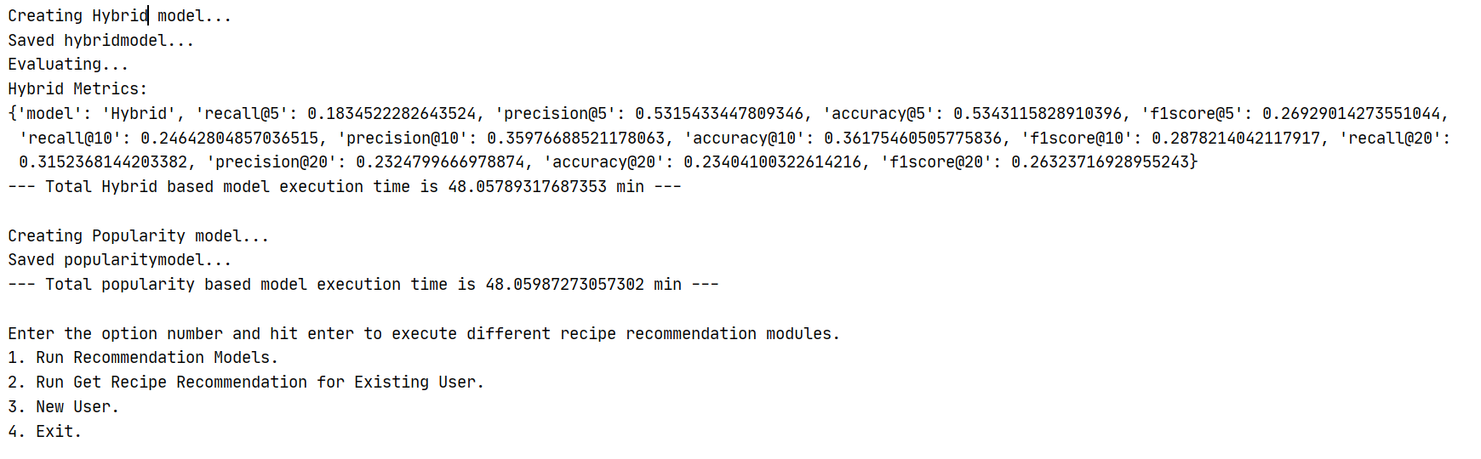

##################### GCP MACHINE ##############################################

1. 10k Users, 23k recipes

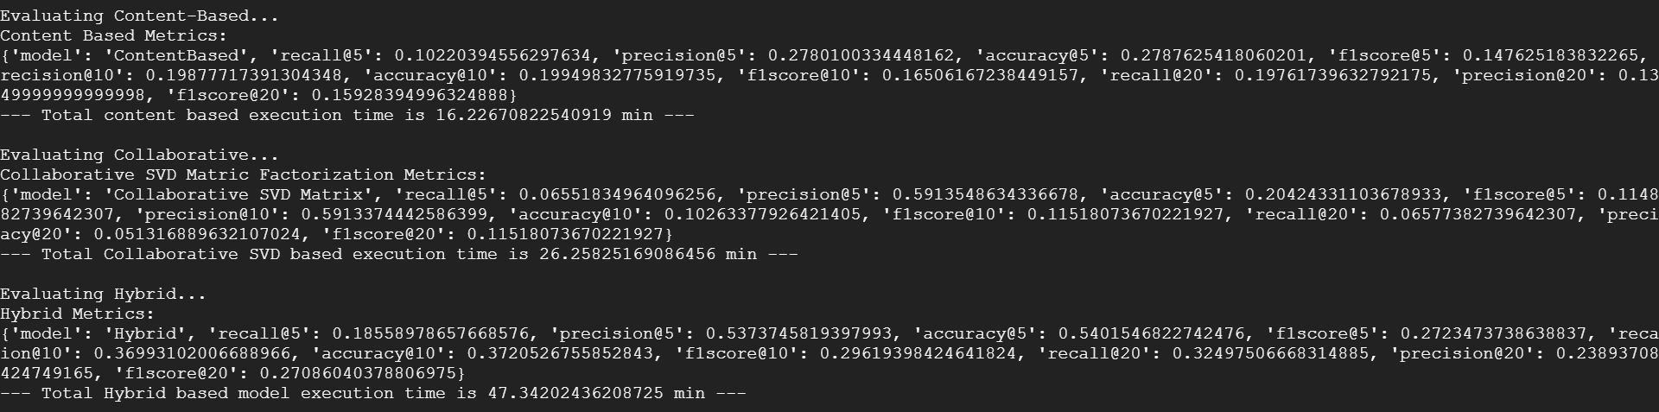

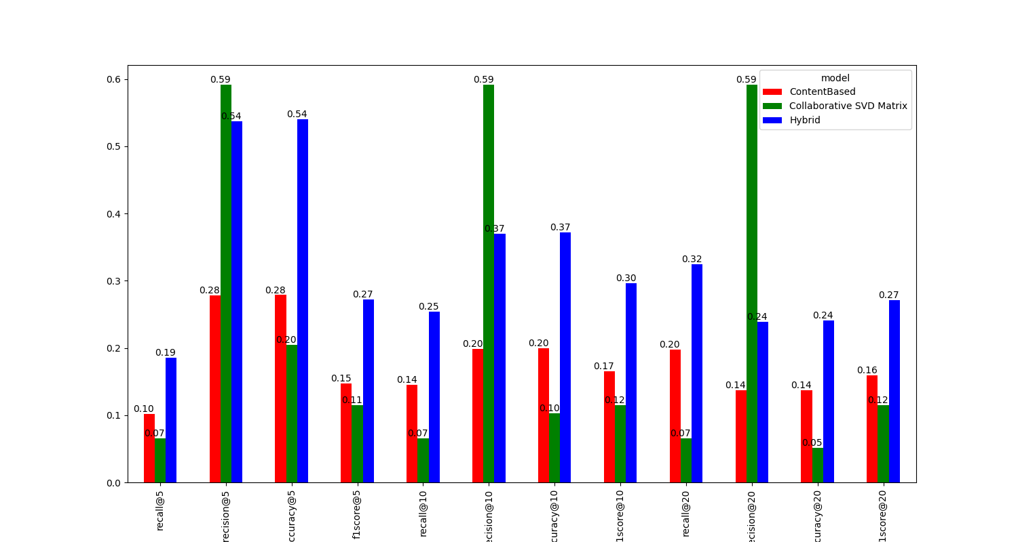

1. 10k Users, 43k recipes

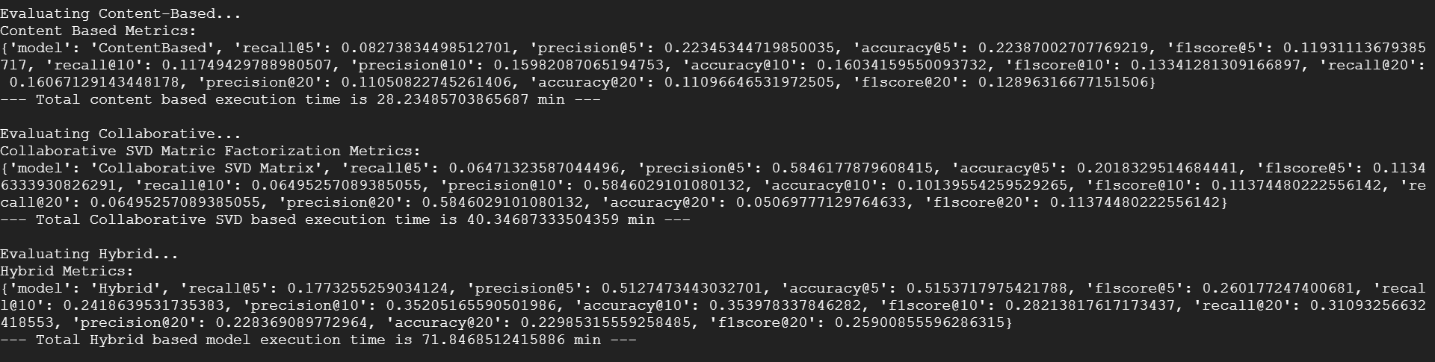

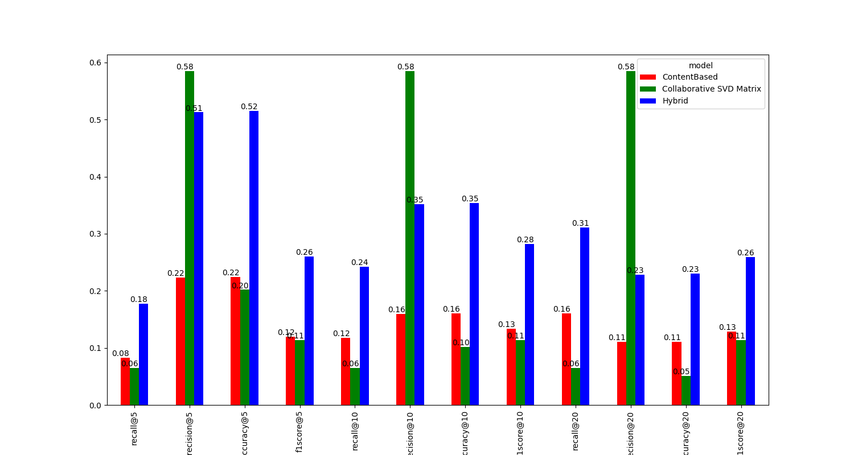

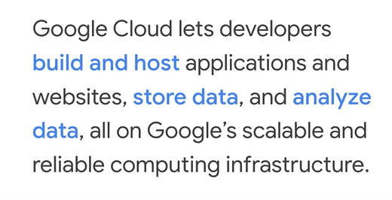

<https://cloud.google.com/python/setup>